USE intership_database;

CREATE TABLE Department (
dept_id INT PRIMARY KEY,dept_name VARCHAR(50));

CREATE TABLE Employee (
emp_id INT PRIMARY KEY AUTO_INCREMENT,emp_name VARCHAR(50),salary DECIMAL(10,2),hire_date DATE,dept_id INT,FOREIGN KEY (dept_id) REFERENCES Department(dept_id));

-- Department Data
INSERT INTO Department VALUES (10, 'IT'), (20, 'HR'), (30, 'Sales');

-- Employee Data
INSERT INTO Employee (emp_name, salary, hire_date, dept_id) VALUES
('Amit Sharma', 90000.00, '2026-01-15', 10),
('Priya Rai', 85000.00, '2025-11-20', 10),
('Rohan Das', 60000.00, '2026-04-10', 20),
('Neha Gupta', 95000.00, '2025-08-05', 10),
('Vikram Singh', 45000.00, '2026-03-01', 30),
('Anjali Verma', 60000.00, '2026-05-12', 20),
('Amit Sharma', 90000.00, '2026-01-15', 10);

# 1. Top 5 highest salary employees
SELECT * FROM Employee ORDER BY salary DESC LIMIT 5;
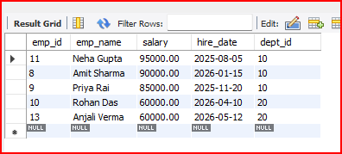

# 2. Department wise employee count
SELECT d.dept_name, COUNT(e.emp_id) AS total_employees
FROM Employee e
JOIN Department d ON e.dept_id = d.dept_id
GROUP BY d.dept_name;
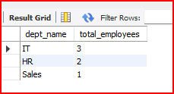
# 3. Find Second highest salary
SELECT MAX(salary) FROM Employee
WHERE salary < (SELECT MAX(salary) FROM Employee);
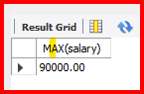

# 4. Employees whose salary > department average salary
SELECT e.emp_name, e.salary, e.dept_id
FROM Employee e
WHERE e.salary > (SELECT AVG(salary) FROM Employee WHERE dept_id = e.dept_id);
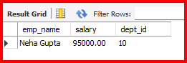

# 5. Inner Join
SELECT e.emp_name, d.dept_name, e.salary
FROM Employee e
INNER JOIN Department d ON e.dept_id = d.dept_id;
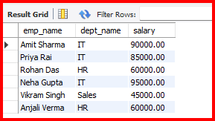

#6. Left Join
SELECT e.emp_name, d.dept_name
FROM Employee e
LEFT JOIN Department d ON e.dept_id = d.dept_id;
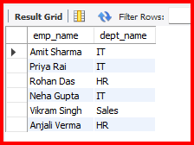
# 7. Group By with Having
SELECT dept_id, AVG(salary) AS avg_salary
FROM Employee
GROUP BY dept_id
HAVING AVG(salary) > 65000;
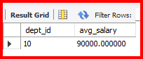

# 8. Employees hired in last 6 months
SELECT emp_name, hire_date FROM Employee
WHERE hire_date >= DATE_SUB('2026-06-25', INTERVAL 6 MONTH);


# 9. Find the Duplicates records
SELECT emp_name, salary, dept_id, COUNT(*)
FROM Employee
GROUP BY emp_name, salary, dept_id
HAVING COUNT(*) > 1;


# 10. How to remove the duplicates record
DELETE e1 FROM Employee e1
INNER JOIN Employee e2
WHERE e1.emp_id > e2.emp_id
AND e1.emp_name = e2.emp_name
AND e1.salary = e2.salary;

