**Singleton Questions**

1. The general purpose of the Singleton pattern is to:
2. Ensure that no more than one instance of a class exists.
3. Ensure that only one instance of a class exists at the same time.
4. Separate objects in a single class from objects in another class.
5. Control creation of objects in a single class or another class.

Answer- (a)

1. Which of the following is true about Singleton class?
2. The class has only a single member method.
3. The class has only a single field.
4. The class should have exactly one instance.
5. The class cannot be sub-classed.

Answer- (c)

1. Implement three Singleton classes in Java.
   1. Using eager initialization
   2. Using lazy initialization
   3. Thread safe version

Solution Github link-https://github.com/ShubhangiSrivastavaqait/mvc/blob/master/Singleton.java

1. Implement the Factory using the given class diagram, in JAVA:

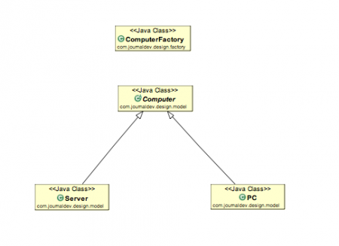

Solution Github link-https://github.com/ShubhangiSrivastavaqait/mvc/tree/master/Factoryimp