Topic 1 : Parametric Inference

Shubhangi Mistari

2024-12-31

#Topic 1

1.Example  
To conduct the simulation study from N($μ$ =1, $σ^{2}$ =1) distribution. Demonstrate the distribution and it’s descriptive statistics for different sample sizes of following statistic/estimators. ##1.sample mean

n=c(5,15,30)  
sam_mean=sam_var=numeric(length(n))  
x_bar_list=list()  
for (i in 1:length(n)){  
 x=matrix(rnorm(1000*n[i],10,1),nrow = 1000,ncol = n[i])  
 x_bar=apply(x,1,mean)  
 sam_mean[i]=mean(x_bar)  
 sam_var[i]=var(x_bar)  
 x_bar_list[[i]]=x_bar  
   
}  
  
hist(x_bar_list[[1]],breaks="FD",col="red",main="Histogram of x_bar for different sample sizes",xlab="x_bar")  
hist(x_bar_list[[2]],col="green",add=T)  
hist(x_bar_list[[3]],col="purple",add=T)  
legend("topright",legend=paste("n=",n),  
 fill=c("red","green","purple"))

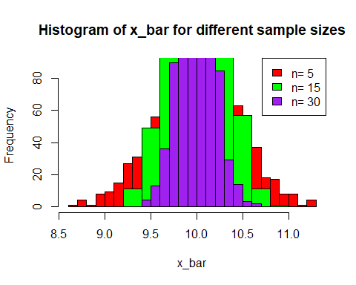

cbind(n,sam_mean,sam_var)

## n sam_mean sam_var  
## [1,] 5 10.010357 0.20344370  
## [2,] 15 10.006069 0.06906252  
## [3,] 30 9.995775 0.03472507

From this output, we conclude that as sample size increases,variability in the sample mean is decreases. Also, sample mean tends to population mean as n increases.

##2.Sample median

n=c(5,15,30)  
sam_median_mean=sam_median_var=numeric(length(n))  
x_median_list=list()  
for (i in 1:length(n)){  
 x=matrix(rnorm(1000*n[i],10,1),nrow = 1000,ncol = n[i])  
 x_median=apply(x,1,median)  
 sam_median_mean[i]=mean(x_median)  
 sam_median_var[i]=var(x_median)  
 x_median_list[[i]]=x_median  
}  
hist(x_median_list[[1]],breaks="FD",col="red",main="Histogram of x_median for different sample sizes",xlab="x_median")  
hist(x_median_list[[2]],col="green",add=T)  
hist(x_median_list[[3]],col="purple",add=T)  
legend("topright",legend=paste("n=",n),  
 fill=c("red","green","purple"))

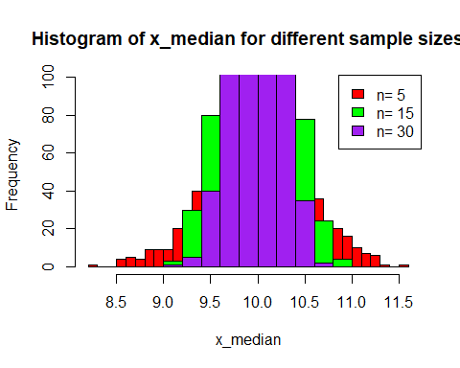

cbind(n,sam_median_mean,sam_median_var)

## n sam_median_mean sam_median_var  
## [1,] 5 9.989167 0.26284511  
## [2,] 15 9.987423 0.09937219  
## [3,] 30 9.991454 0.05201575

From this output, we conclude that as sample size increases,variability in the sample median is decreases.

##3.Sample variance

n=c(5,15,30)  
sam_var_mean=sam_var_var=numeric(length(n))  
x_var_list=list()  
for (i in 1:length(n)){  
 x=matrix(rnorm(1000*n[i],10,1),nrow = 1000,ncol = n[i])  
 x_var=apply(x,1,var)  
 sam_var_mean[i]=mean(x_var)  
 sam_var_var[i]=var(x_var)  
 x_var_list[[i]]=x_var  
   
}  
  
hist(x_var_list[[1]],breaks="FD",col="red",main="Histogram of x_var for different sample sizes",xlab="x_var")  
hist(x_var_list[[2]],col="green",add=T)  
hist(x_var_list[[3]],col="purple",add=T)  
legend("topright",legend=paste("n=",n),  
 fill=c("red","green","purple"))

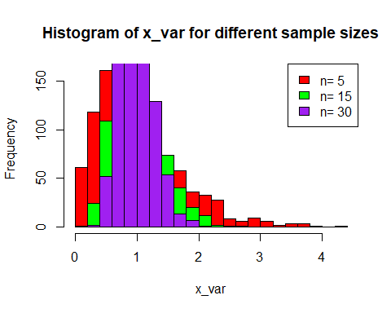

cbind(n,sam_var_mean,sam_var_var)

## n sam_var_mean sam_var_var  
## [1,] 5 1.0135510 0.49156537  
## [2,] 15 0.9917855 0.14672027  
## [3,] 30 0.9968313 0.07143448

From this output, we conclude that as sample size increases,variability in the sample variance is decreases.

##population variance

n=c(5,15,30)  
sam_var_mean=sam_var_var=numeric(length(n))  
T1_list=list()  
for (i in 1:length(n)){  
 x=matrix(rnorm(1000*n[i],10,1),nrow = 1000,ncol = n[i])  
 x_var=apply(x,1,var)  
 T1=((n[i]-1)/n[i])*x_var  
 sam_var_mean[i]=mean(T1)  
 sam_var_var[i]=var(T1)  
 T1_list[[i]]=T1  
   
}  
  
hist(T1_list[[1]],breaks="FD",col="red",main="Histogram of T1 for different sample sizes",xlab="x_var")  
hist(T1_list[[2]],col="green",add=T)  
hist(T1_list[[3]],col="purple",add=T)  
legend("topright",legend=paste("n=",n),  
 fill=c("red","green","purple"))

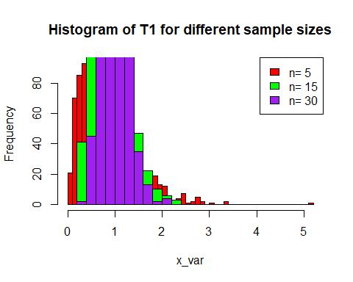

cbind(n,sam_var_mean,sam_var_var)

## n sam_var_mean sam_var_var  
## [1,] 5 0.8098024 0.34121988  
## [2,] 15 0.9251474 0.12401232  
## [3,] 30 0.9760031 0.06379236

2.Example

To conduct the simulation study from Poisson($λ$ =2.5) distribution. Demonstrate the distribution and it’s descriptive statistics for different sample sizes of following statistic/estimators.

## sample mean & sample variance

n=c(5,15,30)  
sam_mean=sam_var=numeric(length(n))  
sam_var_mean=sam_var_var=numeric(length(n))  
x_bar_list1=list()  
x_var_list2=list()  
for (i in 1:length(n)){  
 x=matrix(rpois(1000*n[i],2.5),nrow = 1000,ncol = n[i])  
   
 x_bar=apply(x,1,mean)  
 x_var=apply(x,1,var)  
   
 sam_mean[i]=mean(x_bar)  
 sam_var_mean[i]=mean(x_var)  
   
   
 sam_var[i]=var(x_bar)  
 sam_var_var[i]=var(x_var)  
   
 x_bar_list[[i]]=x_bar  
 x_var_list[[i]]=x_var  
   
}  
  
hist(x_bar_list[[1]],breaks="FD",col="red",main="Histogram of x_bar for different sample sizes",xlab="x_bar")  
hist(x_bar_list[[2]],col="green",add=T)  
hist(x_bar_list[[3]],col="purple",add=T)  
legend("topright",legend=paste("n=",n),  
 fill=c("red","green","purple"))

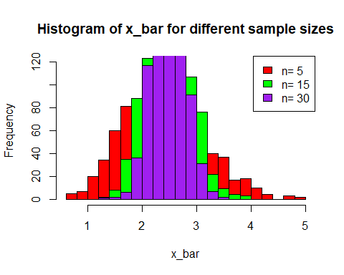

cbind(n,sam_mean,sam_var)

## n sam_mean sam_var  
## [1,] 5 2.504400 0.5036042  
## [2,] 15 2.512733 0.1719654  
## [3,] 30 2.499433 0.0837868

hist(x_var_list[[1]],breaks="FD",col="red",main="Histogram of x_var for different sample sizes",xlab="x_var")  
hist(x_var_list[[2]],col="green",add=T)  
hist(x_var_list[[3]],col="purple",add=T)  
legend("topright",legend=paste("n=",n),  
 fill=c("red","green","purple"))

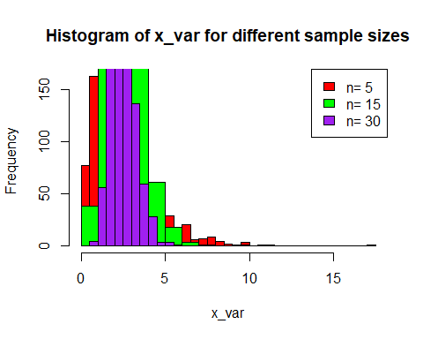

cbind(n,sam_var_mean,sam_var_var)

## n sam_var_mean sam_var_var  
## [1,] 5 2.486600 3.5033638  
## [2,] 15 2.515333 1.0751809  
## [3,] 30 2.515066 0.5280931

From this output, we conclude that as sample size increases,variability in the sample mean and sample variance is decreases. Also, sample mean tends to population mean as n increases and sample variance tends to population variance as n increases.

1. Example To conduct the simulation study from U(0, $θ$), $θ$ >0 distribution. Demonstrate the distribution and it’s descriptive statistics for different sample sizes of following statistic/estimators.

T1=2*($\overset{‾}{x}$) & T2= $x_{\left(n\right)}$

n=c(5,15,30)  
sam_mean_T1=sam_var_T1=numeric(length(n))  
sam_mean_T2=sam_var_T2=numeric(length(n))  
  
T1_list=list()  
T2_list=list()  
  
for (i in 1:length(n)){  
 x=matrix(runif(1000*n[i],0,1),nrow = 1000,ncol = n[i])  
   
 x_bar=apply(x,1,mean)  
 T1=2*x_bar  
 T2=apply(x,1,max)  
   
 sam_mean_T1[i]=mean(T1)   
 sam_mean_T2[i]=mean(T2)  
   
 sam_var_T1[i]=var(T1)  
 sam_var_T2[i]=var(T2)  
   
 T1_list[[i]]=T1  
 T2_list[[i]]=T2  
   
}  
  
hist(T1_list[[1]],breaks="FD",col="red",main="Histogram of T1 with different sample sizes",xlab="T1=2*x_bar")  
hist(T1_list[[2]],col="green",add=T)  
hist(T1_list[[3]],col="purple",add=T)

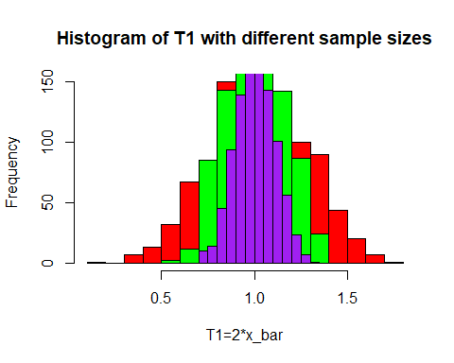

hist(T2_list[[1]],breaks="FD",col="red",main="Histogram of T1 with different sample sizes",xlab="T2=x(n)")  
hist(T2_list[[2]],col="green",add=T)  
hist(T2_list[[3]],col="purple",add=T)  
  
legend("topright",legend=paste("n=",n),  
 fill=c("red","green","purple"))

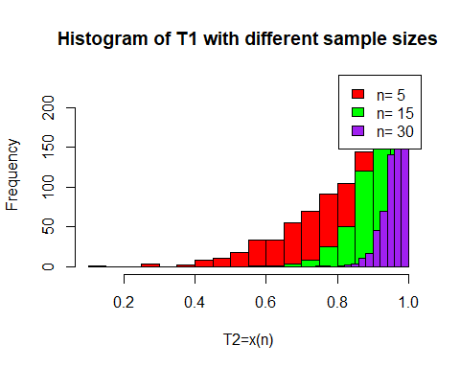

hist(T1_list[[3]],breaks=35,col="pink",main="Histogram of T1=2*x_bar & T2=x(n) with different sample sizes")  
hist(T2_list[[3]],col="blue",add=T,breaks = 50)

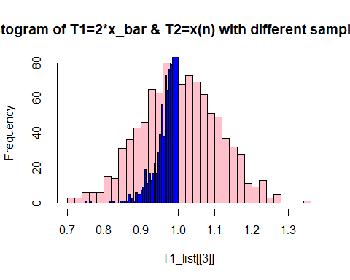

cbind(n,sam_mean_T1,sam_var_T1)

## n sam_mean_T1 sam_var_T1  
## [1,] 5 1.015083 0.06893629  
## [2,] 15 1.003221 0.02200900  
## [3,] 30 1.004161 0.01097508

cbind(n,sam_mean_T2,sam_var_T2)

## n sam_mean_T2 sam_var_T2  
## [1,] 5 0.8376709 0.019157080  
## [2,] 15 0.9370044 0.003627741  
## [3,] 30 0.9683502 0.000952815

From this output, we conclude that as sample size increases variability in T1 and T2 decreases.

1. Example To conduct the simulation study from Exponential distribution with location parameter $μ$. Demonstrate the distribution and it’s descriptive statistics for different sample sizes of following statistic/estimators.

T1= $x_{\left(1\right)}$& T2= $\overset{‾}{x}$

n=c(5,15,30)  
mu=3  
sam_mean_T1=sam_var_T1=numeric(length(n))  
sam_mean_T2=sam_var_T2=numeric(length(n))  
  
T1_list=list()  
T2_list=list()  
  
for (i in 1:length(n)){  
 x=matrix((rexp(1000*n[i],1)+mu),nrow = 1000,ncol = n[i])  
   
 T1=apply(x,1,min)  
 T2=(apply(x,1,mean)-1)  
   
 sam_mean_T1[i]=mean(T1)  
 sam_mean_T2[i]=mean(T2)  
   
 sam_var_T1[i]=var(T1)  
 sam_var_T2[i]=var(T2)  
   
 T1_list[[i]]=T1  
 T2_list[[i]]=T2  
}  
  
hist(T1_list[[1]],breaks="FD",col="red",main="Histogram of T1=x(1) with different sample sizes",xlab="T1")  
hist(T1_list[[2]],col="green",add=T)  
hist(T1_list[[3]],col="purple",add=T)

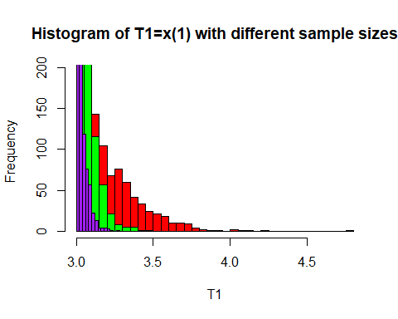

hist(T2_list[[1]],breaks="FD",col="red",main="Histogram of T2=x_bar-1 with different sample sizes",xlab="T2")  
hist(T2_list[[2]],col="green",add=T)  
hist(T2_list[[3]],col="purple",add=T)

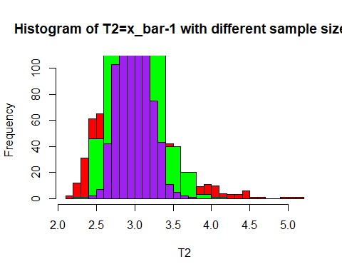

hist(T1_list[[3]],breaks=35,col="pink",main="Histogram of T1=x(1) & T2=x_bar-x(1) with different sample sizes")  
hist(T2_list[[3]],col="purple",add=T,breaks = 40)

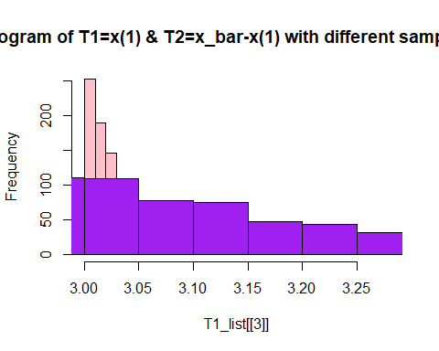

cbind(n,sam_mean_T1,sam_var_T1)

## n sam_mean_T1 sam_var_T1  
## [1,] 5 3.204424 0.036883214  
## [2,] 15 3.064248 0.004168304  
## [3,] 30 3.034695 0.001258468

cbind(n,sam_mean_T2,sam_var_T2)

## n sam_mean_T2 sam_var_T2  
## [1,] 5 3.004824 0.19410768  
## [2,] 15 2.992139 0.06774656  
## [3,] 30 2.990118 0.03540754

From this output, we conclude that as sample size increases variability in T1 and T2 decreases.

5.Example To conduct the simulation study from Exponential distribution with location parameter $μ$ and scale parameter $σ$. Demonstrate the distribution and it’s descriptive statistics for different sample sizes of following statistic/estimators.

T1= $x_{\left(1\right)}$& T2= $\overset{‾}{x}$- $x_{\left(1\right)}$

n=c(50,150,3000)  
sam_mean_T1=sam_var_T1=numeric(length(n))  
sam_mean_T2=sam_var_T2=numeric(length(n))  
mu=2  
sigma=1  
  
T1_list=list()  
T2_list=list()  
  
for (i in 1:length(n)){  
 y=matrix(runif(1000*n[i],0,1),nrow = 1000,ncol = n[i])  
 x=mu-(sigma*log(1-y))  
   
 T1=apply(x,1,min)  
 x_bar=apply(x,1,mean)  
 T2=x_bar-T1  
   
 sam_mean_T1[i]=mean(T1)   
 sam_mean_T2[i]=mean(T2)  
   
 sam_var_T1[i]=var(T1)  
 sam_var_T2[i]=var(T2)  
   
 T1_list[[i]]=T1  
 T2_list[[i]]=T2  
   
}  
  
hist(T1_list[[1]],breaks="FD",col="red",main="Histogram of T1=x(1) with different sample sizes",xlab="T1")  
hist(T1_list[[2]],col="green",add=T)  
hist(T1_list[[3]],col="purple",add=T)

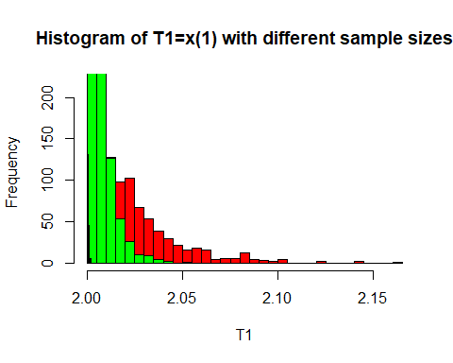

hist(T2_list[[1]],breaks="FD",col="red",main="Histogram of T2=x_bar-x(1) with different sample sizes",xlab="T2")  
hist(T2_list[[2]],col="green",add=T)  
hist(T2_list[[3]],col="purple",add=T)  
  
legend("topright",legend=paste("n=",n),  
 fill=c("red","green","purple"))

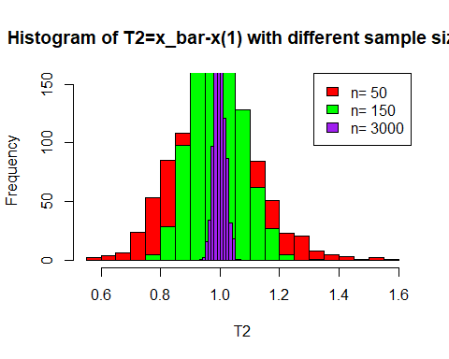

hist(T1_list[[3]],breaks=35,col="pink",main="Histogram of T1=x(1) & T2=x_bar-x(1) with different sample sizes")  
hist(T2_list[[3]],col="purple",add=T,breaks = 40)

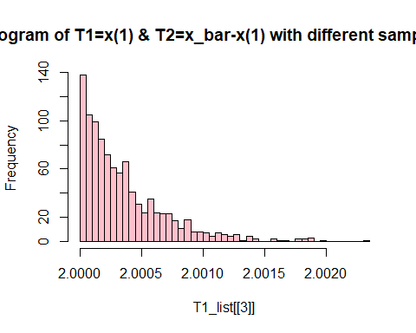

cbind(n,sam_mean_T1,sam_var_T1)

## n sam_mean_T1 sam_var_T1  
## [1,] 50 2.021499 4.642287e-04  
## [2,] 150 2.006874 4.686284e-05  
## [3,] 3000 2.000351 1.158359e-07

cbind(n,sam_mean_T2,sam_var_T2)

## n sam_mean_T2 sam_var_T2  
## [1,] 50 0.9823792 0.0201109863  
## [2,] 150 0.9912014 0.0064092467  
## [3,] 3000 0.9988754 0.0003488897

From this output, we conclude that as sample size increases variability in T1 and T2 decreases.