Topic 2: Method of Moments

Kashish Khangar

2025-01-21

*Topic 2*

1. To conduct the simulation study from N($μ$ =0, $σ^{2}$ =1) distribution. Demonstrate the distribution and it’s descriptive statistics for different sample sizes of following statistic/estimators.

1)T1=x_bar 2) T2=(1/n)*sum(Xi-x_bar)^2

n=c(5,15,30)  
sam_mean_T1=sam_var_T1=sam_var_mean=sam_var_var=numeric(0)  
T1_list=list()  
T2_list=list()  
  
for (i in 1:length(n)){  
 x=matrix(rnorm(1000*n[i],0,1),nrow=1000,ncol=n[i])  
   
 T1=apply(x,1,mean)  
 x_var=apply(x,1,var)  
 T2=((n[i]-1)/n[i])*x_var  
   
 sam_mean_T1[i]=mean(T1)  
 sam_var_mean[i]=mean(T2)  
   
 sam_var_T1[i]=var(T1)  
 sam_var_var[i]=var(T2)  
   
 T1_list[[i]]=T1  
 T2_list[[i]]=T2  
}  
  
hist(T1_list[[1]],breaks="FD",col="red",main="Histogram of T1=x_bar for different sample sizes",xlab="x_bar")  
hist(T1_list[[2]],col="green",add=T)  
hist(T1_list[[3]],col="purple",add=T)  
legend("topright",legend=paste("n=",n),  
 fill=c("red","green","purple"))

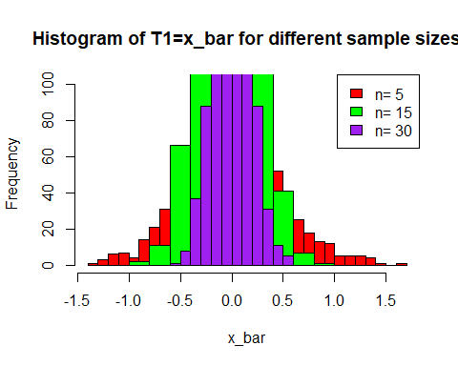

hist(T2_list[[1]],breaks="FD",col="red",main="Histogram of T2 for different sample sizes",xlab="x_var")  
hist(T2_list[[2]],col="green",add=T)  
hist(T2_list[[3]],col="purple",add=T)  
legend("topright",legend=paste("n=",n),  
 fill=c("red","green","purple"))

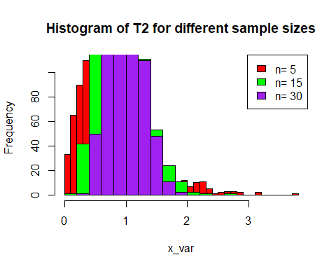

cbind(n,sam_mean_T1,sam_var_T1)

## n sam_mean_T1 sam_var_T1  
## [1,] 5 0.002489765 0.21051017  
## [2,] 15 -0.014859756 0.07012379  
## [3,] 30 0.002177539 0.03192162

cbind(n,sam_var_mean,sam_var_var)

## n sam_var_mean sam_var_var  
## [1,] 5 0.7699123 0.31709677  
## [2,] 15 0.9326848 0.11718472  
## [3,] 30 0.9673025 0.06396639

From this output, we conclude that as sample size increases, variability in the 1st moment estimator (T1=x_bar) is decreases.

1. To conduct the simulation study from U(0, $θ$), $θ$ >0 distribution. Demonstrate the distribution and it’ s descriptive statistics for different sample sizes of the moment estimator.

T1= $2\overset{‾}{x}$

n=c(20,40,70)  
sam_mean_T1=sam_var_T1=numeric(length(n))  
T1_list=list()  
  
for (i in 1:length(n)){  
 x=matrix(runif(1000*n[i],0,1),nrow = 1000,ncol = n[i])  
 x_bar=apply(x,1,mean)  
 T1=2*x_bar  
 sam_mean_T1[i]=mean(T1)   
 sam_var_T1[i]=var(T1)  
 T1_list[[i]]=T1  
}  
  
hist(T1_list[[1]],breaks="FD",col="red",main="Histogram of T1 with different sample sizes",xlab="T1=2*x_bar")  
hist(T1_list[[2]],col="green",add=T)  
hist(T1_list[[3]],col="purple",add=T)  
  
  
legend("topright",legend=paste("n=",n),  
 fill=c("red","green","purple"))

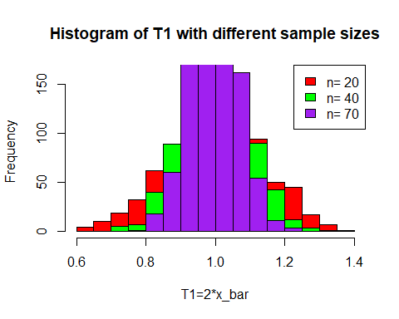

cbind(n,sam_mean_T1,sam_var_T1)

## n sam_mean_T1 sam_var_T1  
## [1,] 20 1.0006734 0.016785320  
## [2,] 40 1.0024291 0.008565162  
## [3,] 70 0.9975787 0.004820991

From this output, we conclude that as sample size increases variability in T1 and T2 decreases.

1. To conduct the simulation study from Gamma distribution with density given by $f\left(x|α,λ\right)=\frac{α^{λ}x^{λ-1}e^{-αx}}{Γ\left(λ\right)} \text{for}x≥0,α>0,λ>0$. Demonstrate the distribution and it’s descriptive statistics for different sample sizes of following statistic/estimators.

rm(list=ls())  
n=c(50,100,200) #To generate 5 r. s. from G(alpha=2.8, lambda(shape)=1.8) dist  
set.seed(120)  
sam_mean_alpha_hat=sam_mean_lambda_hat=sam_var_alpha_hat=sam_var_lambda_hat=numeric(length(n))  
  
alpha_hat_list=list()  
lambda_hat_list=list()  
  
for (i in 1:length(n)){  
 x=matrix(rgamma(1000*n[i],1.8,2.8),nrow=1000,ncol=n[i]) #shape=1.8  
   
 m1_=apply(x,1,mean) #m1'  
 m2_=apply(x^2,1,mean) #m2'  
 m2=m2_-m1_^2 #m2=(1/n*sum(x-x_bar)^2)  
   
 alpha_hat=m1_/m2 #moment est of alpha  
 lambda_hat=m1_^2/m2 #moment estimate of lambda  
   
 sam_mean_alpha_hat[i]=mean(alpha_hat)  
 sam_mean_lambda_hat[i]=mean(lambda_hat)  
   
 sam_var_alpha_hat[i]=var(alpha_hat)  
 sam_var_lambda_hat[i]=var(lambda_hat)  
   
 alpha_hat_list[i]=list(alpha_hat)  
 lambda_hat_list[i]=list(lambda_hat)  
}  
  
hist(alpha_hat_list[[1]],col="red",main="Histogram of alpha_hat with different sample sizes",xlab="alpha_hat")  
hist(alpha_hat_list[[2]],col="green",add=T)  
hist(alpha_hat_list[[3]],col="purple",add=T)

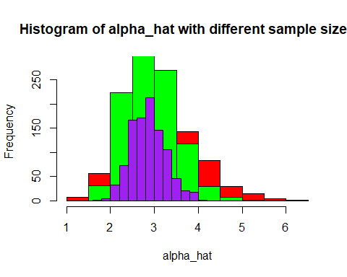

hist(lambda_hat_list[[1]],col="red",main="Histogram of lambda_hat with different sample sizes",xlab="lambda_hat")  
hist(lambda_hat_list[[2]],col="green",add=T)  
hist(lambda_hat_list[[3]],col="purple",add=T)

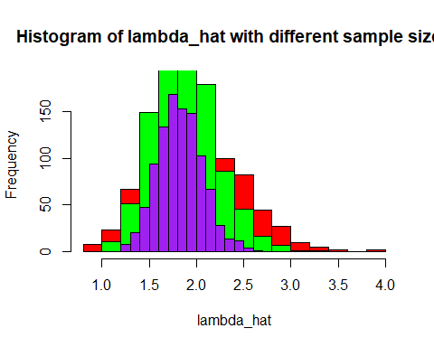

cbind(n,sam_mean_alpha_hat, sam_mean_lambda_hat)

## n sam_mean_alpha_hat sam_mean_lambda_hat  
## [1,] 50 3.077406 1.955498  
## [2,] 100 2.926502 1.873718  
## [3,] 200 2.859333 1.830444

cbind(n,sam_var_alpha_hat,sam_var_lambda_hat)

## n sam_var_alpha_hat sam_var_lambda_hat  
## [1,] 50 0.6235670 0.20971140  
## [2,] 100 0.3280680 0.11227818  
## [3,] 200 0.1572297 0.05594251

4.Example To conduct the simulation study from Exponential distribution with location parameter $μ$ and scale parameter $σ$. Demonstrate the distribution and it’s descriptive statistics for different sample sizes of following statistic/estimators for $μ$ and $σ$ respectively.

1. $m_{1}'$- $\sqrt{m_{2}}$ 2) $\sqrt{m_{2}}$

n=c(100,150,3000)  
sam_mean_T1=sam_var_T1=numeric(length(n))  
sam_mean_T2=sam_var_T2=numeric(length(n))  
mu=2  
sigma=1  
  
T1_list=list()  
T2_list=list()  
  
for (i in 1:length(n)){  
 y=matrix(runif(1000*n[i],0,1),nrow = 1000,ncol = n[i])  
 x=mu-(sigma*log(1-y))  
   
 m1_=apply(x,1,mean) #m1'  
 m2_=apply(x^2,1,mean) #m2'  
 m2=m2_-((m1_)^2) #m2=(1/n*sum(x-x_bar)^2)  
   
 T1=m1_-sqrt(m2)   
 T2=sqrt(m2)   
   
 sam_mean_T1[i]=mean(T1)   
 sam_mean_T2[i]=mean(T2)  
   
 sam_var_T1[i]=var(T1)  
 sam_var_T2[i]=var(T2)  
   
 T1_list[[i]]=T1  
 T2_list[[i]]=T2  
   
}  
  
hist(T1_list[[1]],breaks="FD",col="red",main="Histogram of T1=m1'-sqrt(m2) with different sample sizes",xlab="T1")  
hist(T1_list[[2]],col="green",add=T)  
hist(T1_list[[3]],col="purple",add=T)

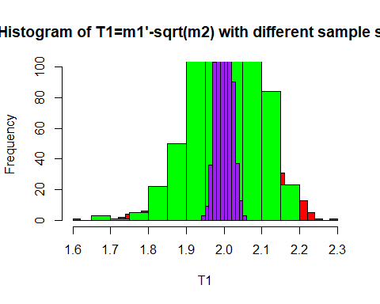

hist(T2_list[[1]],breaks="FD",col="red",main="Histogram of T2=sqrt(m2) with different sample sizes",xlab="T2")  
hist(T2_list[[2]],col="green",add=T)  
hist(T2_list[[3]],col="purple",add=T)  
  
legend("topright",legend=paste("n=",n),  
 fill=c("red","green","purple"))

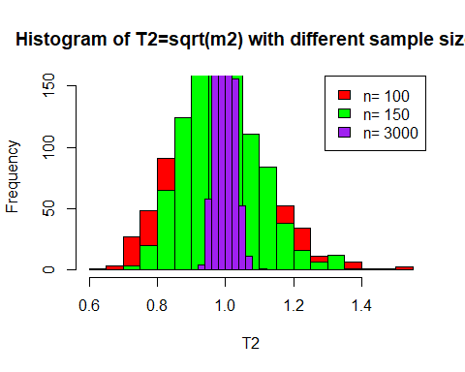

cbind(n,sam_mean_T1,sam_var_T1)

## n sam_mean_T1 sam_var_T1  
## [1,] 100 2.019090 0.0086199415  
## [2,] 150 2.010864 0.0059385257  
## [3,] 3000 2.000307 0.0003435028

cbind(n,sam_mean_T2,sam_var_T2)

## n sam_mean_T2 sam_var_T2  
## [1,] 100 0.9815215 0.0185036824  
## [2,] 150 0.9892342 0.0120541253  
## [3,] 3000 0.9999965 0.0006765653

1. Example Consider a random sample of size 20 from given below from $Beta\left(α,β\right)$ distribution. Obtain moment estimates of and based on given sample.

x=c(0.133904,0.224011,0.062282,0.122690,0.051213,0.620577,0.000650,0.271087,0.827109,0.929479,0.561905,0.160865,  
 0.362565,0.001039,0.883135,0.393477,0.990179,0.045737,0.243155,0.080471)  
n=length(x)  
x_bar=mean(x)  
var_x=var(x)*(n-1)/n  
alpha_hat=x_bar*(x_bar-mean(x^2))/var_x  
beta_hat=(1-x_bar)*alpha_hat/x_bar  
cbind(alpha_hat,beta_hat)

## alpha_hat beta_hat  
## [1,] 0.3952689 0.7396595