

**InfoBeans Foundation**

# **ITEP**

# Project report on

# College Management System

# BY

# Shubhankar Kashyap

# **Introduction**

In today's educational environment, efficient management of academic institutions is crucial for ensuring smooth operations and enhanced educational outcomes. A College Management System (CMS) is a comprehensive software solution designed to streamline various administrative processes within educational institutions. This project report presents a Core Java-based College Management System, which aims to optimize the management of student information, professor details, course and department details along with fee management.

The primary objective of the College Management System is to provide a robust and user-friendly application that addresses the challenges associated with manual management of college activities. By leveraging Core Java, the system offers a reliable, scalable, and platform-independent solution to manage day-to-day operations effectively. The system encompasses several key functionalities, including :

1. Student Management
2. Professor Management
3. Course Management
4. Department Management
5. Fee Management

The College Management System is designed to address the complexities of academic administration, reducing the reliance on manual processes and minimizing errors. The use of Core Java ensures that the system is highly portable and can be deployed across different operating systems, enhancing its accessibility and usability.

The core objectives of this project are to:

1. **Improve Efficiency**: Automate routine tasks to save time and reduce administrative burden.
2. **Enhance Accuracy**: Minimize errors associated with manual data entry and record-keeping.

# **Database Design**

Database :

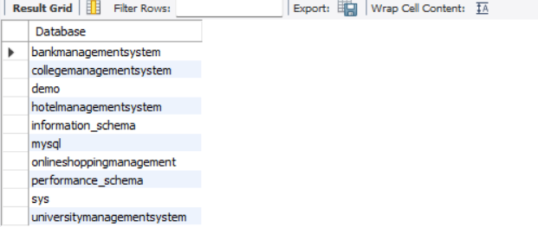

Tables :

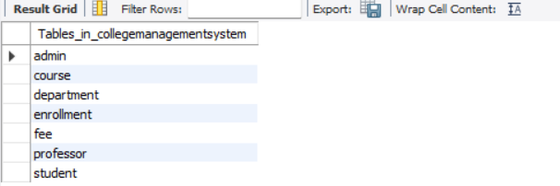

admin

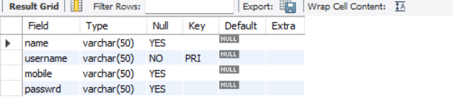

course

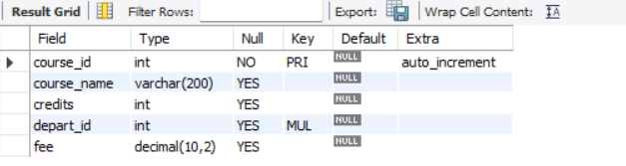

department

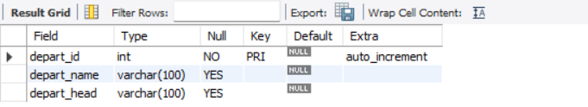

enrollment

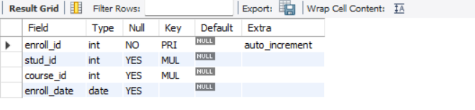

fee

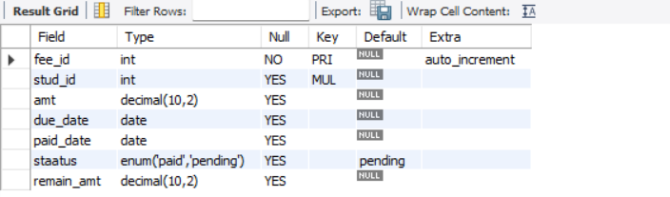

professor

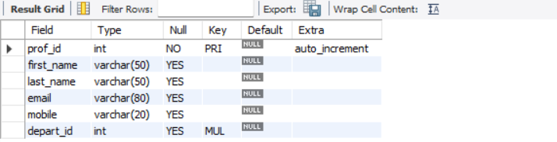

student

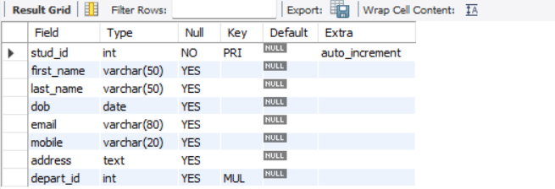

# **JDBC Code**

**package** universitymanagementsystem;

**import** java.sql.*;

**public** **class** Conn {

Connection c;

Statement s;

**public** Conn() {

**try** {

Class.*forName*("com.mysql.cj.jdbc.Driver");

c = DriverManager.*getConnection*("jdbc:mysql://localhost:3306/collegemanagementsystem","root","shubhankar@2004");

s=c.createStatement();

}**catch**(Exception e) {

System.***out***.println(e);

}

}

}

# Project Slides

Splash.java

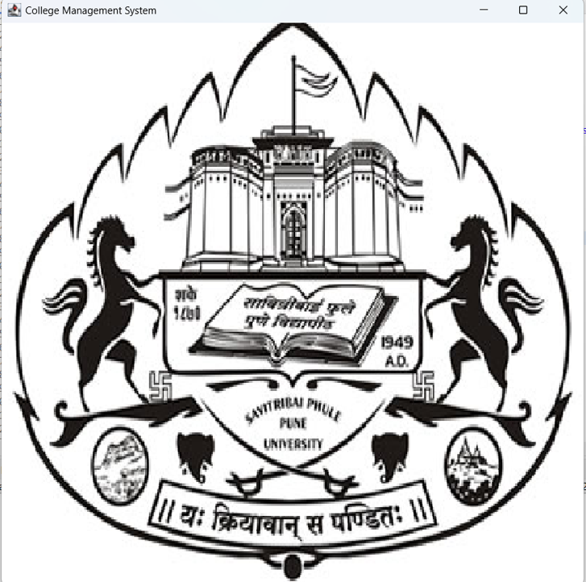

Login.java

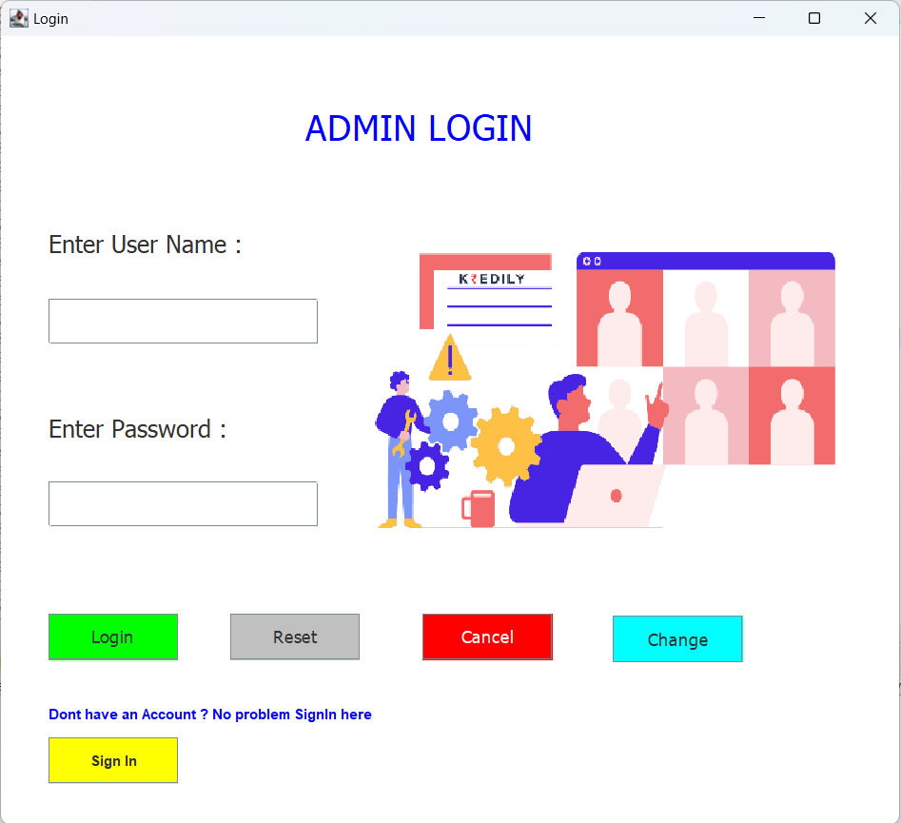

SignIn.java

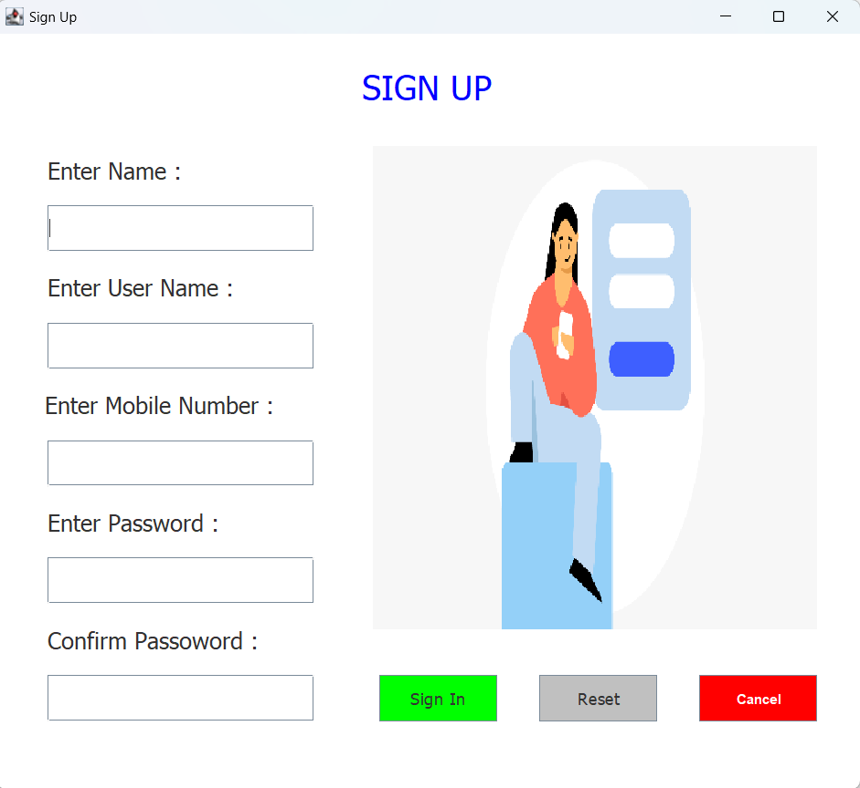

ForgotPassword.java

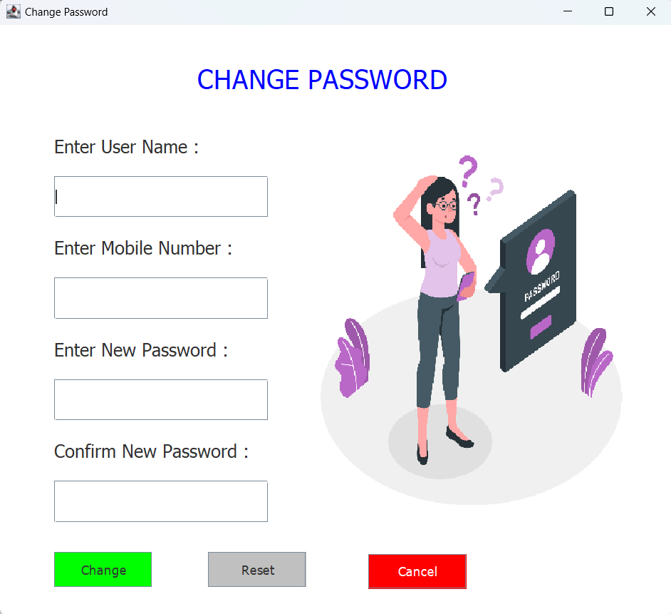

DashBoard.java



AddStudent.java

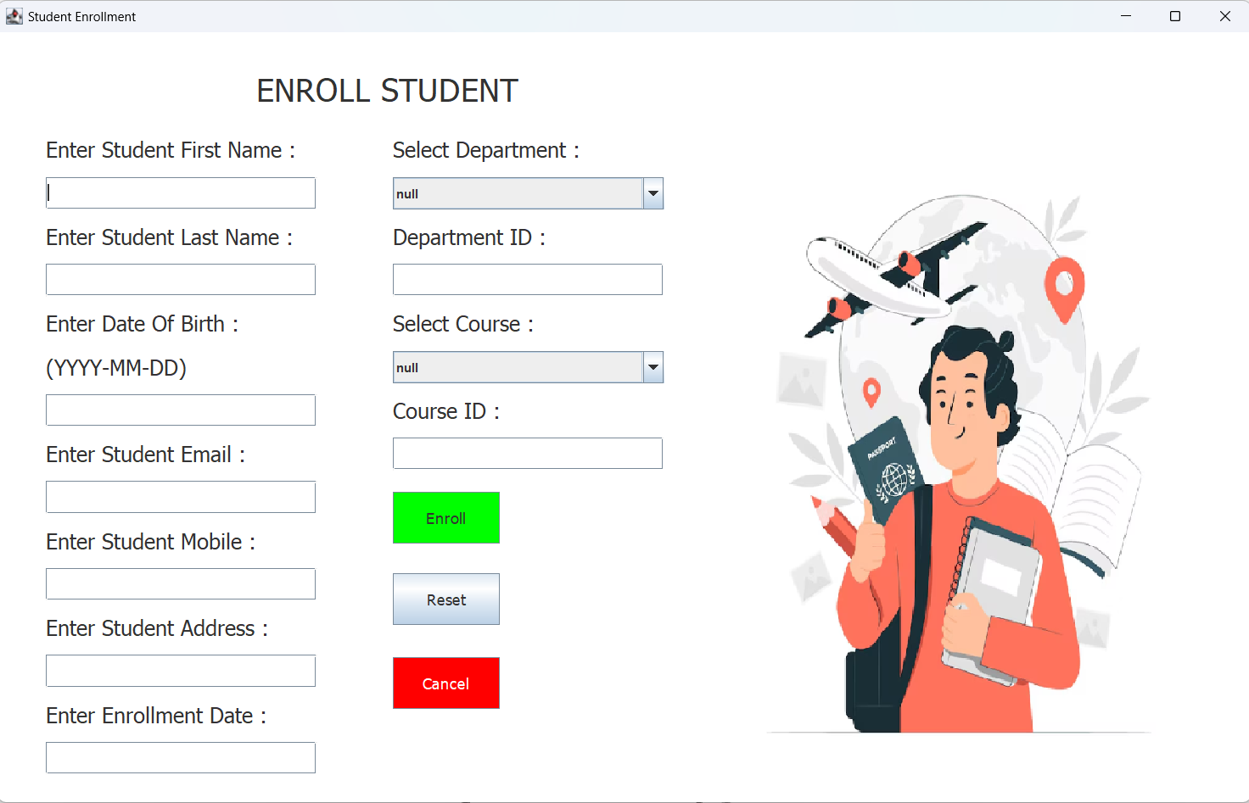

AddProfessor.java

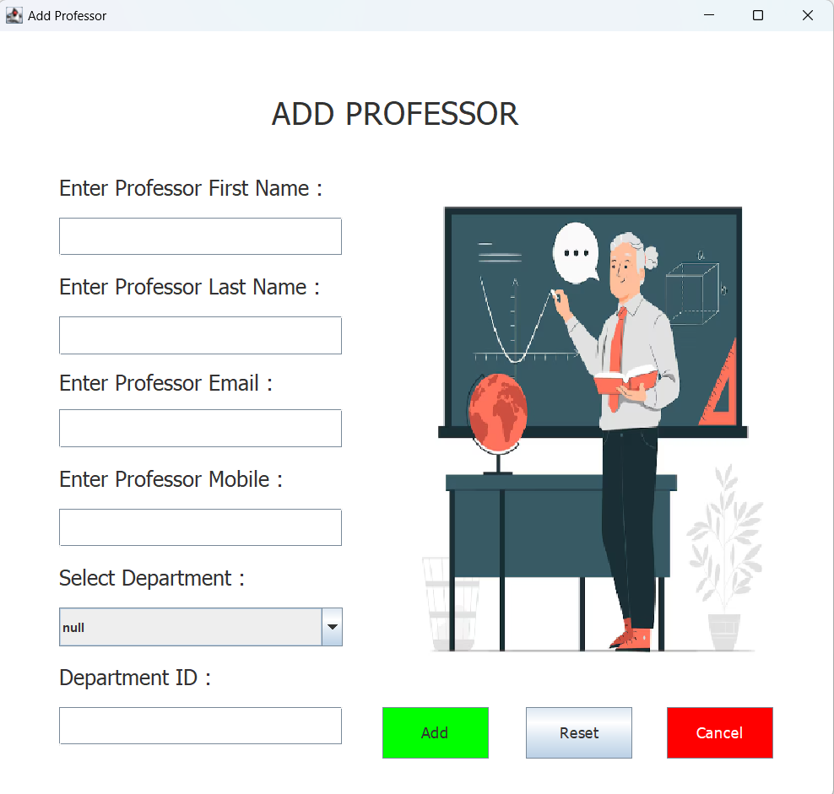

AddDepartment.java

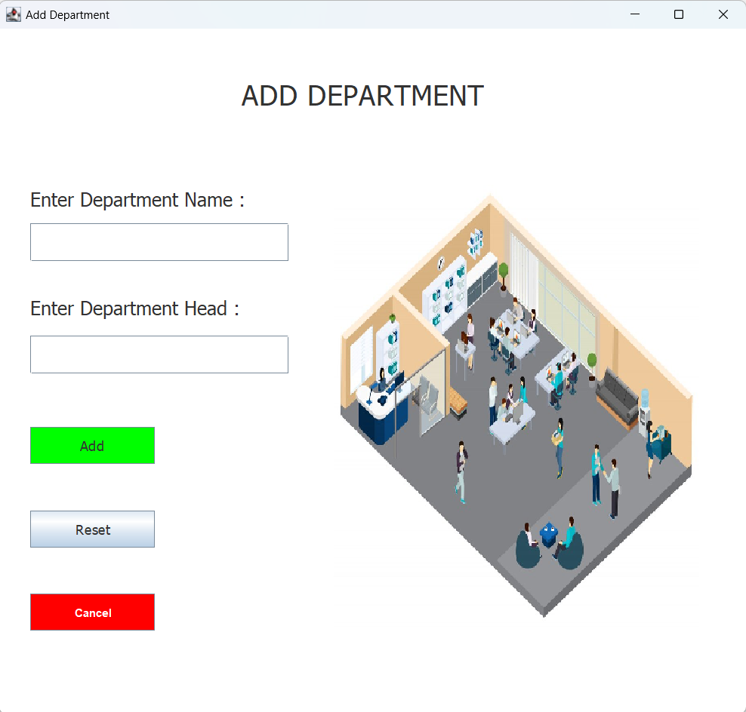

AddCourse.java

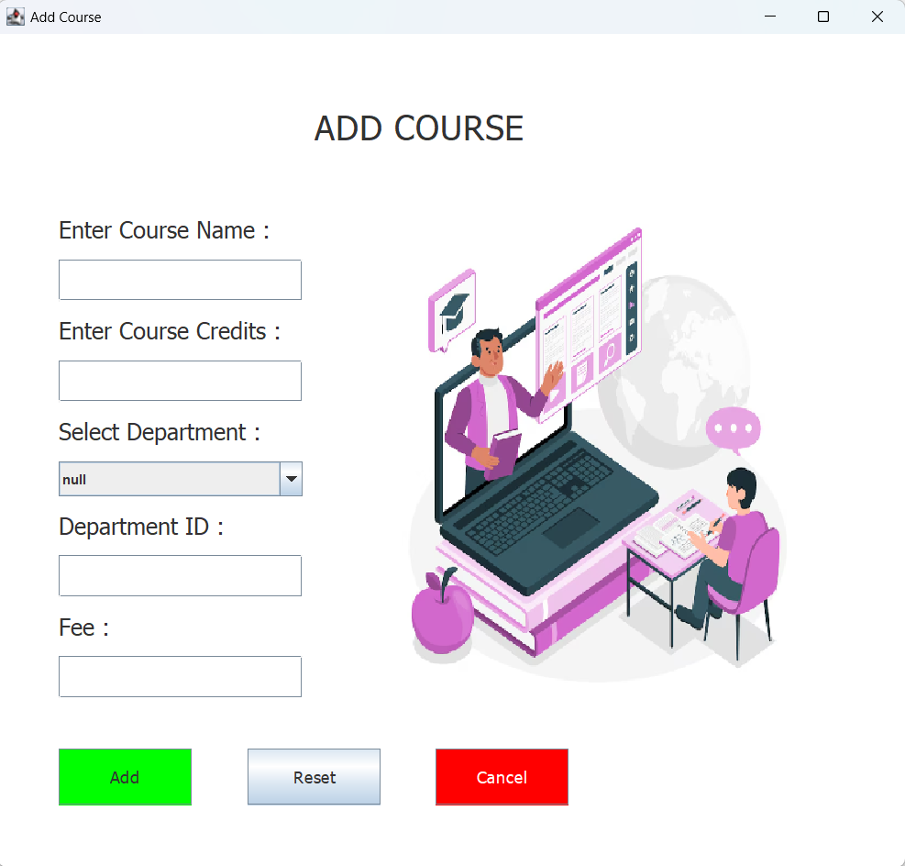

PayFee.java

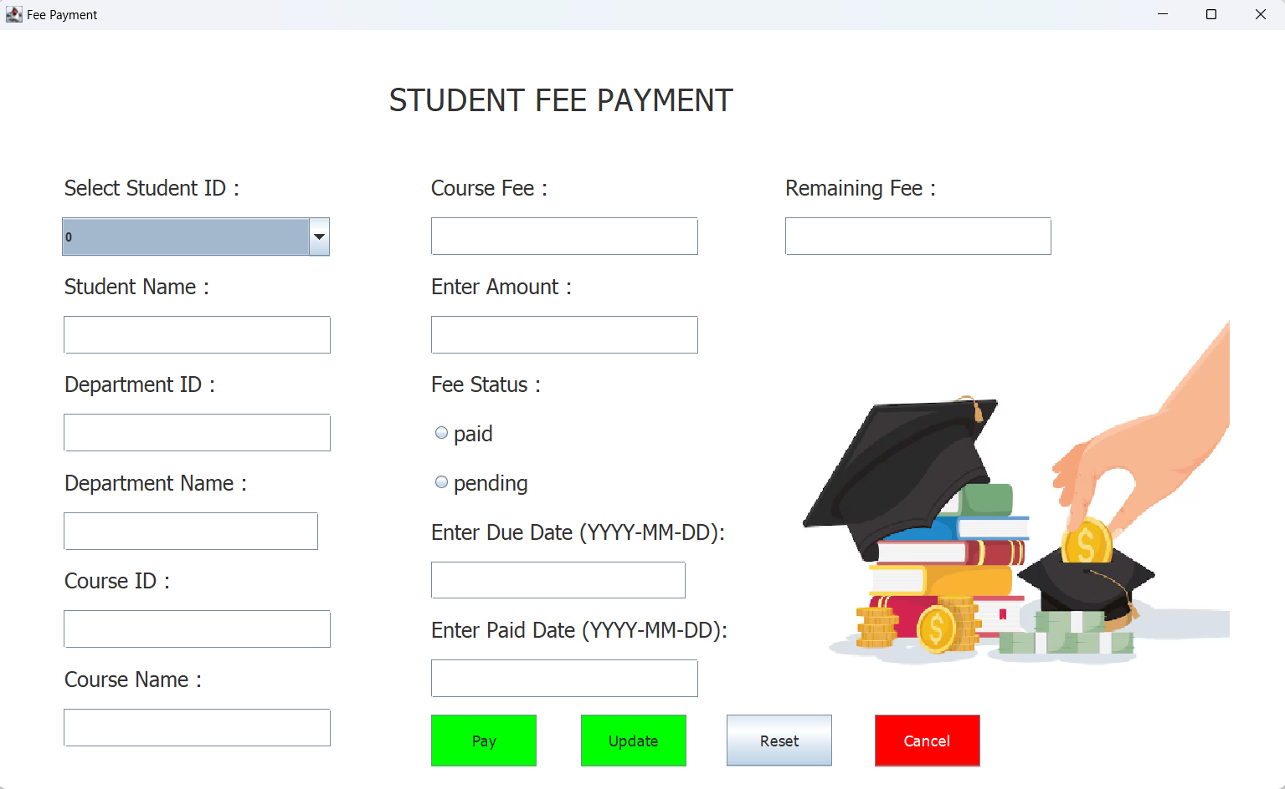

UpdateStudent.java

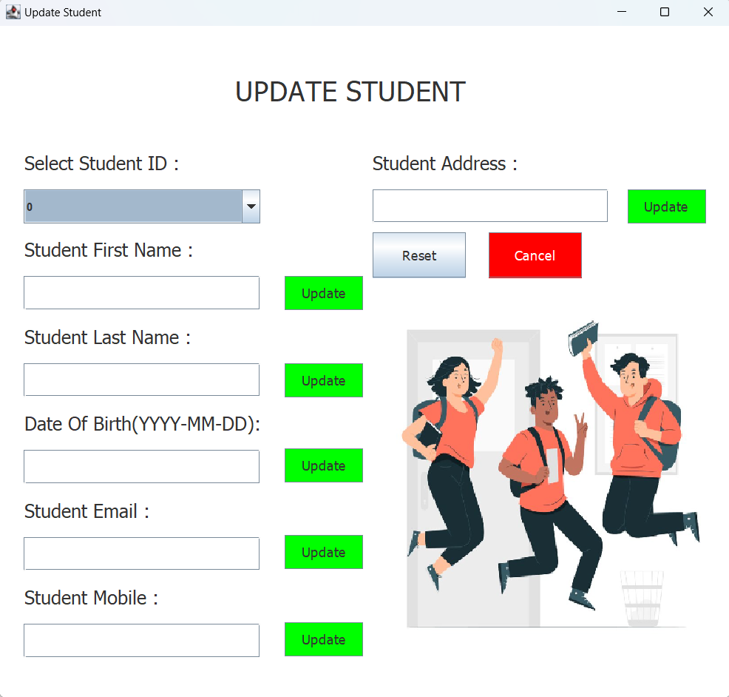

UpdateProfessor.java

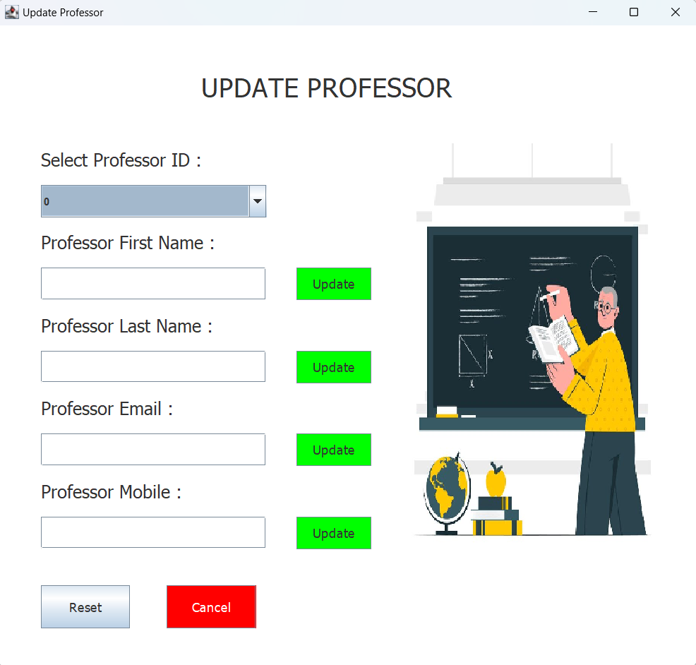

UpdateDepartment.java

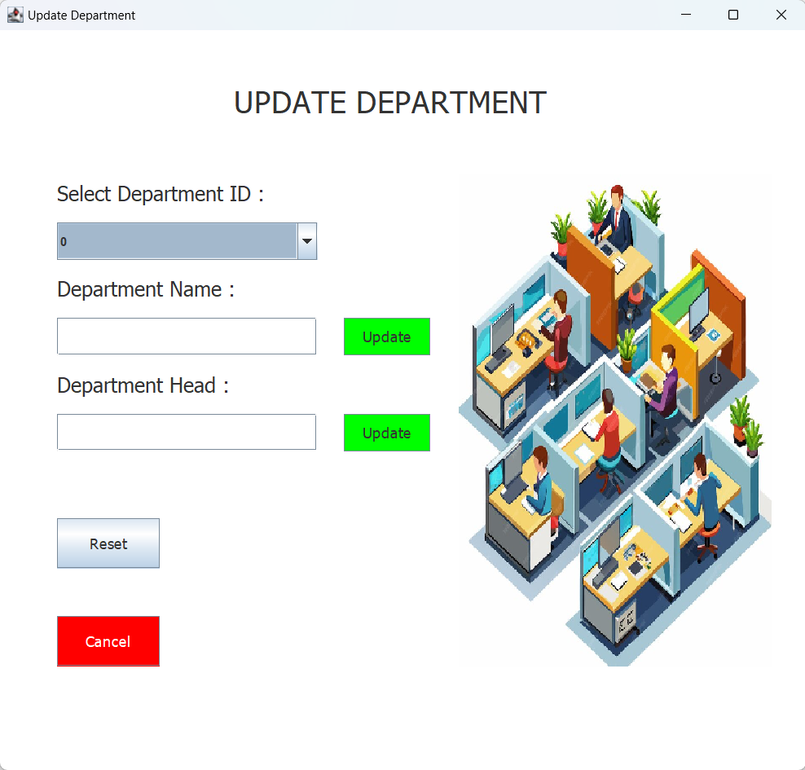

UpdateCourse.java

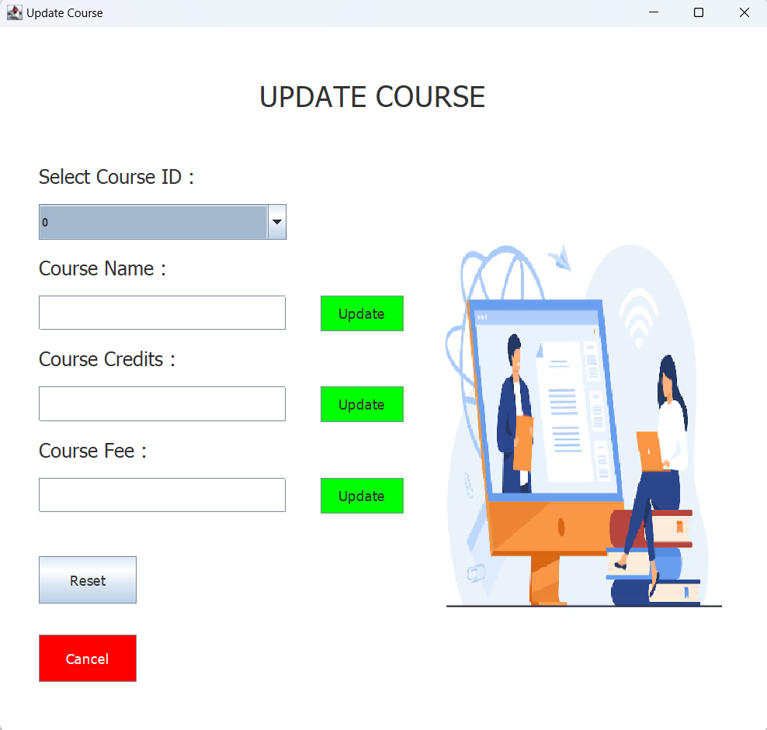

StudentDetails.java

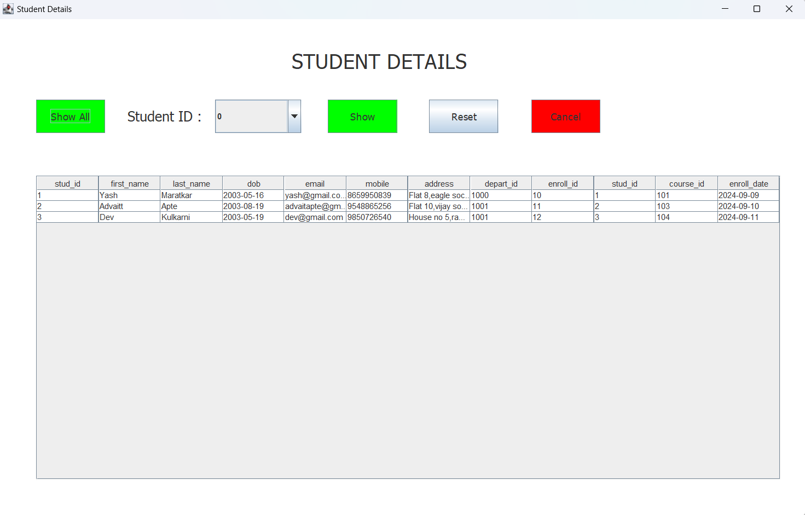

ProfessorDetails.java

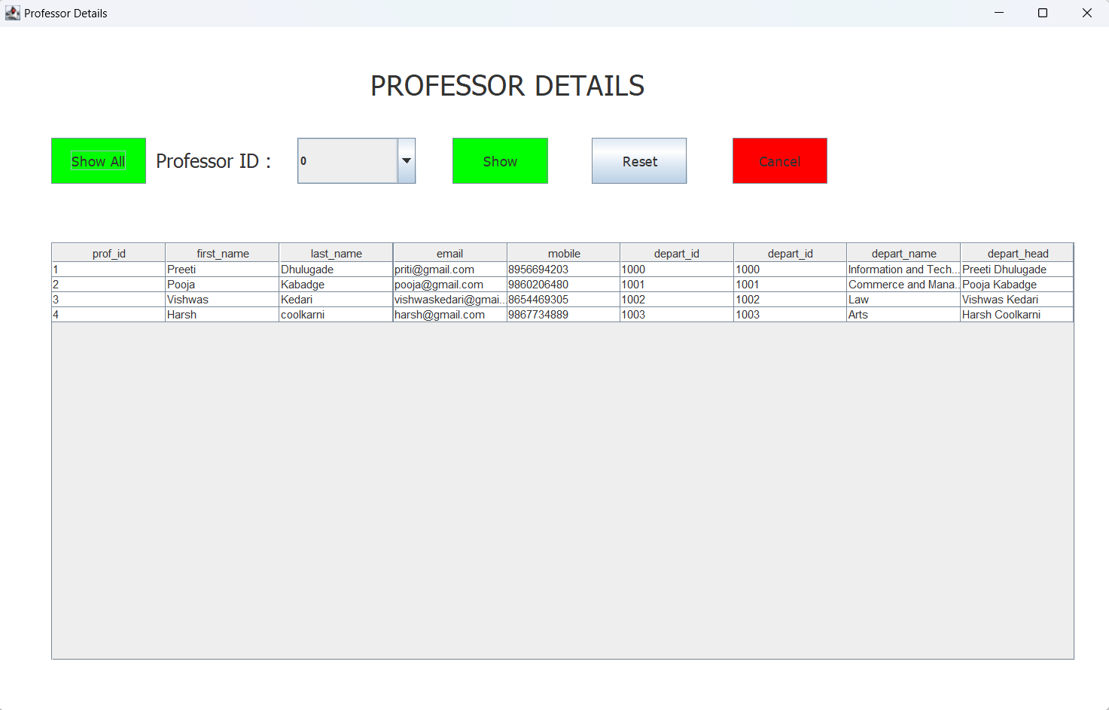

CourseDetails.java

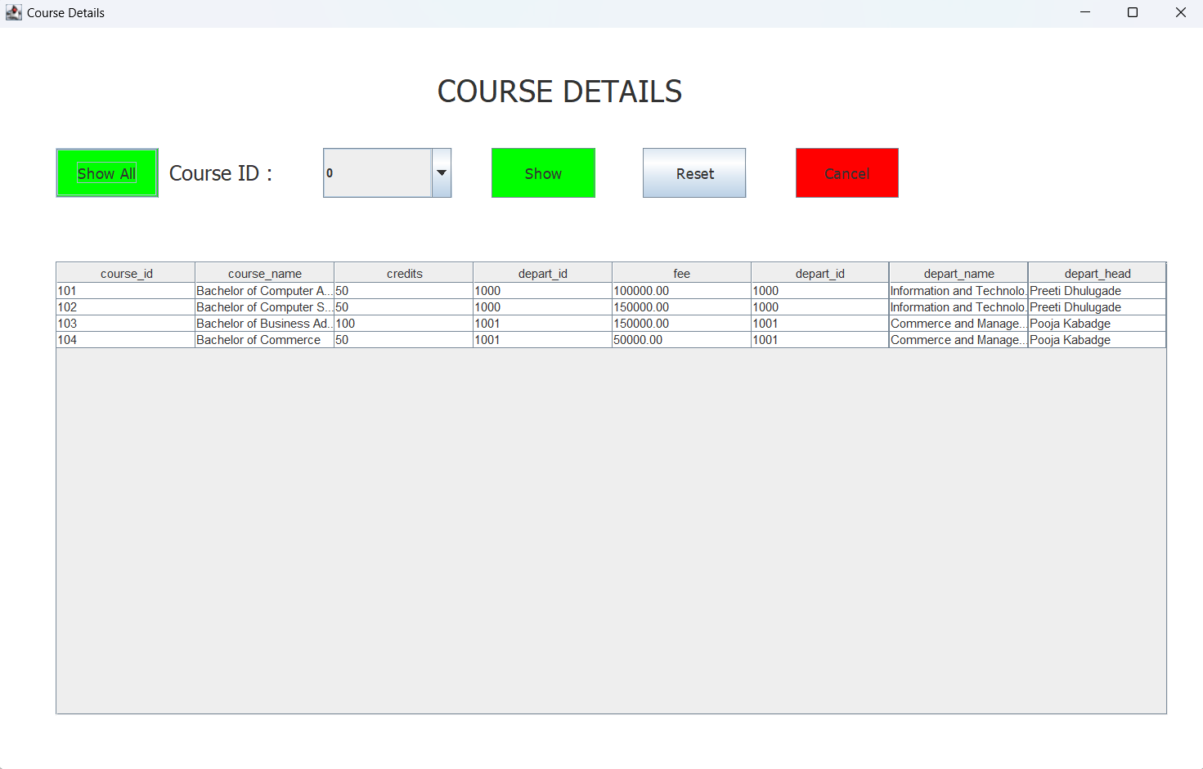

DepartmentDetails.java

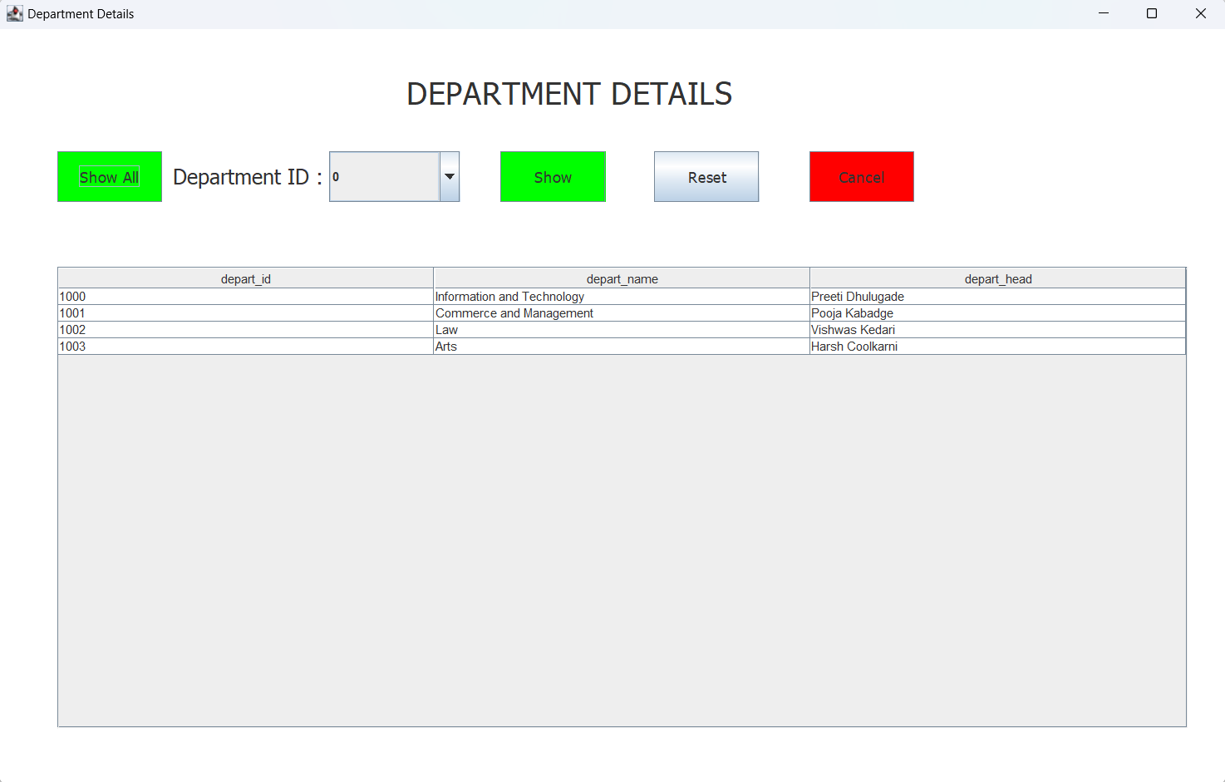

FeeDetails.java

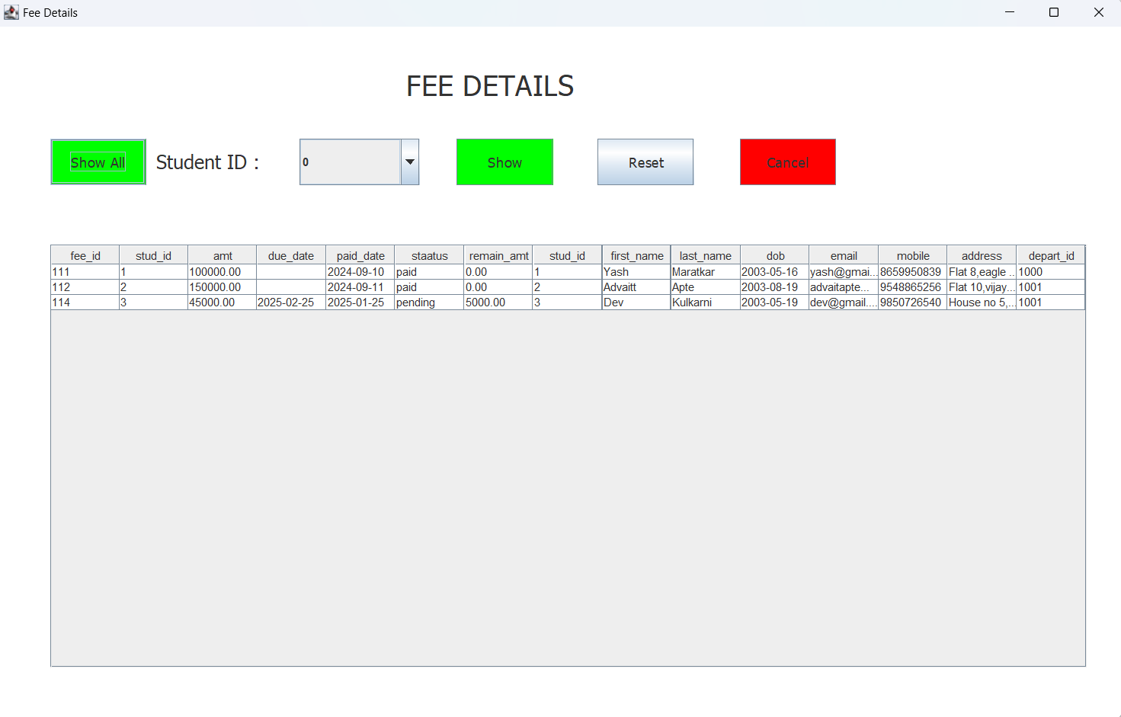

# **ER Diagram**

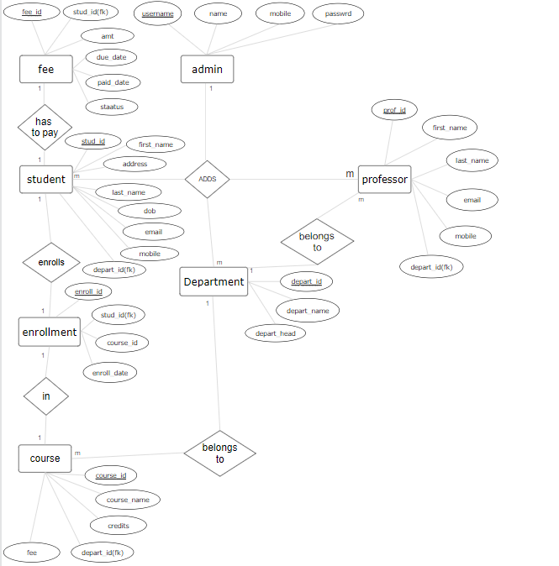

# **Tools Used :**

WindowBuilder

MysqlWorkbench

Eclipse IDE