Assignment – 14

Entering, Deleting, and Changing Field Values.

1) Write a command that puts the following values, in their given order, into the

salespeople table: city – San Jose, name – Blanco, comm – NULL, cnum – 1100.

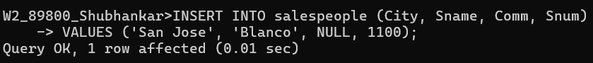

2) Write a command that removes all orders from customer Clemens from the

Orders table.

3) Write a command that increases the rating of all customers in Rome by 100.

4) Salesperson Serres has left the company. Assign her customers to Motika.

