Assignment – 19

Views.

1) Create a view that shows all of the customers who have the highest ratings.

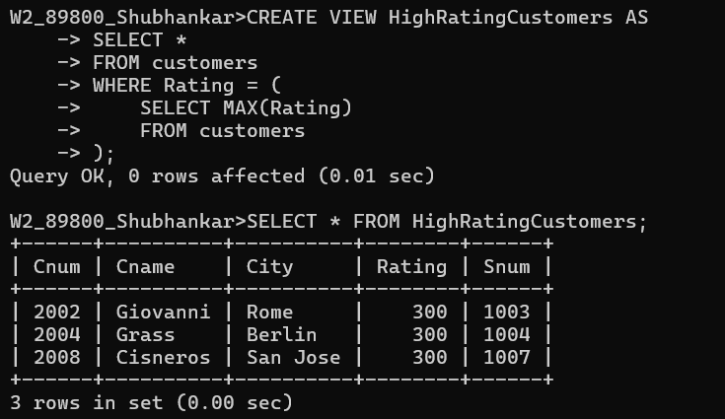

2) Create a view that shows the number of salespeople in each city.

3) Create a view that shows the average and total orders for each salesperson after

his or her name. Assume all names are unique.

4) Create a view that shows each salesperson with multiple customers.

