Assignment –8

Formatting Query output.

Q1. Assume each salesperson has a 12% commission. Write a query on

the orders table that will produce the order number, the salesperson

number, and the amount of the salesperson’s commission for that

order.

Q2. Write a query on the Customers table that will find the

highest rating in each city. Put the output in this form:

For the city (city), the highest rating is : (rating).

=>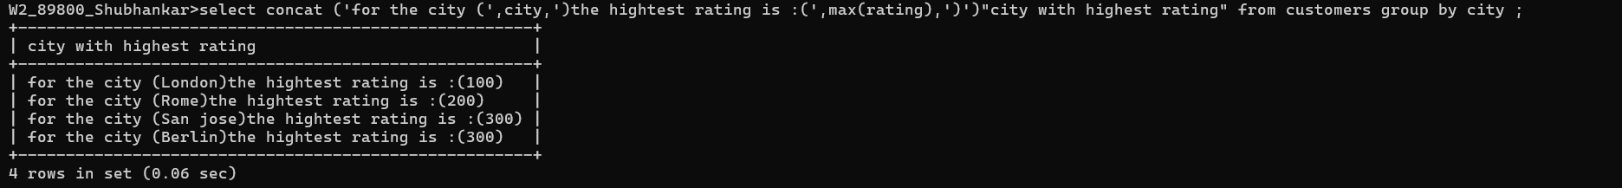

Q3. Write a query that lists customers in descending order of

rating. Output the rating field first, followed by the customer’s

name and number.

Q4. Write a query that totals the orders for each day and places

the results in descending order.

