Assignment –4

1) Write a select command that produces the order number, amount, and date for all rows in the Orders table.

=>W2_89800_Shubhankar>select Onum,Amt,Odate from orders;

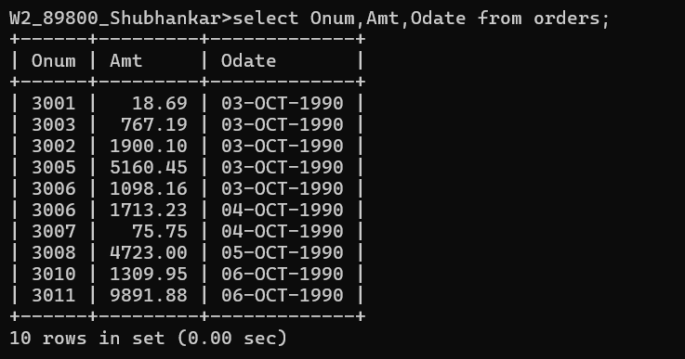

2) Write a query that produces all rows from the Customers table for which the salesperson’s number is 1001.

=>SELECT * FROM Salespeople WHERE Snum = 1001;

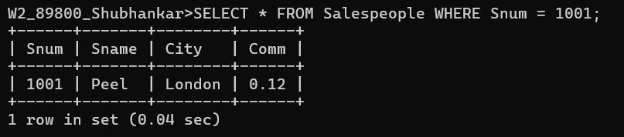

3) Write a query that displays the Salespeople table with the columns in the following order: city, sname, snum, comm.

=> W2_89800_Shubhankar>SELECT City,Sname,Snum,Comm from Salespeople;

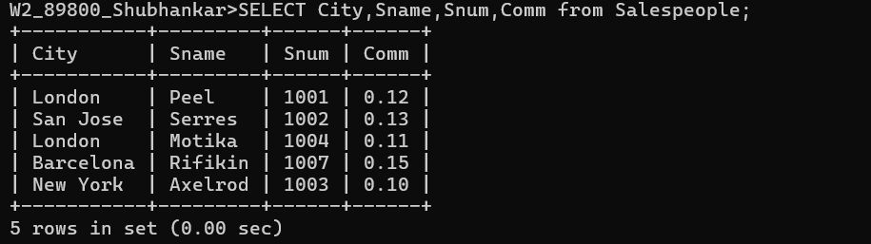

4) Write a select command that produces the rating followed by the name of each customer in San Jose.

=> select rating,Cnum from customers where city='san jose';

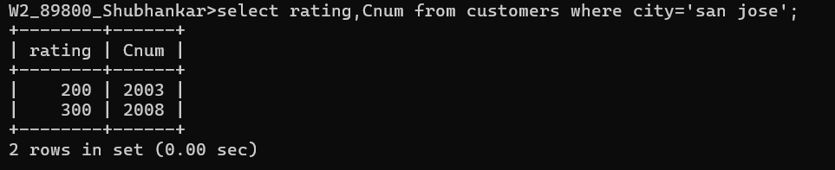

5) Write a query that will produce the snum values of all salespeople (suppress the duplicates) with orders in the Orders table.

=> W2_89800_Shubhankar>SELECT DISTINCT Snum FROM ORDERS;

