# Project 2: Data Carving

The main aim of this lab is to recover the files based on their signature from the provided binary image. Every file type like jpg and png has a specific signature like sof and eof. So, I have done a bit wise analysis on provided binary file and then matched the sof and eof to recover various files.

To run the program, use following command

**#python DataCarving.py <binaryfilename>**

Make sure that you have the binary file in the same folder where you have saved the py file.

Following is the output of the program. It specifies the Name of the file recovered which has sof memory location and eof memory location in the file name. It also provides the size of the recovered file in Bytes.

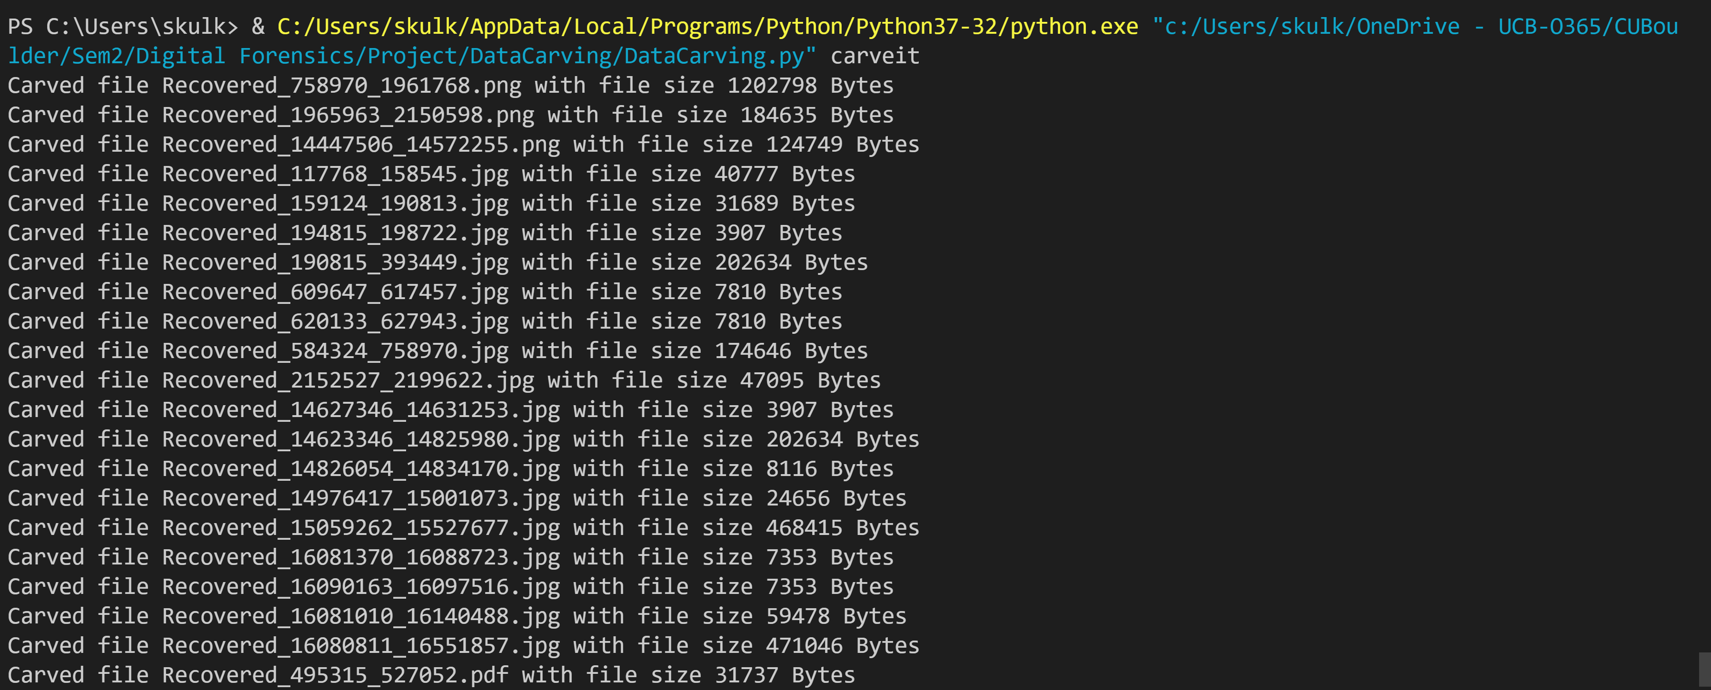

The program creates the directory with my name if it is not already existing then stores the recovered files in that directory. I have hardcoded the directory for now, but it can be modified to have a variable paths.

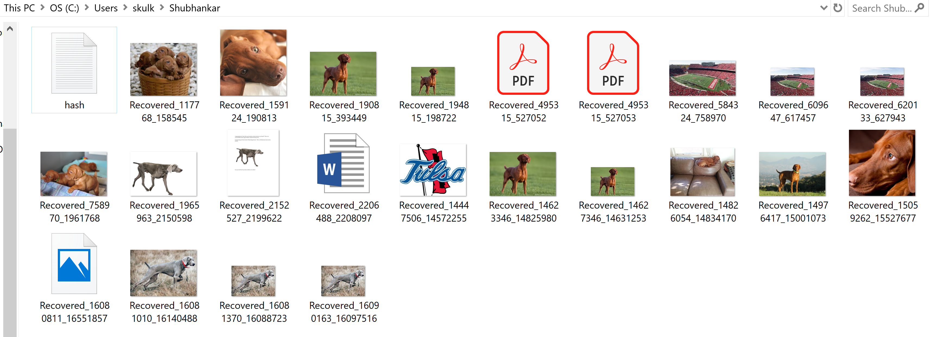

After recovering the file, the program finds the hash of that file and stores the hash in the hash.txt file which is also stored in the directory where all the recovered files are present. If the program is ran multiple times, with various binary files, all the hashes will be appended at the end of the hash.txt file.

