**Practical 8**

## **Task**: Orchestration of Multi Container Website using Docker-Compose

**Tools Used:** VS Code, docker-Compose, GitHub, Docker Desktop

### Procedure:

1. Install above mentioned software.
2. Link of repo: <https://github.com/Shubhanshu-Nishad/docker-compose>
3. Your DockerFile & docker-compose files look like it.

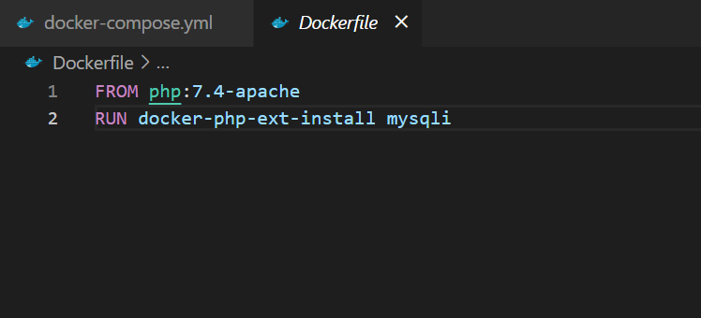

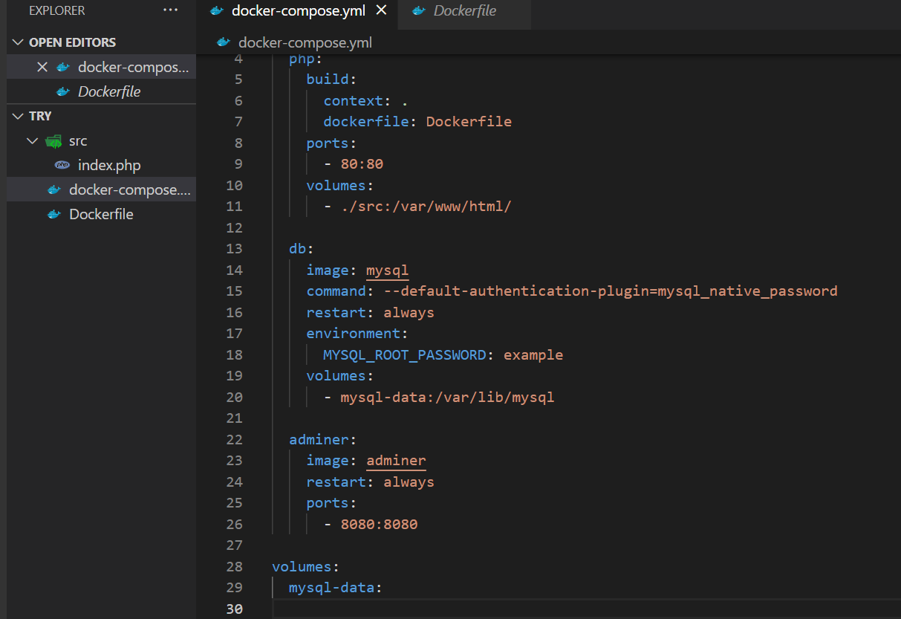

1. Run Command of terminal: docker-compose up -d

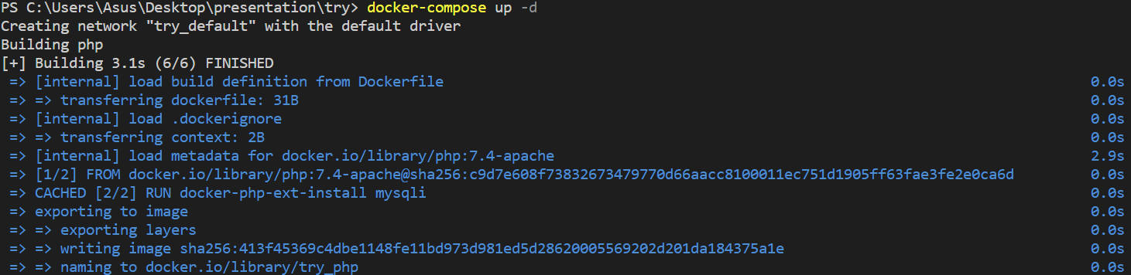

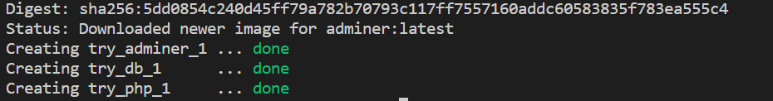

1. Visit on: <http://localhost/> 🡪 it will show error because it did not configure mysql server.
2. Visit on: http://localhost:8080/ 🡪 Enter “root” as a username & “example” as a password because we have mention on docker-compose file.
3. Click on Create database 🡪 Database name “company1”

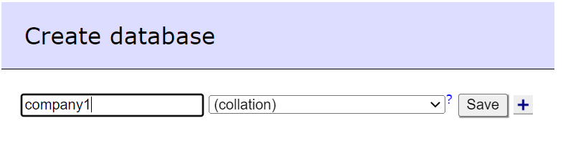

1. Create new table

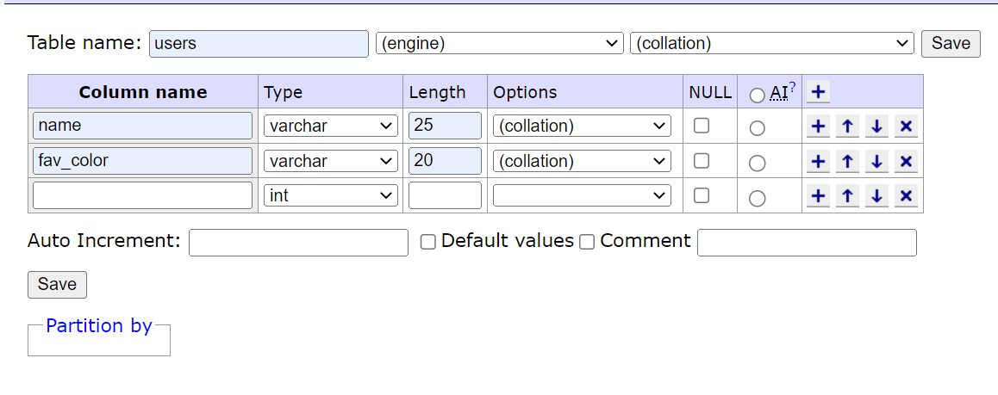

1. Refresh it: <http://localhost/>