**Auction Web Application - A Bidding Management platform**

**Project Link:** [**https://github.com/ShubhanshuV/Web-Auction-App**](https://github.com/ShubhanshuV/Web-Auction-App)

**Project Overview**

An auction platform where users can register, login, create/update/delete auction items, place bids, and view their activities. This project is built using Flask for the backend and HTML,CSS,JavaScript and React for the frontend.

**Features**

* User registration and authentication
* Create, update, delete, and view auction items
* Place bids on auction items not added by us
* View current highest bids and bid history
* User profile with auction and bid history
* Responsive design

**Tech Stack**

* **Backend:** Flask, SQLAlchemy, Flask-Login, Flask-Bcrypt, MySQL, Flask-CORS
* **Frontend:** React, Axios, React Router
* **Database:** MySQL

**Setup Instructions**

These are included in **README.md file >Setup Instructions**

**Database Schema**

**ER Diagram**

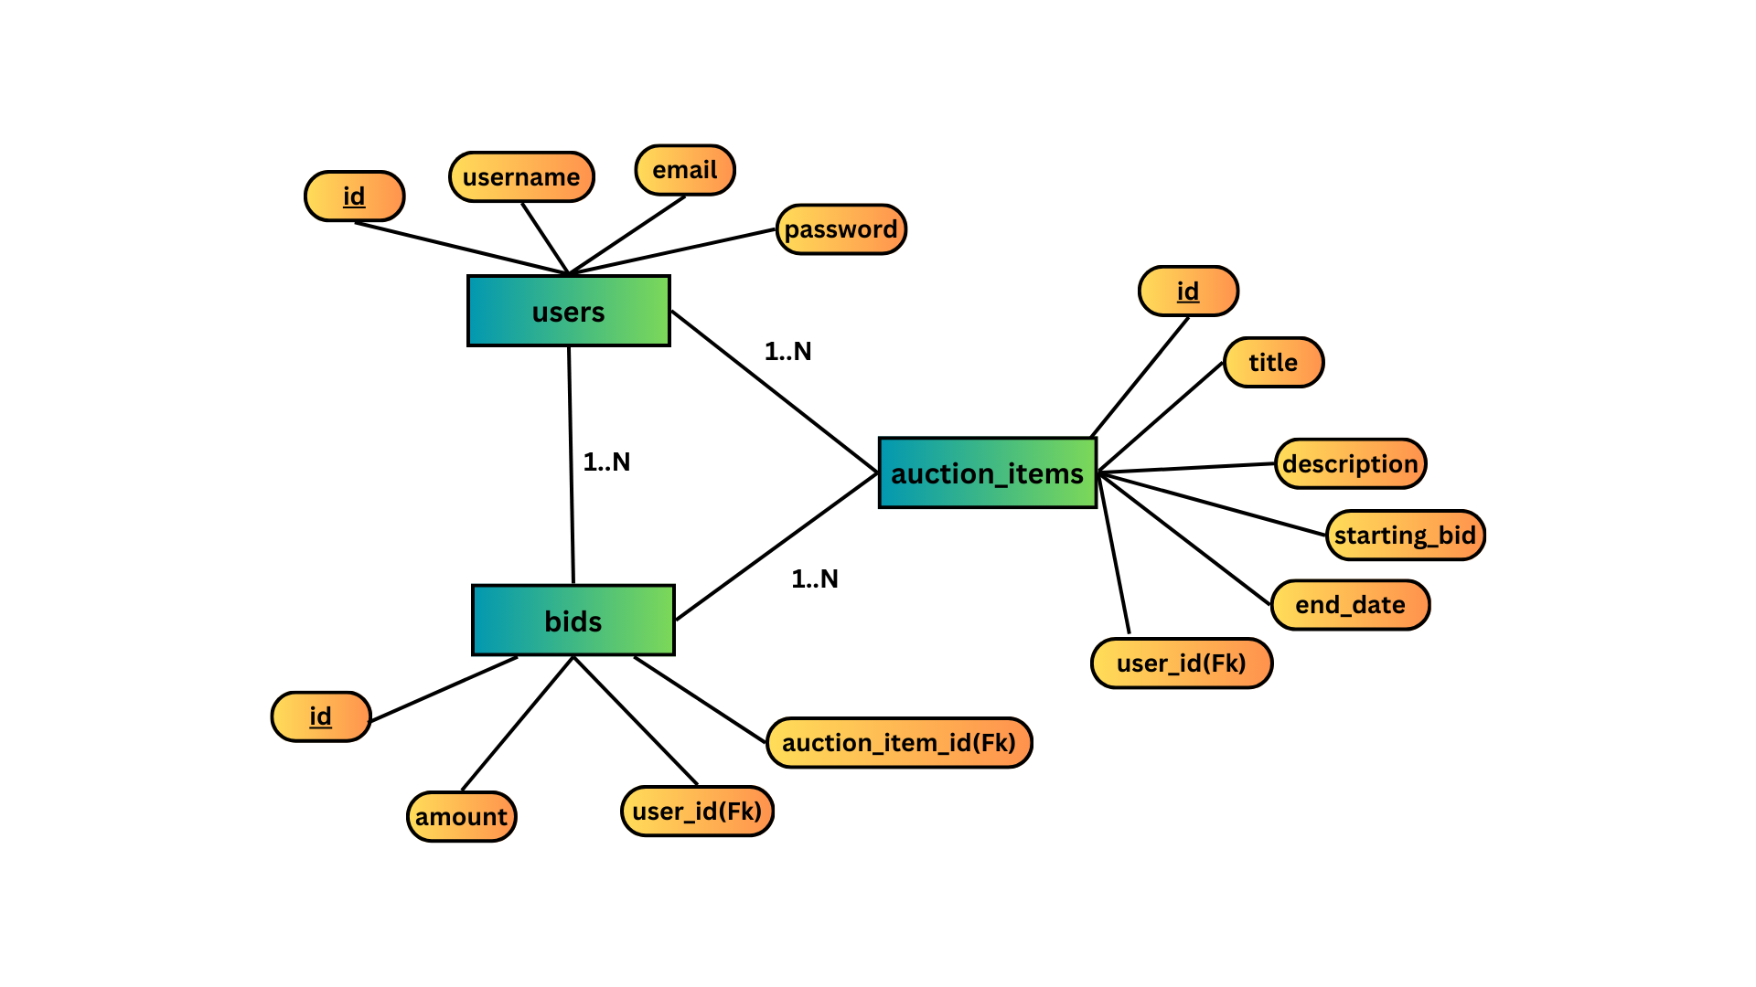

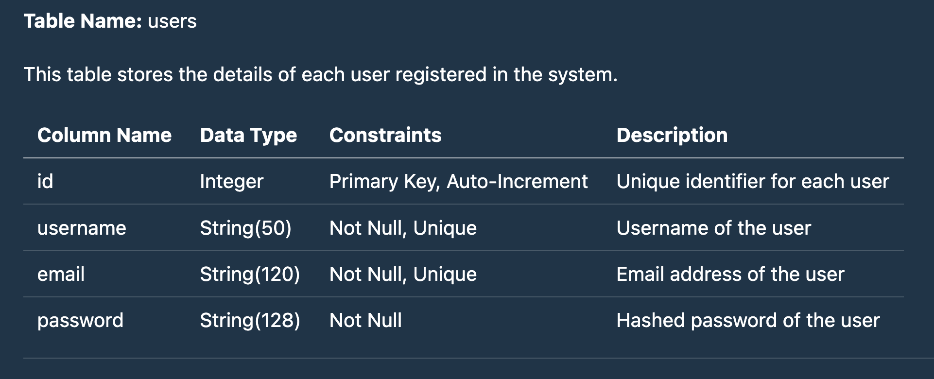

**Tables**

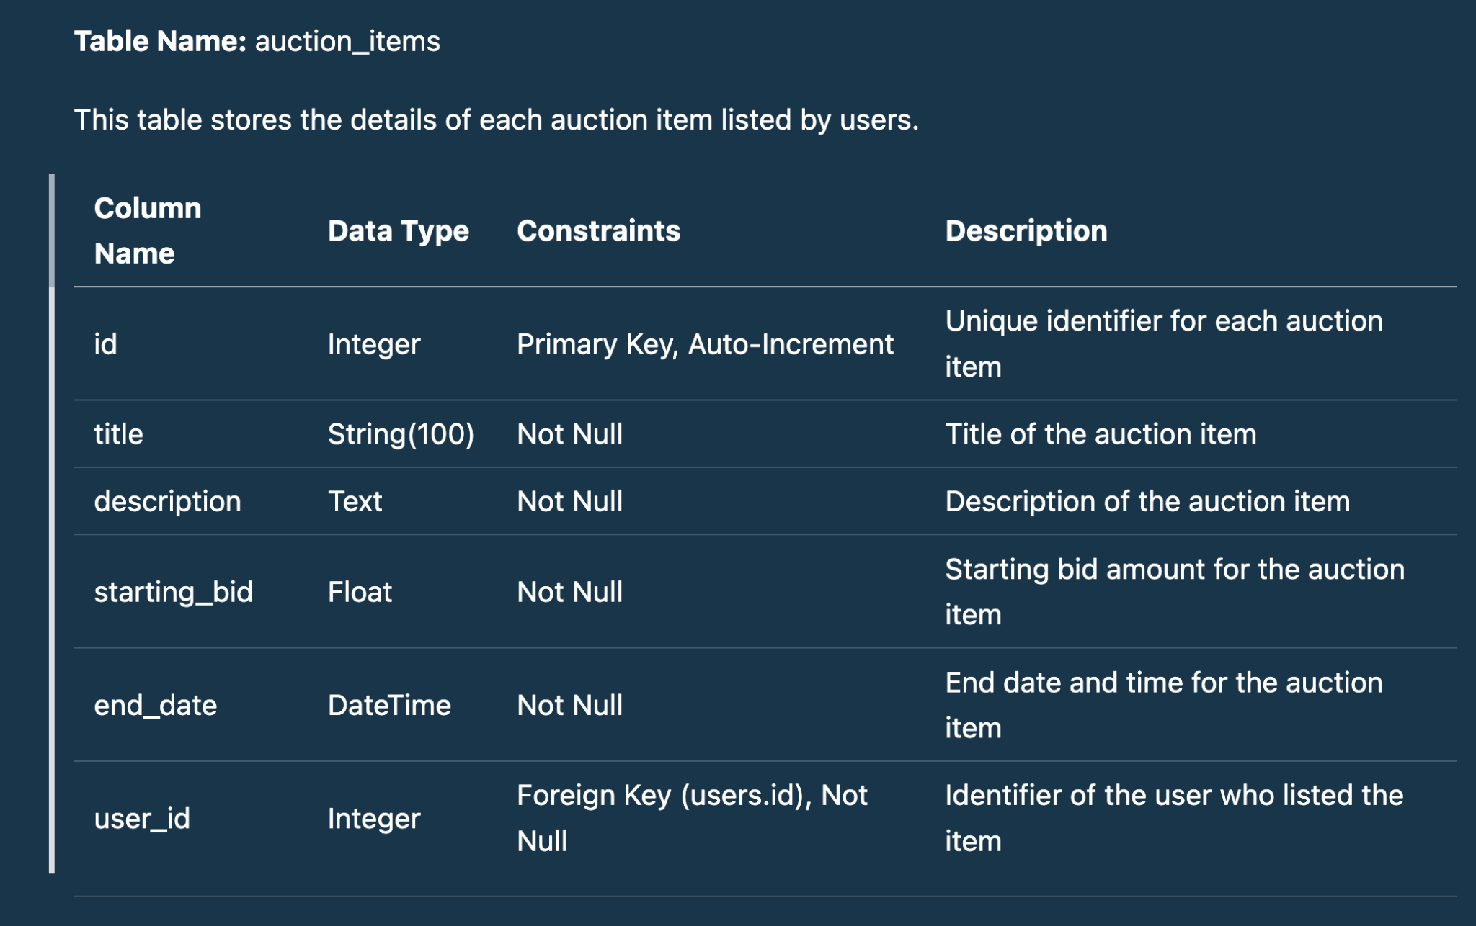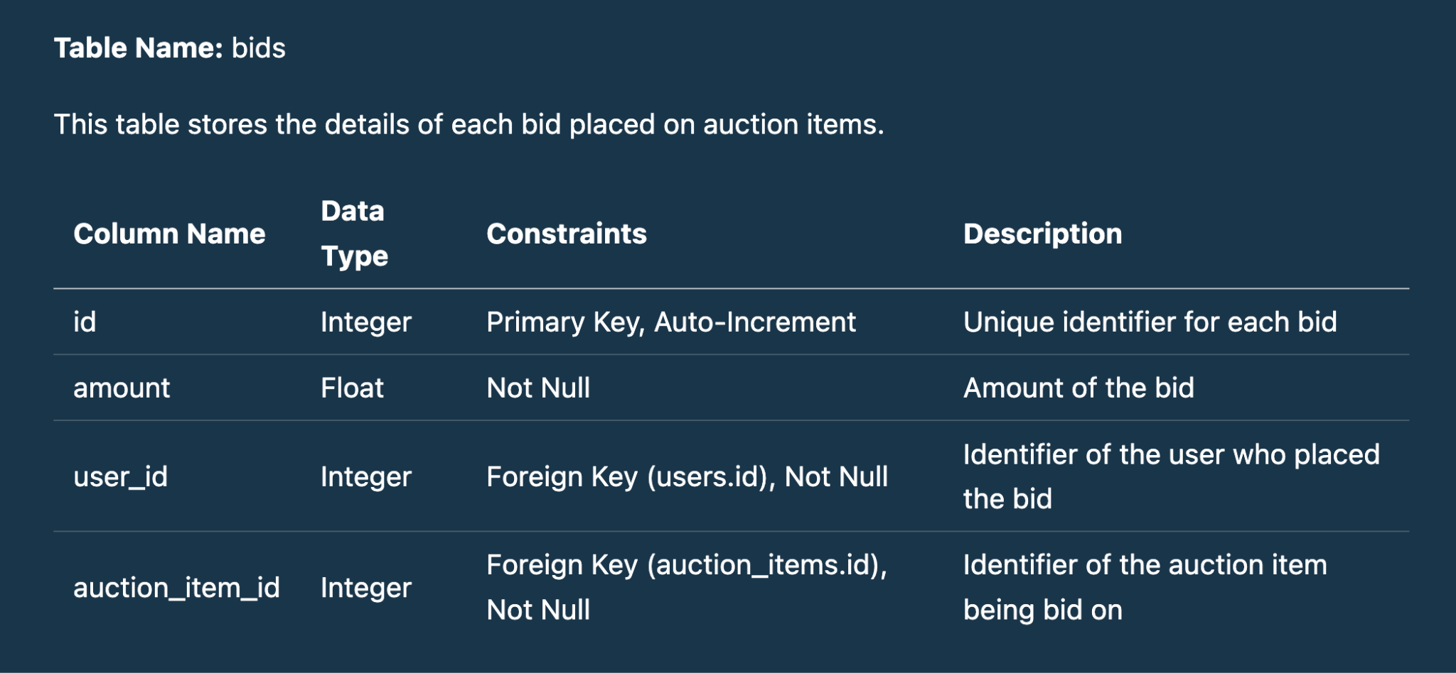

**Design Decisions**

1. **Separation of Concerns:** The project is divided into frontend and backend directories to separate client-side and server-side logic.
2. **Authentication:** Used Flask-Login and Flask-Bcrypt for handling user authentication and password hashing.
3. **API Documentation:** Used Markdown for API documentation to make it easy for developers to understand and use the API.
4. **Responsive Design:** Ensured the frontend is responsive to provide a good user experience across different devices.
5. **Security:** Implemented user authentication and authorization to secure the endpoints.

**Output**

* **Home page(Without Login)**

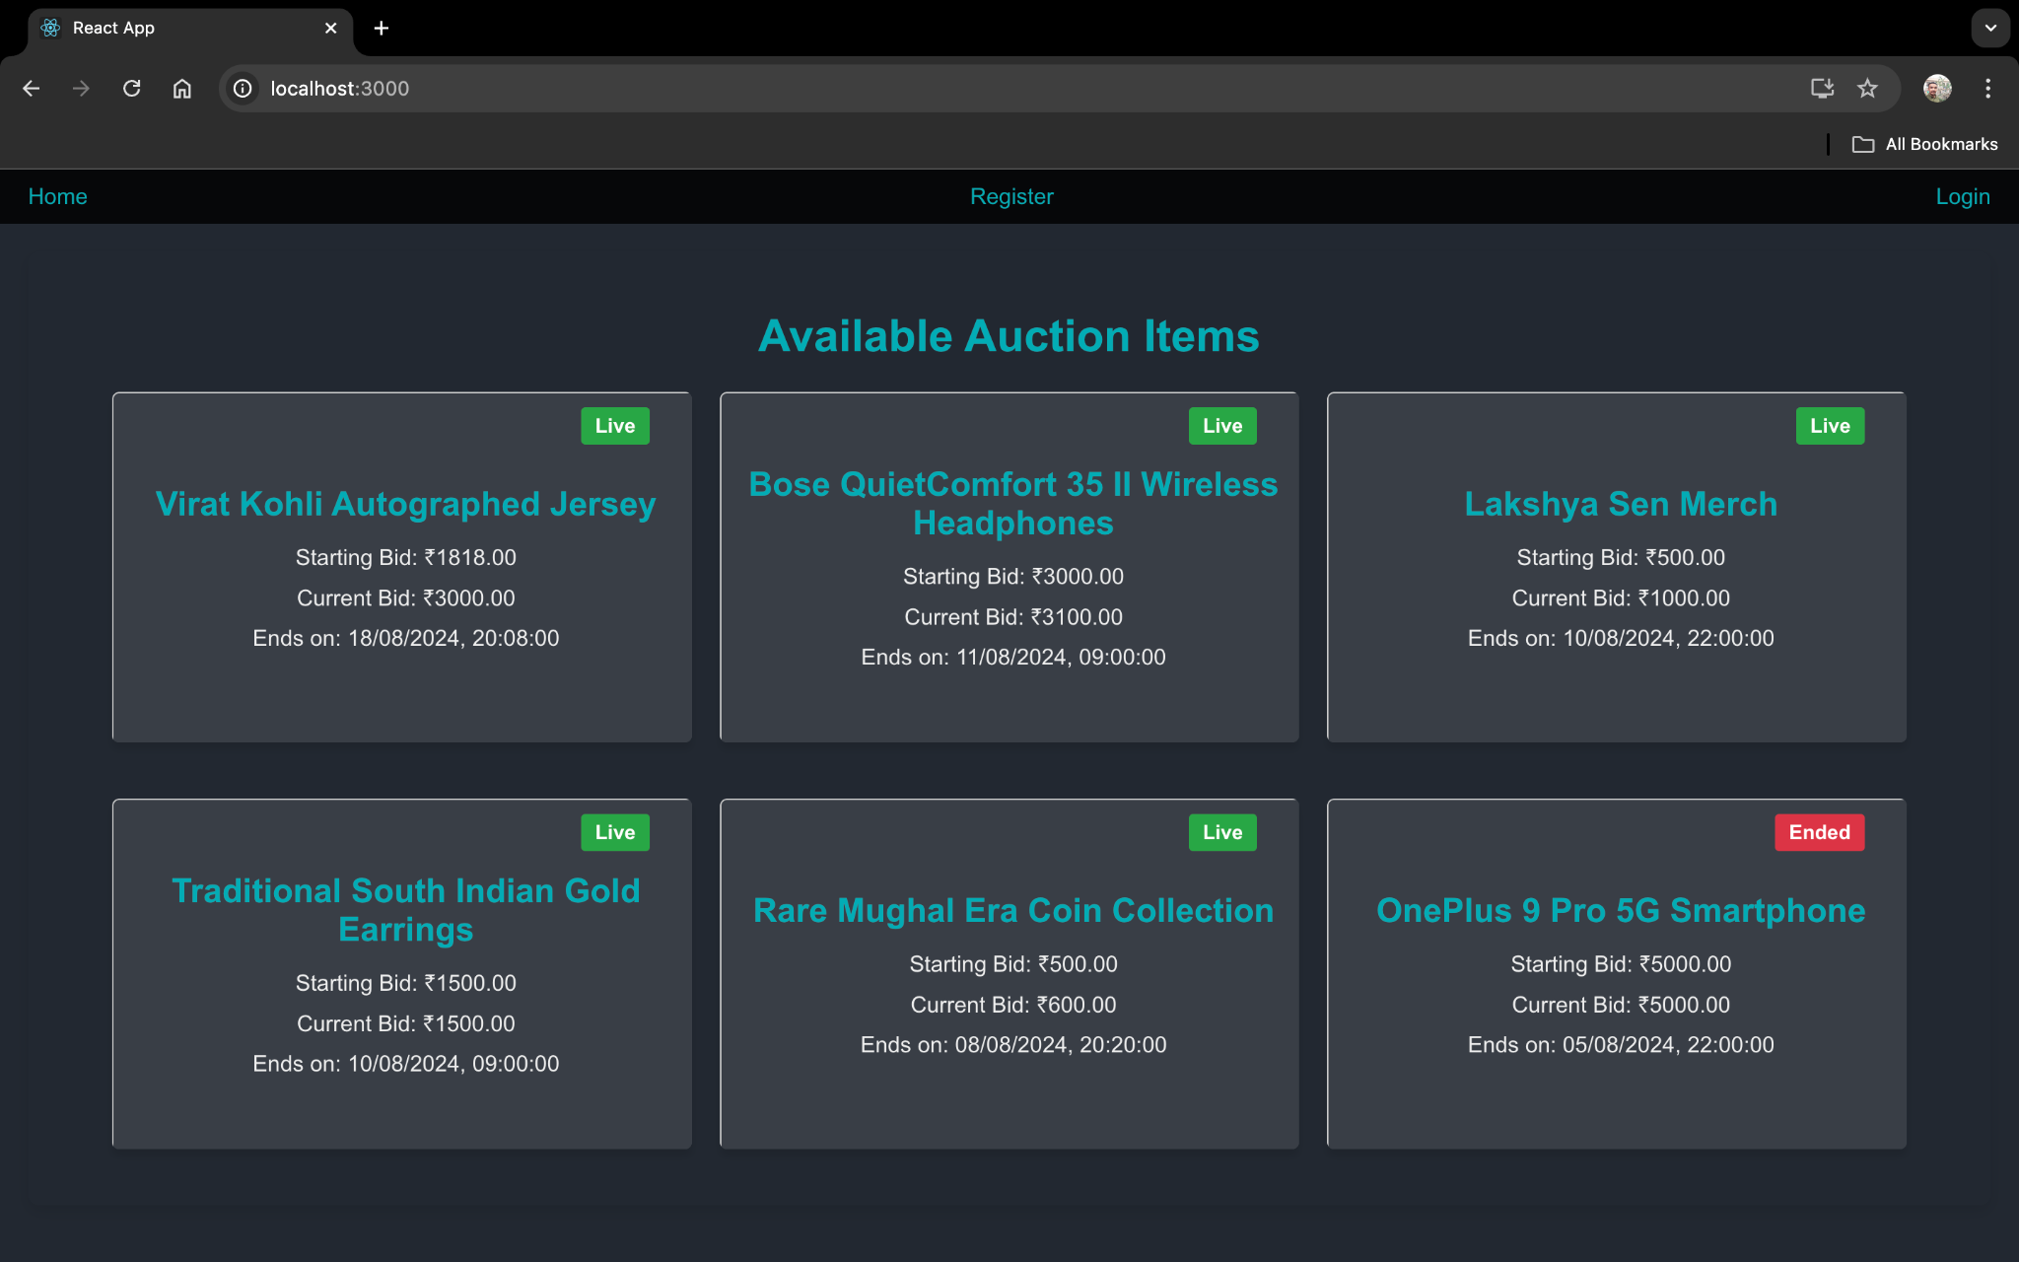

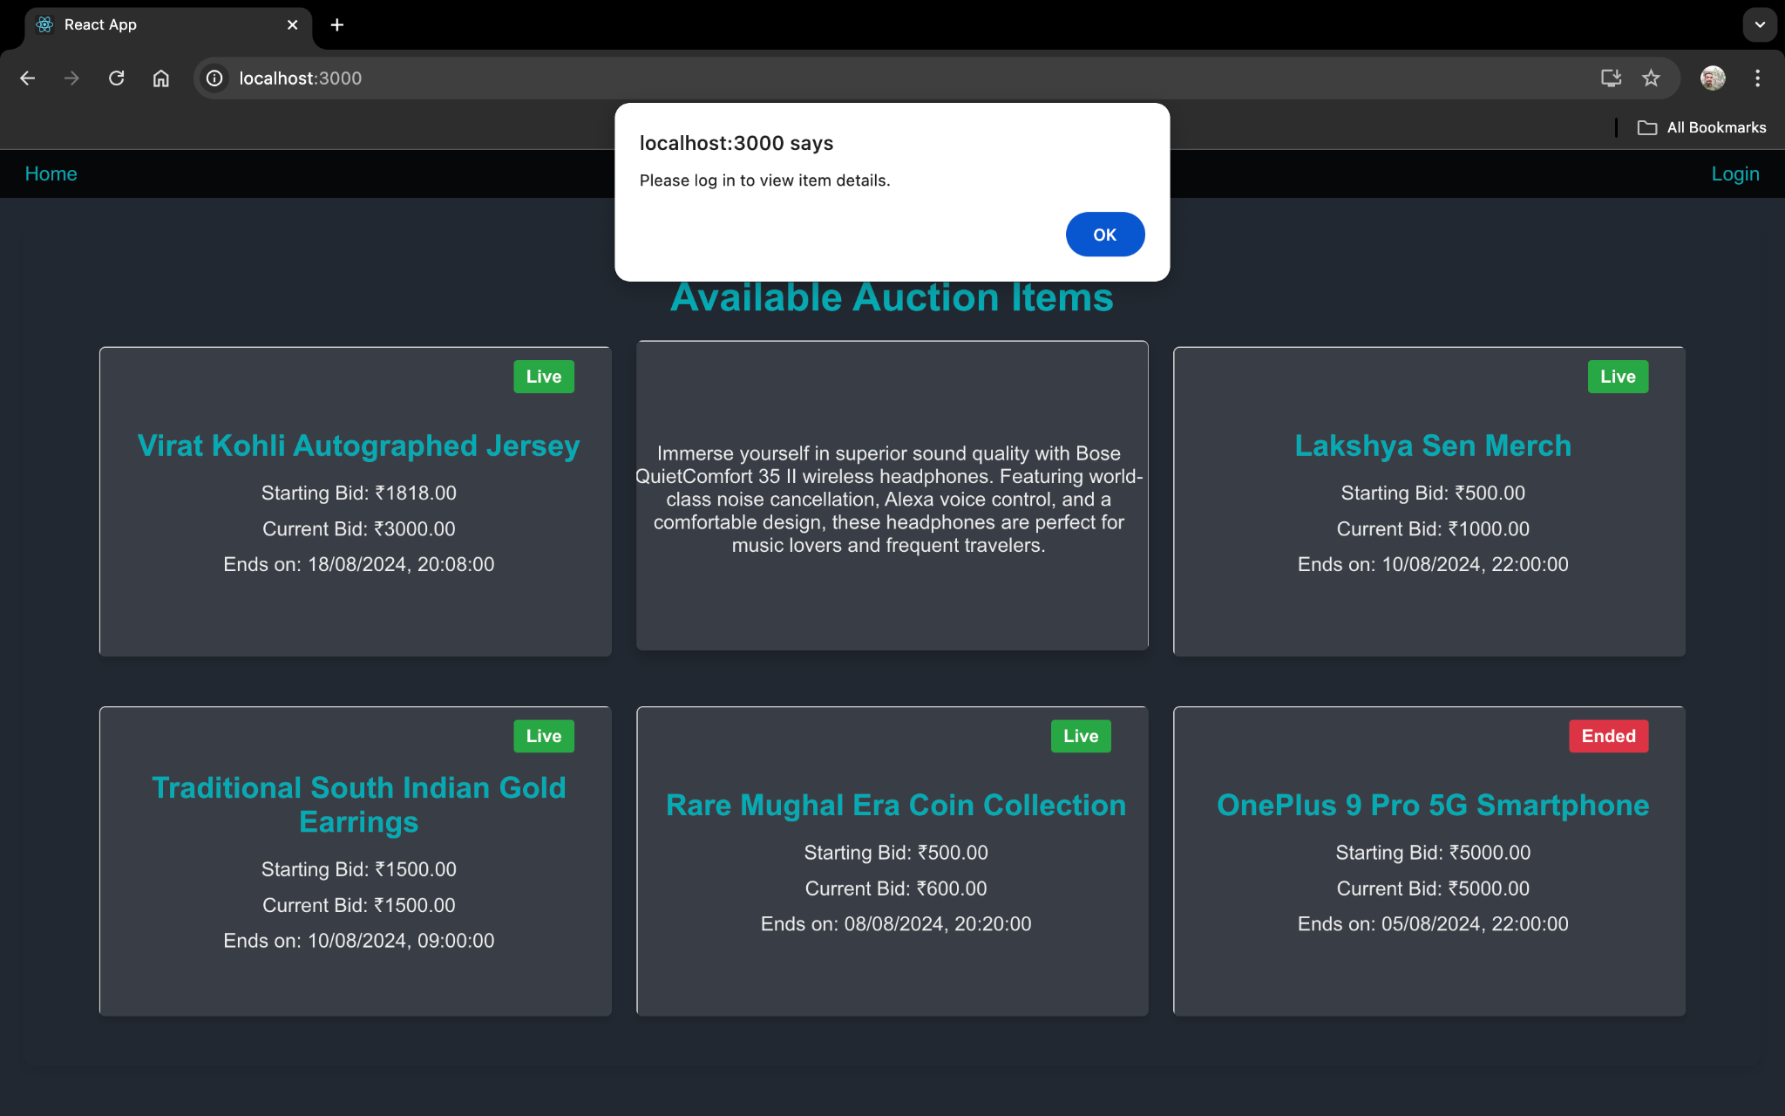

* **Register page**

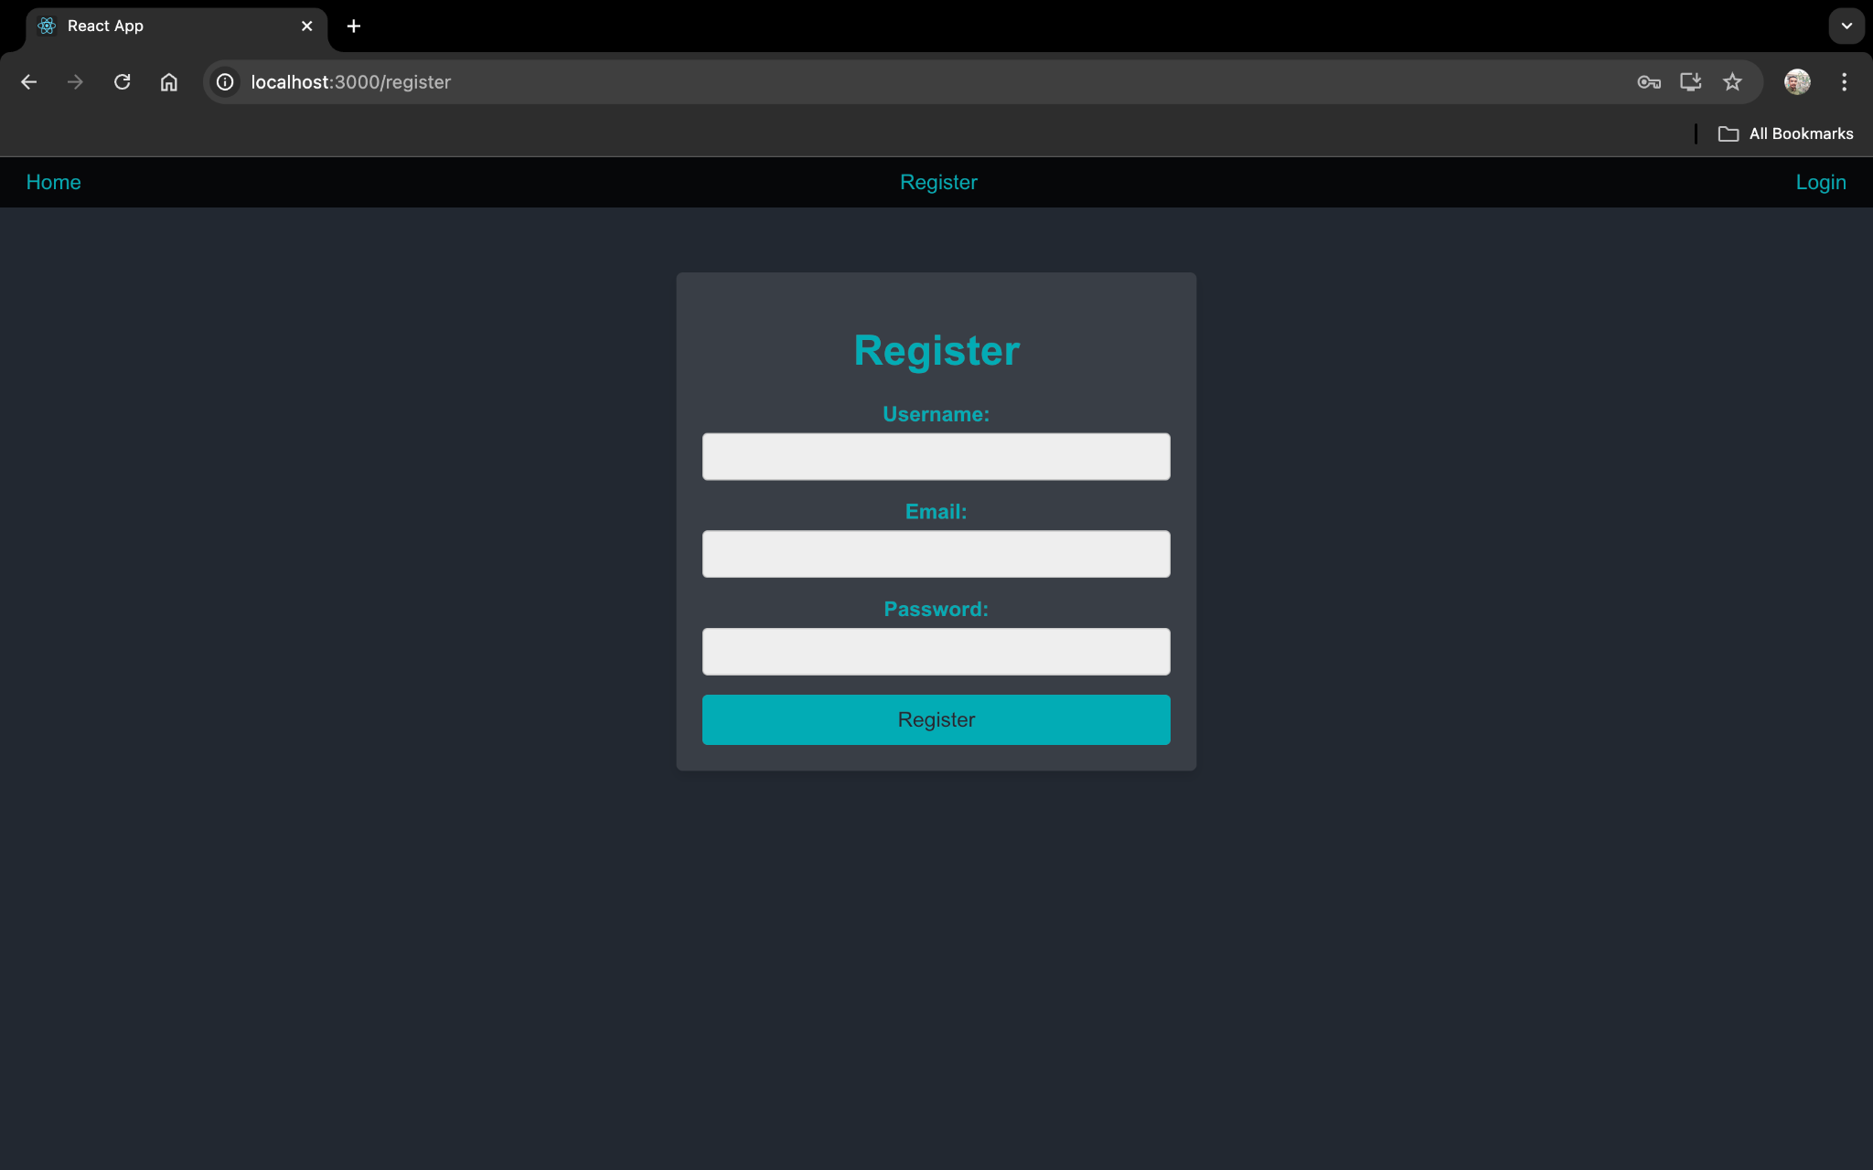

* **Login Page**

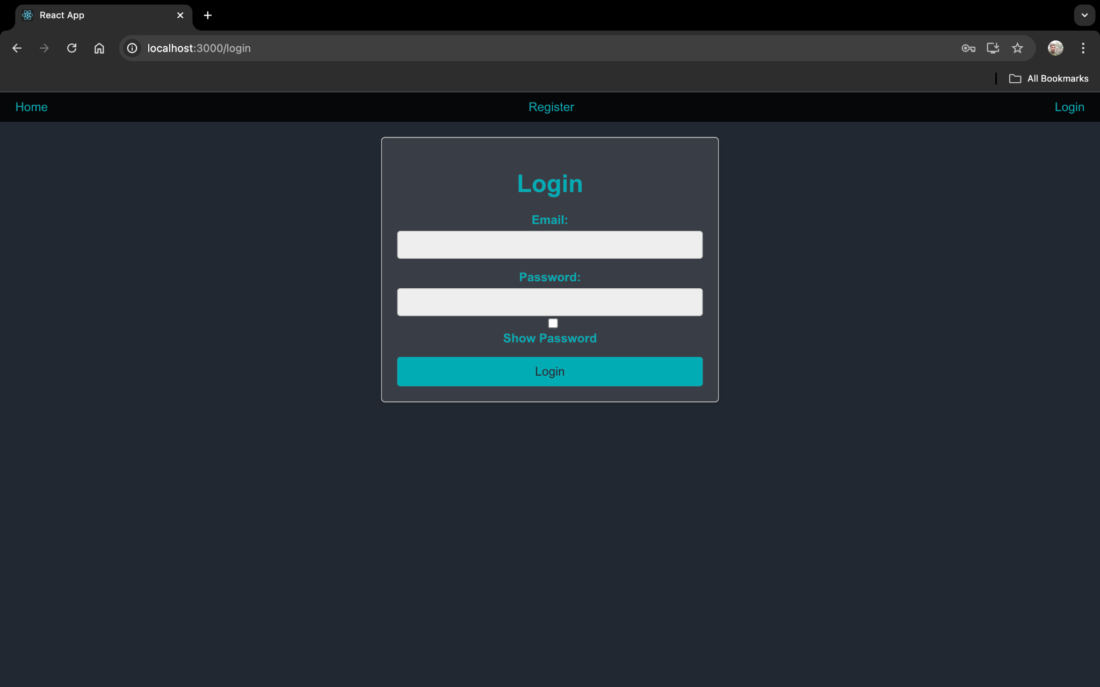

* **Profile Page**

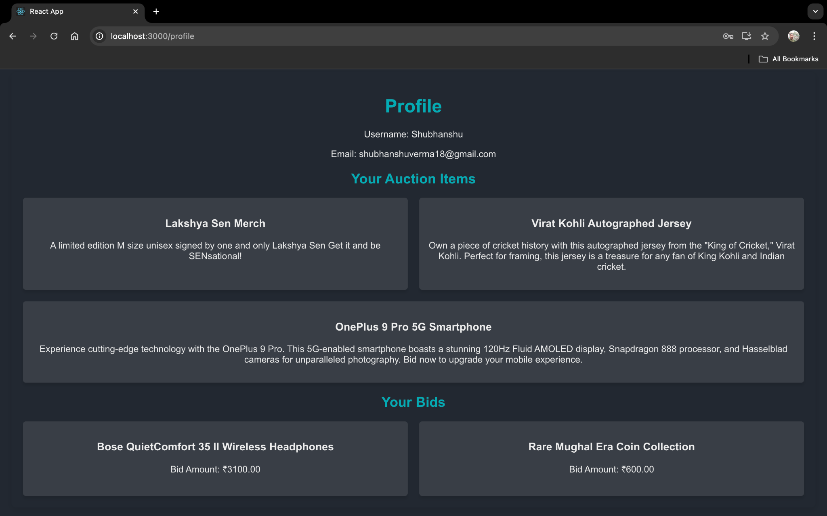

* **Add Auction Item page**

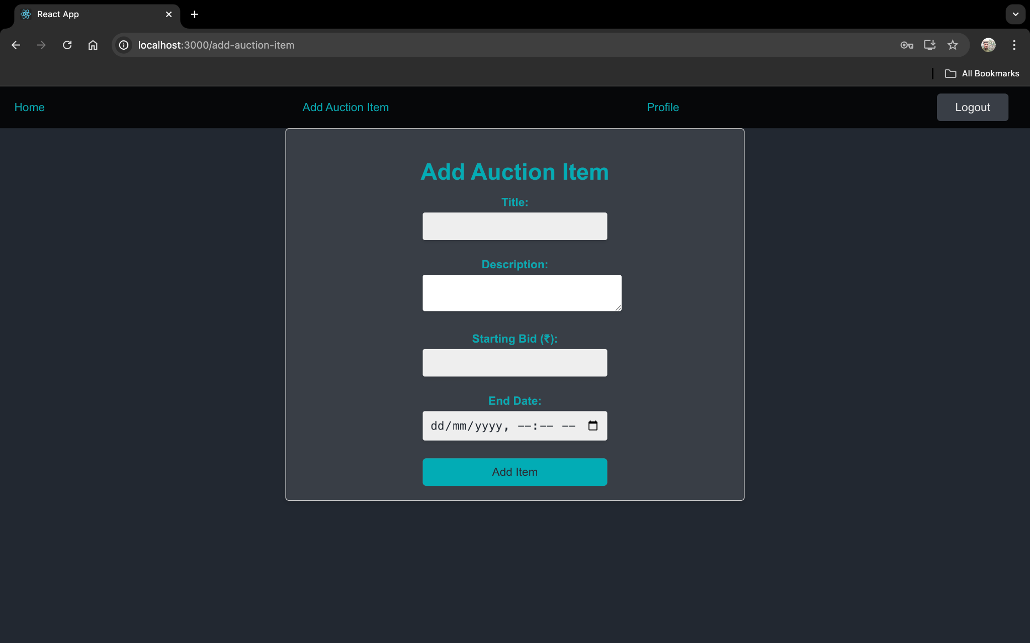

* **Profile Page(After Login)**

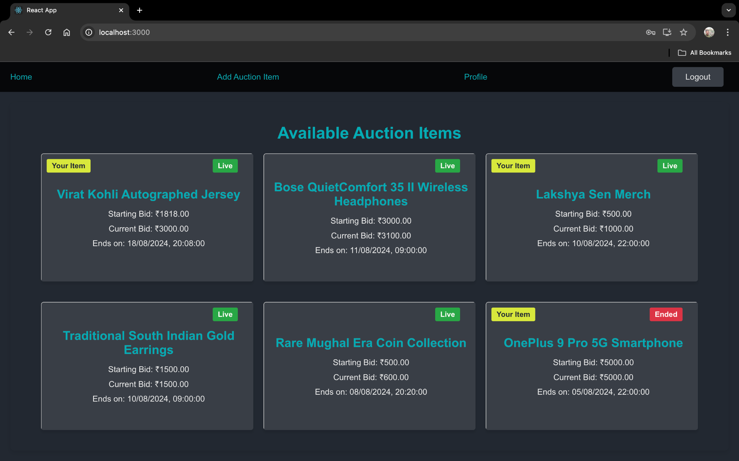

* **Auction Item (Owned and Uploaded for sale by us)**

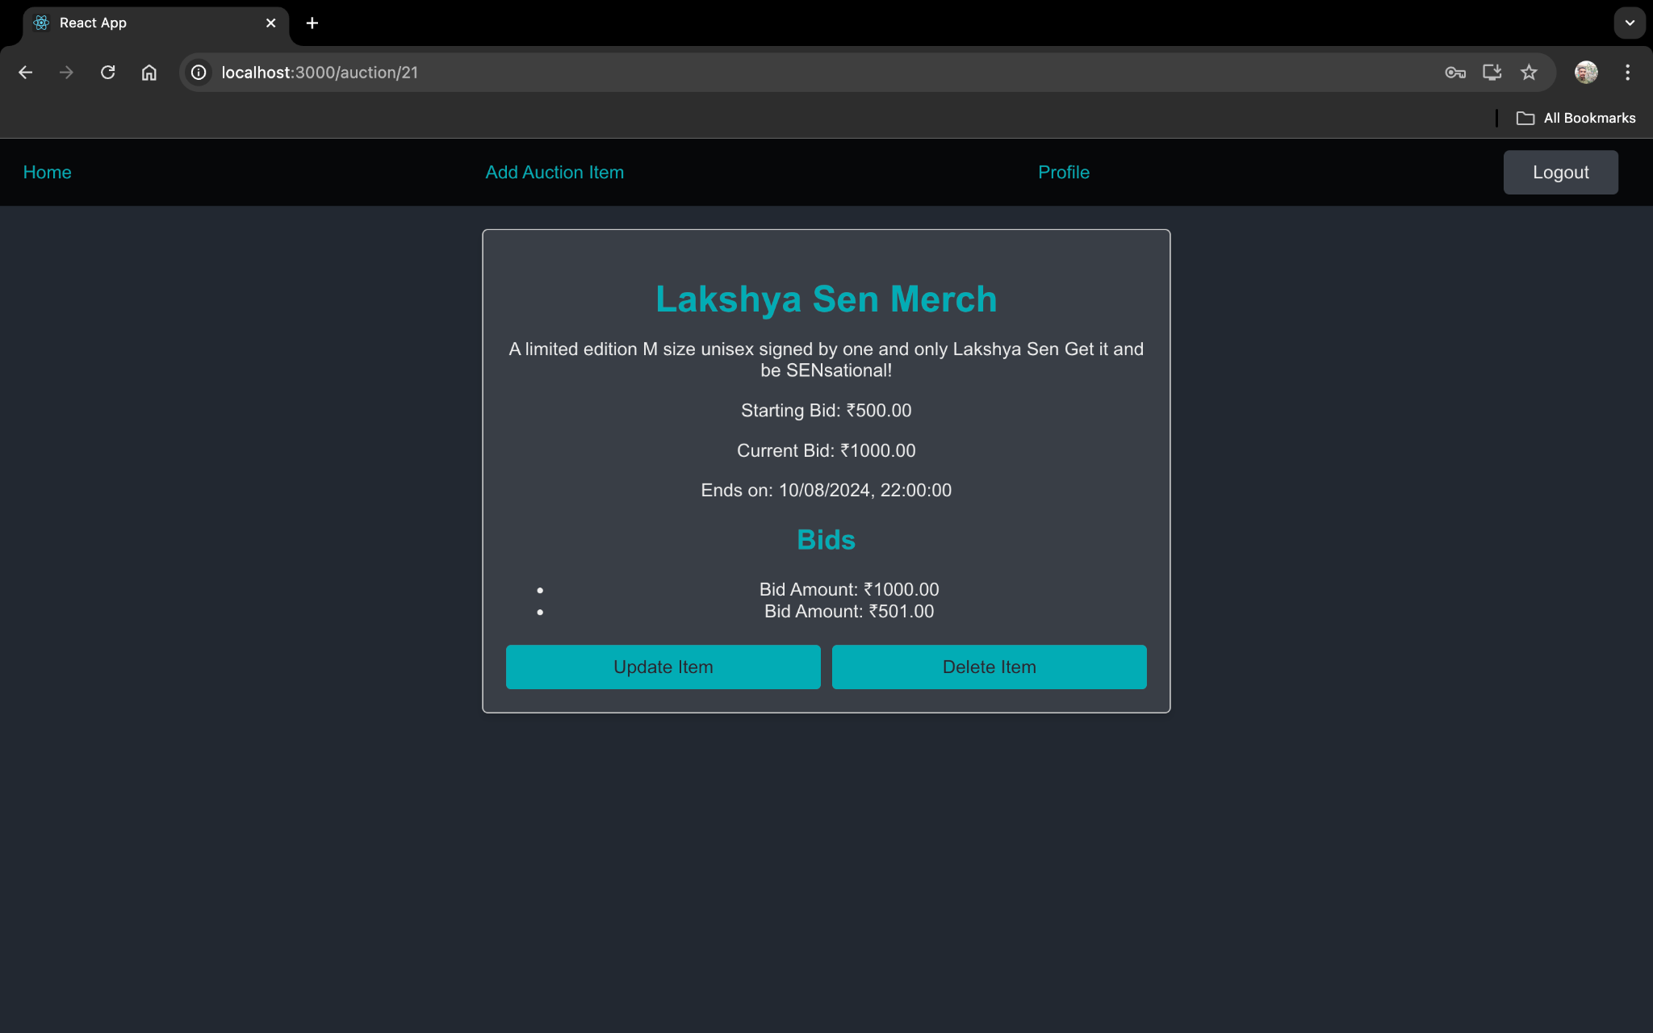

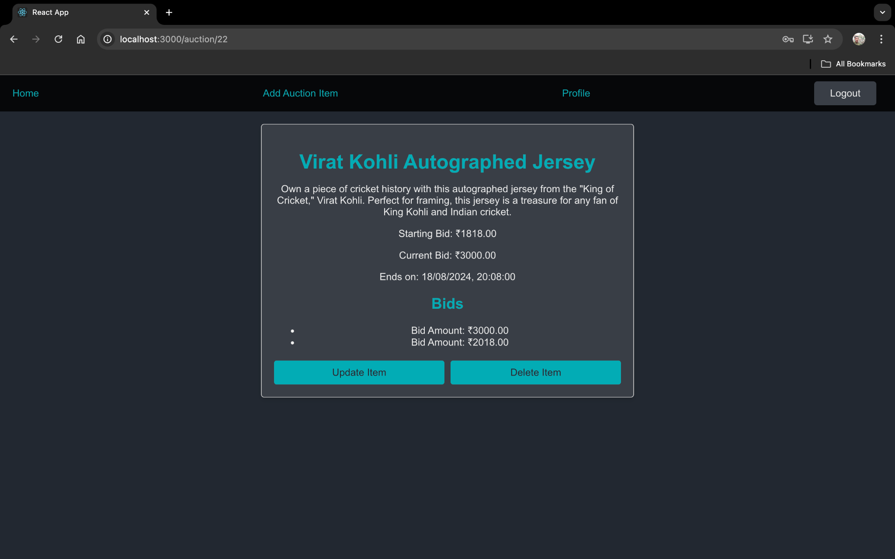

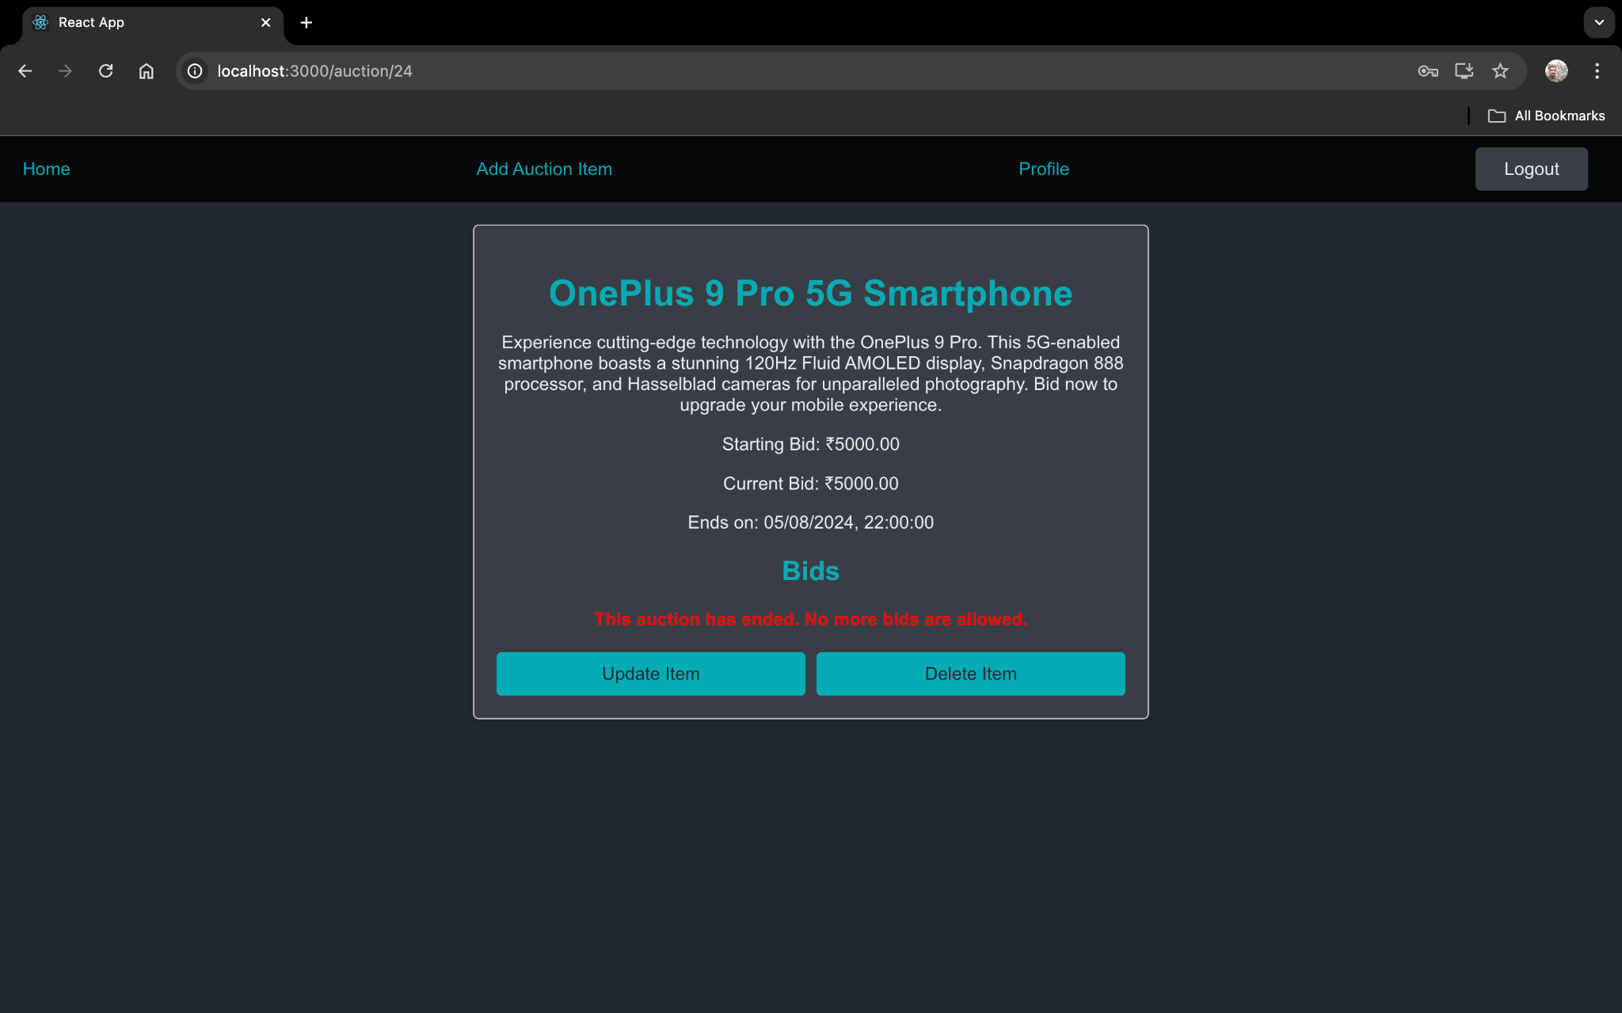

* **Auction Item not owned by us(We can bid for it)**

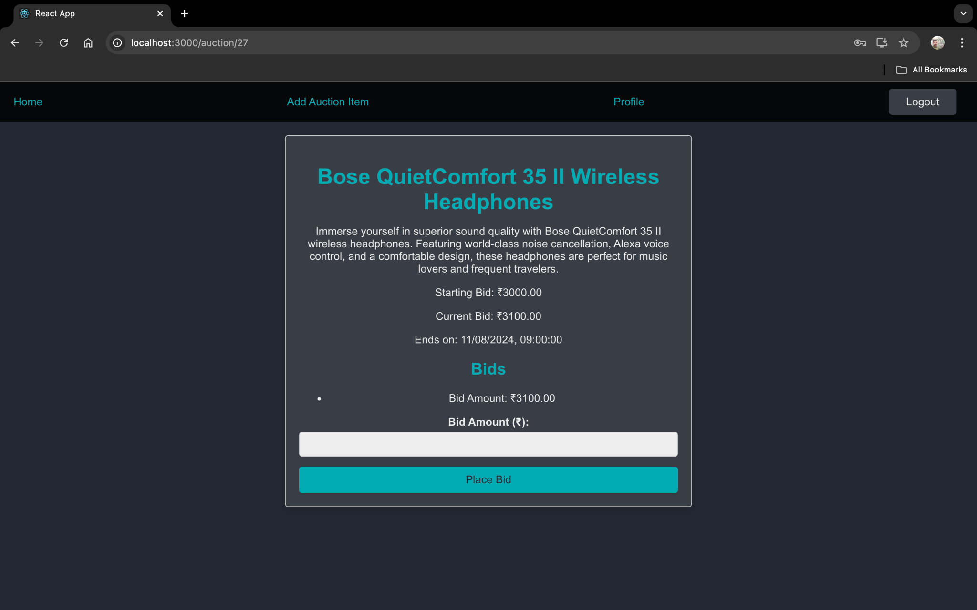

* **Screenshots showing the Responsive nature of the Web App**

