PUSH-BUTTON CONTROLLED BUZZER
USING ARDUINO UNO
Project Report
Submitted by: Shubhashish Mukherji
Registration Number: 26BEE0082

1. Objective
To implement an Arduino circuit in which a buzzer sounds only while a push button is pressed and stops when the button is released.

2. Components
- Arduino Uno
- Push button
- Piezo buzzer
- Breadboard
- Jumper wires

3. Circuit Connections
Component | Connection
Push button terminal 1 | Arduino D2
Push button terminal 2 | GND
Buzzer positive (+) | Arduino D3
Buzzer negative (−) | GND
The button must connect D2 to GND when pressed. The code enables the internal pull-up resistor using INPUT_PULLUP; therefore, an external pull-up resistor is not required.

4. Arduino Code
const int buttonPin = 2;
const int buzzerPin = 3;

void setup() {
pinMode(buttonPin, INPUT_PULLUP);
pinMode(buzzerPin, OUTPUT);
}

void loop() {
if (digitalRead(buttonPin) == LOW) {
tone(buzzerPin, 1000);
} else {
noTone(buzzerPin);
}
}

5. Working Principle
- When released, the button input reads HIGH due to INPUT_PULLUP.
- When pressed, the button connects D2 to GND and the input reads LOW.
- A 1000 Hz tone is generated on D3 while the input is LOW.
- When the button is released, noTone() stops the buzzer on the next loop iteration.

6. Simulation Evidence
Insert two screenshots of the running simulation: (1) button released and buzzer off, and (2) button pressed and buzzer on. The supplied circuit images show the layout but do not prove both output states.
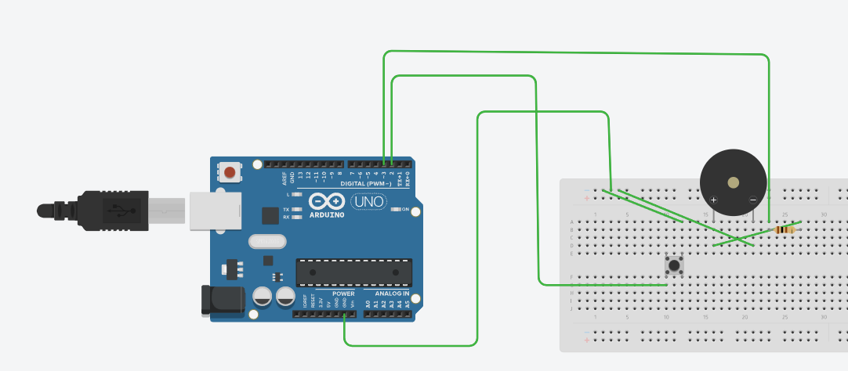
Figure 1. Circuit overview provided for reference.
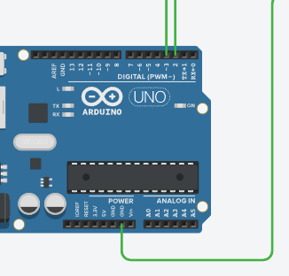
Figure 2. Arduino pin connection close-up provided for reference.

7. Conclusion
The circuit demonstrates digital input/output control using an Arduino Uno. The buzzer is activated when the push button is held and is stopped when the button is released, provided the circuit is wired according to the connections above.

8. Project Link
Tinkercad: https://www.tinkercad.com/things/01SS0R6YXb6-ieee-task

