**Share AWS ami and RDS SnapShot with other AWS accounts**

* Share aws ami
* Share AWS RDS database Snapshot

**STEPS**

1. Add access and secret key in main.tf file
2. aws configure
3. Add account IDs in null-resource -> local-exec -> command
4. terraform init
5. terraform apply
6. It will prompt for variable.account_ids, enter the list of account id. ( [“xxxxxxxxx”] )

Here I’ve created separate file for variables that is variables.tf

I’ve added two variables:

1. Ami_id
2. Account_ids

I’ve set default value of ami_id because as per our requirement, we have to share same ami of the same account every time.

We can also enter ami_id variable at the time of execution of code (If need to use another ami id).

For account_id , it will prompt at the time of execution. We need to pass the list of account ids even if there is only one account id because data type of this variable is set to list.

For sharing RDS DB Snapshot, I’ve used “null_resource”, "local-exec" to execute aws cli command because there is no resource in terraform from which Database SnapShot can be shared.

That’s why,

* In step2, we’re configuring aws over cmd (“aws configure”)
* In step3, we’re adding account IDs in null-resource -> local-exec -> command.

In step3, if wanna pass one account id, we can directly pass int value.

Ex – --values-to-add 217102071764

If need to paas a list of IDs, the correct syntax to pass list on Windows terminal that is cmd sell (command shell) is :

--values-to-add **"[\"xxxxxxxxxxxx\",\"xxxxxxxxxxx\"]"**

Also I’ve hardcoded the value of --db-snapshot-identifier because as per our need, we have to share same snapshot every time. If needed, we can change the database snapshot identifier to be shared.

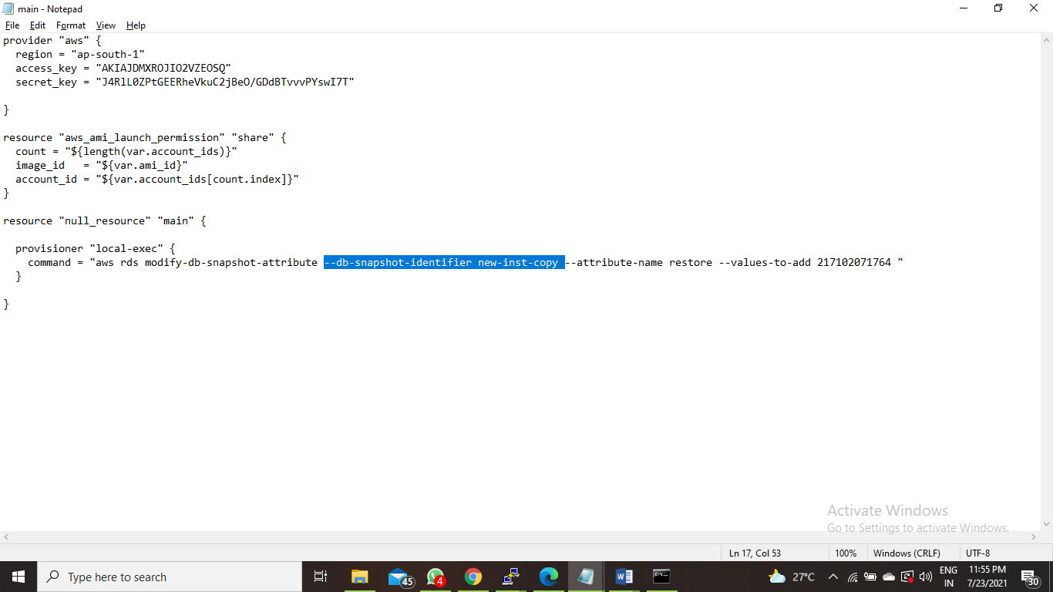

I hope everything is clear now.