
Spiritual Gathering at Richmond, VA April 29th-30th
Babuji’s Birth Celebration

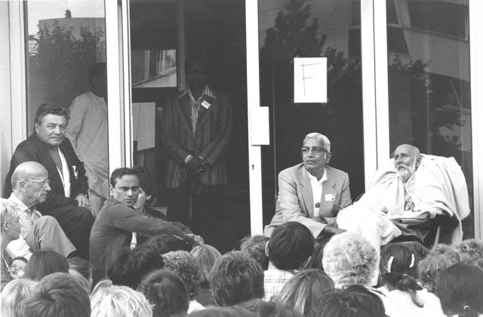

Dear Brothers and Sisters,

You are cordially invited to join us to celebrate the auspicious occasion of our beloved Babuji Maharaj’s 113th Birth anniversary and dedication of the new Meditation Center at Richmond, VA to our beloved Master.

We encourage you to reflect on this Whisper here: Birthday Celebrations(http://www.spiritualityfoundation.org/sm/viewMessage.do?PROPFILE_NAME=Whispers3Batch&list=6&DATE=2012-03-28)

Affectionately,
Abhyasis of Richmond Center
Invitation:

Location | Natural Path Meditation Center  6010 West Broad Street, Suite 103  Richmond, VA 23230 (Please see the directions below)
Dates | Sunday, April 29,2012 - Monday, April 30,2012  We encourage abhyasis to come Friday night or Saturday if they wish
Registration | Please make sure you register using the link below:  http://64.128.16.147/regapp ( We need to change it Prod URL)  Suggested Donation for Adult - $30  Children - Free
Accommodation | Outstation abhyasis will be accommodated at abhyasi's homes. Please contact Sister. Raji at registration desk (804 263 6590).
What should I do upon arriving at the Venue? | Please arrive at the venue and look for registration & information desk. Volunteers will be available to help you there.
What should I bring with me? | General Items to bring:  Umbrella  Sleeping bag or Comforters  Pillows etc
Volunteer Activity | Volunteer work teaches us discipline and enhances our spiritual development.  Kindly register yourself for volunteer activity of your preference during registration and confirm at the registration desk.
Questions or Comments | Srinivas Induri: srinduri@gmail.com (214-724-0909)
Program | Sunday: Apr 29th 2012  7:00 AM – 7:30 AM – Arrival  7:30 AM – 8:30 AM – Satsangh  8:30 AM – 9:00 AM – Video/Talks  9:00 AM – 10:00 AM – Brunch/Break Fast  10:00 AM –12:00 PM – Program 1  12:00 PM – 1:00 PM – Break/Lunch  1:00 PM – 3:00 PM – Program 2  3:00 PM – 4:00 PM – Tea Time  4:00 PM – 5:00 PM – Program 3  5:00 PM – 6:00 PM – Satsangh  6:00 PM – 7:30 PM – Kid’s Cultural Program  7:30 PM – 9:00 PM – Dinner  9:00 PM – 9:15 PM – Universal Prayer  9:15 PM – go home  Monday: Apr 30th 2012  7:00 AM – 7:30 AM – Arrival/Break Fast  7:30 AM – 8:30 AM – Satsangh  8:30 AM – 9:30 AM – Dedication of the Meditation Center  9:30 AM – 10:30 AM – Break/Break Fast Continue...  10:30 AM – 12:00 PM – Program 4  12:00 PM – 1:00 PM – Lunch  1:00 PM – 2:00 PM – Satsangh  2:00 PM – 3:00 PM – Cleanup and Disperse
Directions: | From Washington DC and North Carolina  Take I- 64 W from I- 95  1. Take exit 185 for US-33/Staples Mill Rd E/Staples Mill Rd W on I-64W - 0.2 mile  2. Keep left at the fork, follow signs for US-33 E/Staples Mill Rd and merge onto US-  33 E/Staples Mill Rd - 0.7 mile  3.Turn right onto Bethlehem Rd - 0.4 mile  4.Turn left onto Libbie Ave - 0.5 mile  5.Turn right onto US-250 W/W Broad St - 0.3 mile  Natural Path Meditation Center is on the right side between Latino Market and Chubby’s gas station. For questions on directions Please call Br. Jagadish–573- 368 -8854

