**ASSIGNMENT-1**

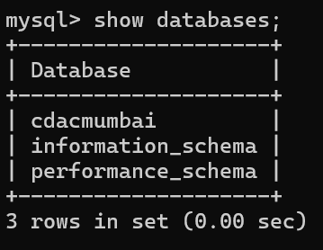



* **create table salespeople(snum int, sname varchar(10), city varchar(10), comm float(3,2));**



* **insert into salespeople (Snum, Sname, City, Comm) values**
* **(1001, 'Peel', 'London', 0.12),**
* **(1002, 'Serres', 'San Jose', 0.13),**
* **(1004, 'Motika', 'London', 0.11),**
* **(1007, 'Rifkin', 'Barcelona', 0.15),**
* **(1003, 'Axelrod', 'New York', 0.10);**

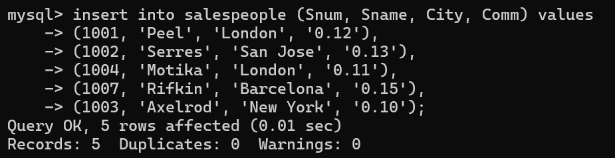

* **create table customers (cnum int, cname varchar(10), city varchar(10), rating int, snum int);**

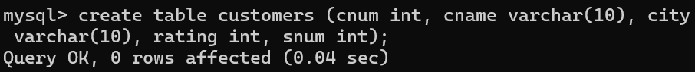

* **insert into customers (cnum, cname, city, rating, snum) values**
* **(2001, 'hoffman', 'london', 100, 1001),**
* **(2002, 'giovanni', 'rome', 200, 1003),**
* **(2003, 'liu', 'san jose', 200, 1002),**
* **(2004, 'grass', 'berlin', 300, 1002),**
* **(2006, 'clemens', 'london', 100, 1001),**
* **(2008, 'cisneros', 'san jose', 300, 1007),**
* **(2007, 'pereira', 'rome', 100, 1004);**

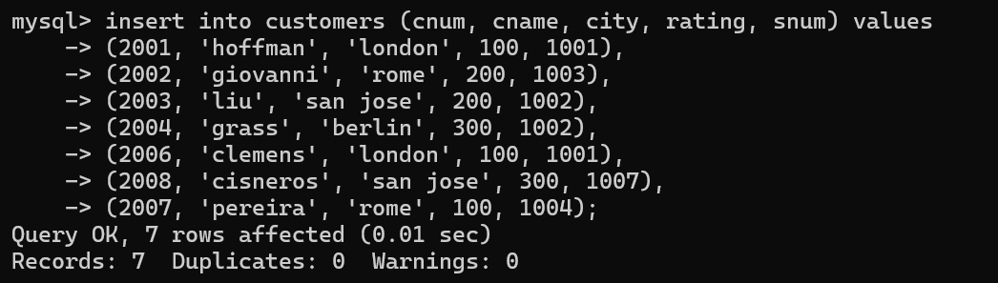

* **create table orders (onum int, amt float(7,2), odate date, cnum int, snum int);**



* **insert into orders (Onum, Amt, Odate, Cnum, Snum) values**
* **(3001, 18.69, '1990-10-03', 2008, 1007),**
* **(3003, 767.19, '1990-10-03', 2001, 1001),**
* **(3002, 1900.10, '1990-10-03', 2007, 1004),**
* **(3005, 5160.45, '1990-10-03', 2003, 1002),**
* **(3006, 1098.16, '1990-10-03', 2008, 1007),**
* **(3009, 1713.23, '1990-10-04', 2002, 1003),**
* **(3007, 75.75, '1990-10-04', 2004, 1002),**
* **(3008, 4723.00, '1990-10-05', 2006, 1001),**
* **(3010, 1309.95, '1990-10-06', 2004, 1002),**
* **(3011, 9891.88, '1990-10-06', 2006, 1001);**

