**Assignment –4**

**Retrieving Information from Tables.**

1) Write a select command that produces the order number, amount, and date for all rows in the Orders table.

-> mysql> select onum,amt,odate from orders;

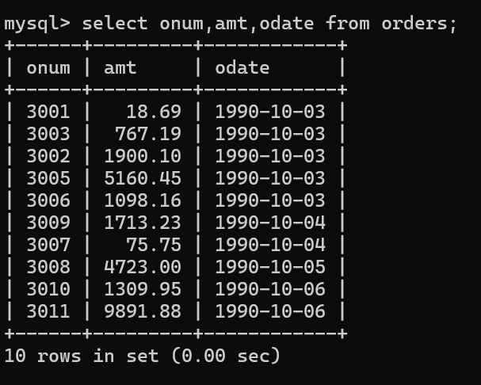

2) Write a query that produces all rows from the Customers table for which the salesperson’s number is 1001.

-> mysql> select * from customers

-> where snum = 1001;

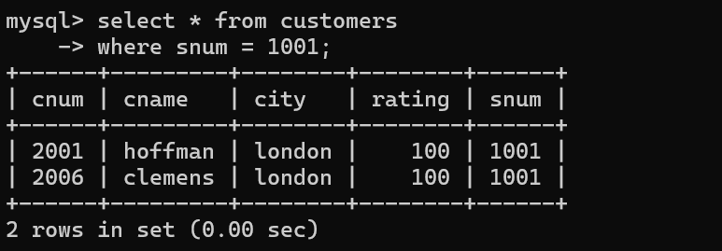

3) Write a query that displays the Salespeople table with the columns in the following order: city, sname, snum, comm.

-> mysql> select city,sname,snum,comm from salespeople;

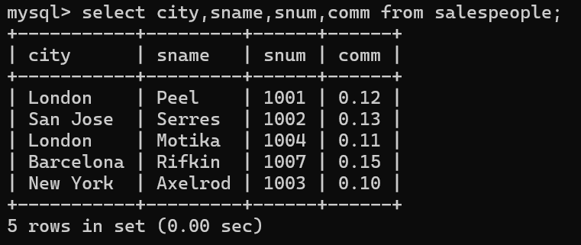

4) Write a select command that produces the rating followed by the name of each customer in San Jose.

-> mysql> select rating,cname from customers

-> where city = 'san jose';

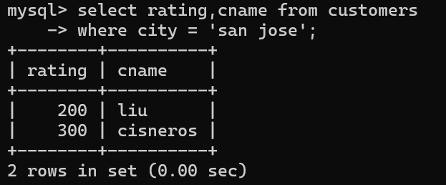

5) Write a query that will produce the snum values of all salespeople (suppress the duplicates) with orders in the Orders table.

-> mysql> select distinct SNUM from Salespeople order by snum;

