**Assignment –5**

**Relational and Logical Operators.**

1) Write a query that will give you all orders for more than Rs. 1,000.

* mysql> select * from orders;

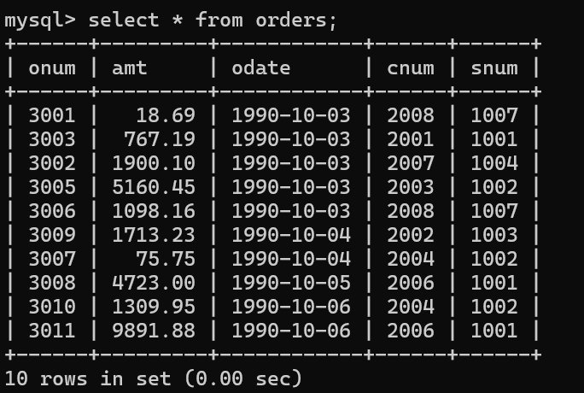

* mysql> select * from orders where amt > 1000;

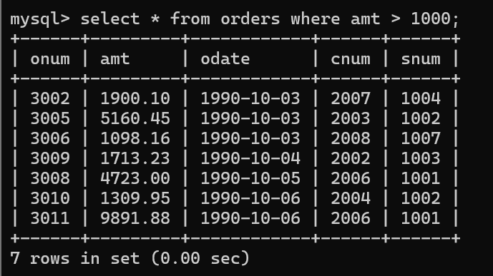

2) Write a query that will give you the names and cities of all salespeople in

London with a commission above .10.

* mysql> select * from salespeople;

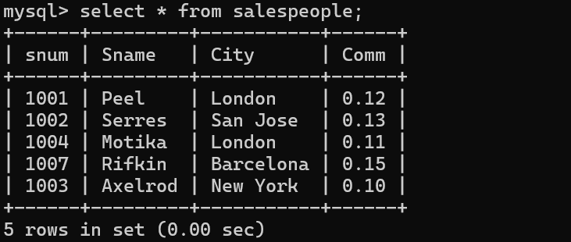

* mysql> select * from salespeople where Comm > 0.10;

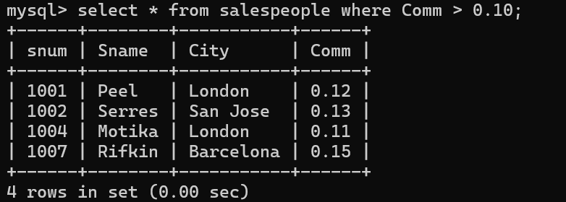

3) Write a query on the Customers table whose output will exclude all customers

with a rating <= 100, unless they are located in Rome.

* mysql> select * from customer;

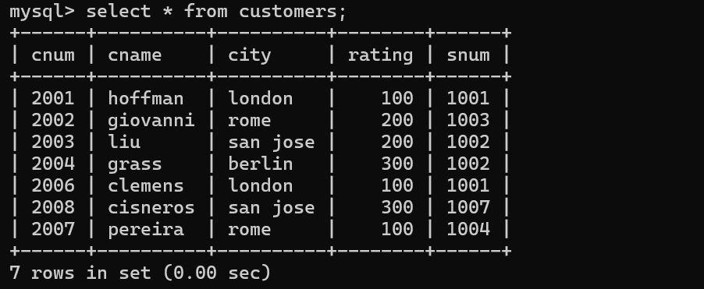

* mysql> select * from customers where rating > 100 and city != 'Rome';

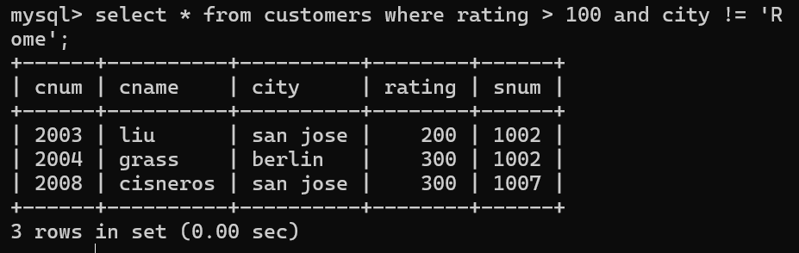

4) What will be the output from the following query?

Select * from Orders

where (amt < 1000 OR

NOT (odate = ‘1990-10-03’

AND cnum > 2003));

* mysql> Select * from Orders
* -> where (amt < 1000 OR
* -> NOT (odate = '1990-10-03'
* -> AND cnum > 2003));

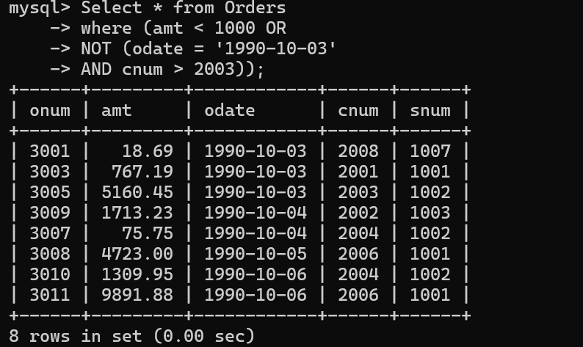

5) What will be the output of the following query?

Select * from Orders

where NOT ((odate = ‘1990-10-03’ OR snum

>1006) AND amt >= 1500);

* mysql> Select * from Orders
* -> where NOT ((odate = '1990-10-03' OR snum
* -> >1006) AND amt >= 1500);

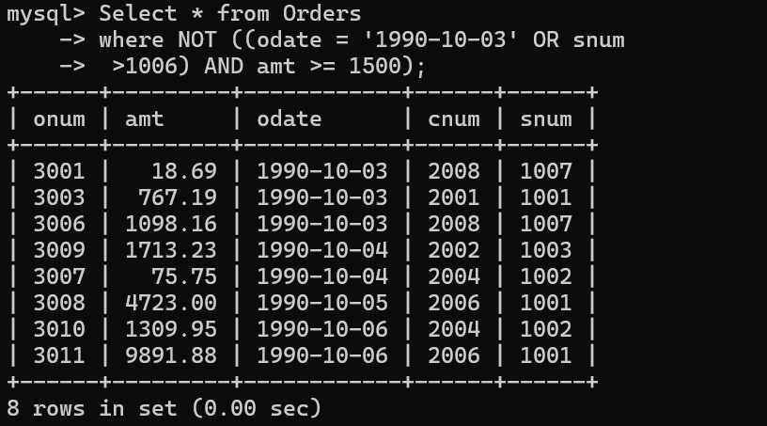

6) What is a simpler way to write this query?

Select snum, sname, city, comm From Salespeople

where (comm > .12 OR comm <.14);

* mysql> select * from salespeople where comm > 0.12 or comm < 0.14;

