**Assignment –6**

**Using Special Operators in Conditions.**

1) Write two different queries that would produce all orders taken on October 3rd or 4th, 1990.

* mysql> select * from orders;

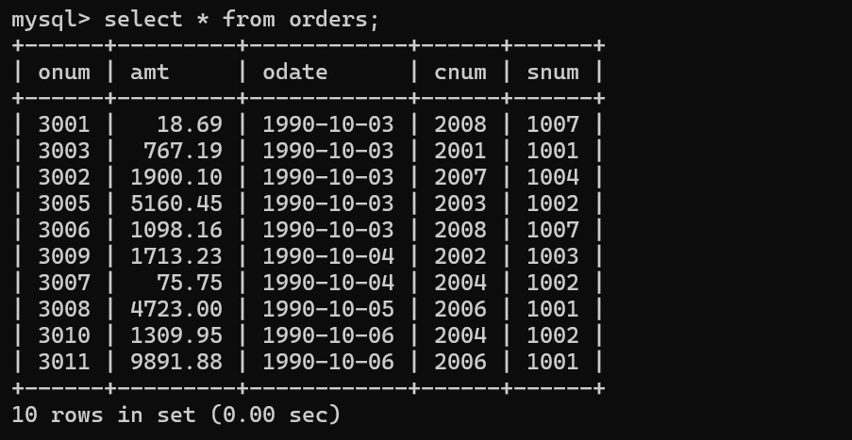

* mysql> select * from orders

-> where odate = '1990-10-03’

-> or odate = '1990-10-04';

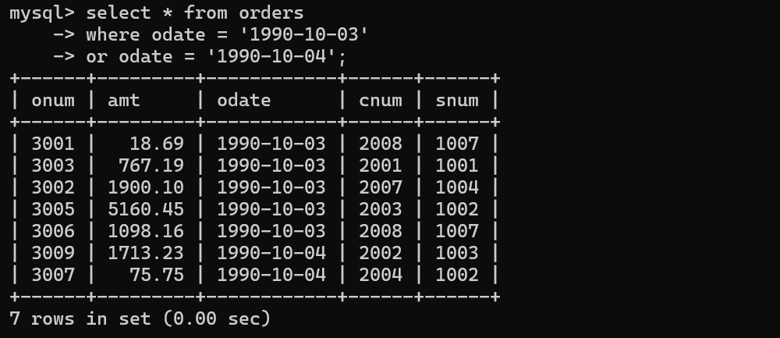

* mysql> select * from orders

-> having odate = '1990-10-04'

-> or odate = '1990-10-03';

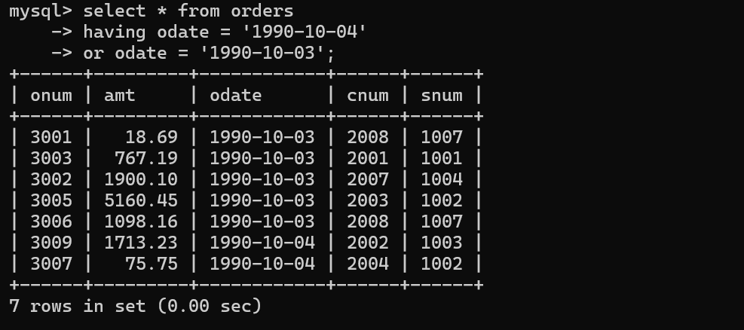

2) Write a query that selects all of the customers serviced by Peel or Motika.

* mysql> select * from customers

-> where snum = 1001 or snum = 1004;

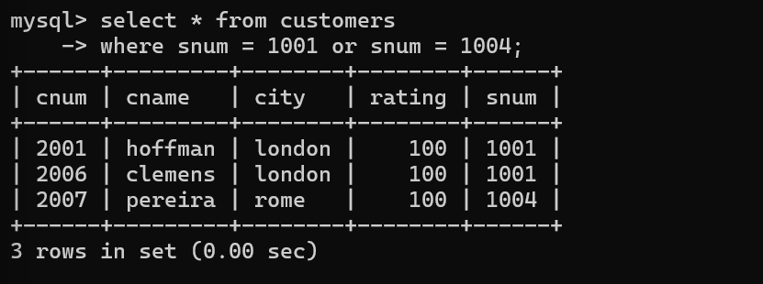

(Hint: the snum field relates the two tables to one another).

3) Write a query that will produce all the customers whose names begin with a letter from ‘A’ to ‘G’.

* mysql> select * from customers

-> where cname like 'A%' or cname like 'G%';

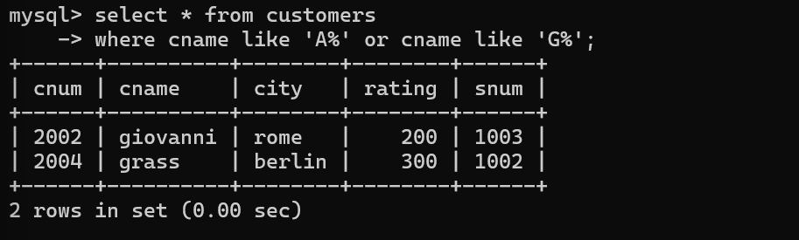

4) Write a query that selects all customers whose names begin with the letter ‘C’.

* mysql> select * from customers

-> where cname like 'C%';

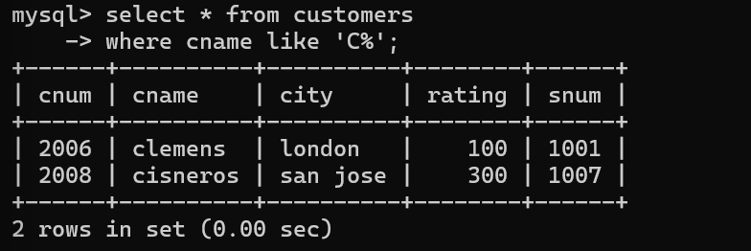

5) Write a query that selects all orders except those with zeroes or NULLs in the amt field

* mysql> select * from orders

-> where amt != 0 or amt != null;

