**Assignment –7**

**Summarizing Data with Aggregate Functions.**

1) Write a query that counts all orders for October 3.

-> select count(*)

-> from orders

-> where odate='1990-10-03';

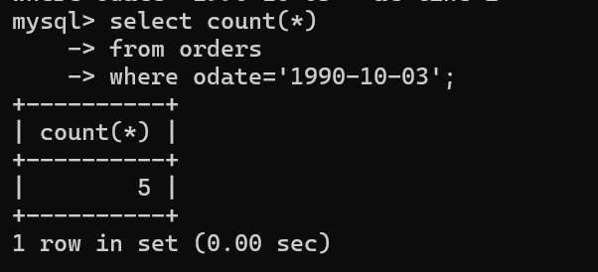

2) Write a query that counts the number of different non-NULL city values in the Customers table.

-> select count(distinct(city))

-> from customers

-> where city is not NULL;

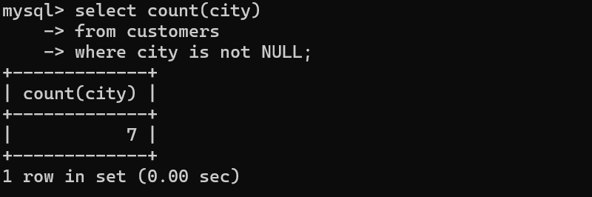

3) Write a query that selects each customer’s smallest order.

-> select cnum ,min(amt)

->from orders

->group by cnum;

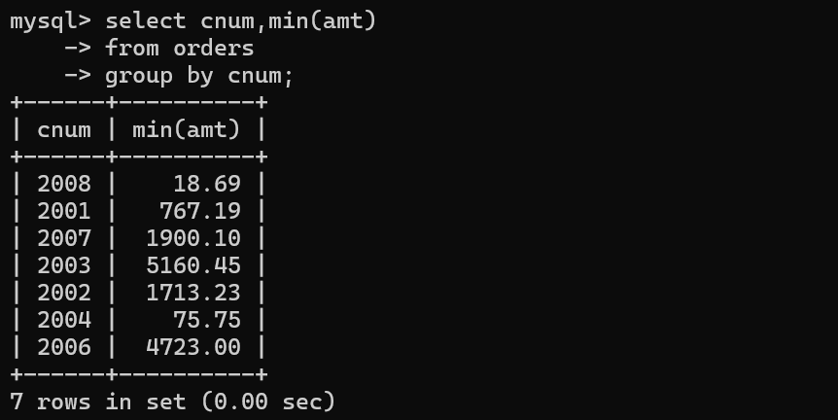

4) Write a query that selects the first customer, in alphabetical order, whose name begins with G.

-> select cname

->from customers

->where cname like 'G%'

->order by cname limit 1;

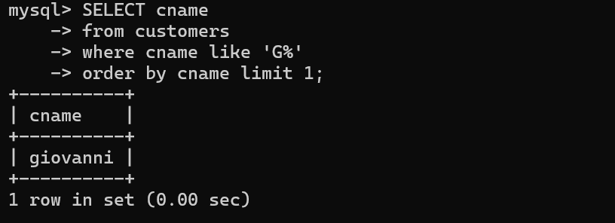

5) Write a query that selects the highest rating in each city.

-> select city, max(rating) as 'HIGHEST RATING'

-> from customers

->group by city;

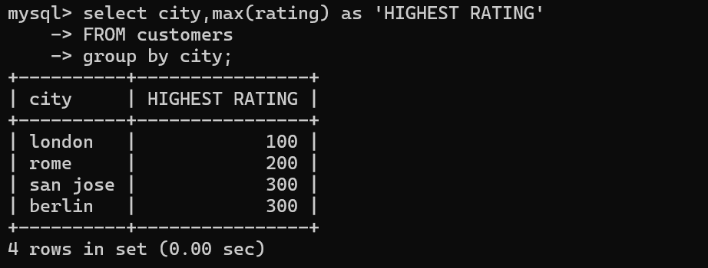

6) Write a query that counts the number of salespeople registering orders for each

day. (If a salesperson has more than one order on a given day, he or she should be

counted only once.)

->select odate, snum, count(distinct odate)

->from orders

->group by odate,snum;

