Assignment –8

Formatting Query output.

1) Assume each salesperson has a 12% commission. Write a query on the orders table that will produce the order number, the salesperson number, and the amount of the salesperson’s commission for that order.

-> select onum, snum, amt*0.12 as COMM_AMT

->from orders;

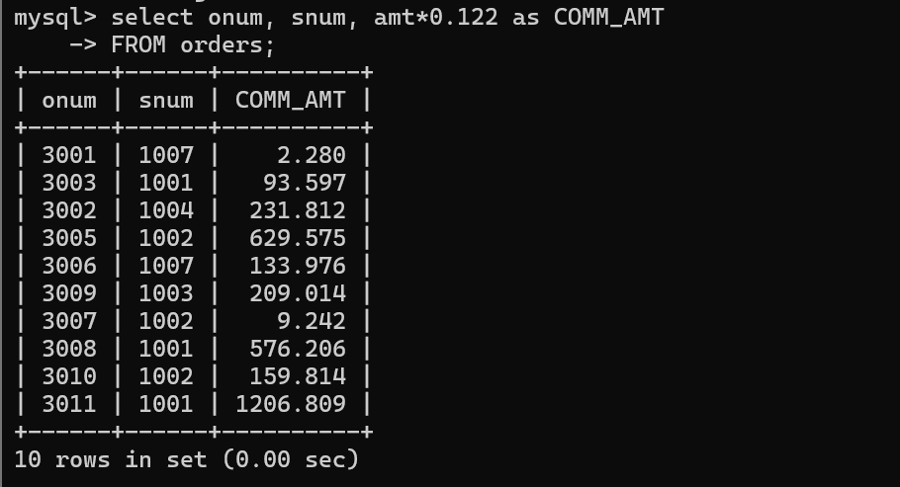

2) Write a query on the Customers table that will find the highest rating in each city. Put the output in this form: For the city (city), the highest rating is : (rating).

-> select city , max(rating) as HIGHEST_RATING

->from customers

->group by city;

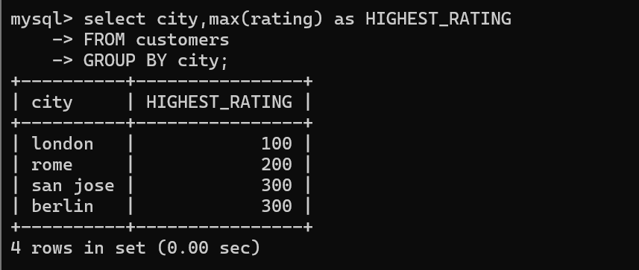

3) Write a query that lists customers in descending order of rating. Output the rating field first, followed by the customer’s name and number.

-> select rating, cname, cnum

-> from customers

-> order by RATING desc;



4) Write a query that totals the orders for each day and places the results in descending order

-> select odate, count(onum) as ONUM

-> FROM orders

-> GROUP BY odate

-> ORDER BY ONUM desc;

