Game Design Document

Fill up the Following document

1. Write the title of your project.

Questionnaire

1. What is the goal of the game?

The Goal is to teach Students with fun games.

1. Write a brief story of your game?

It’s a 2 level game in every level certain goal have been decided we

need to complete them and then a question comes with2 options if it’s a right answer next level would come or else from starting.

1. Which are the playing characters of this game?

* Playing characters are the ones which respond to the user based on the input from the user
* Cars, monkeys, dinos, wizards etc, are the playing characters in the game.

|  |  |  |
| --- | --- | --- |
| Number | Character Name | What can this character do? |
| 1 | Player1/Mario | This character can move by the arrow keys. For the First Level. |
| 2 | Ghost4 | In the pacman game ghost use to eats the pacman if they see it so it moves here and there .If it touches the pacman .Pacman lives =-1. |
| 3 | Ghost3 | In the pacman game ghost use to eats the pacman if they see it so it moves here and there .If it touches the pacman .Pacman lives =-1. |
| 4 | Ghost2 | In the pacman game ghost use to eats the pacman if they see it so it moves here and there .If it touches the pacman .Pacman lives =-1. |
| 5 | Ghost1 | In the pacman game ghost use to eats the pacman if they see it so it moves here and there .If it touches the pacman .Pacman lives =-1. |
| 6 | Pacman | It moves to eat the coins. |
| 7 |  |  |
| 8 |  |  |

1. Which are the Non Playing Characters of this game?

* Non Playing characters are the ones which don't have an action or a behaviour when the user interacts with the game.
* Hurdles, stones, bananas, coins, etc. are non-playing characters in the game.

|  |  |  |
| --- | --- | --- |
| Number | Character Name | What can this character do? |
| 1 | Ground | These are for the first level which helps in a maze. |
| 2 | Maze for pacman | These are for the first level which helps in a maze. |
| 3 | Coin | For the pacman game to earn points. |
| 4 | Treasure | For first level needed to completed the goal. |
| 5 |  |  |
| 6 |  |  |
| 7 |  |  |
| 8 |  |  |

Draw your imagination of this game. What does this game look like?

* Draw the game either on your computer or on paper,
* Add images of scenes of the game to show each of the playing and non-playing characters at least once.

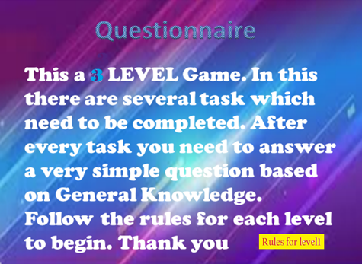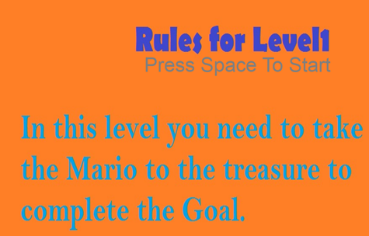

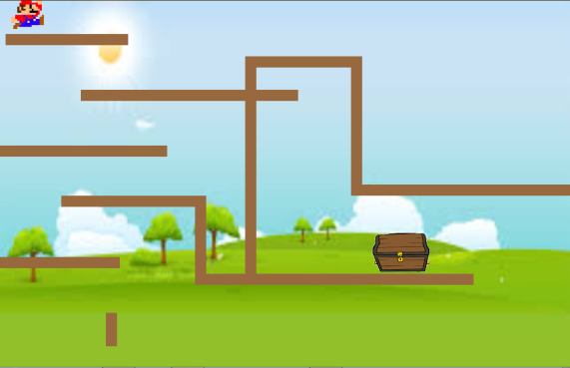 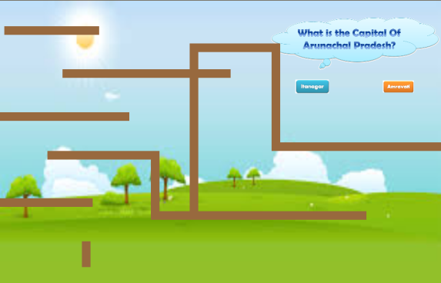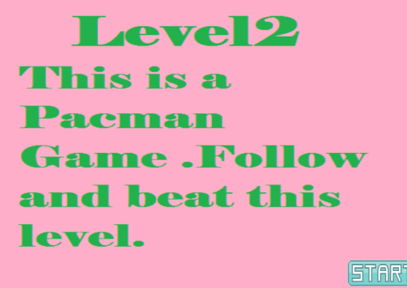 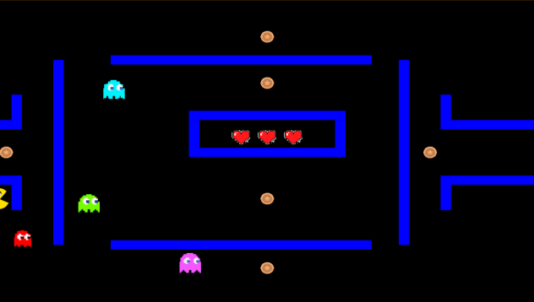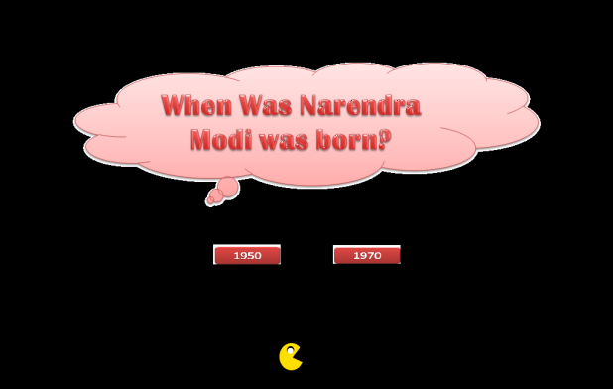

How do you plan to make your game engaging?

To make My Game engaging I created several intresting games which will be played by others and enjoy these game.