**Assignment 1.1**

<!DOCTYPE html>

<html>

    <head>

        <title>Table Formatting</title>

    </head>

    <body>

        <h1><center><strong>The Mobile AMBULANCE-EMRI 108</strong></center></h1>

        <center>

        <table border="1" width = "50%">

            <tr>

                <th>Special Equipments</th>

                <th colspan="2">Specifications/Performance</th>

            </tr>

            <tr>

                <td>Retraceable Protective Armour</td>

                <td width="15%">Engine Type</td>

                <td>Jet Turbine</td>

            </tr>

            <tr>

                <td>Weapons System</td>

                <td>Thrust</td>

                <td>150lbs @<br>103% ROS</td>

            </tr>

            <tr>

                <td>Instruments-Aircraft</td>

                <td>Torque</td>

                <td>175lbs @<br>98.7% ROS</td>

            </tr>

            <tr>

                <td rowspan="9"><img src="EMRI.jpg" alt="AMBULANCE-EMRI"></td>

                <td>0-60 MPH &gt;</td>

                <td>3.7 sec</td>

            </tr>

            <tr>

                <td>Top Speed</td>

                <td>Unknown</td>

            </tr>

            <tr>

                <td>

                    Break Rate

                </td>

                <td>Excellent</td>

            </tr>

            <tr>

                <td>Wheel Base</td>

                <td>141.12 in</td>

            </tr>

            <tr>

                <td>Length</td>

                <td>300.5 in</td>

            </tr>

            <tr>

                <td>Width</td>

                <td>100.0 in</td>

            </tr>

            <tr>

                <td>Height</td>

                <td>200.25 in</td>

            </tr>

            <tr>

                <td>Wheels</td>

                <td>Cast Alloys 15X7.5</td>

            </tr>

            <tr>

                <td>Fuel Required</td>

                <td>pure petrol with 99.9% free carbon</td>

            </tr>

        </table>

    </center>

    </body>

</html>

**Assignment 1.2**

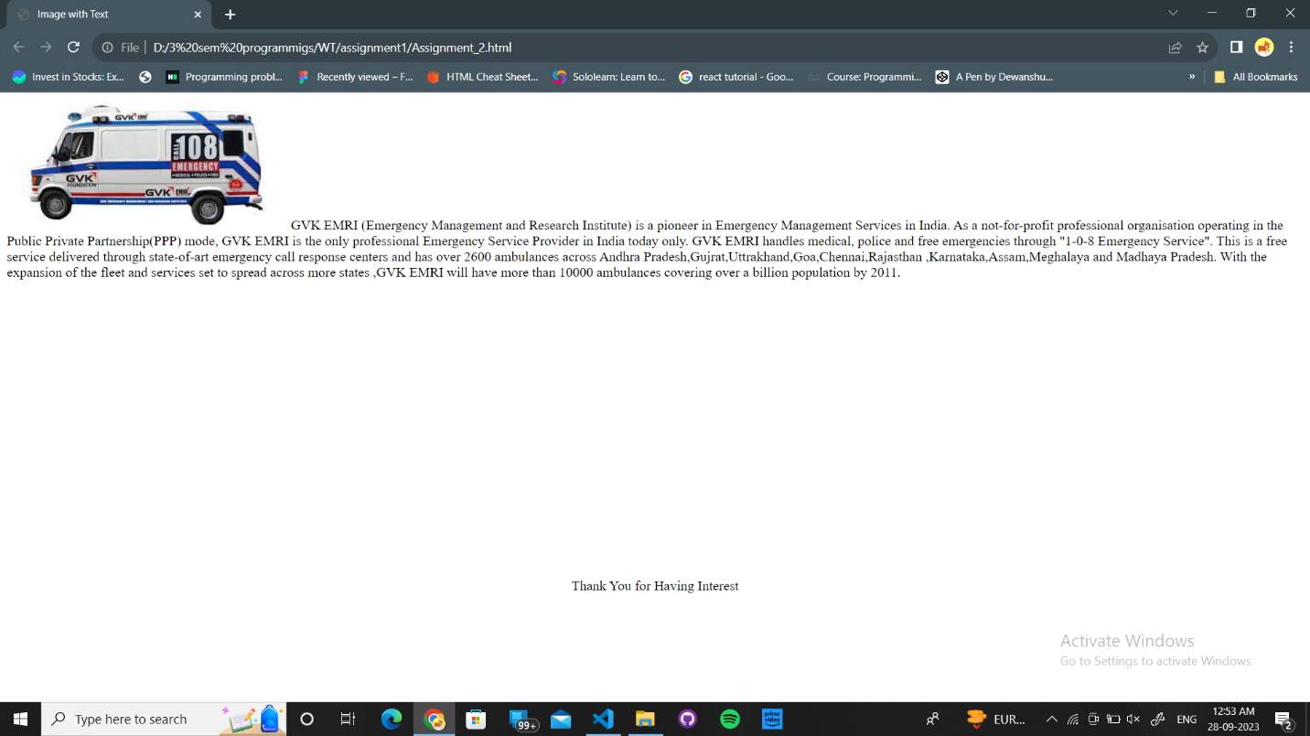

<!DOCTYPE html>

<html>

    <head>

        <title>Image with Text</title>

    </head>

    <body>

        <img src="EMRI.jpg" alt="EMRI Ambulance">

        GVK EMRI (Emergency Management and Research Institute) is a pioneer in Emergency Management Services

        in India. As a not-for-profit professional organisation operating in the Public Private Partnership(PPP)

        mode, GVK EMRI is the only professional Emergency Service Provider in India today only. GVK EMRI handles medical,

        police and free emergencies through "1-0-8 Emergency Service". This is a free service delivered through state-of-art

        emergency call response centers and has over 2600 ambulances across Andhra Pradesh,Gujrat,Uttrakhand,Goa,Chennai,Rajasthan

        ,Karnataka,Assam,Meghalaya and Madhaya Pradesh. With the expansion of the fleet and services set to spread across more states

        ,GVK EMRI will have more than 10000 ambulances covering over a billion population by 2011.

    </body>

    <br><br><br><br><br><br><br><br><br><br><br><br><br><br><br><br><br><br><br><br>

    <footer align = "center">Thank You for Having Interest</footer>

</html>

**Assignment 1.3**

<!doctype html>

<html lang="en">

  <head>

    <meta charset="utf-8">

    <meta name="viewport" content="width=device-width, initial-scale=1">

    <title>My Resume</title>

  <link rel="icon" type="image/x-icon" href="favicon.ico">

    <link href="https://cdn.jsdelivr.net/npm/bootstrap@5.3.0-alpha1/dist/css/bootstrap.min.css" rel="stylesheet" integrity="sha384-GLhlTQ8iRABdZLl6O3oVMWSktQOp6b7In1Zl3/Jr59b6EGGoI1aFkw7cmDA6j6gD" crossorigin="anonymous">

  </head>

  <body>

 <header class="bg-primary bg-gradient text-white py-5">

  <div class="container">

    <div class="row">

      <div class="col-md-3 text-left text-md-center mb-3">

      </div>

      <div class="col-md-9">

        <h1>Shubhangini Agrawal</h1>

        <h5>MCA student at KIET Group of Institution</h5>

        <p class="border-top pt-3">My name is Shubhangini Agrawal. I am from Banaras. Currently I am pursuing MCA from KIET group of institutions. I am goal oriented person I am maintaining schedule to overcome procrastination . </p>

      </div>

    </div>

  </div>

</header>

<nav class="bg-dark text-white-50 mb-5">

  <div class="container">

   <div class="row p-3">

     <div class="col-md pb-2 pb-md-0">

        <svg width="1em" height="1.5em" viewBox="0 0 16 16" class="bi bi-envelope" fill="currentColor" xmlns="http://www.w3.org/2000/svg">

          <path fill-rule="evenodd" d="M0 4a2 2 0 0 1 2-2h12a2 2 0 0 1 2 2v8a2 2 0 0 1-2 2H2a2 2 0 0 1-2-2V4zm2-1a1 1 0 0 0-1 1v.217l7 4.2 7-4.2V4a1 1 0 0 0-1-1H2zm13 2.383l-4.758 2.855L15 11.114v-5.73zm-.034 6.878L9.271 8.82 8 9.583 6.728 8.82l-5.694 3.44A1 1 0 0 0 2 13h12a1 1 0 0 0 .966-.739zM1 11.114l4.758-2.876L1 5.383v5.73z"/>

        </svg>

        <a href="#" class="text-white ml-2">shubhangini.2224mca1@kiet.edu</a>

     </div>

      <div class="col-md text-md-right">

        <svg width="1.5em" height="1.5em" viewBox="0 0 16 16" class="bi bi-telephone-fill" fill="currentColor" xmlns="http://www.w3.org/2000/svg">

          <path fill-rule="evenodd" d="M2.267.98a1.636 1.636 0 0 1 2.448.152l1.681 2.162c.309.396.418.913.296 1.4l-.513 2.053a.636.636 0 0 0 .167.604L8.65 9.654a.636.636 0 0 0 .604.167l2.052-.513a1.636 1.636 0 0 1 1.401.296l2.162 1.681c.777.604.849 1.753.153 2.448l-.97.97c-.693.693-1.73.998-2.697.658a17.47 17.47 0 0 1-6.571-4.144A17.47 17.47 0 0 1 .639 4.646c-.34-.967-.035-2.004.658-2.698l.97-.969z"/>

        </svg>

        <a href="#" class="text-white ml-2">8707082834</a>

      </div>

    </div>

  </div>

</nav>

<main class="container">

  <div class="row">

    <div class="col-md mb-5">

     <!-- education -->

    </div>

  </div>

  <div class="row">

    <div class="col-md mb-5">

      <!-- skills -->

    </div>

    </div>

  </div>

</main>

<div class="accordion" id="accordionExample">

  <div class="accordion-item">

    <h2 class="accordion-header" id="headingOne">

      <button class="accordion-button" type="button" data-bs-toggle="collapse" data-bs-target="#collapseOne" aria-expanded="true" aria-controls="collapseOne">

       <h2 class="mb-5">Education</h2>

      </button>

    </h2>

    <div id="collapseOne" class="accordion-collapse collapse show" aria-labelledby="headingOne" data-bs-parent="#accordionExample">

      <div class="accordion-body">

    <ul>

  <li>

    <h6 class="text-primary">10th</h6>

    <p>Sunbeam English School, Bhagwanpur, Varanasi (CBSE)

        10 CGPA</p>

  </li>

  <li>

    <h6 class="text-primary">12th</h6>

    <p>Sunbeam English School, Bhagwanpur, Varanasi (CBSE)

        93%</p>

  </li>

  <li>

    <h6 class="text-primary">Graduation in Bsc</h6>

    <p>Microtek College of Management and Technology,

        Kerakat, Jaunpur (Affiliated with VBSPU,Jaunpur) 74.6%.</p>

  </li>

  <li>

    <h6 class="text-primary">currently persuing MCA</h6>

    <p>From AKTU KIET Group of Institution.</p>

  </li>

</ul>

      </div>

    </div>

  </div>

  <div class="accordion-item">

    <h2 class="accordion-header" id="headingTwo">

      <button class="accordion-button collapsed" type="button" data-bs-toggle="collapse" data-bs-target="#collapseTwo" aria-expanded="false" aria-controls="collapseTwo">

        <h2 class="mb-5">Skills</h2>

      </button>

    </h2>

    <div id="collapseTwo" class="accordion-collapse collapse" aria-labelledby="headingTwo" data-bs-parent="#accordionExample">

      <div class="accordion-body">

    <div class="progress mb-4" style="height:25px;">

  <div class="progress-bar bg-primary text-left pl-2" role="progressbar" style="width: 60%" aria-valuenow="60" aria-valuemin="0" aria-valuemax="100">HTML</div>

</div>

<div class="progress mb-4" style="height:25px;">

  <div class="progress-bar bg-primary text-left pl-2" role="progressbar" style="width: 50%" aria-valuenow="50" aria-valuemin="0" aria-valuemax="100">CSS</div>

</div>

<div class="progress mb-4" style="height:25px;">

  <div class="progress-bar bg-primary text-left pl-2" role="progressbar" style="width: 50%" aria-valuenow="50" aria-valuemin="0" aria-valuemax="100">java</div>

</div>

<div class="progress mb-4" style="height:25px;">

  <div class="progress-bar bg-primary text-left pl-2" role="progressbar" style="width: 60%" aria-valuenow="60" aria-valuemin="0" aria-valuemax="100">C++</div>

</div>

      </div>

    </div>

  </div>

<div class="accordion-item">

    <h2 class="accordion-header" id="headingTwo">

      <button class="accordion-button collapsed" type="button" data-bs-toggle="collapse" data-bs-target="#collapseTwo" aria-expanded="false" aria-controls="collapseTwo">

      <h2> Technical Profile</h2>

      </button>

    </h2>

    <div id="collapseTwo" class="accordion-collapse collapse" aria-labelledby="headingTwo" data-bs-parent="#accordionExample">

      <div class="accordion-body">

    <br>

   <img class="rounded-circle img-fluid" src="hackerrank.icon"width="50" height="50" >

    Hackerrank:-

    <br>

    <img class="rounded-circle img-fluid" src="linkdin.icon"width="50" height="50" >

    Linkdin:-

   <br>

   <img class="rounded-circle img-fluid" src="github.icon"width="50" height="50" >

    Github:-

      </div>

    </div>

  </div>

</div>

    <script src="https://cdn.jsdelivr.net/npm/bootstrap@5.3.0-alpha1/dist/js/bootstrap.bundle.min.js" integrity="sha384-w76AqPfDkMBDXo30jS1Sgez6pr3x5MlQ1ZAGC+nuZB+EYdgRZgiwxhTBTkF7CXvN" crossorigin="anonymous"></script>

  </body>

</html>

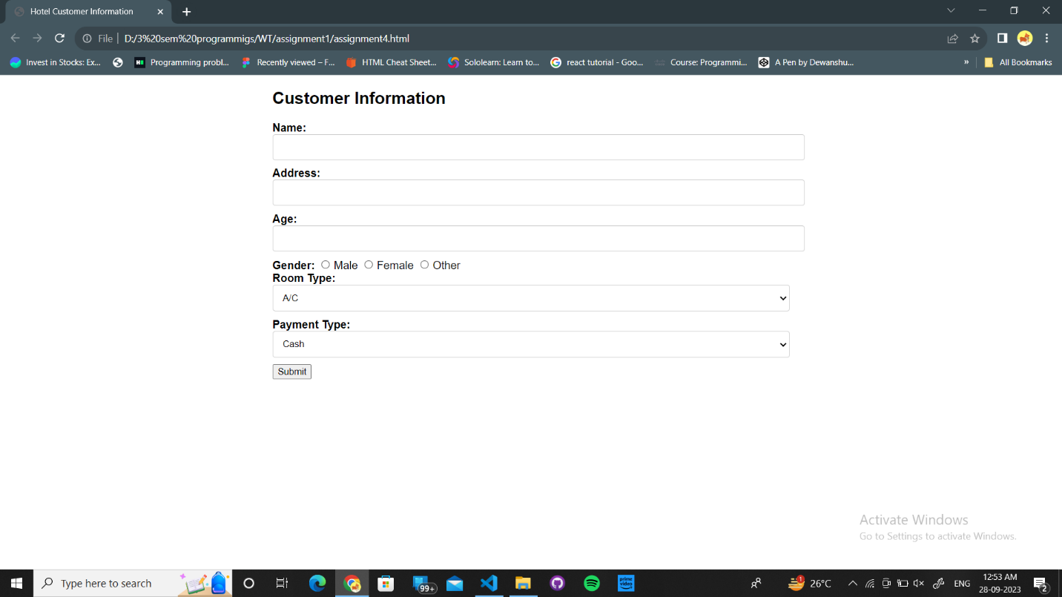**Assignment 1.4**

<!DOCTYPE html>

<html>

<head>

    <title>Hotel Customer Information</title>

    <style>

        body {

            font-family: Arial, sans-serif;

            margin: 20px;

        }

        label {

            font-weight: bold;

        }

        .container {

            width: 50%;

            margin: 0 auto;

        }

        input[type="text"], input[type="number"], select {

            width: 100%;

            padding: 10px;

            margin-bottom: 10px;

            border: 1px solid #ccc;

            border-radius: 4px;

        }

        input[type="radio"] {

            margin-right: 5px;

        }

        .error {

            color: red;

        }

    </style>

</head>

<body>

    <div class="container">

        <h2>Customer Information</h2>

        <form id="customerForm" onsubmit="return validateForm()">

            <label for="name">Name:</label>

            <input type="text" id="name" name="name" required>

            <br>

            <label for="address">Address:</label>

            <input type="text" id="address" name="address" required>

            <br>

            <label for="age">Age:</label>

            <input type="number" id="age" name="age" required>

            <br>

            <label>Gender:</label>

            <input type="radio" id="male" name="gender" value="Male">Male

            <input type="radio" id="female" name="gender" value="Female">Female

            <input type="radio" id="other" name="gender" value="Other">Other

            <br>

            <label for="roomType">Room Type:</label>

            <select id="roomType" name="roomType" required>

                <option value="AC">A/C</option>

                <option value="NonAC">Non-A/C</option>

                <option value="Deluxe">Deluxe</option>

            </select>

            <br>

            <label for="paymentType">Payment Type:</label>

            <select id="paymentType" name="paymentType" required>

                <option value="Cash">Cash</option>

                <option value="Card">Credit/Debit Card</option>

                <option value="Coupons">Coupons</option>

            </select>

            <br>

            <input type="submit" value="Submit">

        </form>

        <p id="error" class="error"></p>

    </div>

    <script>

        function validateForm() {

            var name = document.getElementById("name").value;

            var address = document.getElementById("address").value;

            var age = document.getElementById("age").value;

            var gender = document.querySelector('input[name="gender"]:checked');

            var roomType = document.getElementById("roomType").value;

            var paymentType = document.getElementById("paymentType").value;

            var error = document.getElementById("error");

            // Basic validation

            if (!name || !address || !age || !gender || !roomType || !paymentType) {

                error.textContent = "All fields are required.";

                return false;

            }

            // Age should be a number

            if (isNaN(age)) {

                error.textContent = "Age must be a number.";

                return false;

            }

            return true;

        }

    </script>

</body>

</html>

**Assignment 1.5**

<!DOCTYPE html>

<html>

<head>

    <title>Employee Bio-data</title>

    <style>

        body {

            font-family: Arial, sans-serif;

            margin: 20px;

        }

        label {

            font-weight: bold;

        }

        .container {

            width: 50%;

            margin: 0 auto;

        }

        input[type="text"], input[type="number"], select {

            width: 100%;

            padding: 10px;

            margin-bottom: 10px;

            border: 1px solid #ccc;

            border-radius: 4px;

        }

        .error {

            color: red;

        }

    </style>

</head>

<body>

    <div class="container">

        <h2>Employee Bio-data</h2>

        <form id="employeeForm" onsubmit="return validateForm()">

            <label for="name">Full Name:</label>

            <input type="text" id="name" name="name" required>

            <br>

            <label for="age">Age:</label>

            <input type="number" id="age" name="age" required>

            <br>

            <label for="email">Email:</label>

            <input type="text" id="email" name="email" required>

            <br>

            <label for="designation">Designation:</label>

            <input type="text" id="designation" name="designation" required>

            <br>

            <label for="department">Department:</label>

            <input type="text" id="department" name="department" required>

            <br>

            <input type="submit" value="Submit">

        </form>

        <p id="error" class="error"></p>

    </div>

    <script>

        function validateForm() {

            var name = document.getElementById("name").value;

            var age = document.getElementById("age").value;

            var email = document.getElementById("email").value;

            var designation = document.getElementById("designation").value;

            var department = document.getElementById("department").value;

            var error = document.getElementById("error");

            // Basic validation

            if (!name || !age || !email || !designation || !department) {

                error.textContent = "All fields are required.";

                return false;

            }

            // Age should be a number

            if (isNaN(age)) {

                error.textContent = "Age must be a number.";

                return false;

            }

            // Email validation using regular expression

            var emailRegex = /^[A-Za-z0-9._%+-]+@[A-Za-z0-9.-]+\.[A-Za-z]{2,}$/;

            if (!email.match(emailRegex)) {

                error.textContent = "Invalid email format.";

                return false;

            }

            return true;

        }

    </script>

</body>

</html>