DocChat
PDF Research Assistant
Technical Design Document

Version 1.0
Date: June 2026
Author: Mohit

1. High-Level Design (HLD)

1.1 System Overview
DocChat is a Retrieval-Augmented Generation (RAG) application that enables users to upload PDF documents, create vector embeddings, and query the documents through a conversational chat interface powered by a Large Language Model (LLM).
The system follows a three-stage pipeline:
- Ingestion: PDF upload, text extraction, chunking, and vector embedding generation
- Storage: Document metadata in PostgreSQL, vector embeddings in pgvector
- Retrieval & Generation: Semantic similarity search, context assembly, and LLM-powered answer generation

1.2 Architecture Diagram
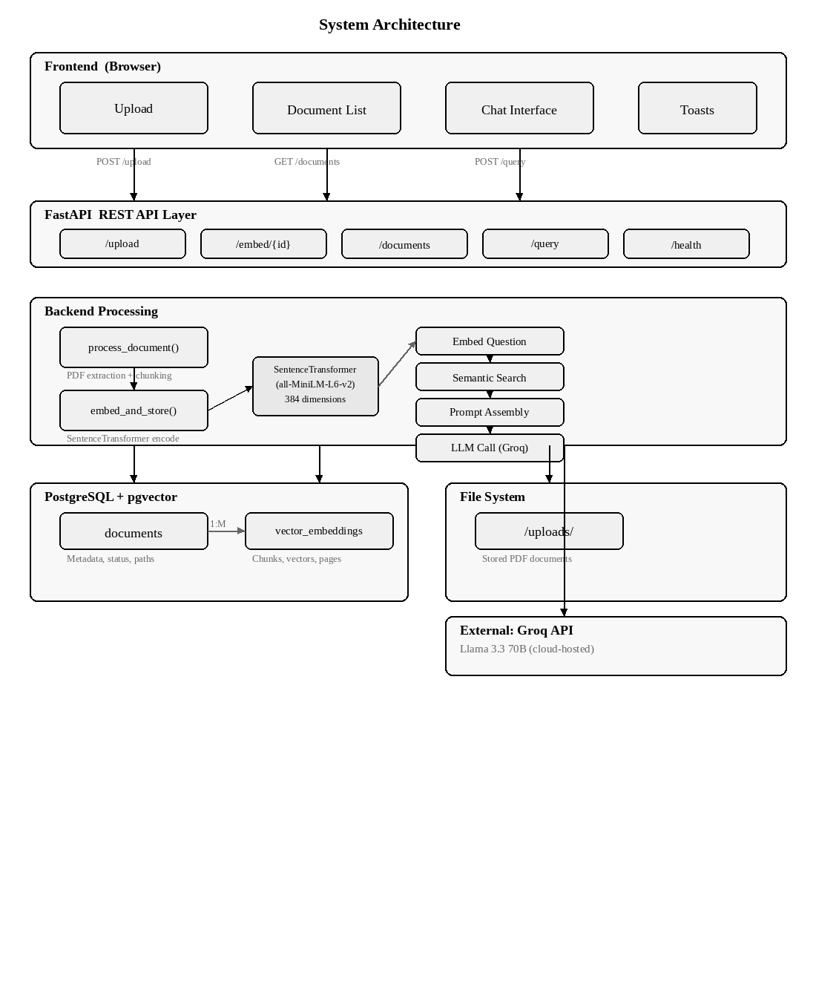

1.3 Core Components
- Frontend: Single-page HTML/CSS/JS application served by FastAPI
- Backend: FastAPI application handling REST API requests
- Embedding Engine: SentenceTransformer model (all-MiniLM-L6-v2) for vectorization
- Vector Database: PostgreSQL with pgvector extension for similarity search
- LLM Service: Groq API with Llama 3.3 70B model for answer generation
- File Storage: Local filesystem for uploaded PDF documents

1.4 Tech Stack
Layer | Technology | Purpose
Language | Python 3.11+ | Backend logic, ML model integration
Backend | FastAPI | Async REST API with auto-generated Swagger docs
Embedding | all-MiniLM-L6-v2 | 384-dim sentence embeddings, runs locally
Vector DB | PostgreSQL + pgvector | Cosine similarity search on embeddings
LLM | Groq (Llama 3.3 70B) | Free API, fast inference for answer generation
PDF Processing | pdfplumber | Text extraction from PDF documents
Frontend | HTML / CSS / JS | Single-page interface with drag-drop upload
Validation | Pydantic | Request/response model validation

1.5 External Integrations
- Groq API: Cloud-hosted LLM inference. Requires API key via GROQ_API_KEY environment variable.
- SentenceTransformers: Model downloaded once at startup; runs locally with no external calls during inference.
- No other external services required. The system is fully self-contained with a local PostgreSQL instance.

2. Low-Level Design (LLD)

2.1 Core Functions
Function 1: process_document(file_path)
Responsibility: Extract text from a PDF and split it into overlapping chunks.
- Input: file_path (str) — path to the PDF file on disk
- Output: List of dictionaries, each containing "page_no" (int) and "text" (str)
- Open the PDF using pdfplumber
- Iterate through each page using enumerate for page numbers
- Extract text; skip pages that return None
- Normalize whitespace: collapse tabs, newlines, multiple spaces into single spaces
- Chunk the text using a sliding window: step 400 chars, window 500 chars (100-char overlap)
- Append each chunk with its 1-indexed page number to the output list
Function 2: embed_and_store(document_id, chunks)
Responsibility: Convert text chunks to vectors and persist them in pgvector.
- Input: document_id (int), chunks (list of dicts from Function 1)
- Output: None (side effect: rows inserted into vector_embeddings table)
- Open a database connection with pgvector type registered
- For each chunk, encode the text using SentenceTransformer.encode()
- Convert the numpy array to a Python list with .tolist()
- Execute an INSERT with document_id, page_no, text, and vector
- Commit all inserts in a single transaction after the loop
Function 3: query(question, document_ids)
Responsibility: Full RAG pipeline — embed query, retrieve context, generate answer.
- Input: question (str), document_ids (list of int)
- Output: Answer string from the LLM
- Embed the question using the same SentenceTransformer model
- Execute cosine similarity search against pgvector, filtered by selected document_ids
- Retrieve top 5 most similar chunks, ordered by descending similarity
- If no chunks found, return a fallback message
- Build a labeled context string: "Source 1 (Page N): [chunk text]" for each result
- Assemble the prompt with system message (constraints) and user message (question + context)
- Call Groq API and return the response text

2.2 Key Design Decisions
- Single embedding model instance: Loaded once at startup to avoid reloading 90MB per request.
- Overlapping chunks: 100-char overlap prevents information loss at chunk boundaries.
- Cosine similarity via pgvector: The <=> operator computes cosine distance natively in PostgreSQL.
- Prompt engineering: System prompt constrains the LLM to answer only from provided context, reducing hallucination.
- Synchronous embedding: Appropriate for demo scope; production would use a background task queue.

2.3 Sequence Diagram: Document Upload & Embedding
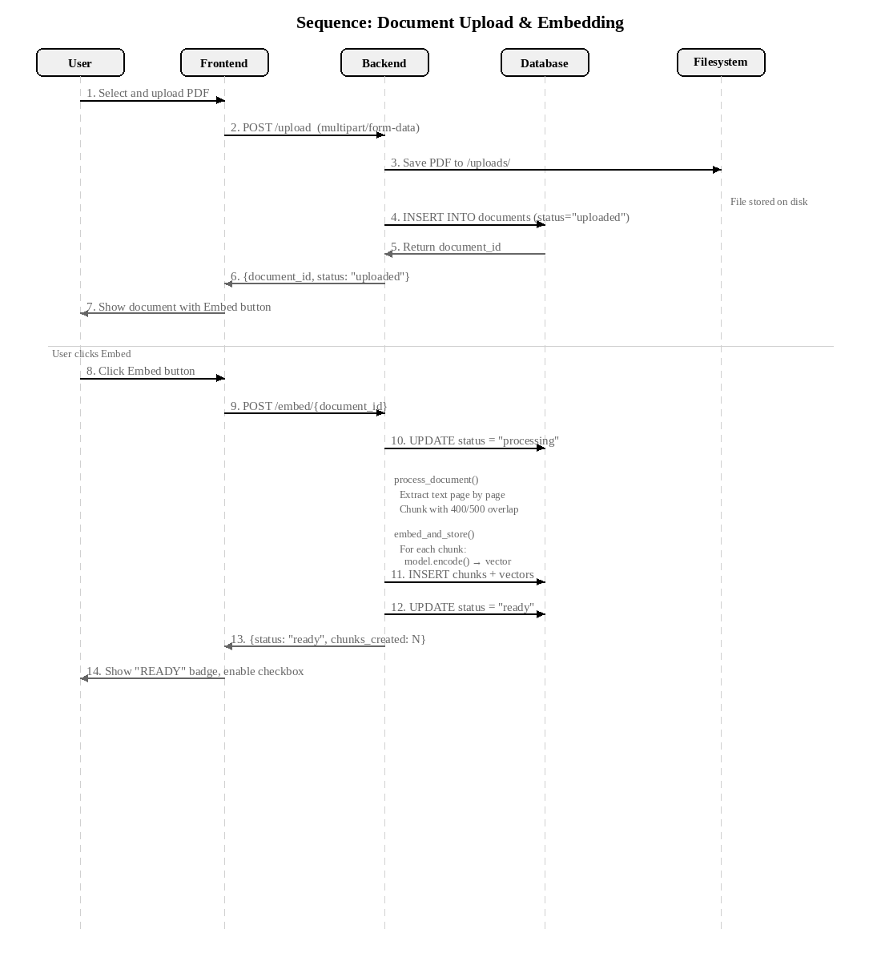

2.4 Sequence Diagram: Query Pipeline
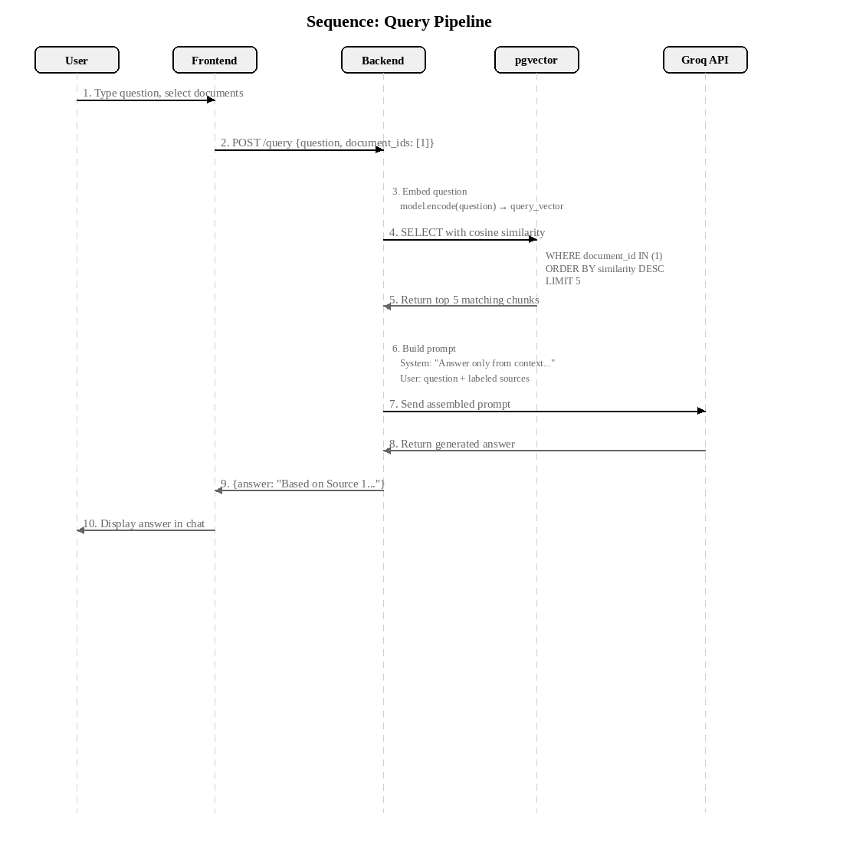

3. Data Model / Database Schema (ERD)

3.1 Entity Relationship Diagram
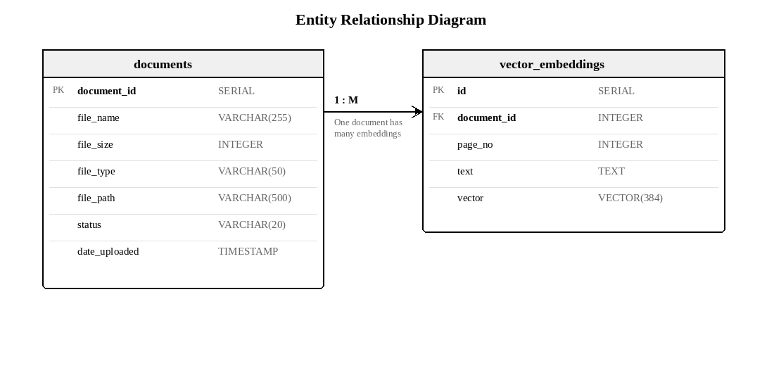

3.2 Data Dictionary: documents
Column | Type | Null | Description
document_id | SERIAL (PK) | No | Auto-incremented primary key
file_name | VARCHAR(255) | No | Original filename of the uploaded PDF
file_size | INTEGER | Yes | File size in bytes
file_type | VARCHAR(50) | Yes | File extension (e.g., 'pdf')
file_path | VARCHAR(500) | No | Path to file on server filesystem
status | VARCHAR(20) | Yes | uploaded | processing | ready | failed
date_uploaded | TIMESTAMP | Yes | Defaults to CURRENT_TIMESTAMP

3.3 Data Dictionary: vector_embeddings
Column | Type | Null | Description
id | SERIAL (PK) | No | Auto-incremented primary key
document_id | INTEGER (FK) | Yes | References documents.document_id
page_no | INTEGER | Yes | 1-indexed page number of source chunk
text | TEXT | No | Original chunk text for LLM context
vector | VECTOR(384) | Yes | 384-dim embedding from all-MiniLM-L6-v2

4. API Contracts / Interface Specs
Base URL: http://localhost:8000
Auto-generated OpenAPI documentation available at /docs (Swagger UI)

4.1 GET /health
Health check endpoint.
Field | Value
Method | GET
Response | {"status": "ok"}

4.2 POST /upload
Upload a PDF document. Saves file to disk and creates a metadata record.
Field | Value
Content-Type | multipart/form-data
Request Body | file: UploadFile (PDF only)
Success (200) | {"document_id": 1, "file_name": "report.pdf", "status": "uploaded"}
Error (400) | Non-PDF file uploaded

4.3 POST /embed/{document_id}
Trigger text extraction, chunking, and embedding for a document.
Field | Value
Path Parameter | document_id (integer)
Success (200) | {"document_id": 1, "status": "ready", "chunks_created": 34}
Error (404) | Document ID not found
Error (500) | Processing or embedding failure

4.4 GET /documents
Retrieve list of all documents with metadata and processing status.
Field | Value
Success (200) | {"documents": [{document_id, file_name, status, ...}]}

4.5 POST /query
Submit a question against selected documents. Returns LLM-generated answer.
Field | Value
Content-Type | application/json
Request Body | {"question": "...", "document_ids": [1]}
Success (200) | {"answer": "Based on Source 1...", "question": "..."}
Error (400) | Empty document_ids list

4.6 Error Response Format
All errors follow the standard FastAPI format: {"detail": "error message"}
Code | Meaning | When
400 | Bad Request | Invalid file type, missing fields, empty document_ids
404 | Not Found | Document ID does not exist
500 | Server Error | PDF processing, embedding, or LLM API failure

5. UI/UX Design

5.1 Wireframe
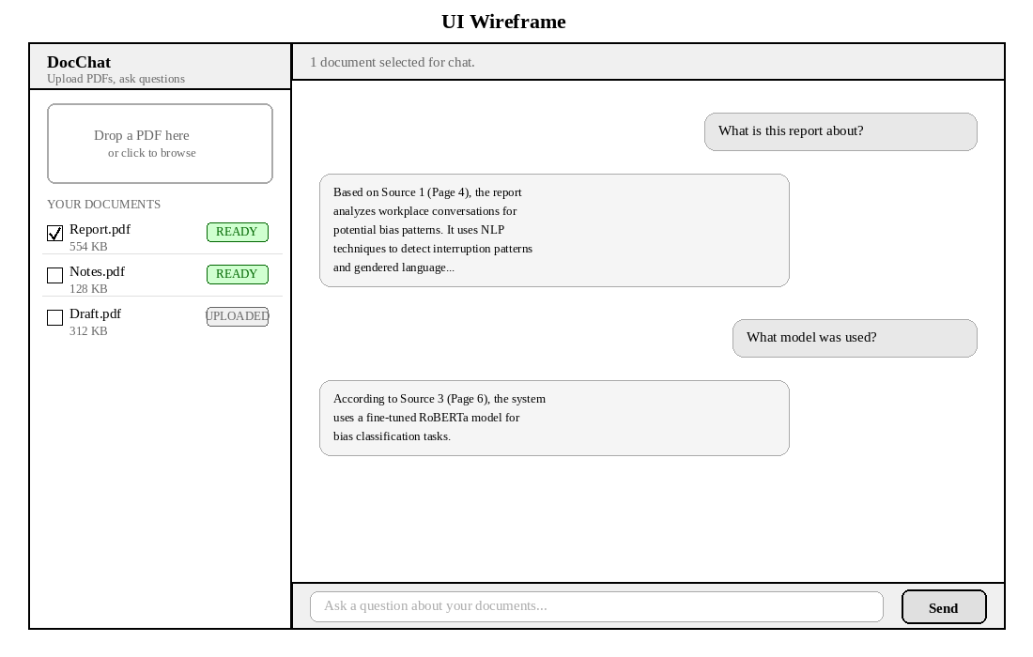

5.2 Component Breakdown
Upload Dropzone
- Drag-and-drop zone with click-to-browse fallback
- Accepts only .pdf files; rejects others with error toast
- Visual feedback on dragover (border color change)
Document List
- Displays all documents sorted by upload date (newest first)
- Each document shows: filename, size, status badge, action button
- Status badges: UPLOADED (grey), PROCESSING (blue animated), READY (green), FAILED (red)
- Checkbox enabled only when status is READY
Chat Interface
- Header shows count of selected documents
- User messages right-aligned; assistant messages left-aligned
- Input bar with text field and Send button; supports Enter key
- Thinking indicator shown during LLM processing
Toast Notifications
- Bottom-right positioned; auto-dismiss after 4 seconds
- Three variants: info (blue), success (green), error (red)

5.3 Style Guide
Property | Value
Background (main) | #0f1117 (near-black)
Background (sidebar) | #161822 (dark charcoal)
Text (primary) | #e1e4e8 (light grey)
Accent | #4f8ff7 (blue)
Font family | Segoe UI, -apple-system, sans-serif
Border radius | 8-10px for cards, 16px for chat bubbles

