CA PROJECT REPORT
Title: Movie Recommender System
Subject Course Code: INT248


BY

Name: Shubhi Awasthi
Roll No: RKM073B70

To

Ankita Wadhavan

Under
Department Of Computer Science and Engineering

Contents
1) Introduction
2) Literature review
3) Dataset used
4) Proposed architecture
5) Conclusion
6) Future scope
7) References

INTRODUCTION
Recommendation systems have been around since some time now, and they prove to be quite powerful providing meaningful insights. These systems have a strong influence on our preferences and decisions recently. From E-commerce to Entertainment i.e. online shopping stores to movie streaming services, they are almost everywhere. All this is possible due to the data we generate every moment.
People may seem very different from each other, but their habits, likings can be very similar. Hence various organizations solely work upon the data we generate process it and insight meaningful results which in turn derive enormous profits.
Recommendation algorithms use input about a customer’s interests to generate a list of recommended items. At Amazon.com, recommendation algorithms are used to personalize the online store for each customer, for example showing programming titles to a software engineer and baby toys to a new mother. Organizations like these keep an eye upon our activities at backend. If a group of people who bought a particular “a” item also bought another “b” item, the system will most probably suggest you to buy “b” item. The system gets trained consistently interacting with people activities and understands the patterns to make new suggestions.
Platforms like Amazon and Netflix need to serve better experience by suggesting products relevant to their audience’s interests. These can be recommendations due to some past behavior of users or some other profiles similar to theirs. We can trace this behavior in our daily life too, as recommendation systems not only work in the case of mobile applications/web but in real life also, e.g. if we walk into a nearby store, and show some interest in any item or sought to buy it, the shopkeeper will further recommend according to our interest to attract us towards more and more items.

Literature Review
- pzs.dstu.dp.ua/DataMining/recom/bibl/1jannach_dietmar_zanker_markus_felfernig_alexander_friedrich.pdf

- The Use of Machine Learning Algorithms in Recommender Systems: A Systematic Review
https://www.researchgate.net/publication/284219925_The_Use_of_Machine_Learning_Algorithms_in_Recommender_Systems_A_Systematic_Review

- Context - aware recommender systems, handbook
https://www.cse.iitk.ac.in/users/nsrivast/HCC/Recommender_systems_handbook.pdf

Github Link for Project
ShubhiAwasthi/MovieRecommendationSystem-using-ML (github.com)

Project Dataset
The dataset which is used in this project is taken from kaggle. The original dataset which was available there was very large and was having different files; I have reduced the number of entries to around 5000 values.
https://www.kaggle.com/rounakbanik/the-movies-dataset/data

Proposed Architecture
For any recommendation system there are users and then there are items. There are mostly three ways to build recommendation engine:
- Popularity based recommendation engine
- Content based recommendation engine
- Collaborative filtering based recommendation engine
Systems implementing a content-based recommendation approach analyze a set of documents and/or descriptions of items previously rated by a user, and build a model or profile of user interests based on the features of the objects rated by that user. The profile is a structured representation of user interests, adopted to recommend new interesting items. The recommendation process basically consists in matching up the attributes of the user profile against the attributes of a content object. The result is a relevant judgment that represents the user’s level of interest in that object. If a profile accurately reflects user preferences, it is of tremendous advantage for the effectiveness of an information access process. For instance, it could be used to filter search results by deciding whether a user is interested in a specific Web page or not and, in the negative case, preventing it from being displayed.
This movie recommender program is created using python and portrays how machine learning can be used in daily life. In this project recommendation system will be content based so one has to find and recommend similar movies to a given movie. In this system if a user has seen or liked a movie the system will find similarities between this movie and all others on the basis of content, genre, director etc and will assign them a similarity or confidence score. After that comparison between the similarity score of inputted movie and all other movies will be done, past this process the movies whose similarity score is close to the score of the particular movie will be there, they will be found out and recommended to the user.

The step by step approach to build the recommendation engine consists of the following steps:
- Importing the required libraries, loading data, checking for irregularities in data.
- Selecting the required features to be taken into account for our system and ignoring all other features.
- Replacing null values with null string
- Combining the selected features.
- Converting the text data into feature vectors
- Evaluating the similarity scores of the calculated feature vectors using cosine similarity.
- Getting the input from user and finding the close match for the movie name given by user if in case some order or spelling mistake is there in the input.
- Comparing and sorting similar movies on the basis of similarity score.

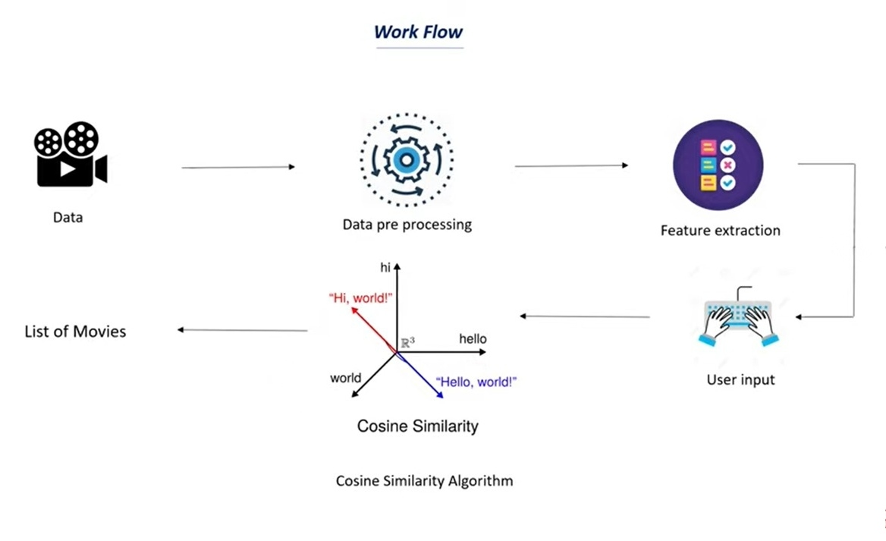

Conclusion
In this project I came across the field of content-based recommender system and applied a basic approach/algorithm to make one such system. Although there are a bunch of recommender systems in different domains, they share in common a means for representing items to be recommended and user profiles.
Finally, a very specific aspect of content recommender systems is presented. Due to the nature of this kind of systems, they can only recommend items that score highly against a user’s profile, thus the user is limited to being recommended items similar to those already rated. This shortcoming, called over-specialization, prevents these systems to be effectively used in real world scenarios. Possible ways to feed users with surprising and unexpected (serendipitous) recommendations are analyzed.

Nowadays, recommender systems (RS) are widely used in e-commerce, social network,
and several other domains. Since its introduction in mid 1990s, this research field has
been evolving. One progress step in RS history is the adoption of machine learning (ML)
algorithms, which allow computers to learn based on user information and to further
personalize recommendations
Future Scope
Nowadays, recommender systems (RS) are widely used in e-commerce, social network,
and several other domains. Since its introduction in mid 1990s, this research field has
been evolving. One progress step in RS history is the adoption of machine learning (ML)
algorithms, which allow computers to learn based on user information and to further
personalize recommendations
5 Conclusion & Future Work
Nowadays, recommender systems (RS) are widely used in e-commerce, social network,
and several other domains. Since its introduction in mid 1990s, this research field has
been evolving. One progress step in RS history is the adoption of machine learning (ML)
algorithms, which allow computers to learn based on user information and to further
personalize recommendations
Nowadays, recommendation systems are used in e-commerce, entertainment, social networks and various other domains. It was introduced in 1990s, since then the research in this field is evolving after the adoption of machine learning algorithms in these systems, computers are allowed to learn based on user information and personalizing recommendations. Because of the important results derived from these systems many organizations rely upon them to a greater extent and these systems are a part and in future will be a huge part of many industries, hence further research is always in the process.

References

pzs.dstu.dp.ua/DataMining/recom/bibl/1jannach_dietmar_zanker_markus_felfernig_alexander_friedrich.pdf

https://www.researchgate.net/publication/284219925_The_Use_of_Machine_Learning_Algorithms_in_Recommender_Systems_A_Systematic_Review

https://www.cse.iitk.ac.in/users/nsrivast/HCC/Recommender_systems_handbook.pdf

Building a Movie Recommender using Python | by Behic Guven | Towards Data Science

