Guided Capstone Project Report

Big Mountain Resort is $81 currently

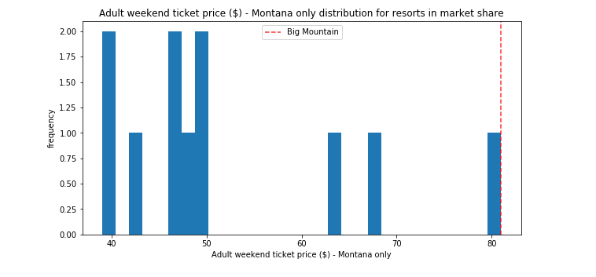Compared to its competitors, it has the highest ticket price in its state Montana.

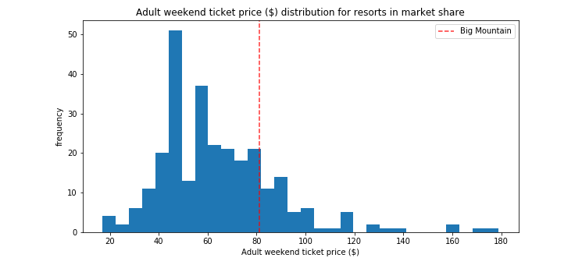

When looking at the Big Mountain resort ticket prices compared to competitors, there is a prediction that our ticket is 94% - a 16% increase from our current ticket price.

Furthermore, it has been observed that people are willing to pay more for certain facilities. For example, increasing the vertical drop, chair lifts, runs and snow making in acres shows a significant increase in the ticket prices for the resort.