SQL

1. Create a view to display number of employees working in each department. Display this view

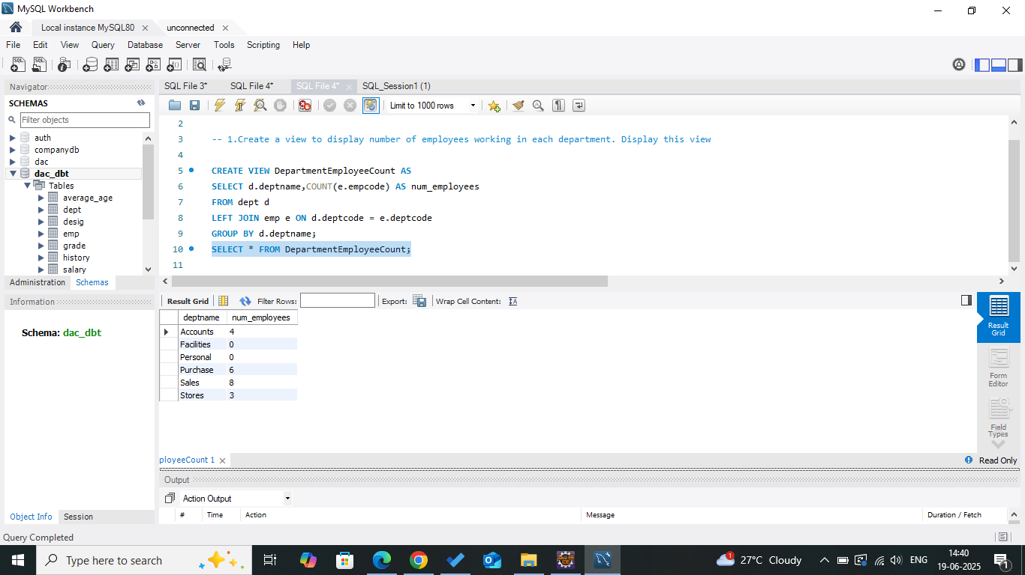

1. List the employee with maximum number of promotions. Also list the number of promotions that he/she got..

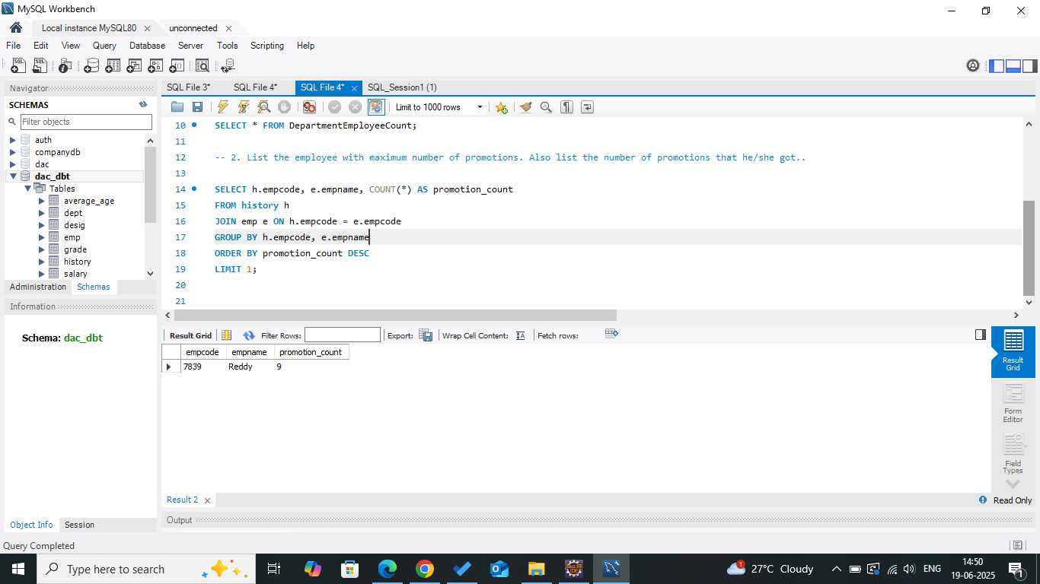

1. List the empcode, average take home pay and department name for those employees who are drawing salary lesser than the average salary of employees working for ‘accounts’ department

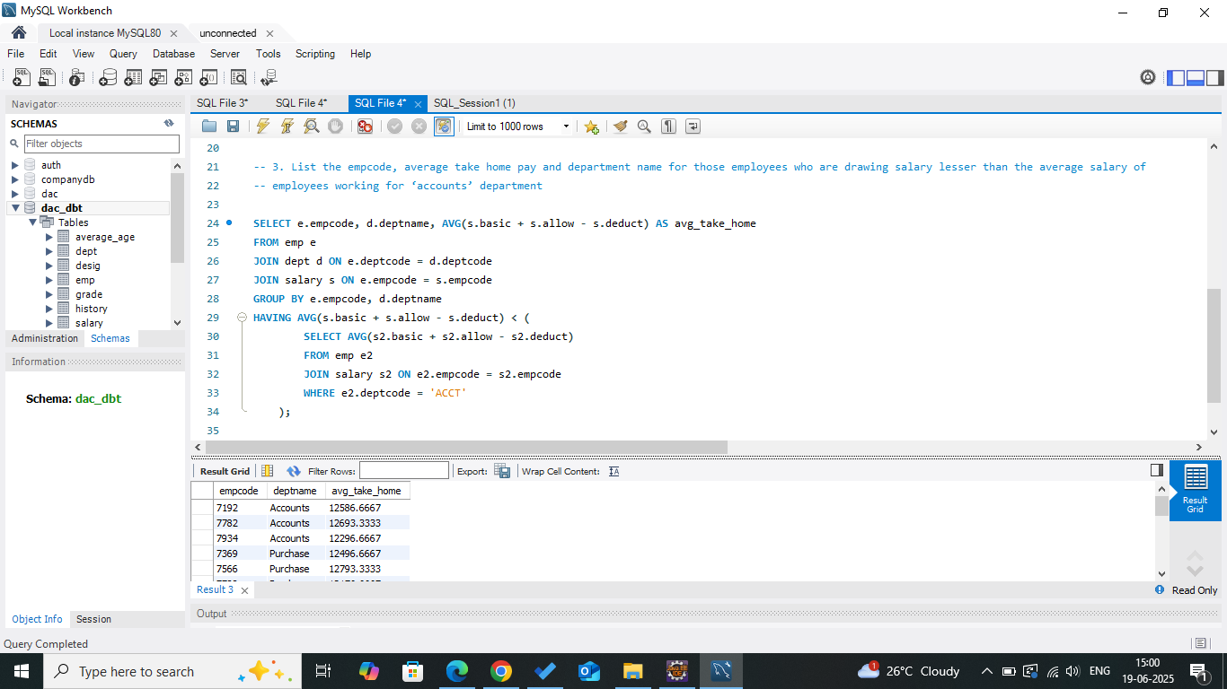

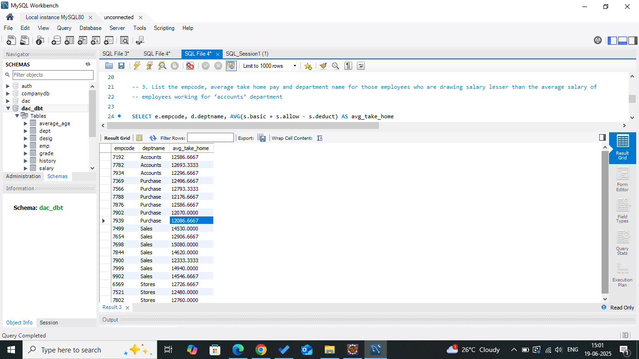

1. List the supervisor code, supervisor name and number of subordinates for those supervisor who have minimum 3 employee working under him.

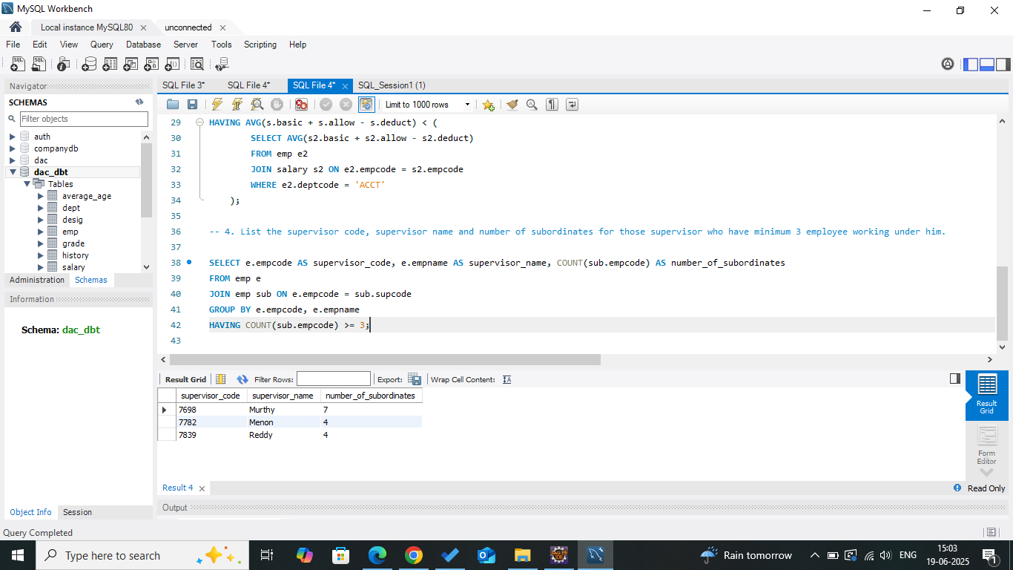

1. Create a procedure to count number of employee born in a particular year. Execute this function by passing an year 1970

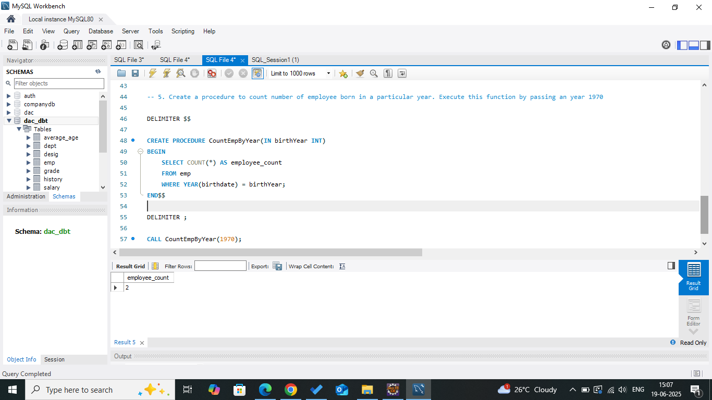

1. Create a procedure to get maximum salary for a particular department. Use a variable grade to set the grade as A if max salary is more than 5000. Execute this procedure

