**DEVOPS LAB**

NAME- Shubhi Dixit

SAP ID- 500094571

BATCH- 05

**Linux Commands-1**

**Set up a virtual machine running Linux and access the terminal within it.**

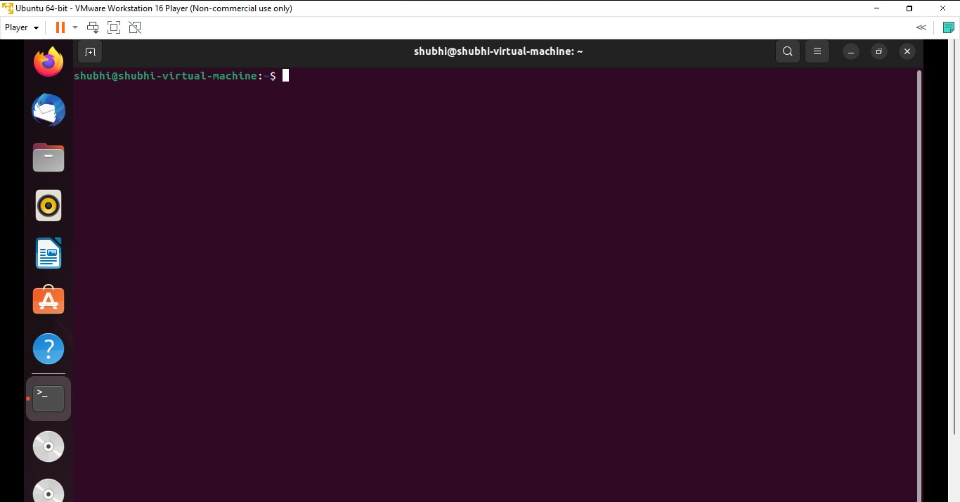

1. **Create directory structure (Directory 1 inside it 2 and 3)**

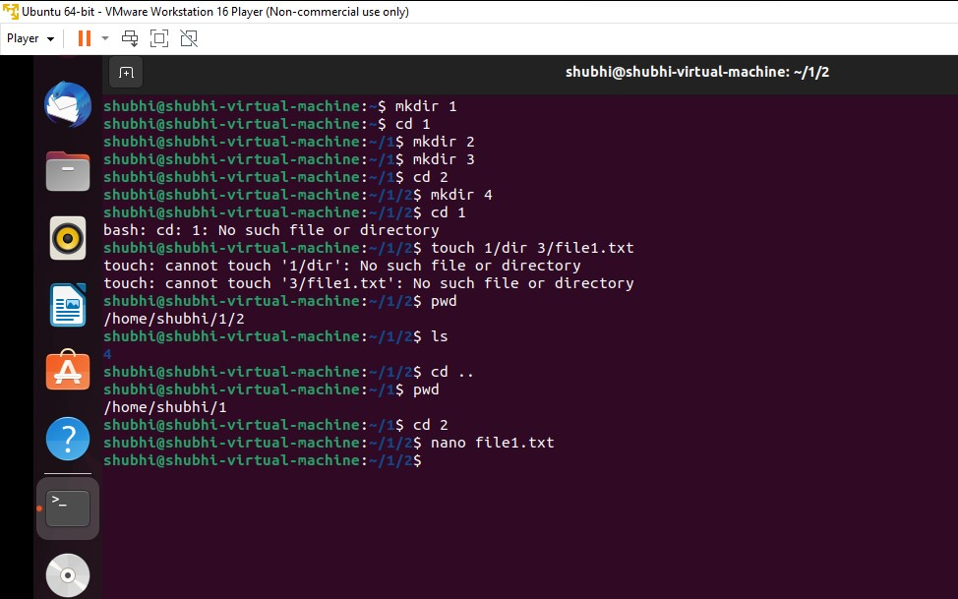

These commands will create:

* A directory named 1.
* Inside 1, two directories named dir2 and dir3.
* Inside dir2, a directory named dir4.

1. 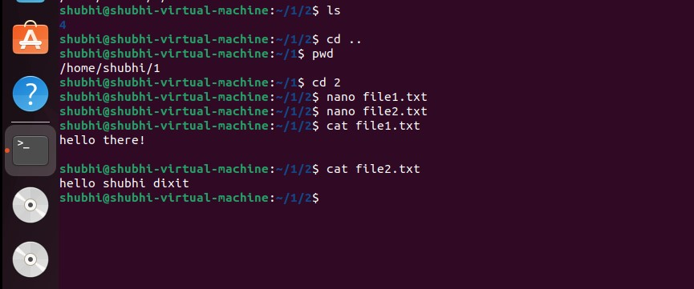**Create 2 files in directory 2 (file1.txt, file2.txt) using touch command and edit the files with nano/gedit**
2. **View the files with cat command**
3. **Copy file1.txt in Directory 4**

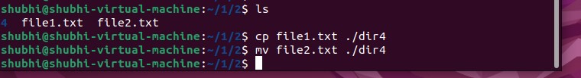

1. **Move file2.txt in Directory 4**



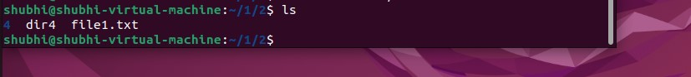

1. **Rename file2.txt to new_file.txt**

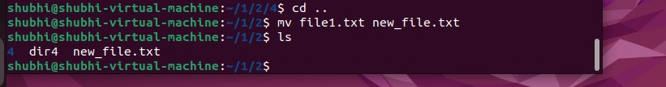

1. 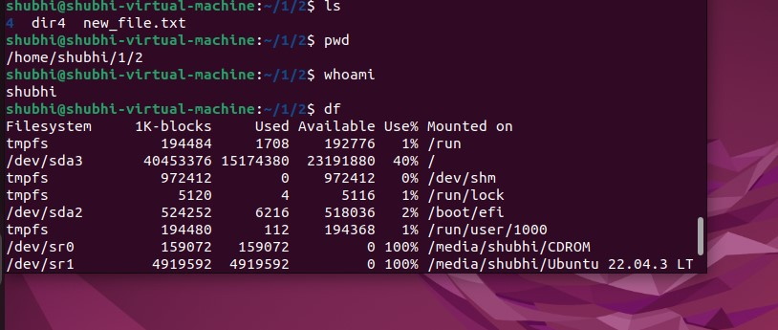**Find Present working directory**
2. **Find username**
3. 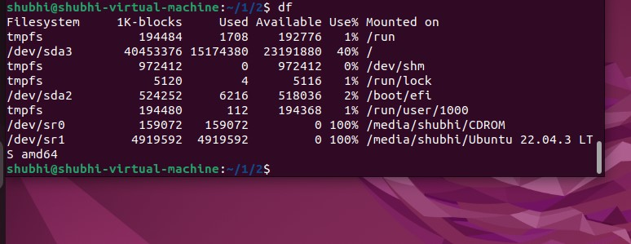**Find out disk space usage**
4. **List the running processes**

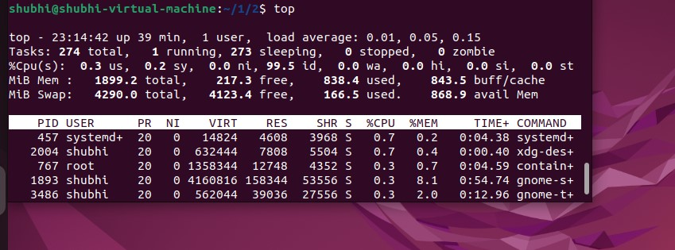

1. **Delete file1.txt from directory 2**

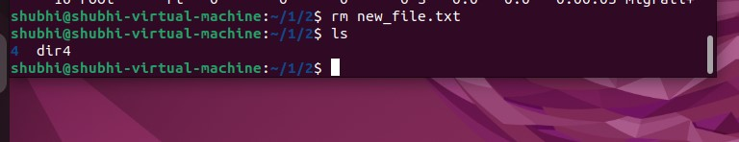

1. **Delete directory 2 and directory 1**

