1. **PROJECT OVERVIEW**

* **Objective:** The objective of this project is to analyze and visualize the dynamics of digital payment transactions, user engagement, and insurance-related data on the PhonePe platform. With the increasing reliance on digital payments, understanding regional variations in transaction behavior, user engagement, and insurance adoption is critical for improving services and effectively targeting users. The project will focus on analyzing aggregated values across various payment categories, creating detailed maps to visualize total transaction values at state and district levels, and identifying the top-performing states, districts, and pin codes. Additionally, the project aims to uncover trends in device usage, assess user behavior, and explore growth potential in the insurance domain to optimize PhonePe's strategies, drive targeted marketing efforts, and enhance user engagement across different regions.
* **Scope:** The scope of this project encompasses the analysis and visualization of PhonePe’s digital payment transactions, user engagement metrics, and insurance-related data across various geographic regions, including states, districts, and pin codes. It involves aggregating transaction values for different payment categories, mapping these values to understand regional performance, and identifying top-performing areas. The project also covers an analysis of device usage trends, registered user behaviors, and app engagement across different device brands and time periods. Additionally, the scope includes evaluating the penetration of insurance services on the platform, identifying regions with the highest adoption, and assessing growth potential for targeted marketing and strategic decision-making. Ultimately, the project aims to provide insights to optimize PhonePe's offerings, user experience, and market positioning.

1. **Data Analysis Methodology**
2. **Data Collection:** The data for this project is sourced from a GitHub repository containing comprehensive PhonePe transaction data, which includes user information, transaction records, and insurance-related data. The first step is to clone the GitHub repository to obtain the raw datasets. After the data is acquired, it is cleaned to remove any inconsistencies, missing values, or outliers to ensure quality and accuracy for analysis. Once cleaned, the data is then loaded into a relational SQL database for further analysis. The datasets are organized into multiple folders, with each folder containing specific types of information. The relevant tables within these datasets are as follows:

**Aggregated Tables:**

* + - **Aggregated_user**: Stores aggregated data related to users.
    - **Aggregated_transaction:** Contains aggregated transaction values for mapping data.
    - **Aggregated_insurance:** Holds aggregated data related to insurance transactions.

**Map Tables:**

* + - **Map_user:** Stores mapping information related to users.
    - **Map_map:** Contains mapping data for total transaction amounts at the state and district levels.
    - **Map_insurance**: Holds mapping information for insurance transactions at various locations.

**Top Tabels:**

* + - **Top_transaction_district:** Stores transaction data at the district level, including transaction count, amount, and type for each state, year, and quarter.
    - **Top_transaction_pincode:** Stores transaction data at the pin code level, including transaction count, amount, and type for each state, year, and quarter.
    - **Top_users_district:** Stores data on registered users at the district level for each state, year, and quarter.
    - **Top_users_pincode:** Stores data on registered users at the pin code level for each state, year, and quarter.
    - **Top_insurance_district:** Stores insurance transaction data at the district level, including count, amount, and type of insurance for each state, year, and quarter.
    - **Top_insurance_pincode:** Stores insurance transaction data at the pin code level, including count, amount, and type of insurance for each state, year, and quarter.

1. **Data Cleaning and Preprocessing:**

The dataset was preprocessed to ensure its quality and suitability for analysis. The following steps were performed:

* + **Handling Missing Values**: In the datasets **Top_Transaction_Pincode** and **Top_Insurance_Pincode**, some rows had null values in the "pincode" column. Specifically, **Top_Transaction_Pincode** contained 2 null values out of a total of 9,281 rows, and **Top_Insurance_Pincode** contained 3 null values out of 5,955 rows. Given the small percentage of missing values (less than 1%), the rows with null values were dropped instead of imputing them, as this would not significantly impact the overall analysis or results. This approach ensures that the integrity of the dataset is maintained while minimizing the influence of missing data.
  + **Data Type Conversion:** During the data cleaning process, the "year" column was initially stored as an object (string) data type. To ensure consistency and facilitate numerical operations, the "year" column was converted to an integer data type. This conversion allows for more efficient handling and analysis of the data, particularly when performing operations based on the year.
  + **Handling Duplicates**: Duplicate rows were checked in the dataset, and it was confirmed that no duplicate rows were found. This ensures that the data is unique and reliable for analysis.

1. **AnalysisTechniques:**

The analysis process started by importing the cleaned data into an SQL database via a Python-MySQL connection. Following the data upload, 12 structured tables were created to organize the data in alignment with the different case studies. SQL queries were then applied to aggregate, filter, and process the data, generating meaningful insights. Once the SQL analysis was complete, the database was integrated with Tableau to create interactive visualizations and dashboards. Tableau facilitated the exploration of trends and key performance metrics, providing a visual representation of the insights derived from the data. This integration of SQL and Tableau ensured an efficient and comprehensive approach to data analysis and visualization.

**3.Individual Use Cases, Visualization Insights and Recommendations:**

**Case Study 1: Decoding Transaction Dynamics on PhonePe**

**Scenario:** PhonePe, a leading digital payments platform, has observed notable variations in transaction behavior across different states, quarters, and payment categories. While some regions and transaction types have shown consistent growth, others have experienced stagnation or decline. To better understand these patterns, the leadership team aims to analyze the transaction data at various levels to identify key trends. By gaining deeper insights into these variations, PhonePe can implement targeted business strategies that foster growth, optimize service delivery, and address underperforming regions or transaction categories.

**USE CASE 1: State Level Transaction Trends**

**Use Case Description :** This analysis aggregates transaction data at the state level, calculating the total number of transactions and the total transaction value for each state. The result is ordered by the total number of transactions in descending order, highlighting the most active states. This helps identify high-performing regions, enabling targeted marketing strategies and resource allocation to drive growth in underperforming states.

**Visualization:**

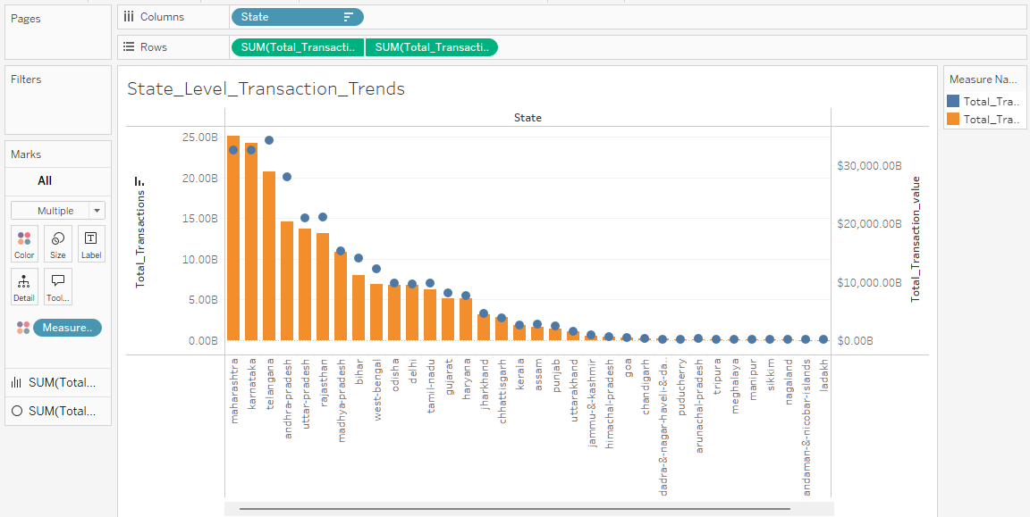

**Insights from the graph:**

1. **Leading States:**
   * **Maharashtra, Karnataka, and Telangana** are the top three states with the highest total transactions, indicating robust user engagement in these areas.
   * **Telangana’s**transaction amount significantly exceeds other states, suggesting it may be a prime market for digital payment services.
2. **Transaction count Trends:**
   * The total transaction count show a similar trend to the number of transactions, with **Maharashtra** leading, followed by Karnataka and Telangana.
   * States like **Odisha, Bihar,** and **West Bengal** show lower transaction counts and values, indicating potential underperformance.
3. **Distribution Pattern:** 
   * There's a long tail effect, where a few states dominate the transaction volume and value, while many states have significantly lower figures.
   * This suggests that a concentrated marketing effort may be more effective in high-performing states

**Recommendations:**

1. **Targeted Marketing Campaigns:** Focus marketing efforts on Maharashtra, Karnataka, and Telangana with promotions and offers to further increase user engagement.
2. **Growth in underperforming states**: Investigate why states like Odisha and West Bengal have low transactions and launch localized campaigns or partnerships to boost adoption.Also, investigate their population and earning levels.
3. **Analyze user behaviour:** Study user demographics and behaviors in successful states to replicate these strategies in underperforming regions.
4. **Enhance Service offerings:** Consider introducing new features or services in regions with slow growth to encourage more digital transactions.
5. **Resource Allocation:** Allocate resources strategically, focusing on expanding in high-performing states while also investing in underperforming ones for growth.

**USE CASE 2: Analyzing discrepancies between transaction counts and amounts by category**

**Use Case Description:** This analysis compares transaction categories based on both transaction counts and monetary contributions. By examining the total number of transactions and the total transaction amount for each category, it highlights discrepancies such as high transaction volume with low revenue or vice versa. These insights help identify which categories may require adjustments in pricing or promotion strategies to optimize revenue.

**Visualization:**

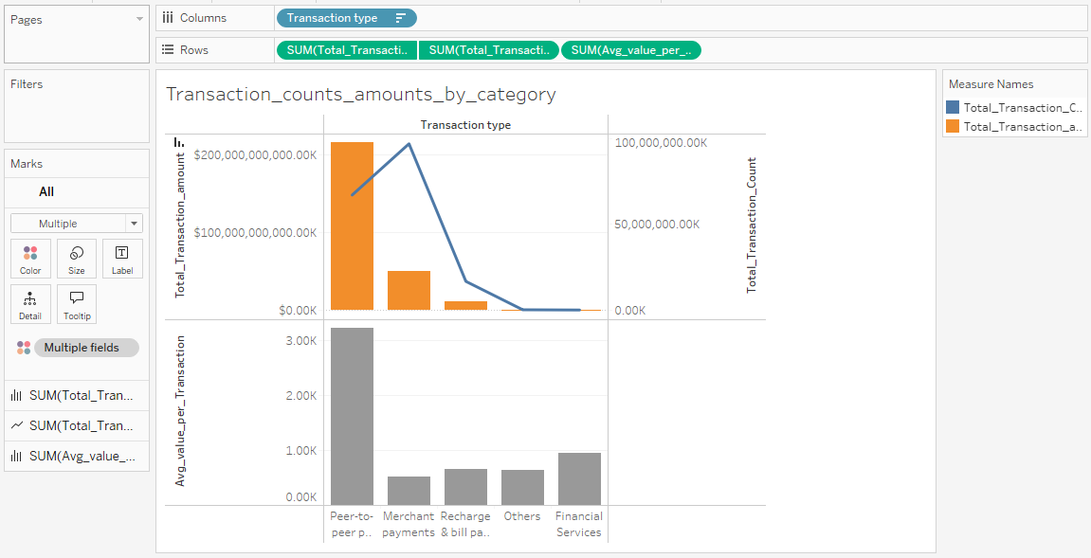

**Insights from the graph:**

**1.High Transaction Volume and Value**:

Categories like **Peer-to-Peer Payments** have a significantly high transaction value but relatively lower transaction count, indicating that while these transactions are frequent, they may not contribute substantially to overall revenue. Similarly, **Merchant Payment** has high transaction count but low transaction value. Thereafter, there is a decline in transaction volume and value for other trandaction types including Recharge and bill payment, financial services and others.

**2.Average Transaction Value:**

Categories like **peer to peer payments** has highest average value per transaction whereas **Merchant Payment** has the lowest average_value_per_transaction. suggesting that these transactions might be smaller in nature, which could impact profitability. Also, there is a decline in the average value for other remaining categories.

**3.Discrepencies:**

The graph indicates clear discrepancies between transaction counts and total amounts. For example, while **Merchant Payments** show a high amount, the transaction value does not reflect a similar level, suggesting a need for a pricing strategy.

**Recommendations:**

**1.** **Optimize Pricing Strategies for Peer-to-Peer Payments:** Since Peer-to-Peer Payments have a high transaction value but a relatively lower transaction count, consider revisiting the pricing or fee structure for this category. Explore strategies like increasing fees for higher transaction values, or introducing premium features for high-value transactions to maximize revenue.

**2. Focus on Increasing Transaction Volume in Merchant Payments:** While Merchant Payments have a high transaction count but low transaction value, there is potential for growth by focusing on increasing the average value per transaction. Consider introducing targeted promotions or discounts to encourage larger transactions, or offer loyalty programs to encourage repeat purchases, increasing both the transaction value and overall revenue.

**3.** **Recharge and Bill Payments:** Reintroduce offers or bundles to stimulate transaction volume and value.

**4.Financial Services:** Streamline processes and explore partnerships to enhance transaction volume and engagement.

**5.Merchant Payment Pricing**: Reevaluate pricing models to boost revenue per transaction, especially for high-frequency transactions.

**6.Targeted Marketing**: Launch campaigns to increase transaction volume in Peer-to-Peer Payments and value in Merchant Payments.

**7. Monitor Trends:** Continuously track performance and adjust strategies based on real-time data.

**USE CASE 3: Identify seasonal or quarterly patterns (Trend Analysis)**

**Use Case Description:** This analysis identifies seasonal or quarterly patterns in transaction behavior by examining spikes in transaction counts and amounts across different quarters. Understanding these trends helps pinpoint periods of high activity, enabling targeted marketing campaigns or operational adjustments during peak seasons, thus optimizing revenue and improving resource allocation.

**Visualization:**

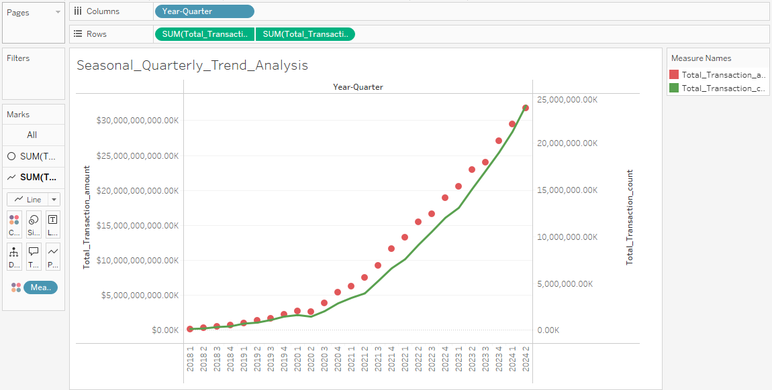

**Insights from the graph:**

**1.Seasonal Peaks:** Q4 (October – December) typically experiences a surge in transactions due to festivals such as Diwali and Christmas, as well as year-end spending. Q1 (January–March) often sees a dip post-holidays but may rise due to factors like tax-filing seasons and New Year promotions.

**2.Transaction Growth:** There is a noticeable increase in both transaction count and amount from 2018 to 2024, indicating overall growth in user engagement and the adoption of digital payments over time.

**Recommendations:**

**1.Capitalize on Q4:** Use promotions and discounts during the holiday season (October–December) to boost transactions.

**2.Encourage Activity in Q1:** Create special offers after the holidays (January–March) to keep users engaged, like tax-related incentives.

**3.Keep the growth going:** Maintain the upward trend by improving the user experience and offering rewards to encourage more transactions.

**USE CASE 4: Regional Performance Analysis**

**Use Case Description**: This analysis identifies states or regions with consistently low transaction volumes and values, helping to pinpoint areas of underperformance. By examining whether these regions struggle across all payment categories or specific ones, businesses can craft targeted strategies to boost engagement and growth. These insights enable businesses to optimize revenue by addressing gaps and implementing localized marketing or partnership initiatives in underperforming regions.

**Visualization:**

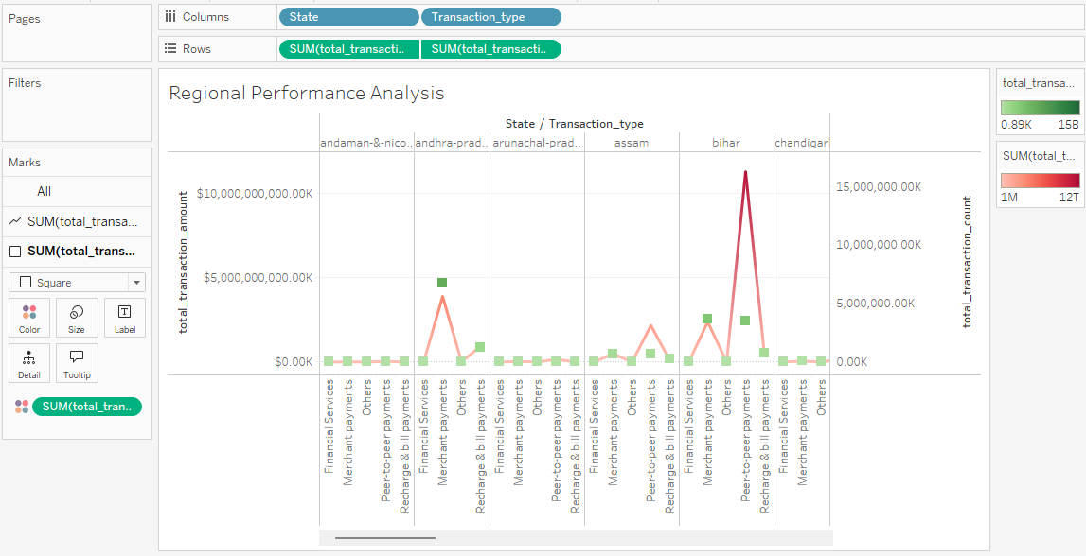

**Insights from the graph:**

1.**Consistently Low Transaction Activity:**  
States such as Andaman & Nicobar Islands, Arunachal Pradesh, Chandigarh, Ladakh, Lakshadweep, Manipur, Meghalaya, Mizoram, Nagaland, Puducherry, Sikkim, and Tripura exhibit very low transaction counts and values, indicating limited adoption of digital payments. These regions may face challenges like poor infrastructure (e.g., internet connectivity), lack of awareness, or low trust in digital payment systems. As a result, they underperform across all payment categories.

2.**Discrepancies Between Volume and Value:**  
States like Bihar, Chhattisgarh, Delhi, Gujarat, Haryana, Jharkhand, Karnataka, Madhya Pradesh, Maharashtra, Odisha, Telangana, and West Bengal show significant discrepancies between transaction counts and values. This suggests that while there is a high number of transactions, the transaction amounts are disproportionately low, which could be due to a large volume of low-value transactions or inefficient pricing strategies in these regions.

**Recommendations:**

1.Improve Internet and Awareness: Help regions with poor internet or low awareness by offering better connectivity and teaching people about digital payments.

2.Use Special Offers: Give discounts or rewards in low-performing areas to encourage more transactions.

3.Partner Locally: Work with local businesses to promote digital payments in specific regions.

4.Review Fees: Change transaction fees in certain regions to encourage people to make higher-value payments.

5.Keep Track and Adjust: Regularly check how things are going and make changes to improve performance.

**CASE STUDY 2: Device Dominance and User Engagement Analysis**

**Use Case 1 : Device Brand Analysis**

**Use Case Description:** PhonePe aims to improve user engagement by analyzing device brand performance, focusing on user registrations and app opens. By identifying top-performing brands and detecting underperforming devices with low engagement rates, PhonePe can develop targeted marketing strategies and optimize app features. This data-driven approach will enable more efficient resource allocation, enhance user experience, and ultimately boost user retention across regions.

**Visualization:**

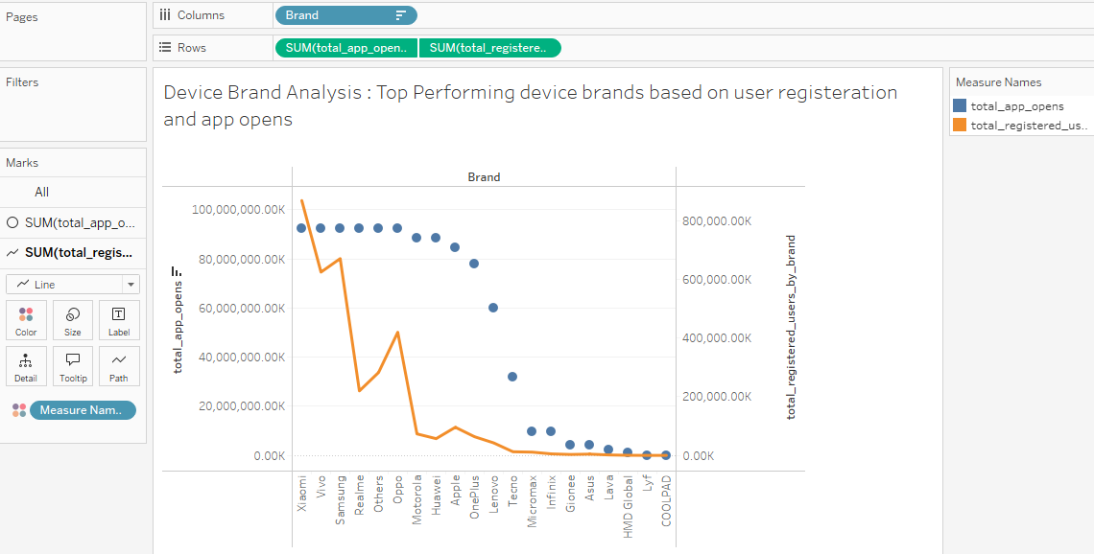

**Insights from the graphs:**

**1.Top Performing Brands**:

* **Xiaomi and Vivo** are the leading brands with a substantial number of total registered users and high app opens.
* **Samsung**  follows closely, indicating strong total_app_opens but moderate amount of registered users.
* **Realme** seems to have less of a presence compared to the top two brands but still registers a notable number of app opens.

**2.Underperforming Brands:** CertainBrands like Coolpad, HMD Global, Lava, Gionee, Infinix, Micromax, and and Lyf show low registrations and app opens, suggesting poor market presence and limited user engagement.

3.Other brands like Motorola, Huawei, apple, oneplus, Lenovo have discrepencies between total app opens and registered users by brand. All these brands have high total_app_opens with low registered users.

**Recommendations:**

1.Top Brands (Xiaomi, Vivo, Samsung):

* Increase marketing efforts to maintain high engagement and expand the user base.

2.Underperforming Brands (Coolpad, Lava, Micromax, etc.):

* Analyze why these brands have low engagement and consider special offers or campaigns to boost activity.

3.Brands with High App Opens but Low Registrations (Motorola, Apple, OnePlus, etc.):

* Focus on converting app opens to registrations through better onboarding or exclusive incentives.

**Comparison of user engagement (app opens) to registration rates for each device brand to detect underperforming or overperforming brands.**

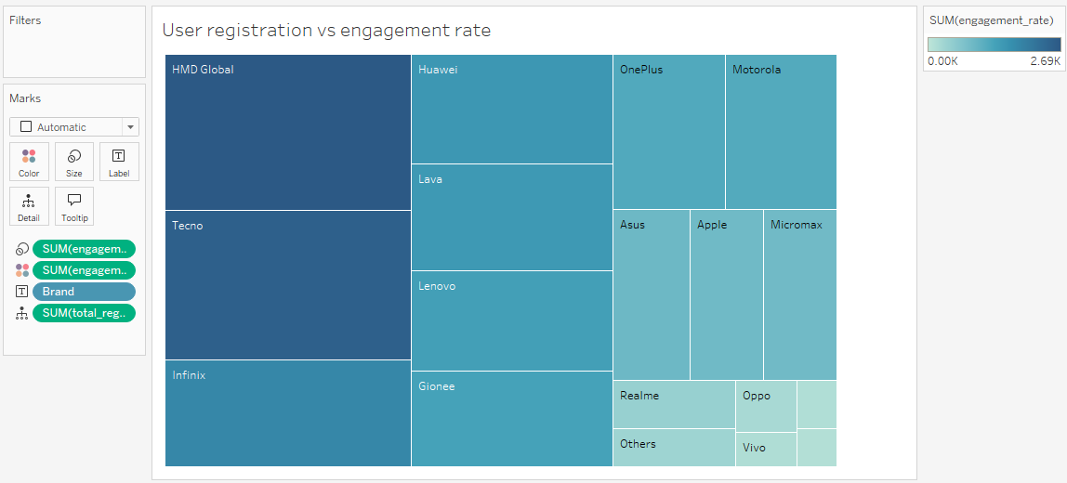

**Insights from the graph:**

**1.High Engagement rate :** From the above graph, the brands represented in dark blue color with large square size like HMD Global, Techno followed by infinix have high engagement rate. As the color and size decreases the engagement rate also decreases, with Samsung and Xiaomi having the lowest engagement rate.

2.Brands like HMD Global, Techno have high engagement rate and low user registration. This indicates a strong interest in the app but suggests possible barriers to completing registrations (e.g., lengthy processes)

3.**Moderate Engagement with registration rate:** Brands like Huawei and OnePlus may be witnessing moderate registration numbers and engagement rates.

4.**Low Performance**: Brands such as Samsung and Xiaomi appear to have balanced registration and engagement rates, suggesting a successful user acquisition strategy combined with effective retention practices.

**Recommendations:**

1. **High Engagement, Low Registration (HMD Global, Techno, Infinix):**
   * Make the registration process easier to get more users to sign up.
   * Offer rewards or incentives to encourage completing registration.
2. **Moderate Engagement (Huawei, OnePlus):**
   * Improve user experience to increase both sign-ups and app usage.
   * Run special promotions to attract more users and boost engagement.
3. **Balanced Performance (Samsung, Xiaomi):**
   * Keep up the good work in acquiring and retaining users.
   * Introduce new features or campaigns to increase engagement while keeping current users happy.

**USE CASE 2: Regional Trends**

**Use Case Description :** This query analyzes the regional variations in device preferences by evaluating the number of registered users and app opens for different brands across states. Understanding which brands dominate in specific regions helps in identifying market trends and targeting regional marketing strategies, ultimately leading to improved product positioning and increased regional sales.

**Visualization:**

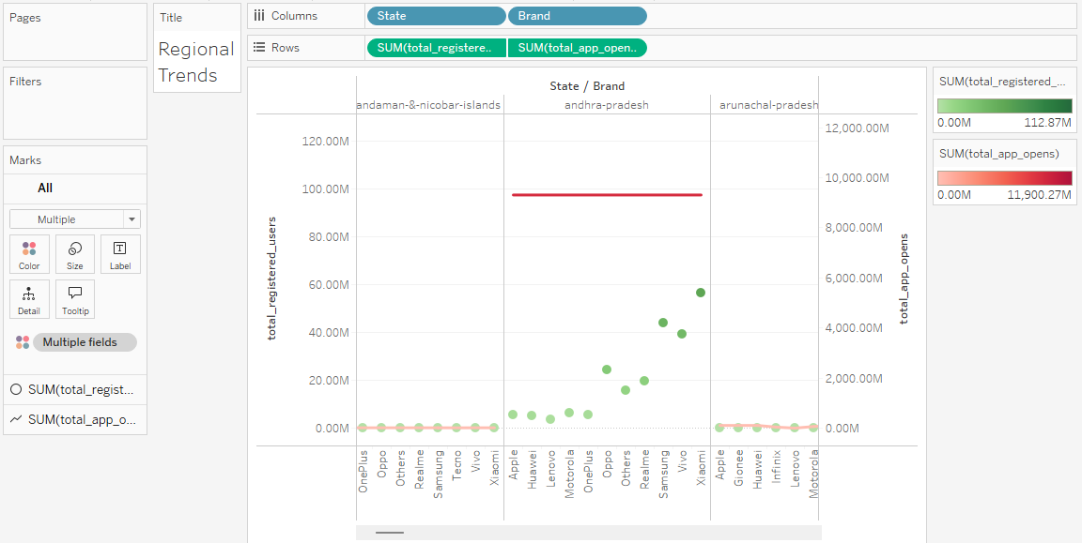

**Insights from the graph**

**1.Low Engagement in Smaller States:** States like Andaman & Nicobar Islands, Arunachal Pradesh, Goa, Himachal Pradesh, and several others show low user registrations and app opens across all brands, with no clear dominant brand.

**2.Xiaomi Leading in Andhra Pradesh:** In Andhra Pradesh, Xiaomi stands out with high user registrations and app opens, while all brands have high app opens.

**3.Xiaomi Dominates in Multiple States:** Brands like Xiaomi lead in states such as Assam, Bihar, Haryana, Kerala, Madhya Pradesh, Punjab, Rajasthan, Tamil Nadu, and others, both in user registrations and app opens. Vivo also performs well in Chhattisgarh and Gujarat.

**4.High Engagement in Karnataka:** All brands show high app opens in Karnataka, with Xiaomi leading in both user registrations and app opens.

**5.Maharashtra’s Highest Engagement:** Maharashtra shows the highest app opens across all brands, with Xiaomi leading in both registrations and app opens.

**Recommendations:**

**1.For Low-Engagement States (Andaman & Nicobar, Arunachal Pradesh, etc.):**

* Focus on targeted marketing efforts to increase brand presence and awareness. Consider localized campaigns or promotional offers to drive registrations and engagement.

**2.For States with Xiaomi as the Leader (Andhra Pradesh, Assam, Bihar, etc.):**

* Continue supporting Xiaomi's strong performance with exclusive offers or loyalty programs. Expand marketing efforts to further consolidate Xiaomi's leadership.

**3.For States with Multiple Strong Brands (Karnataka, Maharashtra):**

* Leverage high app engagement by offering cross-brand campaigns or incentives to encourage users from various brands to stay engaged and increase overall retention.

**4.For States with Strong Regional Performers (Chhattisgarh, Gujarat):**

* Focus on growing Vivo’s and Xiaomi's market share in these regions by refining user acquisition strategies and enhancing brand-specific offers.

**USE CASE 3: Market Potential**

**Use Case Description:** Identifying Market Potential for Low Penetration Brands

This analysis identifies device brands with low market penetration but high engagement rates, highlighting opportunities for growth. By focusing on these brands, PhonePe can implement targeted strategies to increase user registrations, capitalize on existing engagement, and expand their market presence where there is untapped potential.

**Visualization**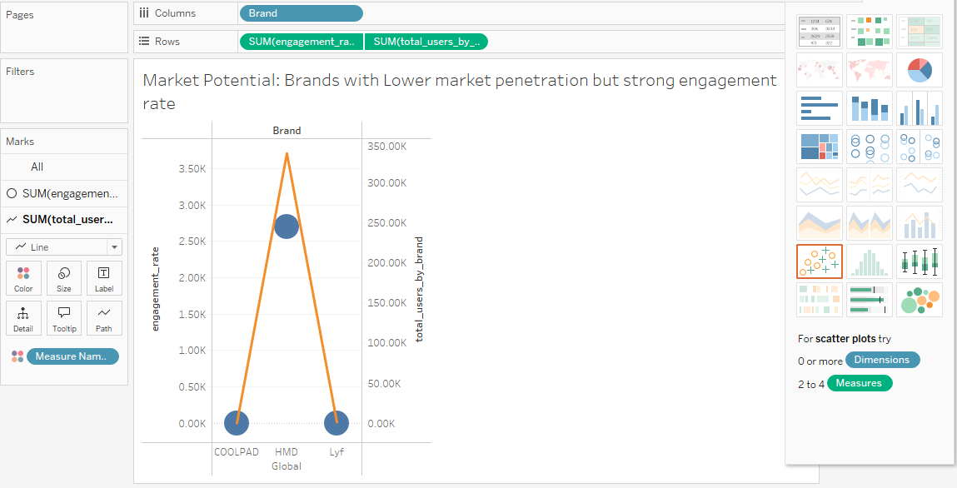

**Insights from the graph:**

HMD GLOBAL is the brand with lower market penetration and strong engagement rate .

**Recommendations:**

1.**Boost Brand Awareness**: Run targeted ads or campaigns to make more people aware of the brand.

2.**Improve User Acquisition**: Offer promotions or incentives to attract new users and increase registrations.

3.**Enhance Retention**: Use rewards or loyalty programs to keep users engaged and coming back.

4.**Partner with Influencers**: Collaborate with local influencers to reach new audiences.

5. **Highlight Strengths**: Focus on what makes HMD Global unique to attract more users.

**USE CASE 4: User Loyalty**

**Use Case Description:** The goal of this analysis is to understand the impact of unrecognized devices (categorized as "Others") on user engagement. By comparing the engagement rate of users on unrecognized devices to users on recognized devices, we can assess if "Others" users are more or less engaged. This will provide insights into whether these users show strong or weak app interaction, helping to determine if focusing on these devices could improve user loyalty and retention.

**Visualization**

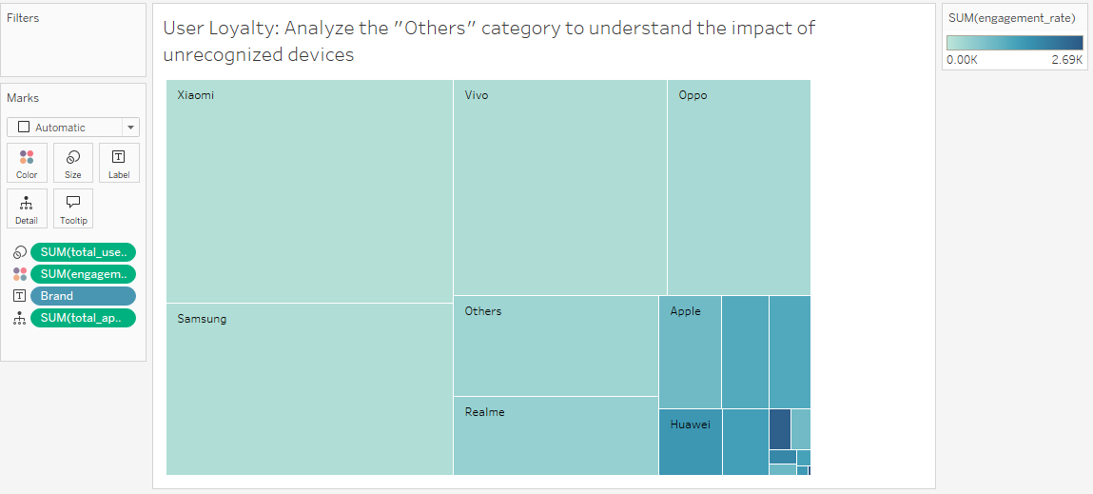

**Insights from the graph**

**1.Engagement Rate Comparison**:

* Users on **recognized devices** (e.g., Vivo, Xiaomi, Samsung) generally have a **lower engagement rate** compared to the "Others" category.
* The **"Others" category** shows **moderate engagement**, with **HMD Global** leading with the highest engagement rate.
* This suggests that while **unrecognized devices** have moderate engagement overall, certain brands, like **HMD Global**, exhibit significantly higher levels of user interaction than recognized brands.

**2.Total Users**:

* The **"Others" category** has **fewer total users** than popular brands like Xiaomi, Vivo, Oppo, and Samsung. However, it has **more users** than smaller brands like **Apple**, **Realme**, and **Huawei**.
* This highlights the **substantial presence** of unrecognized devices in the market, showing that although they may have lower user numbers compared to top brands, they still represent a notable portion of the user base.

**CASE STUDY 3: Insurance Penetration and growth potential analysis**

**USE CASE 1: Insurance Penetration by State**

**Use case Description:** The goal of this analysis is to identify the states with the highest and lowest insurance penetration. By evaluating the distribution of insurance coverage across different states, we can prioritize regions that need targeted marketing and customer outreach initiatives. This will help improve insurance adoption, drive sales, and ensure resources are allocated effectively to areas with the greatest potential for growth.

**Visualization:**

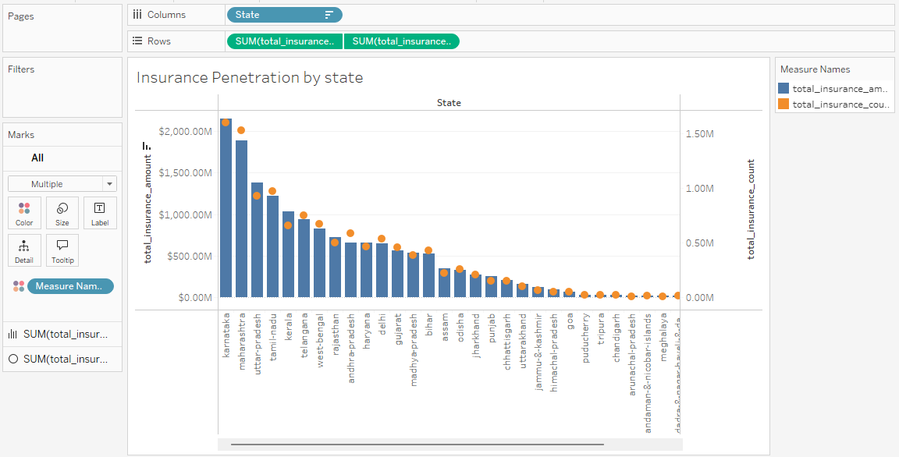

**Insights from the graph:**

1.States with Highest Insurance Penetration

* Karnataka and Maharashtra exhibit the highest insurance amounts and count, suggesting these states have strong insurance markets.
* Uttar Pradesh and Tamil Nadu also show significant insurance penetration, pointing to robust demand in these regions.

2.States with Lower Insurance Penetration

* Many states towards the right show decreasing insurance amounts, indicating lower market penetration.
* States like **Puducherry, Tripura, chandigarh,Arunachal Pradesh, meghalya, Sikkim, Nagaland, laddakh, Manipur, Mizoram, lakshadweep**  have the least insurance presence, highlighting potential growth areas for marketing initiatives.

3.Comparison of insurance count and amount

* In the above graph there is not much significant gap between the count and amount.

**Recommendations:**

**1.** **Focus on High Penetration States**:

* **Karnataka, Maharashtra, Uttar Pradesh, and Tamil Nadu** have strong insurance markets. Focus on reinforcing customer loyalty and expanding product offerings in these regions to maintain and grow market share.

**2.Target Low Penetration Areas**:

* States like **Puducherry, Tripura, Arunachal Pradesh, and Nagaland** show low insurance penetration. These areas should be prioritized for marketing and awareness campaigns to educate and encourage adoption of insurance products.

**3.Localized Marketing Strategies**:

* Design targeted outreach programs tailored to each state's unique needs. For example, offer region-specific insurance plans or awareness campaigns in states like **Sikkim**, **Meghalaya**, and **Manipur**, where market penetration is still low.

**4.Increase Awareness and Accessibility**:

* In regions with low penetration, focus on improving accessibility to insurance products, providing easy-to-understand information, and offering incentives to attract first-time buyers. Consider using local influencers or community events to boost trust and engagement.

**USE CASE 2: Inusrance adoption by year and quarter**

**Use Case Description:** The goal of this analysis is to track trends in insurance adoption over time by focusing on yearly and quarterly data. By simplifying the query and removing the need to differentiate by insurance type, we can effectively monitor changes in adoption rates. This will allow businesses to identify patterns, assess seasonal variations, and make data-driven decisions to optimize marketing and sales strategies, ensuring they capitalize on peak periods for growth.

**Visualization:**

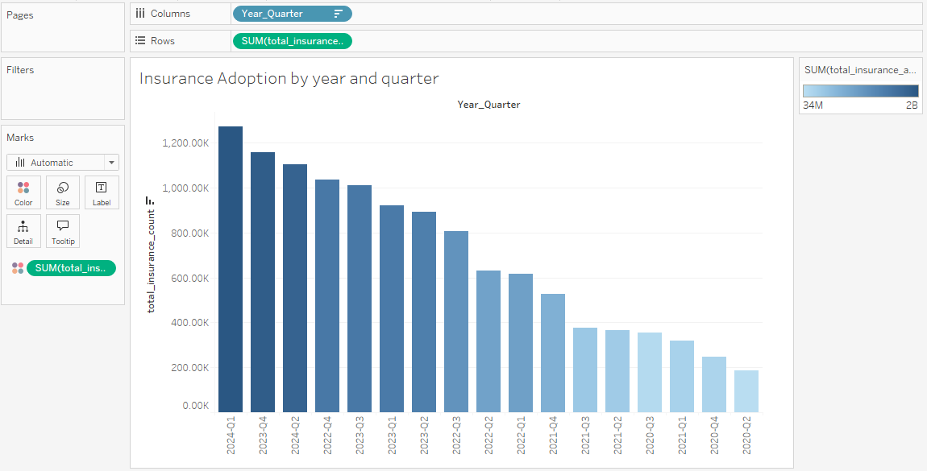

**Insights from the graph:**

1.Overall Trend:

* + The graph shows a general decline in total insurance counts from Q1 2024 through Q4 2020.
  + Insurance adoption peaked in late 2023, suggesting a strong demand or effective marketing strategies during that period.

2.Quarterly Fluctuations:

* + There are visible fluctuations on a quarterly basis, particularly in 2023 and 2024, where counts seem to be more stable compared to earlier years.
  + Notably, Q4 of 2023 and 2024 shows the highest adoption, indicating potential seasonal effects.

**Recommendations:**

**1.Boost Marketing in Peak Periods**: Since **Q4 of 2023 and 2024** show high adoption, run special promotions or campaigns during these months to take advantage of the demand.

**2.Address the Decline**: The drop in adoption after 2023 suggests a slowdown. Investigate the cause and focus on re-engaging customers with new offers or campaigns.

**3.Stabilize Adoption**: To avoid big ups and downs, keep the adoption rate steady throughout the year by offering ongoing promotions or loyalty programs.

**4.Seasonal Offers**: Since Q4 is strong, create seasonal offers that align with customers' needs during this period to further increase adoption.

**USE CASE 3: State-Wise Comparison of Insurance Adoption (By Quarter and Year)**

**Use Case Description:** The goal of this analysis is to compare insurance adoption (both count and amount) across different states within the same quarter and year. By identifying regional variations and outliers, we can pinpoint underperforming areas and develop targeted marketing or outreach strategies. This will help PhonePe focus efforts on improving insurance adoption in states where it's lagging, ultimately driving growth in those regions.

**Visualization:**

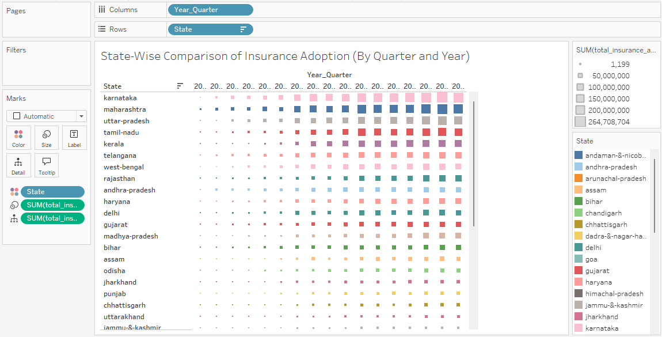

**Insights from the graph:**

1.**Overall Trends**

* The graph shows a clear increase in insurance adoption from **Q2 2020 to Q2 2024** across all states. The tree map effectively visualizes this growth, where larger squares represent higher insurance amounts, clearly indicating the states with the highest adoption.

2. **Key States Observed**

* **Karnataka, Maharashtra, Uttar Pradesh, Tamil Nadu,** and **Kerala** are highlighted as the top states with the highest insurance amounts in **Q1 2024**. This is reflected in the tree map, where the larger squares correspond to these states' higher insurance adoption.

3.**General Observations**

* A noticeable **decrease** in insurance adoption is seen for states ranked below the top five, as represented by smaller squares in the tree map, indicating a decline in both insurance amount and count.

4.**Insurance Count**

* Similar to the amount, the **insurance count** for the top five states in **Q1 2024** is significantly higher. There is a clear **decline** in transaction counts for other states, suggesting lower adoption rates outside the top performers.

5.**States with Lowest Adoption**

* **Nagaland, Ladakh, Mizoram, Manipur, Lakshadweep,** and similar states have the **lowest insurance adoption** both in terms of count and amount, with noticeably smaller squares on the tree map indicating limited market penetration.

**Recommendations:**

**1.Strengthen Efforts in Top States:**  
Keep focusing on high-adoption states like Karnataka, Maharashtra, and Tamil Nadu with more promotions and customer loyalty programs.

**2.Target Low-Adoption States:**Launch special campaigns in states like Nagaland, Ladakh, and Manipur to raise awareness and encourage people to buy insurance.

**3.Use Seasonal Offers:**Take advantage of high-demand periods, especially in Q1, with seasonal deals in the top states to boost adoption.

**4.Offer Incentives in Underperforming States:**  
Provide discounts or free trials in low-adoption areas to encourage first-time insurance buyers.

**5.Understand Local Barriers:**  
Look into why adoption is low in some states and address any challenges, like lack of awareness or trust in insurance, with targeted education.

**6.Track and Adjust Regularly:**Keep monitoring the trends and adjust marketing strategies to continuously improve insurance adoption across different states.

**USE CASE 4: Insurance Adoption by Season**

**Use Case Description:** This analysis aims to examine insurance adoption across different seasons (Winter, Spring, Summer, and Fall) to identify any seasonal trends in insurance purchases. By grouping data based on quarters, we can understand how adoption rates vary by season and across states. This will help PhonePe tailor marketing strategies to capitalize on high-adoption periods and address any slow seasons to boost overall insurance uptake.

**Visualization:**

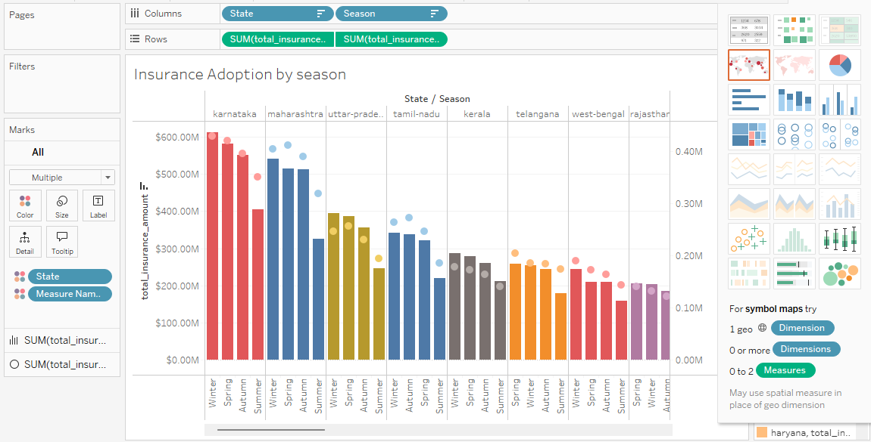

**Insights from the graph:**

**1.States with High Adoption Rates**  
States like **Karnataka, Maharashtra, Uttar Pradesh, Tamil Nadu, Kerala, West Bengal, Madhya Pradesh, Assam, Jharkhand, Chhattisgarh,** and **Uttarakhand** show the highest adoption rates, indicating a strong preference for insurance during the **colder months**. The total insurance counts are notably higher during these months compared to other seasons.

**2.Seasonal Trends in Key States**  
Among the states listed, **Maharashtra, Uttar Pradesh,** and **Tamil Nadu** see the highest insurance adoption during the **Spring season**, while other states show the highest adoption in **Winter**.

**3.Low Adoption in Other States**  
States like **Puducherry, Tripura,** and others in the lower ranks have nearly **equal and extremely low insurance counts** across all four seasons, indicating minimal insurance adoption year-round.

**Recommendations:**

1.Boost Marketing in Winter and Spring  
Focus on states like Karnataka, Maharashtra, Tamil Nadu, and Kerala during Winter and Spring, as these seasons have higher insurance adoption. Offer special discounts or promotions to attract more customers.

2.Target Spring for Certain States  
Since Maharashtra, Uttar Pradesh, and Tamil Nadu see high adoption in Spring, create specific campaigns with offers for these states during that season to increase sign-ups.

3.Improve Awareness in Low-Adoption States  
For states like Puducherry and Tripura, where adoption is low, run awareness campaigns to educate people about the benefits of insurance. Offer simple, easy-to-understand insurance plans to encourage adoption.

4.Plan Campaigns Based on Seasons  
Use seasonal data to run campaigns at the right time. For example, promote Winter deals in cold months and Spring offers when adoption is higher in certain states.

5.Keep Tracking and Adjusting Campaigns  
Regularly check how campaigns are doing across different seasons. Adjust the strategy as needed to make sure you’re reaching customers at the right time and in the right way.

**CASE STUDY 4: User Engagement and growth strategy**

**USE CASE 1: App Open Frequency by State and Quarter (Active vs Passive Users)**

**Use case Description:** This analysis focuses on distinguishing active users from passive users based on their app open frequency across different quarters. By categorizing users into active (those opening the app more than 5 times) and passive (those opening the app 5 or fewer times), PhonePe can evaluate engagement trends over time. This insight will help optimize marketing strategies, target passive users for re-engagement, and enhance overall app usage.

**Visualization:**

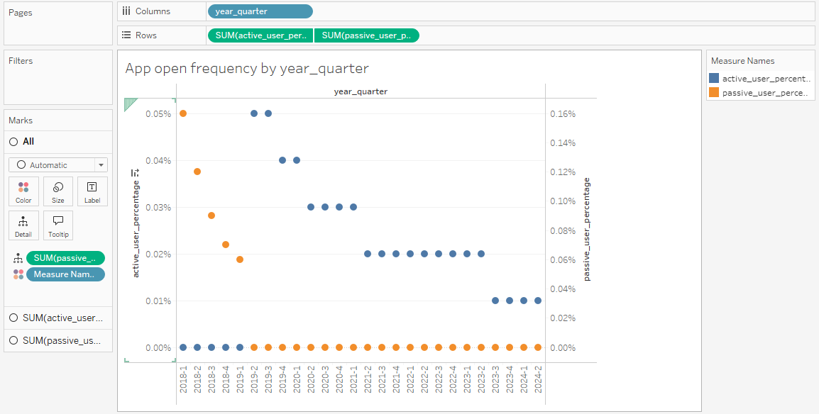

**Insights from the graph:**

1.**Trends Over Time:**

* The chart illustrates trends in active and passive user percentages across quarters from 2018 to 2024.
* Early years show a higher percentage of passive users, but over time, the trend shifts with increasing active users, particularly in the earlier quarters.

2. **Key Observations:**

* From **2019-Q2**, the percentage of passive users drops to zero, and active user percentage peaks in **Q2** and **Q3 of 2019**.
* However, from **2019-Q4** and **2020-Q1**, there is a noticeable decline in active user percentage, followed by a steady decrease over the following years.

**Recommendations:**

1.Boost Active User Engagement:

* Since active user engagement peaked in 2019-Q2 and Q3, it would be beneficial to analyze what strategies or features were successful during that time. PhonePe should explore replicating or enhancing those strategies to reignite similar engagement levels.

2.Re-engage Passive Users:

* With a significant decline in active user engagement since 2020, focusing on re-engaging passive users could help. Targeted campaigns or personalized offers could be introduced to convert passive users into active ones.

3.Seasonal Campaigns:

* Given the fluctuations in active user percentages, PhonePe could plan seasonal campaigns around the periods with historically higher engagement (e.g., Q2 and Q3 of 2019) to capitalize on natural peaks in usage.

4.Feature Enhancements and User Retention:

* Investigate reasons behind the decline from 2019-Q4 onwards and focus on improving user experience, possibly through new features or optimizations. Monitoring user feedback can help address issues before they lead to further disengagement.

**USE CASE 2: Quarterly Growth in Registered Users**

**Use Case Description:** This query helps analyze the quarterly growth in registered users by calculating the total registered users for each quarter and comparing it with the previous quarter's registered users. By tracking the change in registered users, PhonePe can identify trends, forecast future growth, and plan targeted marketing strategies based on periods of significant growth or decline. This information is crucial for optimizing resource allocation and improving user acquisition strategies.

**Visualization:**

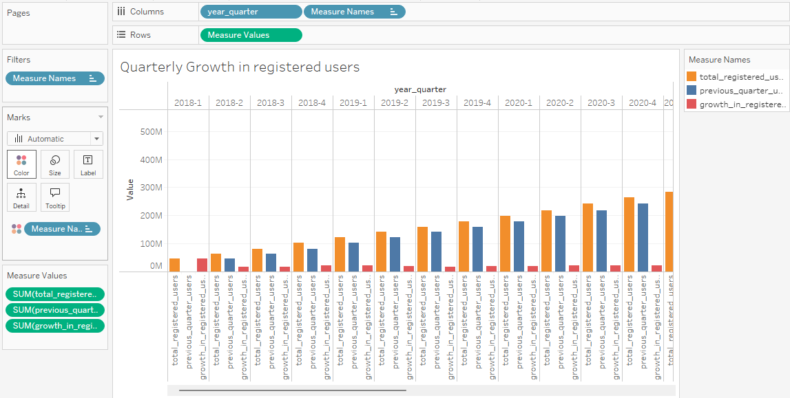

**Insights from the graph:**

The graph shows that the highest growth in registered users occurred in 2018 Q1 which is approximately 46,877.65K, followed by stagnation or a slight decline starting from 2018 Q2 which is around 16770.36K . From that point onward, the growth in registered users remains relatively stable across all subsequent years and quarters. However, there is a noticeable overall increase in both the total number of registered users and the comparison with previous quarter’s users, indicating consistent but moderate growth over time.

**Recommendations:**

1.**Focus on Low Growth Quarters:** Since growth slowed after 2018 Q2, try to increase marketing efforts in the quarters with lower growth to boost user numbers.

2.**Repeat Successful Strategies:** 2018 Q1 saw high growth. Find out what worked well during that time (like promotions or new features) and try to use those same strategies in the future.

3.**Improve User Retention:** Make sure users stay active and engaged. Retaining users will help keep growth steady over time.

4.**Check Progress Regularly:** Keep an eye on growth every quarter and adjust strategies if needed to make sure growth continues.

**USE CASE 3: User Engagement by State and Quarter**

**Use Case Description:** The objective of this query is to analyze user engagement across different states over time by examining app opens relative to the number of registered users. This helps in identifying how users in various states are interacting with the app each quarter. By calculating the engagement rate, we can uncover growth trends and spot regions with high or low engagement, which can guide targeted marketing efforts and product improvement strategies. The query organizes the data by state, year, and quarter to track changes in engagement over time.

**Visualization:**

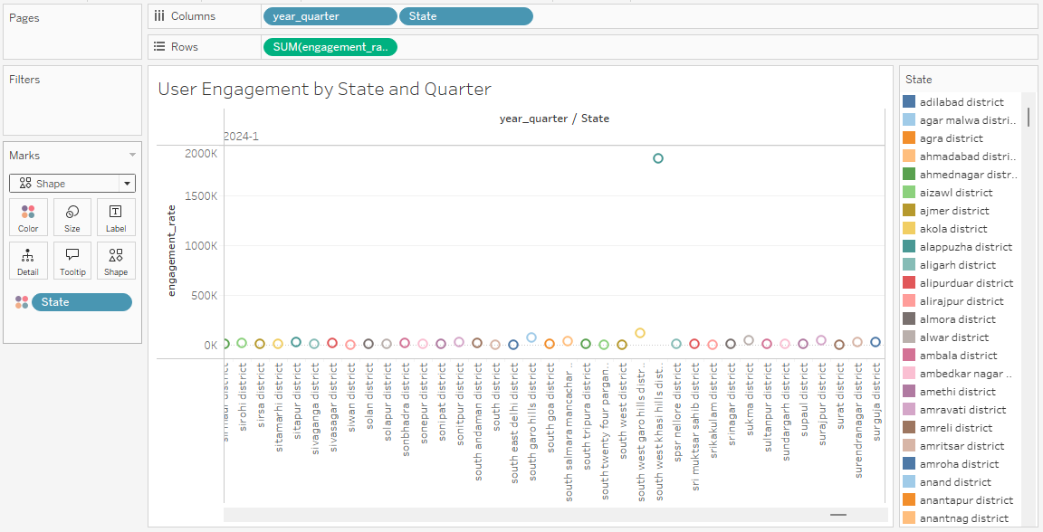

**Insights from the graph:**

1.User Engagement Overview

* The graph displays user engagement rates across various states (or districts) for different years, and4 quarters

2. Engagement Trends

* High Engagement: South west khasi hills district has significantly higher engagement rates, reaching over 2000K. This suggests that specific districts may have implemented successful engagement strategies or have a larger user base.
* Low Engagement: Most states/districts appear to have low engagement rates, clustering near the baseline. The majority of the states show minimal user engagement compared to the outlier.

**Recommendations:**

1.**Learn from High Engagement Areas:**

* Look at places like South West Khasi Hills where engagement is high. See what’s working there, and try to use similar strategies in other areas to boost engagement.

2.**Improve Low Engagement Areas:**

* For places with low engagement, figure out why people aren’t using the app much (e.g., poor internet or lack of interest). Fixing these issues could help people use the app more.

3.**Run Marketing Campaigns:**

* Plan marketing campaigns in areas with low engagement to get more users to try the app. Offering special deals or promotions might help.

4.**Create Localized Content:**

* Make content that is relevant to specific regions to attract more users. Showing them things they care about can increase engagement.

5.**Ask Users for Feedback:**

* Ask users in low engagement areas what they like or don’t like about the app. This feedback can help improve the app and keep users coming back.

**CASE STUDY 5: Insurance Transactions Analysis**

**USE CASE 1: Identifying Top States**

**Use case Description**: The analysis identifies the top 10 states based on the total number of insurance transactions and their corresponding transaction values for the most recent year and quarter. By focusing on these metrics, it highlights states with the highest transaction volumes, helping to pinpoint regions performing well in terms of insurance activity. The data is filtered to only include the latest year and quarter, ensuring that the insights reflect current trends, which can aid in making informed decisions and planning targeted marketing or business strategies.

**Visualization:**

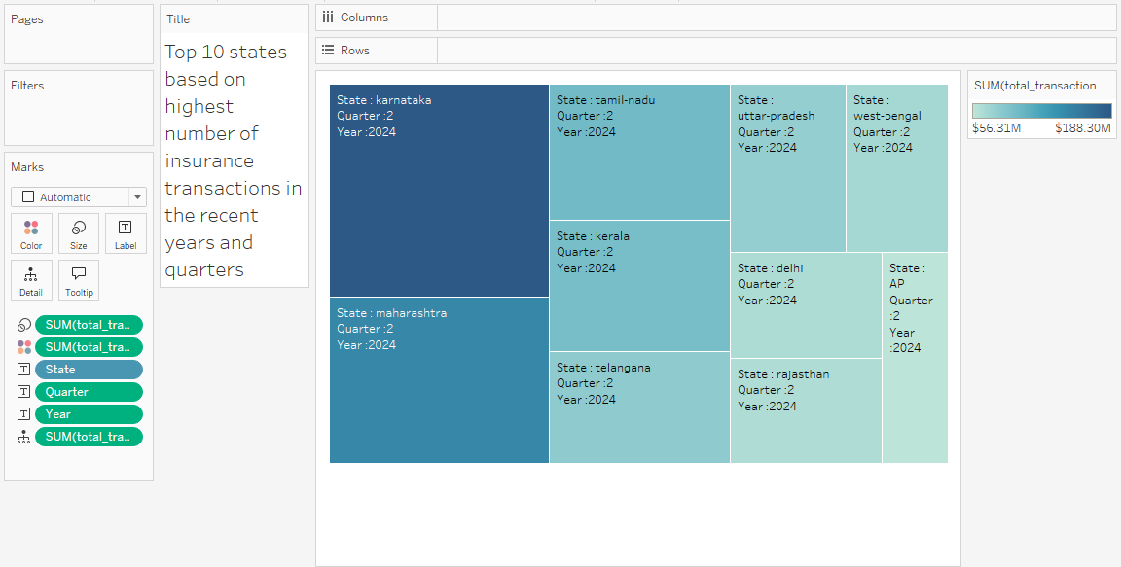

**Insights from the graph:**

1. The graph shows the top 10 states based on the highest number of insurance transactions for Quarter 2 of 2024.
2. Each state is visually represented by varying shades, with darker shades indicating higher total transaction amounts.
3. Karnataka and Maharashtra stand out with the highest transaction amounts and counts, suggesting significant insurance activity.
4. There is a noticeable decrease in transaction activity among the remaining states, with Andhra Pradesh indicating the lowest levels.

**Recommendations:**

1.Focus on Karnataka and Maharashtra: These states show high insurance activity. Target them with more tailored marketing campaigns to capitalize on their strong performance.

2.Increase Engagement in Lower Performing States: Work on boosting insurance adoption in states with lower transaction counts, like Andhra Pradesh, through awareness campaigns or localized promotions.

3.Monitor Transaction Trends: Keep an eye on the other states with moderate performance and assess strategies to maintain or improve their growth in future quarters.

**USE CASE 2: Percentage share of each state and district in the overall insurance transactions**

**Use Case Description:** This analysis helps determine the contribution of each state and district to the overall insurance transactions in terms of both count and amount. By calculating the total insurance count and amount for each district and comparing them to the overall totals, we can identify the percentage share of each district in the broader market. This insight allows businesses to focus on high-performing areas and target underperforming regions for growth. The result helps in strategic decision-making for marketing and resource allocation.

**Visualization:**

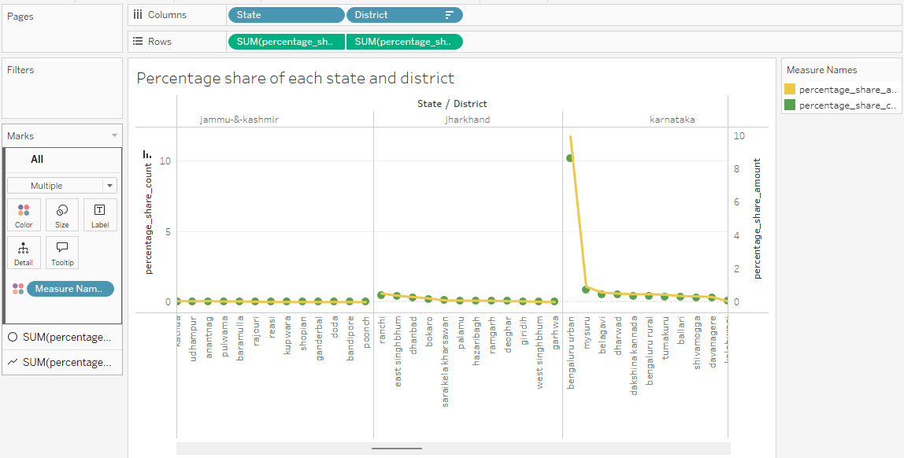

**Insights from the graph:**

1.**State and District Contribution:**  
The analysis highlights the contribution of each state and district to the overall insurance transactions, providing a clear picture of market penetration. States and districts with higher contributions are identified, enabling targeted efforts for growth.

2.**Top Contributor - Karnataka:**  
Karnataka stands out as a major contributor, with a notably high concentration of both insurance count and transaction amounts, particularly in urban areas like Bengaluru. This suggests a well-established insurance market in this state.

3.**Underperforming Regions:**  
Several states, including Andaman & Nicobar Islands, Andhra Pradesh, Arunachal Pradesh, Chhattisgarh, Delhi, Goa, Himachal Pradesh, Ladakh, Lakshadweep, Manipur, Meghalaya, Mizoram, Nagaland, Odisha, Puducherry, Punjab, Sikkim, Tripura, Uttarakhand, Jammu & Kashmir, and Jharkhand, show minimal contributions to the overall transactions. These regions represent untapped potential for growth and could benefit from targeted marketing and awareness efforts.

4.**District-Level Insights - Bihar:**  
Within Bihar, Patna stands out as the top district, with the highest percentage of both insurance count and transaction amount compared to other districts in the state. This indicates that Patna plays a central role in driving insurance adoption in the region.

5.**District-Level Insights - Maharashtra:**  
Similarly, in Maharashtra, the districts of Pune and Thane have the highest contribution in terms of both insurance count and transaction amounts. These districts are key drivers of insurance activity in the state.

6.**Low Contribution in Other States:**  
For other states, the percentage of insurance transactions (both count and amount) is comparatively low. This highlights the need for increased engagement and promotional strategies in these regions to boost market penetration.

**Recommendations:**

1.**Focus on High-Performing Areas:** Continue strengthening the insurance market in Karnataka, particularly in Bengaluru, to maintain its strong position.

2.**Target Underperforming States:** Invest in marketing and awareness campaigns in states like Andhra Pradesh, Arunachal Pradesh, Goa, and others to increase adoption and drive growth.

3.**District-Level Strategies:** In Bihar, focus efforts on expanding insurance offerings in Patna, while in Maharashtra, enhance engagement in Pune and Thane to capitalize on their high contribution.

4.**Promote Insurance in Low-Contributing Regions:** For states with minimal contributions, such as Sikkim, Tripura, and Jammu & Kashmir, initiate programs to boost market awareness and drive transactions.

5.**Monitor Emerging Trends:** Continuously track performance across districts and states to adjust strategies and identify new growth opportunities.

**USE CASE 3: District Performance Evaluation**

**Use Case Description:** This analysis identifies the top 10 districts within the top 10 states based on their contribution to insurance transactions. By calculating the total insurance count and amount for each district, this evaluation helps pinpoint the highest-performing districts. The query also helps explore factors contributing to higher transaction volumes in specific districts, allowing for targeted strategies to boost insurance adoption in underperforming areas. The results are ranked by transaction count, focusing on the most active districts for further investigation and growth opportunities.

**Visualization:**

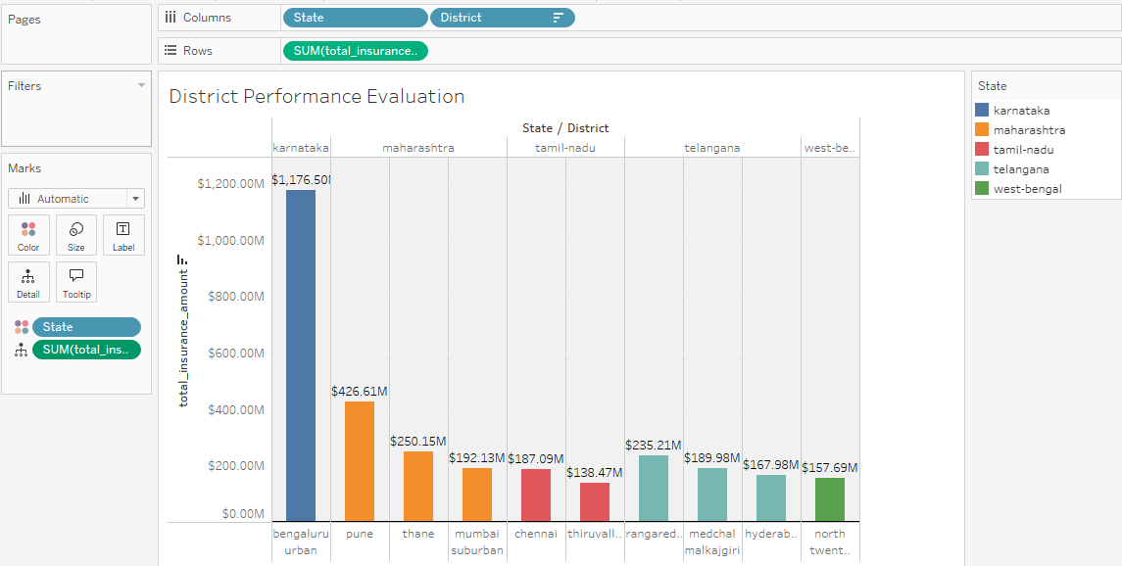

**Insights from the graph:**

1.Top Districts:

* + Bengaluru Urban (Karnataka) leads significantly, showing a total insurance amount of $1.176 billion.
  + Pune (Maharashtra) follows, contributing $426.61 million.
  + Other notable districts include Thane and Mumbai Suburban, reflecting the strength of Maharashtra in insurance transactions.

2.State Contributions:

* + Karnataka stands out as a major contributor with the highest total insurance amount across its districts.
  + Maharashtra also shows strong performance with multiple high-contributing districts.

3.Transaction Distribution:

* + There's a wide variation in transaction volumes among districts, indicating potential regional strengths and weaknesses.
  + Smaller districts in Tamil Nadu and Telangana contribute lower amounts compared to their larger counterparts in Karnataka and Maharashtra.

**Recommendations:**

1.Focus on High-Performing Districts: Continue to strengthen insurance strategies in Bengaluru Urban, Pune, Thane, and Mumbai Suburban, as they are major contributors to insurance transactions.

2.Expand Efforts in Karnataka and Maharashtra: Given their significant contributions, develop more localized campaigns and incentives in these states to further boost insurance adoption.

3.Target Smaller Districts for Growth: Focus on regions with lower transaction volumes, like smaller districts in Tamil Nadu and Telangana, by introducing targeted awareness and promotional activities to improve engagement.

4.Monitor Regional Trends: Conduct deeper analyses of districts with varying performance levels to identify key drivers for success in high-performing areas, which can be replicated in other regions.

5.Enhance Digital Engagement: As urban districts show higher engagement, invest in digital platforms and campaigns to target tech-savvy users in these areas while considering outreach to underserved regions.

**USE CASE 4: Pin code Insights**

**Use Case Description**: The objective of this analysis is to identify the top 10 pin codes with the highest number of insurance transactions. By analyzing the total insurance count and amount for each pin code, the goal is to uncover patterns or trends in the regions driving the most significant insurance activity. Understanding these areas will allow businesses to focus on high-performing locations while also identifying potential demographic or geographic factors influencing the data. The insights will help in formulating targeted marketing strategies and expanding efforts to regions with higher growth potential.

**Visualization:**

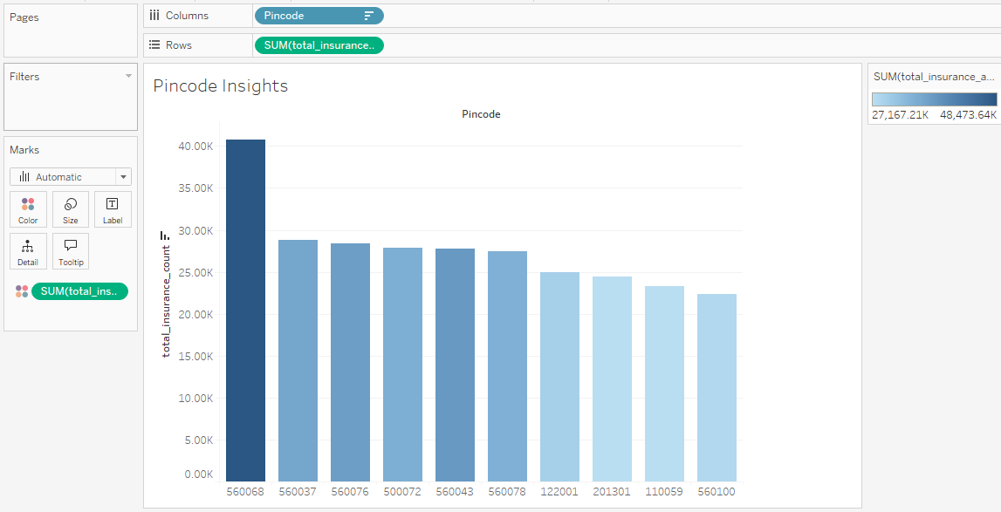

**Insights from the graph:**

1.Highest Value:

* + The pincode 560068 shows the highest total insurance count, exceeding 40,000.

2.Mid-Range Values:

* + Several pincodes such as 560037, 560076, 560072, and 560043 display insurance counts in the range of 30,000 to 40,000.

3.Lower Values:

* + Pincodes like 122001, 201301, and 110059 show lower total insurance counts, under 30,000.

4.Overall Trend:

* + There is a noticeable decline from the highest bar to the lower ones, indicating a significant disparity in total insurance counts across different pincodes.

**Recommendations:**

1.Focus marketing efforts on high-performing pincodes like 560068, which show the highest insurance activity, to further boost engagement.

2.Explore reasons behind the strong performance of pincodes 560037, 560076, 560072, and 560043 to replicate successful strategies in other regions.

3.Investigate low-performing pincodes such as 122001, 201301, and 110059 to identify potential barriers and improve adoption in these areas.

4.Target areas with mid-range values for growth opportunities through tailored promotional campaigns.

**Dashboard Creation:**

Creating a dashboard in Tableau involves combining multiple visualizations into a cohesive, interactive layout that communicates insights clearly. The process begins by preparing the data and creating individual sheets for each chart or graph. Once the visualizations are ready, a new dashboard is created where we can arrange and organize the sheets using containers, either floating or tiled, to control positioning. Floating containers provide flexibility in placing elements freely, while tiled containers ensure alignment and uniform spacing. The dashboard size can be set as fixed or automatic, depending on whether we want it to adjust dynamically to different screen sizes. To enhance user interaction, filters, legends, and dashboard actions can be added to allow viewers to explore the data in more detail. By carefully arranging the visualizations and interactive elements, Tableau allows you to create a dynamic, insightful dashboard that is visually appealing.

