Instagram Performance Analytics for Sugar Cosmetics
Insights Document · Data period 19 Apr 2024 – 19 Apr 2025 · 50,000 posts

1. Executive summary
The account is healthy and remarkably consistent: 18.54% average engagement rate, 147.7M likes, 18.5M comments and 987M accounts reached across 50,000 posts. About 29.9% of profile visits become follows. The headline insight is that no post type, weekday, campaign, source or hashtag stands out statistically (differences below 0.25 pp in most cases). Strategy should therefore focus on funnel depth (shares/saves), the Story-to-follow journey, paid efficiency and structured A/B testing rather than on switching formats.

2. Data & method
- Source: sugar_cosmetics_instagram_data.xlsx – 14 columns, 50,000 rows, no nulls, no duplicates; reach ≤ impressions on every row.
- Engagement rate (ER) = (likes + comments + shares + saves) ÷ reach × 100, computed per post and averaged.
- Added fields: month, weekday, interactions, ER, follow conversion (follows ÷ profile visits), hashtag count and an exploded hashtag table (100,044 post×hashtag rows).
- Significance: one-way ANOVA on per-post ER for each category.
- Limitations: no caption, posting time, spend or follower-count columns; no demographic fields (only “Audience Emotion”). Growth is proxied by follows. 50,000 posts in a year is implausible for one account, so the data is likely simulated/aggregated.

3. Findings by task

3.1 KPI overview
KPI | Value
Total posts | 50,000
Total likes | 147,728,279
Total comments | 18,459,361
Total shares / saves | 8,115,338 / 8,861,439
Total reach / impressions | 987.4M / 1,276.0M
Average engagement rate | 18.54%
Profile visits → follows | 29.63M → 8.87M (29.9%)

3.2 Monthly posting trend
Volume is steady at roughly 4,100–4,300 posts per full month (February dips to 3,930 because it is shorter). April 2024 (1,626) and April 2025 (2,460) are partial months because data spans 19 Apr – 19 Apr. Posting consistency is high; there is no seasonal ramp-up for festive periods.
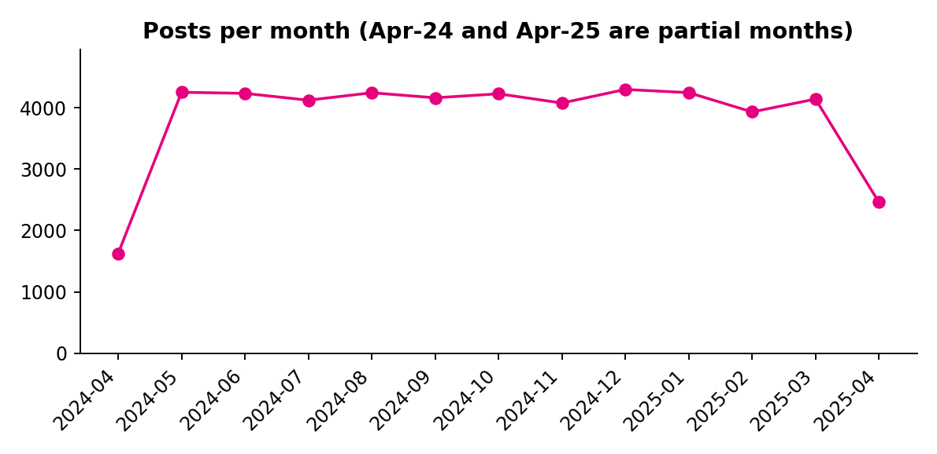

3.3 and 3.4 Top posts by likes and by engagement rate
The top 10 posts by engagement rate sit between 33.8% and 34.1%, nearly double the average, while the top-10 posts by likes (11,043–11,392 likes, about 3.8× the average post) all have very high reach (≈45,000 on average), so raw likes mostly track reach. The ER top 10 contains 4 videos, 2 images, 2 reels, 2 stories and every campaign type, so there is no repeatable creative pattern. Giveaway and Influencer-Collab posts account for 6 of the top 10 by likes, a pattern worth testing rather than relying on.
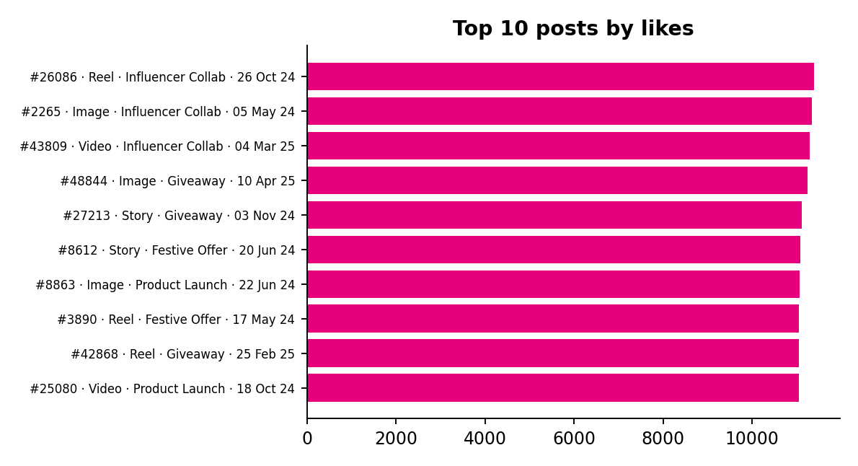
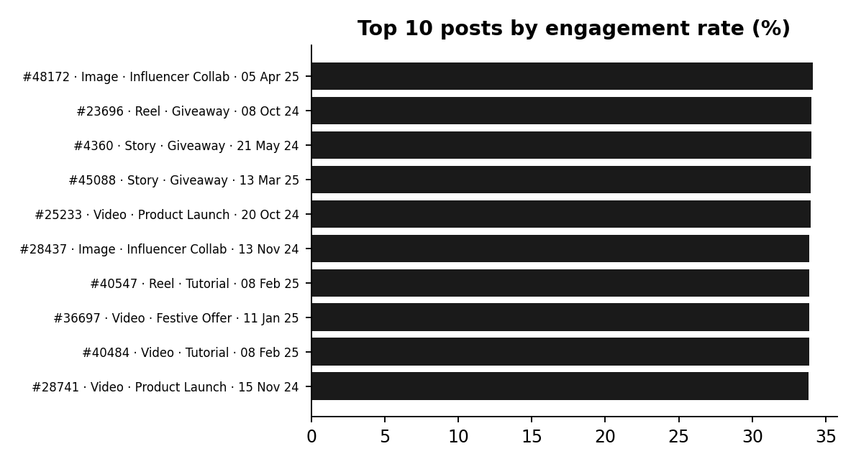

3.5 Post type performance
Post type | Avg likes | Avg comments | Avg shares | Avg saves | Avg ER %
Image | 2,954 | 367 | 161 | 177 | 18.43
Reel | 2,960 | 369 | 162 | 178 | 18.61
Story | 2,964 | 371 | 165 | 178 | 18.60
Video | 2,941 | 370 | 162 | 176 | 18.51

Differences are under 1% on every metric (ANOVA p = 0.15). Reels lead on ER and saves; Stories lead on likes, comments and shares but generate the fewest follows (≈175 per post vs ≈179 for Images; visit-to-follow 29.4% vs 29.9%).
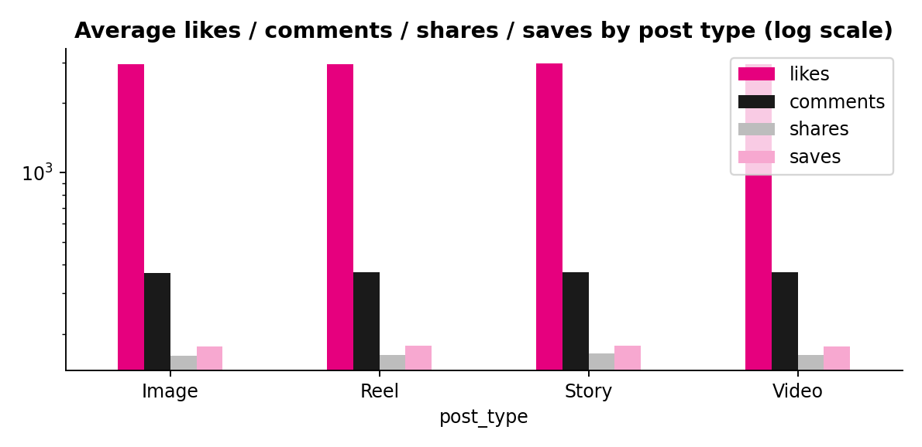

3.6 Day of week
Wednesday has the highest average ER (18.63%) and Sunday the lowest (18.42%), a 0.21 pp spread (p = 0.57). Saturday has the lowest average reach (≈19,500) and Wednesday the highest (≈19,870). Weekday is not a meaningful lever with this data; posting time (not provided) may matter more.
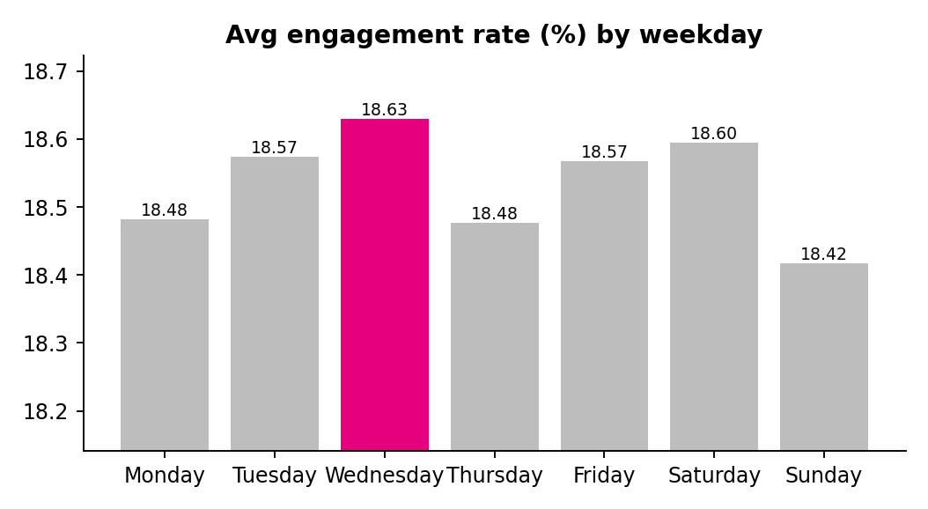

3.7 Engagement funnel
Stage | Total | % of previous / of reach
Impressions | 1,276.0M | –
Reach | 987.4M | 77.4% of impressions
Likes | 147.7M | 15.0% of reach
Comments | 18.5M | 1.9% of reach
Saves | 8.9M | 0.9% of reach
Shares | 8.1M | 0.8% of reach

The average person sees a post 1.29 times. Likes dominate; saves and shares, the strongest intent signals, are the thinnest layer. Likes, comments, shares and saves are parallel actions rather than a strict sequence.
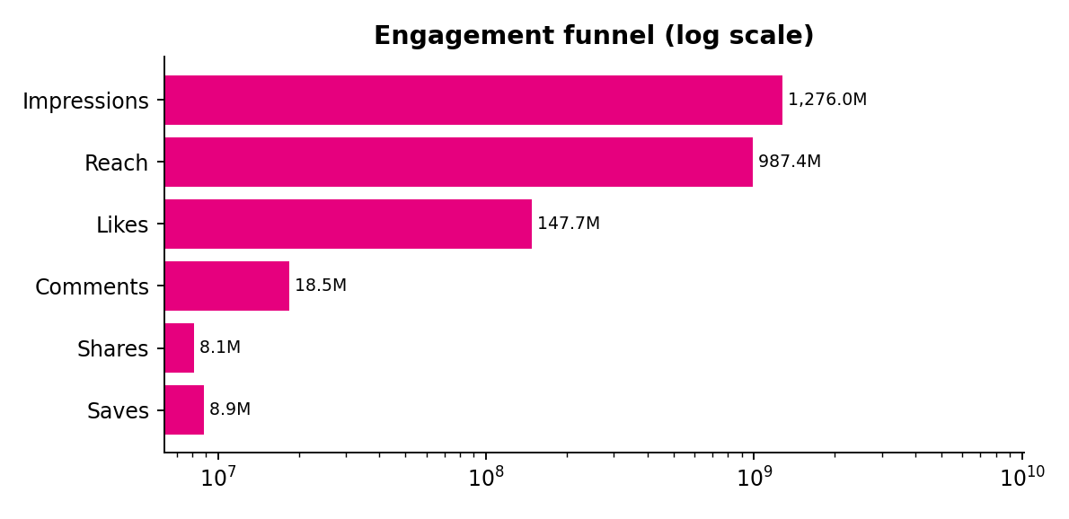

3.8 Hashtag analysis
Only five hashtags are used (#SugarCosmetics, #MakeupGoals, #BoldLooks, #VeganBeauty, #CrueltyFree), each on roughly 40% of posts. #VeganBeauty (18.61%) and #BoldLooks (18.58%) lead; #MakeupGoals trails (18.51%). Posts with two hashtags average 18.63% vs 18.44% with one (p = 0.054, borderline). The data does not include niche or trending tags, which limits hashtag strategy.
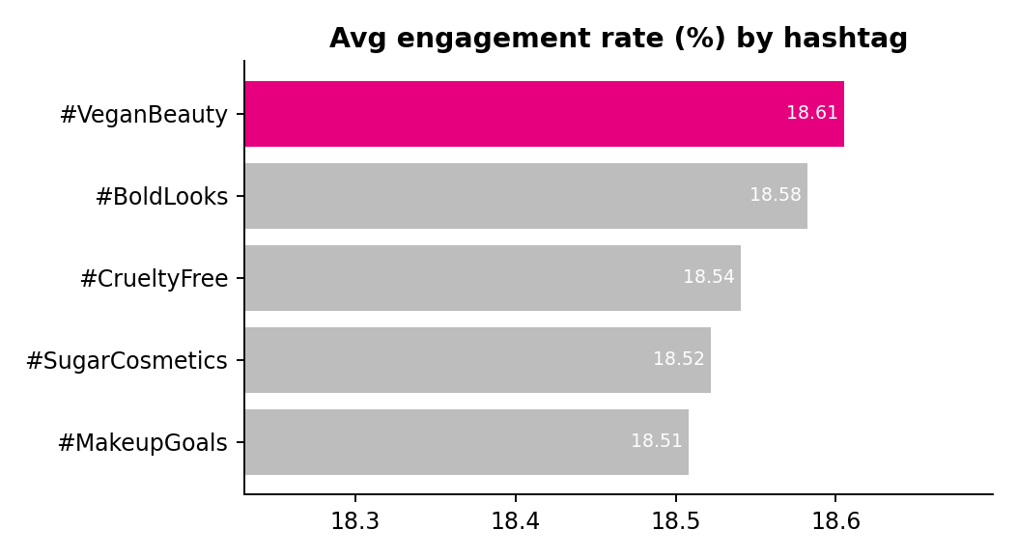

3.9 Campaign, source and audience emotion (extra cuts)
- Campaign: Influencer Collab has the highest reach (≈19,875) and likes (≈2,983); Festive Offer is lowest on reach (≈19,506), likes (≈2,903) and ER (18.44%). Tutorial has the best visit-to-follow conversion (30.0%).
- Source: Organic has the highest reach per post (≈19,970) but the lowest ER (18.44%); Collab and Influencer lead ER (≈18.59%); Paid has the lowest reach (≈19,617).
- Audience emotion: all five emotions are within 0.16 pp of each other (Curious highest).
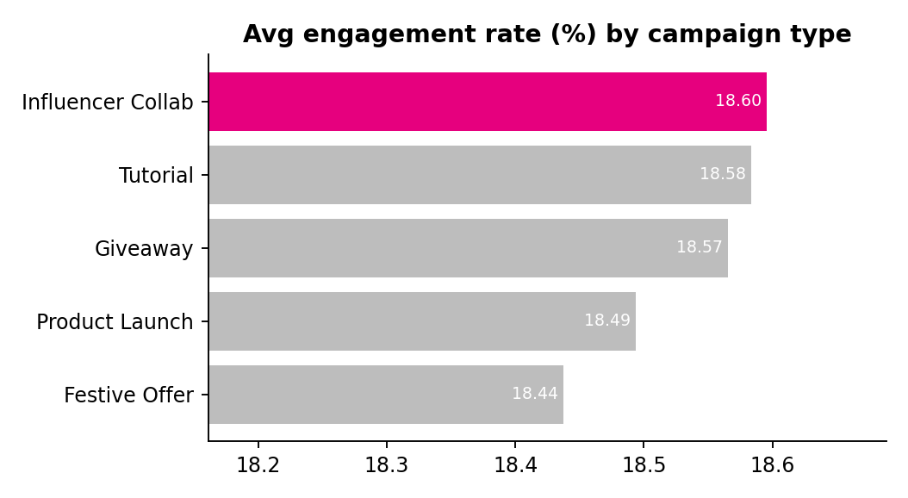

4. Strategic recommendations

4.1 Posting strategy
- Timing: keep the daily cadence; mid-week (Wed) and Saturday show the best ER, Sunday the weakest. Treat this as a testing hypothesis; capture post time in future exports.
- Frequency: current cadence is stable and no month shows a performance penalty, so there is no evidence for increasing volume. Prioritise quality of saves/shares.
- Content type: Reels for tutorials and launches (best ER and saves); Stories for time-sensitive offers, with a follow call-to-action.

4.2 Improve engagement and follower growth
- Add follow prompts and link stickers to Stories, the lowest follow-driver.
- Create saveable assets (shade guides, routines) and shareable hooks to lift the weakest funnel layers.
- Use two or three hashtags per post; place #VeganBeauty and #BoldLooks in core content.
- Re-evaluate paid promotion: it is not buying additional reach compared with organic. Measure cost per follow.

4.3 Gaps and how to close them
Gap | Why it matters | Fix
No caption, post time, cost or followers | Cannot study copy, timing or ROI | Export these fields from Instagram Insights/Meta Business Suite
No demographics | Objective asks for audience analysis | Add age, gender, city breakdown
Uniform results | No clear winner to scale | Run one-variable A/B tests for 4–6 weeks
Partial months | Distorts trends | Report full months only

4.4 Campaign ideas
- #BoldLooksChallenge: UGC makeup challenge with a giveaway for best look.
- Vegan & Cruelty-Free, Explained: short Reel series with saveable ingredient cards.
- Festive Collab Drop: influencer-led festive offer to lift the lowest-performing campaign type.

