Reliable Data Transfer over UDP
Project Report
CS-30003 · Coding Assignment 1 · Project P3 · Path A (Catalogue Project)
Team member | Roll number | Owned component (from the approved proposal)
Shubhojit Dey | 25057064 | Stop-and-Wait protocol; Channel emulator (shared)
Shwe Yee Mon | 24052735 | Go-Back-N protocol; Channel emulator (shared)
Souvick Biswas | 25057075 | Selective Repeat protocol; Experiment harness and hash-integrity checks (shared)
Snigdhanil Sabud | 25057071 | Adaptive RTO (Jacobson/Karels and Karn); Experiment harness and hash-integrity checks (shared)

Team: 4 Repository: github.com/Shubhojit-dey/Udp
Languages: Java (transport core and channel emulator, about 1,050 lines) and Python (experiments and plots, about 320 lines).

1. Introduction
UDP delivers packets without any guarantee: packets can be lost, duplicated, reordered or corrupted, and the sender is never told. This project builds reliability on top of raw UDP sockets. We implemented a file-transfer tool in which reliability is constructed by hand rather than inherited from TCP, and we measured how different reliability strategies behave on a deliberately bad network.
The project has five deliverables, taken from the proposal:
- Protocol suite: one file-transfer application with three interchangeable ARQ protocols (Stop-and-Wait, Go-Back-N, Selective Repeat) chosen at run time.
- Reliability primitives: hand-built sequence numbers, checksums, cumulative ACKs (Go-Back-N) and selective ACKs (Selective Repeat), each with a retransmission timer.
- Adaptive timing: retransmission timeout (RTO) estimated with the Jacobson/Karels algorithm, with Karn's algorithm excluding retransmitted segments from RTT samples.
- Channel emulator: a deterministic, seed-controlled fault injector for loss, duplication, reordering, corruption and jittered delay.
- Integrity verification: SHA-256 comparison of the source and received files, confirming that every completed transfer is byte-for-byte correct.
Claim tested. As loss and reordering increase, Selective Repeat holds a materially higher goodput than Go-Back-N and Stop-and-Wait, because it never retransmits segments the receiver already has.

2. System Design

2.1 Architecture
The sender and receiver talk through the channel emulator, which sits in the middle as a UDP proxy: Sender → Emulator → Receiver, with ACKs travelling back the same way. The receiver learns the protocol, window size, file size and the source SHA-256 from a handshake packet (SYN), so it needs no manual configuration. When the last segment arrives, the receiver recomputes the SHA-256 of the file it wrote and compares it with the hash from the sender.

2.2 Packet format
Every datagram has a 22-byte header followed by the payload: type (1 byte), flags (1), sequence number (4), cumulative ACK (4), SACK bitmap (8), payload length (2) and a 16-bit ones'-complement checksum (2). Bit i of the SACK bitmap means that segment ACK+1+i is buffered at the receiver, so Selective Repeat supports windows up to 64 segments.

2.3 The three protocols
Protocol | How it works | Weakness / strength
Stop-and-Wait | One segment in flight; wait for its ACK; retransmit on timeout. | Throughput is limited to one segment per round trip, whatever the window.
Go-Back-N | Window of W segments, one timer on the oldest unacknowledged segment, cumulative ACKs. A timeout resends the whole window; the receiver discards out-of-order segments. | One lost or late segment makes it resend many that already arrived.
Selective Repeat | Window of W segments, a deadline per segment. The receiver buffers out-of-order segments and returns a cumulative ACK plus a SACK bitmap; only missing segments are resent. | Retransmits only what the receiver reports missing, so it wastes far fewer retransmissions. A few spurious ones still occur when a timer fires before an ACK has been processed.

2.4 Adaptive timing
RTO = SRTT + 4 × RTTVAR, with SRTT and RTTVAR updated using gains 1/8 and 1/4, clamped between 20 ms and 1 s, and doubled after every timeout. Karn's algorithm is enforced in all three senders: a segment that was ever retransmitted never produces an RTT sample, and the backed-off RTO is kept until a clean sample arrives.

2.5 Concurrency
The proposal listed concurrent timer races as the first risk, with a centralised timer as the fallback. We adopted the fallback from the start: each sender is a single-threaded event loop that sends what the window allows and then waits on the socket until the earliest retransmission deadline. Timer expiry and ACK processing can never interleave, so there is no timer race to debug.

2.6 Channel emulator
Every fault decision is a hash of (seed, direction, packet type, sequence or ACK number, occurrence count), not a draw from a shared random stream. The same transmission of the same data segment therefore meets the same fate on every run with the same seed, for every protocol. Jitter is modelled as queueing delay on a FIFO link and never reorders packets by itself; reordering is a separate, explicit impairment in which a selected packet is held back by an extra 15 ms so that later packets overtake it. This lets each experiment change one cause at a time.

3. Team Members and Their Work
The proposal gives every member one protocol or component to own end to end, plus one shared task, so that scope and accountability are equal. The tables below record each member's assigned work, where it lives in the code, and when it was due in the weekly plan.

3.1 Shubhojit Dey
Member | Shubhojit Dey (Roll no. 25057064)
Owns end to end | Stop-and-Wait — framing, sequencing and checksum logic.
Shared task | Channel emulator, together with Shwe Yee Mon.
Where in the code | StopAndWaitSender.java, Packet.java (framing), Checksum.java; ChannelEmulator.java (shared).
Weekly plan | Week 2: Stop-and-Wait complete end to end on a lossless channel. Week 6 (with Shwe Yee Mon): emulator built and integrated.
Must be able to explain | Why Stop-and-Wait throughput is about one segment per round-trip time; why the checksum catches every single-bit error; how packets are framed; how the emulator's fault decisions stay reproducible.

3.2 Shwe Yee Mon
Member | Shwe Yee Mon (Roll no. 24052735)
Owns end to end | Go-Back-N — cumulative ACKs and the sliding window.
Shared task | Channel emulator, together with Shubhojit Dey.
Where in the code | GoBackNSender.java; the in-order receiving branch of ArqReceiver.java; ChannelEmulator.java (shared).
Weekly plan | Week 3: Go-Back-N complete with cumulative ACKs, sliding window and timeout-driven retransmission. Week 6 (with Shubhojit Dey): emulator built and integrated.
Must be able to explain | Why Go-Back-N uses one timer; why a timeout resends the whole window; why reordering hurts it even with zero loss; why the receiver repeats the cumulative ACK for out-of-order segments.

3.3 Souvick Biswas
Member | Souvick Biswas (Roll no. 25057075)
Owns end to end | Selective Repeat — selective ACKs and the receiver's reorder buffer.
Shared task | Experiment harness and hash-integrity checks, together with Snigdhanil Sabud.
Where in the code | SelectiveRepeatSender.java; the SACK and reorder-buffer branch of ArqReceiver.java; run_experiments.py, plot.py, Sha256Util.java (shared).
Weekly plan | Week 4: Selective Repeat complete with SACK bitmap and reorder buffer. Week 7 (with Snigdhanil Sabud): full experiment sweep, plots and hash-integrity validation.
Must be able to explain | How the 64-bit SACK bitmap maps to segment numbers and why the window is at most 64; what happens if a SACK is lost; why the reorder buffer is bounded by the window; why each experiment varies only one parameter.

3.4 Snigdhanil Sabud
Member | Snigdhanil Sabud (Roll no. 25057071)
Owns end to end | Adaptive RTO — Jacobson/Karels algorithm and Karn's algorithm.
Shared task | Experiment harness and hash-integrity checks, together with Souvick Biswas.
Where in the code | RtoEstimator.java and its use inside all three senders; run_experiments.py, plot.py, Sha256Util.java (shared).
Weekly plan | Week 5: adaptive RTO wired into all three protocols. Week 7 (with Souvick Biswas): full experiment sweep, plots and hash-integrity validation.
Must be able to explain | The SRTT/RTTVAR update and the RTO formula; why Karn's algorithm excludes retransmitted segments; why the backed-off RTO is kept until a clean sample; how the RTO-sensitivity experiment is built.

All four members take part together in Week 1 (repository, socket scaffolding, shared header format) and Week 8 (report, AI-USE.md, code clean-up and viva rehearsal).

4. Experimental Method
Each experiment sends a file with all three protocols through the emulator. Exactly one parameter is varied at a time; everything else stays at the baseline.
Setting | Value
Baseline | loss 1%, window 16 segments, reordering 0%, adaptive RTO
Network | 5 ms one-way delay with 1 ms jitter (round trip about 10 ms), segment size 1,200 bytes; reordered packets are held back by 15 ms
Loss sweep | 0, 1, 2, 5, 10, 15, 20 %
Window sweep | 4, 8, 16, 32, 64 segments
Reordering sweep | 0, 2.5, 5, 10, 15 %
RTO sweep (loss 5%) | adaptive, and fixed 20, 50, 100, 250, 500 ms
Repeats | 3 per point, seeds 1000, 1001, 1002 (same seed means the same network decisions for all three protocols)
File size | 0.5 MB per transfer for all protocols (the proposal specified 100 MB; see Section 7)
Total runs | 207 (4 sweeps × protocols × values × 3 repeats); all 207 completed and passed the SHA-256 check
Failed runs | Some runs crashed because Windows ran out of memory for the Java process. They were run again, and where the same run was recorded twice the later record was kept.
Metric | Goodput in Mbps = file size in bits divided by transfer time (handshake excluded)

5. Results

5.1 Goodput versus packet loss
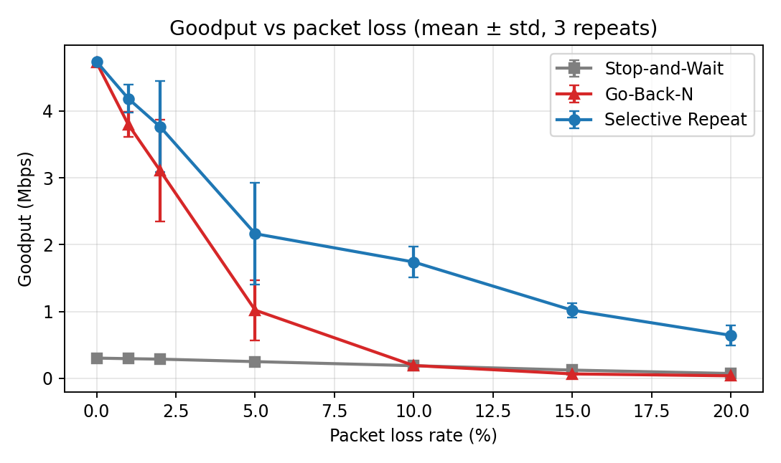
Figure 1. Goodput of the three protocols as loss rises from 0% to 20% (mean ± std of 3 repeats).
Loss (%) | Selective Repeat (Mbps) | Go-Back-N (Mbps) | Stop-and-Wait (Mbps) | SR / GBN | SR / SW
0 | 4.74 | 4.72 | 0.30 | 1.00x | 15.57x
1 | 4.18 | 3.80 | 0.30 | 1.10x | 14.15x
2 | 3.76 | 3.11 | 0.29 | 1.21x | 13.06x
5 | 2.16 | 1.02 | 0.25 | 2.12x | 8.61x
10 | 1.74 | 0.19 | 0.19 | 9.03x | 9.14x
15 | 1.02 | 0.07 | 0.12 | 15.09x | 8.19x
20 | 0.64 | 0.04 | 0.07 | 16.47x | 8.76x

Reading. On a clean network Selective Repeat and Go-Back-N are equal. As loss grows, Go-Back-N collapses because every loss triggers a retransmission of the whole window: at 10% loss it is about as slow as Stop-and-Wait (0.19 and 0.19 Mbps), and at 15% and 20% it is slower. Selective Repeat degrades gradually and is about 16 times faster than Go-Back-N at 20% loss.

5.2 Goodput versus reordering
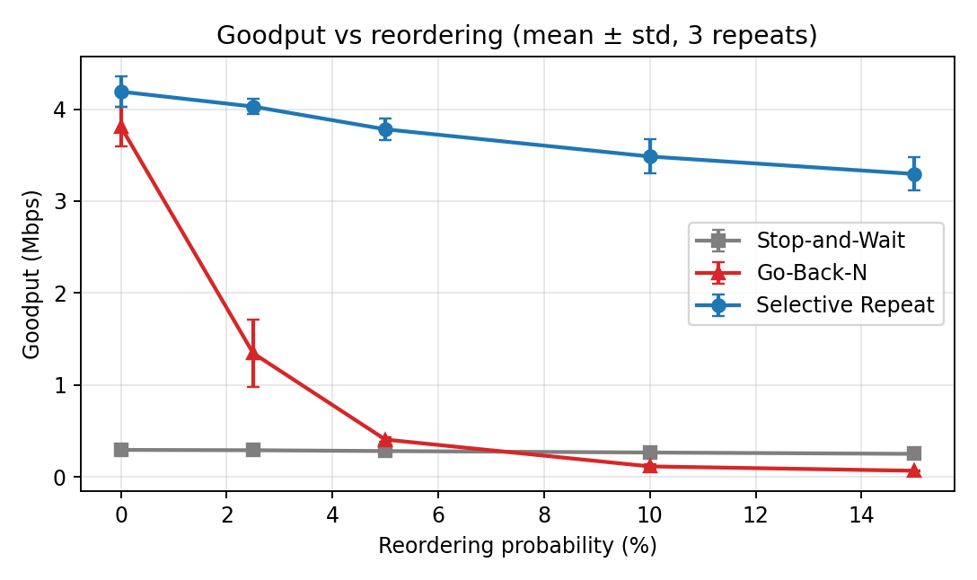
Figure 2. Goodput as the probability of reordering rises from 0% to 15% (mean ± std of 3 repeats).
Reordering (%) | Selective Repeat (Mbps) | Go-Back-N (Mbps) | Stop-and-Wait (Mbps) | SR / GBN | SR / SW
0 | 4.19 | 3.81 | 0.30 | 1.10x | 14.17x
2.5 | 4.03 | 1.35 | 0.29 | 2.99x | 13.79x
5 | 3.78 | 0.41 | 0.28 | 9.27x | 13.36x
10 | 3.48 | 0.12 | 0.27 | 29.97x | 13.04x
15 | 3.29 | 0.07 | 0.25 | 47.96x | 13.04x

Reading. Reordering is where the two window protocols differ most. Go-Back-N treats a late segment as a lost one, discards everything behind it and resends it; with 2.5% reordering its goodput already falls by about two thirds. Selective Repeat buffers the early arrivals and loses only about 20% of its speed even at 15% reordering.
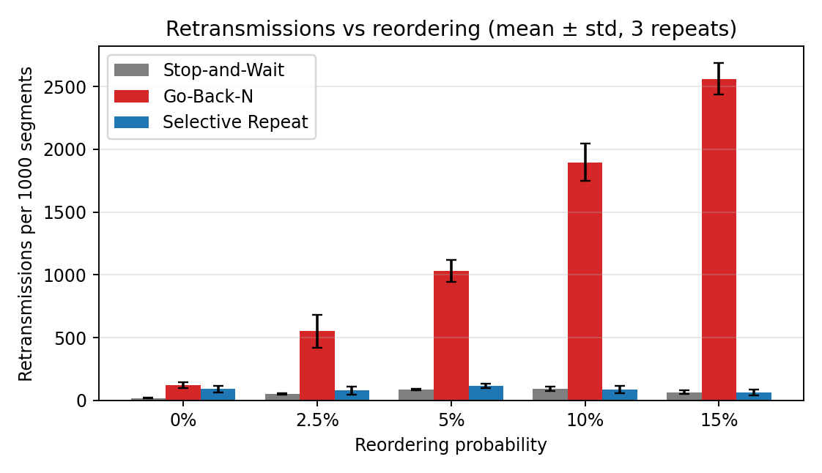
Figure 3. Retransmissions per 1000 segments as reordering rises (mean ± std of 3 repeats).
Reordering (%) | Stop-and-Wait | Go-Back-N | Selective Repeat
0 | 18 | 122 | 92
2.5 | 53 | 551 | 79
5 | 87 | 1032 | 116
10 | 95 | 1897 | 89
15 | 66 | 2562 | 66

Reading. Go-Back-N's retransmissions grow from 122 to 2,562 per 1,000 segments, so at 15% reordering it retransmits each segment about two and a half times on average. Selective Repeat's retransmissions stay between 66 and 116 per 1,000 segments and show no upward trend, which is the mechanism the claim describes. Note that Selective Repeat is not at zero even without reordering (92 at 0%): some of its retransmissions are spurious, as discussed in Section 7.

5.3 Window size
The window sweep keeps the loss rate at the baseline of 1% and varies the window from 4 to 64 segments.
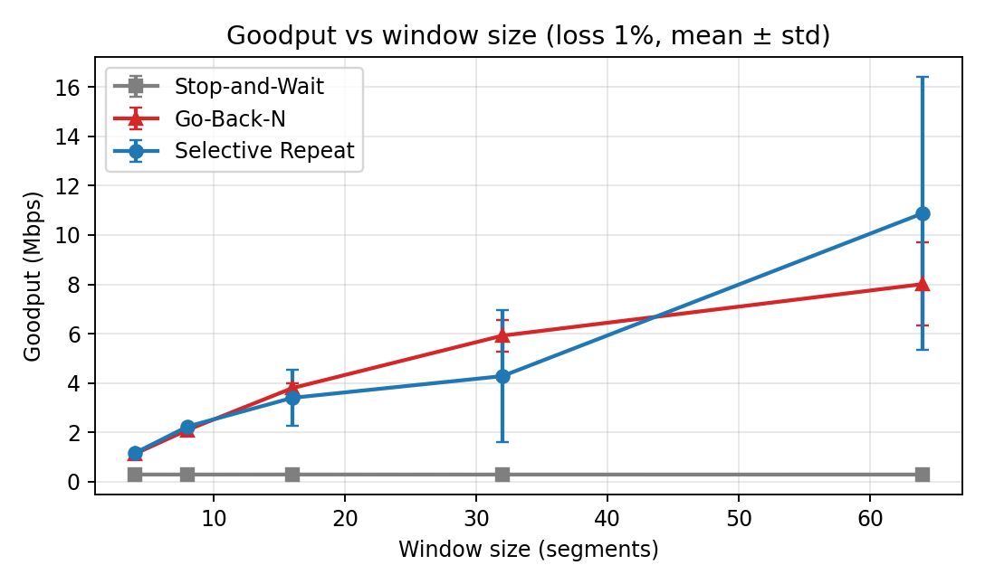
Figure 4. Goodput as the window size grows (loss 1%, mean ± std of 3 repeats).
Window | Stop-and-Wait (Mbps) | Go-Back-N (Mbps) | Selective Repeat (Mbps)
4 | 0.30 ± 0.00 | 1.13 ± 0.00 | 1.16 ± 0.01
8 | 0.30 ± 0.00 | 2.10 ± 0.04 | 2.24 ± 0.02
16 | 0.30 ± 0.00 | 3.80 ± 0.21 | 3.40 ± 1.13
32 | 0.29 ± 0.00 | 5.92 ± 0.65 | 4.28 ± 2.68
64 | 0.30 ± 0.00 | 8.01 ± 1.69 | 10.87 ± 5.51

Reading. Stop-and-Wait is flat because it ignores the window. Go-Back-N and Selective Repeat both grow with the window, as expected, since a larger window keeps more of the pipe full. At only 1% loss the two are close, and this sweep does not show a clear Selective Repeat advantage: Go-Back-N has the higher mean at windows 16 and 32 (by 12% and 38%), while Selective Repeat is ahead at windows 4 and 8 (by only 3% and 7%) and at window 64 (by 36%). Selective Repeat's standard deviations at windows 16, 32 and 64 are large (1.13, 2.68 and 5.51), so with 3 repeats those three differences are not statistically reliable. This does not contradict the claim, which concerns higher loss and reordering, but it shows that the benefit of Selective Repeat appears when the network is bad, not simply when the window is large.

5.4 RTO sensitivity (loss = 5%)
RTO | Stop-and-Wait goodput (Mbps) | retx per 1000 | Go-Back-N goodput (Mbps) | retx per 1000 | Selective Repeat goodput (Mbps) | retx per 1000
adaptive | 0.25 ± 0.01 | 99 | 1.02 ± 0.45 | 712 | 2.66 ± 1.00 | 98
fixed 20 ms | 0.28 ± 0.00 | 1094 | 3.40 ± 0.58 | 1450 | 3.71 ± 0.35 | 1053
fixed 50 ms | 0.26 ± 0.00 | 99 | 1.73 ± 0.27 | 712 | 2.82 ± 0.45 | 55
fixed 100 ms | 0.23 ± 0.01 | 99 | 1.26 ± 0.23 | 712 | 2.08 ± 0.42 | 52
fixed 250 ms | 0.17 ± 0.01 | 99 | 0.69 ± 0.14 | 712 | 1.15 ± 0.29 | 52
fixed 500 ms | 0.12 ± 0.01 | 99 | 0.39 ± 0.09 | 712 | 0.66 ± 0.19 | 52

Reading. Goodput falls steadily as a fixed RTO grows, because every loss then costs a longer idle wait. A fixed 20 ms timeout gave the highest goodput of all, but at the price of many extra retransmissions (about 1,000 per 1,000 segments for Stop-and-Wait and Selective Repeat), which suggests that on a round trip of about 10 ms it often fires before the ACK arrives. The adaptive timer sent far fewer retransmissions yet was slower than the aggressive fixed timer. A likely reason, which we did not test separately, is that it doubles the RTO after each timeout and, with frequent losses, spends long periods backed off. This is a trade-off between wasted retransmissions and idle waiting.
Note on Selective Repeat at 5% loss. The adaptive Selective Repeat row here (2.66 Mbps) differs from the 5% row of the loss sweep (2.16 Mbps), although the configuration is the same. They are separate sets of 3 runs, and Selective Repeat varies a lot at this point (standard deviations 1.00 and 0.76). In contrast, the Go-Back-N and Stop-and-Wait retransmission counts are identical in both sweeps (712 and 99 per 1,000), so those two protocols are reproducible while Selective Repeat's timing-dependent behaviour is not (see Section 7).

6. Verification and Integrity
The self-test (rdt.SelfTest) checks that a one-bit error is always detected by the checksum, that the Jacobson/Karels first-sample rule and the RTO doubling behave as specified, and that all three protocols deliver a byte-identical file through a hostile channel (loss, duplication, reordering and corruption together).
In the experiments every one of the 207 runs finished with a matching SHA-256 hash between the source and the received file.

7. Discussion and Limitations
Claim. The results support the claim. Selective Repeat matches Go-Back-N on a clean network and is far ahead as loss and reordering increase, with the gap reaching about 16 times at 20% loss and about 48 times at 15% reordering. It is also at least 8 times faster than Stop-and-Wait across the whole loss sweep. At low loss (1%) with different window sizes, however, Selective Repeat and Go-Back-N are close and the advantage is not established (Section 5.3).
Limitations that should be stated honestly:
- File size. The proposal specifies a 100 MB file. All reported results use a 0.5 MB file, because 100 MB runs of Stop-and-Wait and of Go-Back-N under heavy loss take many hours on a laptop. The trends should carry over, but absolute goodput values might differ for larger files.
- Single machine. Sender, emulator and receiver run on one computer over the loopback interface, so absolute Mbps depend on the CPU. The ordering of the protocols and the trends are what the claim concerns.
- Repeats. Three repeats per point give modest statistical power; some points (for example Go-Back-N at 5% loss and Selective Repeat with adaptive RTO) show a large standard deviation.
- Run-to-run variation of Selective Repeat. The same configuration (loss 1%, window 16, no reordering) produced Selective Repeat goodputs of 3.40, 4.18 and 4.19 Mbps in the window, loss and reordering sweeps, while Go-Back-N gave 3.80, 3.80 and 3.81. Selective Repeat's result depends on timing, so its means carry more uncertainty than the tables suggest.
- Spurious retransmissions in Selective Repeat. Even with 0% loss it retransmitted about 64 segments per transfer (147 per 1,000), whereas Go-Back-N and Stop-and-Wait sent none. A likely cause is that when the sender wakes up late (timer granularity on Windows), it checks expired deadlines before it reads ACKs already waiting in the socket. Reading pending ACKs first would probably remove most of these; we did not change the transport code after collecting the data, so that the reported results match the submitted code.
- Emulator scope. ACK fates are reproducible only statistically, because the number of ACKs depends on the protocol. Jitter never reorders packets by itself; all reordering is injected explicitly.
- Go-Back-N. Our version has no fast retransmit, so it is the plain textbook form; a variant with fast retransmit would suffer less under reordering.
Deviations from the proposal. (1) Per-segment OS timers were replaced by a single-threaded event loop per sender (the centralised-timer fallback from the risk table), which removed the timer race risk. (2) The transfer file size was reduced from 100 MB to 0.5 MB, as explained above.

8. Conclusion
We built a reliable file-transfer tool on raw UDP with three hand-written ARQ protocols, adaptive timing, a reproducible fault-injecting network emulator and end-to-end SHA-256 verification. Across 207 experiment runs, all transfers were byte-for-byte correct, and Selective Repeat held a materially higher goodput than Go-Back-N and Stop-and-Wait as loss and reordering increased, which supports the claim stated in our proposal. The window-size sweep at low loss and the run-to-run variation of Selective Repeat show where the evidence is weaker, and we report them as such.

9. Use of AI
An AI assistant (Claude, by Anthropic) was given the approved proposal and produced the first complete implementation of the Java transport core, the emulator, the Python experiment scripts and the documentation. It also fixed defects found during testing, including the emulator's packet ordering under jitter and process start-up failures on Windows. The team ran the self-test and the full experiment sweep on its own computers and used the resulting data in this report. Full details are in AI-USE.md in the repository.
Repository layout. src/main/java/rdt/ (Java), experiments/ (Python), results/ (data and plots), docs/ (viva notes), README.md, AI-USE.md.

