**Netaji Subhash Engineering College**

**Department of Computer Science & Engineering**

B. Tech CSE 2nd Year 3rd Semester

**2021-2022**

**--------------------------------------------------------------------------------------------**

**Name of the Course : IT Workshop**

**Course Code : PCC-CS393**

**Name of the Student : Shubhradeep Maity**

**Class Roll No : 14**

**University Roll No : 10900120014**

**Date of Experiment : 19-11-2021**

**Date of Submission :25-11-2021**

**Assignment No** :21

**Problem Statement**: Write a program to count the number of each vowel in a sentence.

**Python Code** :

# string of vowels

vowels **=** 'aeiou'

ip_str **=** input**(**'Enter the string: '**)**

# make it suitable for caseless comparisions

ip_str **=** ip_str**.**casefold**()**

# make a dictionary with each vowel a key and value 0

count **=** **{}.**fromkeys**(**vowels**,**0**)**

# count the vowels

**for** char **in** ip_str**:**

**if** char **in** count**:**

count**[**char**]** **+=** 1

print**(**count**)**

**Sample Output :**

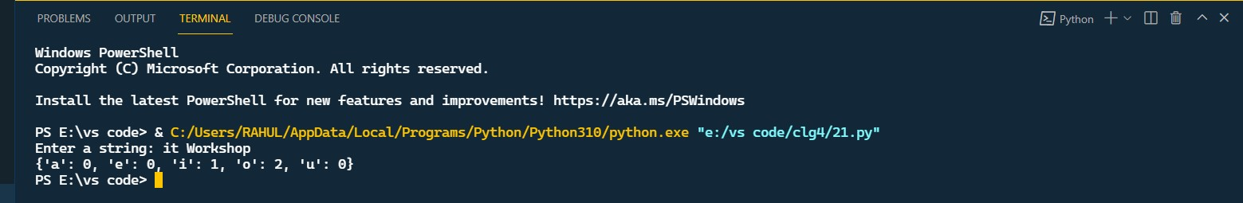

**Assignment No :22**

**Problem Statement :** Write a program to read a string and check whether the string is a palindrome or not.

Python Code :

x **=** input**(**'Enter the string '**)**

w **=** ""

**for** i **in** x**:**

w **=** i **+** w

**if** **(**x **==** w**):**

print**(**"Yes"**)**

**else:**

print**(**"No"**)**

**Simple Output :**

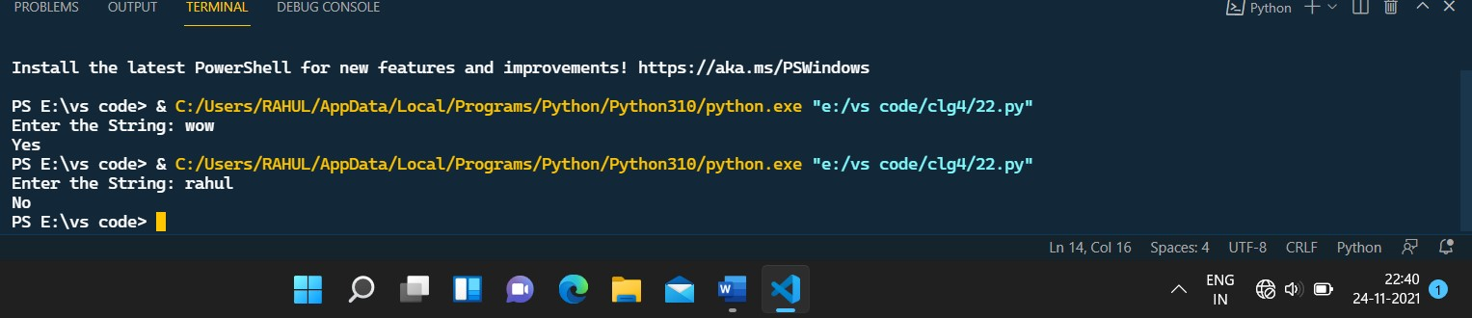

**sAssignment no :23**

**Problem Statement :** Write a program to get a string from a given string where all occurrences of the last character have been changed to ‘*’, except the last character.

Python Code :

**def** change_char**(**str1**):**

char **=** str1**[**0**]**

str1 **=** str1**.**replace**(**char**,** '*'**)**

str1 **=** char **+** str1**[**1**:]**

**return** str1

x**=**input**(**"Enter the string: "**)**

print**(**change_char**(**x**))**

**Simple Output :**

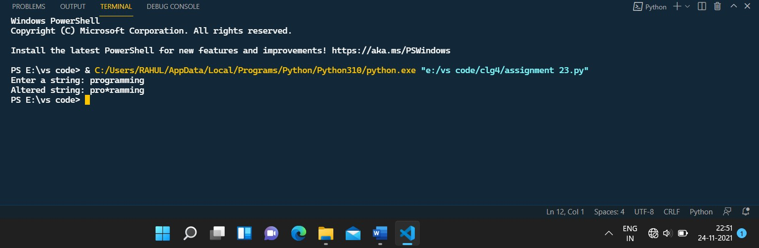

**Assignement No: 24**

**Problem Statement :** Write a program to count the occurrences of a word in a given sentence.

Python Code :

**def** countOccurrences**(**str**,** word**):**

# split the string by spaces in a

a **=** str**.**split**(**" "**)**

# search for pattern in a

count **=** 0

**for** i **in** range**(**0**,** len**(**a**)):**

# if match found increase count

**if** **(**word **==** a**[**i**]):**

count **=** count **+** 1

**return** count

# Driver code

str **=**input**(**"Enter the string: "**)**

word **=**input**(**"Enter the word: "**)**

print**(**countOccurrences**(**str**,** word**))**

**Simple Output:**

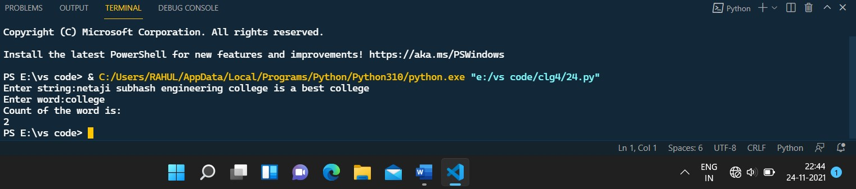

**Assignment No : 25**

**Problem Statement :** Write a program to get all substrings of a given string.

Python Code :

**def** subString**(**Str**,**n**):**

**for** Len **in** range**(**1**,**n **+** 1**):**

**for** i **in** range**(**n **-** Len **+** 1**):**

j **=** i **+** Len **-** 1

**for** k **in** range**(**i**,**j **+** 1**):**

print**(**Str**[**k**],**end**=**""**)**

print**()**

Str **=** input**(**'Enter the string: '**)**

subString**(**Str**,**len**(**Str**))**

**Simple Output :**

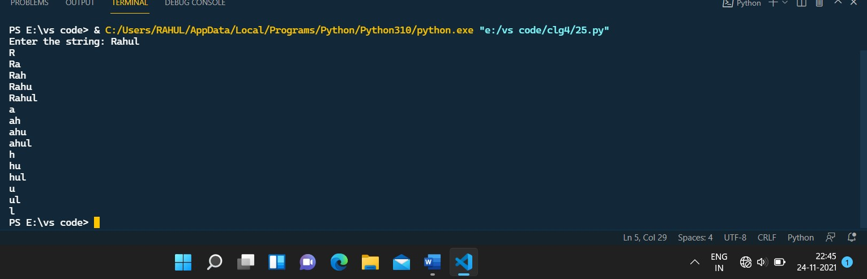

**Assignment No :26**

**Problem Statement :** Write a program to detect whether two strings are anagrams or not.

Python Code :

**def** areAnagram**(**str1**,** str2**):**

n1 **=** len**(**str1**)**

n2 **=** len**(**str2**)**

**if** n1 **!=** n2**:**

**return** 0

str1 **=** sorted**(**str1**)**

str2 **=** sorted**(**str2**)**

**for** i **in** range**(**0**,** n1**):**

**if** str1**[**i**]** **!=** str2**[**i**]:**

**return** 0

**return** 1

str1 **=** input**(**"Enter the 1st string: "**)**

str2 **=** input**(**"Entre the 2nd string"**)**

**if** areAnagram**(**str1**,** str2**):**

print**(**"The two strings are anagram of each other"**)**

**else:**

print**(**"The two strings are not anagram of each other"**)**

**Simple Output :**

