1. **GIT-HOL**

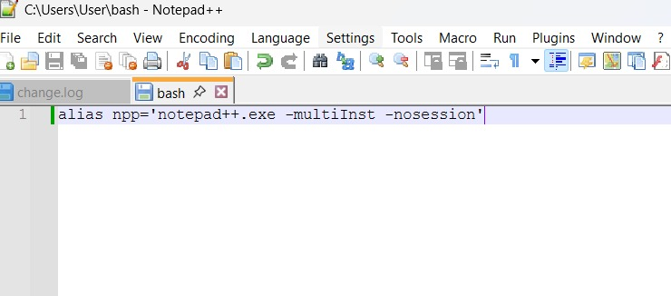

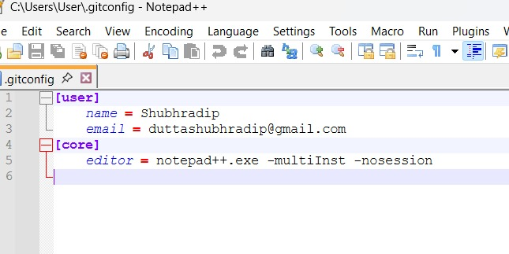

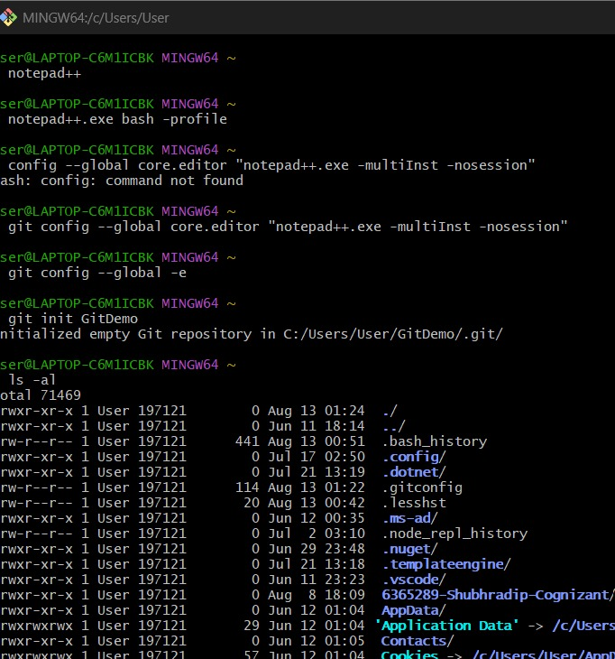

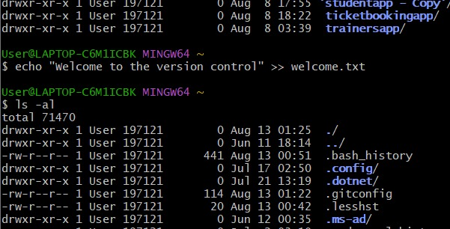

1. **GIT-HOL**

**Step 1 – Make sure you have a Git repository**

mkdir GitIgnoreDemo

cd GitIgnoreDemo

git init

**Step 2 – Create test files and folder**

echo "This is a log file" > error.log

mkdir log

echo "Another log" > log/debug.log

**Step 3 – Create or edit .gitignore**

notepad++ .gitignore

**Step 4 – Check Git status**

git status

**Step 5 – Add and commit changes**

git add .gitignore

git commit -m "Added .gitignore to ignore .log files and log folder"

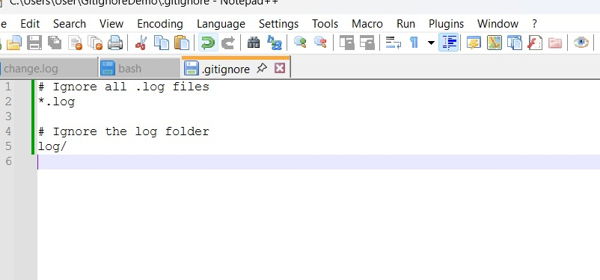

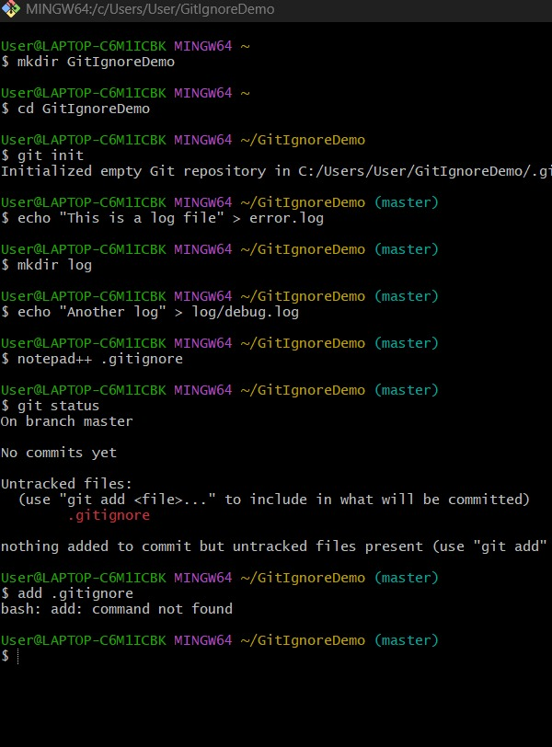

1. **GIT-HOL**

**Go to the folder where you want the repo:**

cd path/to/your/project

git init

**This creates a hidden .git folder, making it a Git repository.**

git branch GitNewBranch

**If you already have a Git repository somewhere**

**Navigate to it first:**

cd path/to/your/git-repo

1. **GIT-HOL**

**Step 1 – Create a new folder and initialize Git**

mkdir GitBranchDemo

cd GitBranchDemo

git init

**Step 2 – Create an initial file on master**

echo "This is the master branch file" > masterfile.txt

git add masterfile.txt

git commit -m "Initial commit on master"

**Step 3 – Create and switch to a new branch**

git branch GitNewBranch

git checkout GitNewBranch

**Step 4 – Add files in the new branch**

echo "This is content in GitNewBranch" > branchfile.txt

git add branchfile.txt

git commit -m "Added branchfile.txt in GitNewBranch"

**Step 5 – Switch back to master**

git checkout master

**Step 6 – See differences**

git diff master GitNewBranch

**Step 7 – Merge the branch into master**

git merge GitNewBranch

