Daily Supply Chain & Procurement Report
Purchase Orders | Goods Receipt (GRN) | Issue Analysis
REPORTING CONTEXT | AUTOMATION STATUS
Date: December 05, 2025  Data Period: FY 24/25 (Q2/Q3 Snapshot)  Source: On-Prem PostgreSQL Warehouse | ETL Script Run: 10:00 AM (Daily)  Power BI Refresh: 11:00 AM (Daily)  Pipeline Health: ✅ SUCCESS

1. Executive Summary
This report provides a daily snapshot of the procurement and inventory lifecycle. Data is extracted from legacy client applications via Python automation, processed for duplicates (SCD Type 1), and visualized via Power BI Fabric.
- Procurement Volume: Total Open PO Value stands at ₹2.39 Cr with an average cycle time of ~20 days.
- Inventory Mix: Stock is currently weighted 86.67% towards Revenue (Operational) and 13.33% towards Capital assets.
- Critical Items: Top 20% of SKUs are driving 55% of total inventory value (Pareto analysis).

2. Purchase Order Strategy
Analysis of open orders and supplier performance based on the 'pur_order_daily_main' dataset.
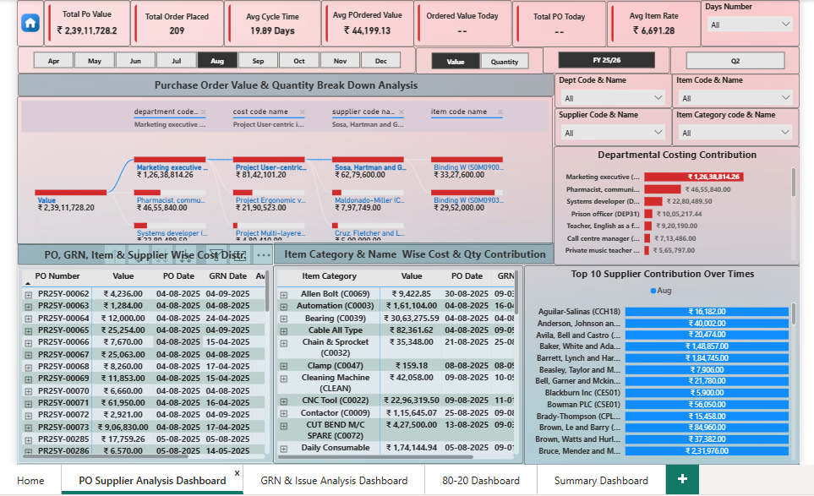
Key Insight: Supplier 'Aguilar-Salinas' remains the top contributor by value. Significant capital is currently allocated to the 'Project Ergonomic' cost center.

3. GRN & Issue Analysis
Tracking the conversion of Orders to Delivered Goods (GRN) and daily issues to departments.
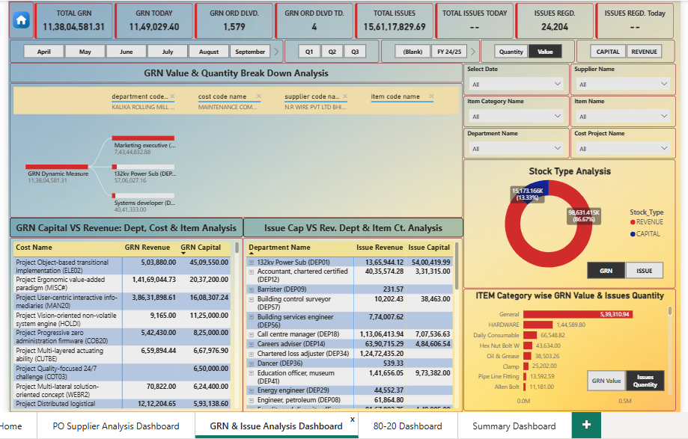
Operational Note: There is a delivery lag in the '132kv Power Sub' department. Immediate verification of challan quantity vs received quantity is recommended.

4. Strategic Inventory Control (80/20)
Pareto Principle applied to identifying high-value inventory items for strict audit control.
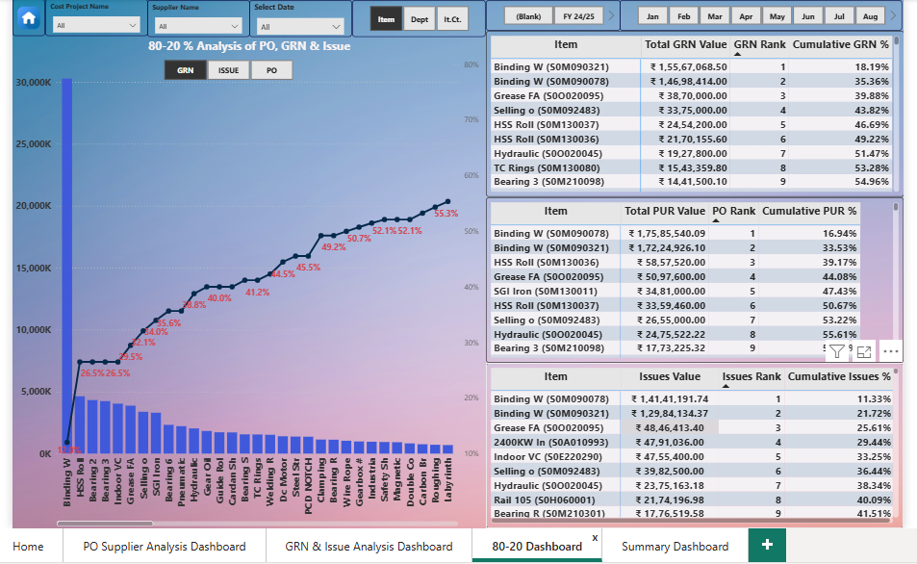
Action Item: The top 9 items (including 'Binding W' and 'HSS Roll') constitute the majority of value. Procurement negotiations should focus on these specific SKUs.

Appendix: Technical Architecture
This report was generated via an automated data engineering pipeline:
- 10:00 AM: Python (PyAutoGUI) script triggers legacy client to download raw Excel datasets.
- 10:15 AM: Pandas processes data; Logic handles Upserts (Updates vs Inserts) into PostgreSQL.
- 11:00 AM: Power BI On-Premises Gateway refreshes the dataset for dashboard visualization.

