**DESIGN**

**OF**

**LIFI**

**TRANSCEIVER**

**Table of Contents**

CHAPTER 1 OBJECTIVES 3

1.1 Goals and outcomes 3

CHAPTER 2 INTRODUCTION 4

2.1 What is LiFi? 4

2.1.1 Advantages and Disadvantages 4

2.1.2 Key Components 5

2.1.3 Applications 6

CHAPTER 3 7

3.1 Proposed hardware design 7

CHAPTER 5 HARDWARE DETAILS 8

5.1 Block Diagram 8

5.2 Circuit Diagram 9

CHAPTER 6 SOFTWARE DETAILS 10

6.1 Flowchart and algorithms 10

6.2 Programming language and code 11

CHAPTER 7 RESULTS AND DISCUSSIONS 14

7.1 Result 14

7.2 Discussion 15

# CHAPTER 1 OBJECTIVES

## Goals and outcomes

* + - The topic of the project is “Designing a LiFi Transceiver.”
    - The main goal of the project is to design a LiFi transmitter and receiver using Arduino boards and other modules, such that

1. It is portable

2. It has fast rates of data transmission

3. It can transmit text, image as well as audio

# CHAPTER 2 INTRODUCTION

## What is LiFi?

Li-Fi, also written as LiFi, stands for Light Fidelity. It's a wireless communication technology that uses light waves, instead of radio waves like Wi-Fi, to transmit data at high speeds.

### Advantages and Disadvantages

### Key Components

### Applications

# CHAPTER 3

**PROPOSED SYSTEM MODEL AND IDEA**

## 3.1 Proposed hardware design

* + - Following is a block diagram of how a data input at the transmitter is converted into an output signal at the receiver.

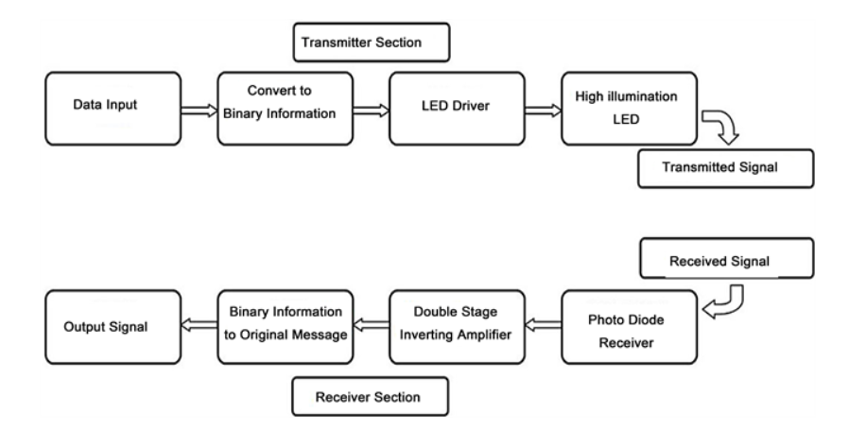

* Based on the above transmitter and receiver circuits were separately made using the elements:
  + Arduino Uno boards.
  + Laser module.
  + Light dependent resistor (LDR).
  + LCD (JHD 162A).

# CHAPTER 5 HARDWARE DETAILS

## Block Diagram

## Circuit Diagram Circuit Diagram of Transmitter and receiver is as shown below:

Fig: Circuit diagram of transmitter (above) and receiver (below)

# CHAPTER 6 SOFTWARE DETAILS

## Flowchart and algorithms

The software logic is shown using a flowchart.

## Programming language and code

The code is extensively written in Arduino IDE ( C language), and the code is added below:

**Transmitter Code (for text):**

#define TRANSMIT_LED 11                                // Connect a led with resistor to D11 of arduino

#define SAMPLING_TIME 20                               // increasing PERIOD will reduce the speed of communication while reducing the probability of error

 char text[] = "Jay Shree Ram ";

//Declaration

bool transmit_data = true;

int bytes_counter = 1;

int total_bytes;

void setup()                                           // setting up the output

{

  pinMode(TRANSMIT_LED,OUTPUT);                        // measuring the length of input text data

  total_bytes = strlen(text);

}

void loop()                                            // loop for the string which iterates length of string + 1 times

{

   while(transmit_data)

   {

    transmit_byte(text[total_bytes - bytes_counter]);

    bytes_counter--;

      if(bytes_counter == 0)

      {

        transmit_data = false;

      }

   }

   transmit_data = true;

   bytes_counter = total_bytes;

   delay(1000);

 }

void transmit_byte(char data_byte)                      // function for transmitting each charcter as a byte or 8 bits

{

  digitalWrite(TRANSMIT_LED,LOW);                       // output-ing low in digital pin D11 to mark the start of transmission of 1 byte

  delay(SAMPLING_TIME);

  for(int i = 0; i < 8; i++)                            // loop for transmission of 8 bits=1 byte=1 character which iterates 8 times

  {

    digitalWrite(TRANSMIT_LED,(data_byte >> i) & 0x01); // bit wise and-ing each bit of byte from LSB side with 1 to get 1 bit at a time

    delay(SAMPLING_TIME);

  }

 digitalWrite(TRANSMIT_LED,HIGH);                       // output-ing high in digital pin D11 to mark the end of 1 byte transmission

 delay(SAMPLING_TIME);

}

**Receiver code (for text):**

#define LDR_PIN A1

// #define LED A4

#define SAMPLING_TIME 20

#include<LiquidCrystal.h>

const int rs = 12, en = 11, d4 = 5, d5 = 4, d6 = 3, d7 = 2;

LiquidCrystal lcd(rs, en, d4, d5, d6, d7);

//Declaration

bool led_state = false;

bool previous_state = true;

bool current_state = true;

char buff[64];

// int j= 0;

// int k= 0;

void setup()

{

  // pinMode(LED,OUTPUT);

  lcd.begin(16, 2);

  Serial.begin(9600);

  lcd.setCursor(0,0);

}

void loop()

{

  current_state = get_ldr();

  if(!current_state && previous_state)

  {

    sprintf(buff, "%c", get_byte());

    Serial.print(buff);

    // if(k>15){j=1;}

    // if(k>31){j=0;

    // k=0;}

    // lcd.setCursor(j,k);

    lcd.write(buff);

  }

  // digitalWrite(LED, current_state);

  previous_state = current_state;

}

bool get_ldr()

{

  bool val = analogRead(LDR_PIN) > 700 ? true : false;

  return val;

  // digitalWrite(LED, val);

}

char get_byte()

{

  char data_byte = 0;

  delay(SAMPLING_TIME * 1.5);

  for(int i = 0; i < 8; i++)

  {

    data_byte = data_byte | (char)get_ldr() << i;

    delay(SAMPLING_TIME);

    // k++;

  }

  return data_byte;  


# CHAPTER 7 RESULTS AND DISCUSSIONS

## 7.1 Result

Text and images were successfully transmitted as shown:

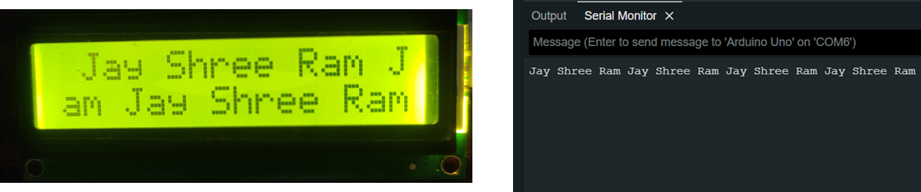

Fig: Text output on LCD (top left).

Text output in Arduino IDE (top right)

Image input at transmitter side (bottom left)

Image received displayed on GLCD (bottom right)

## 7.2 Discussion

## 