Elastic Cloud Computing (EC2)
is a web service that provides resizable computing capacity in the cloud. EC2 reduces the time required to obtain and boot new server instances to minutes, allowing you to quickly scale capacity (up or down) as the computing requirements change.
EC2 pricing models:
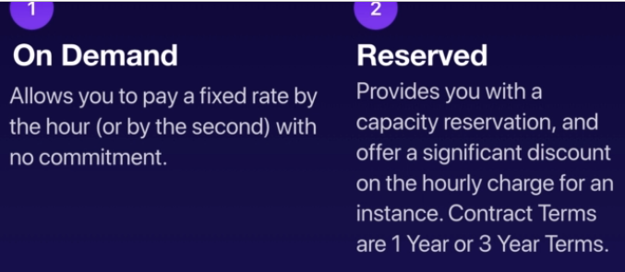
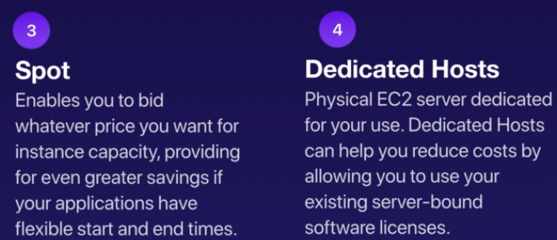
On-Demand Pricing: (used for)
1) Users who want low cost and flexibility of Amazon EC2 without any up-front payment or long term contract.
2) Applications with short term, spiky or unpredictable workloads that cannot be interrupted.
3) Applications on being developed or tested on EC2 for first time.
Reserved Pricing: (used for)
1) Applications with steady state or predictable usage..
2) Applications that require reserved capacity.
3) Users are able to make upfront payments to reduce total computing costs even further.

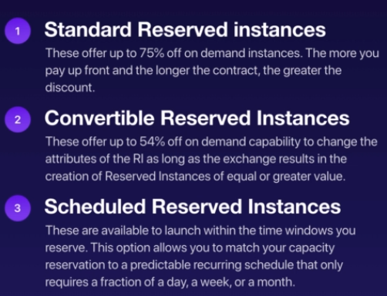
ex, if u run a school and at 9 AM when every one logs in, user needs to scale up the RI, this is where Scheduled RI is useful.
helps user convert from one virtual machine type to another to improve computing capacity. This transition cannot be cone in Standard RI
Spot Pricing : (is useful for)
is AWS feature to sell off the excess computing capacity at lower rates. If user is not willing to pay the excess price, the EC2 instances are then terminated.
1) Applications that have flexible Start and End Times.
2) Applications that are only feasible at very low computing prices.
3) Users with urgent computing needs for large amount of additional capacity.
Dedicated Pricing : (is useful for)
1) regulatory requirements that may not support multi-tenant virtualization. i.e. if government mandates dedicated servers for SPI/PCI data processing.
2) Good for licensing which does not support multi-tenancy or cloud deployments. for instance, if user has a oracle based application.
3) can be purchased on-demand on an hourly basis.
4) can be purchased on reservation for upto 70% off the on-demand price.
EC2 instance Categories/type:
