AWS Command line:
Allows you to interact with AWS platform from anywhere in the world. User can provision EC2 instances or S3 buckets etc without using AWS console.
To activate AWS command line,
- Go to Services -> Security, Identity & Compliance section -> IAM
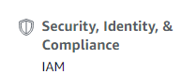

- Set up a group and add a user to the group.
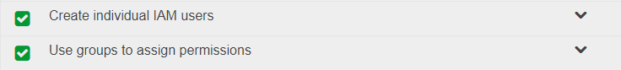

NOTE: User should only be given “Programmatic Access” and not “AWS Management Console Access” i.e.
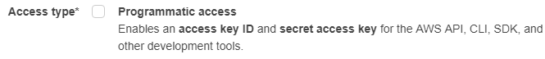
This process will generate an access key ID and secret access key ID which will be used to login to AWS.

It is important to know that user receives these keys only once. If you lose these keys,
Go to IAM Dashboard -> users -> Security credentials -> “make inactive” the access key ID -> then, create access key .

- Create a new EC2 instance and access it from a PUTTY session or Chrome SSH. To use a AWS command, we need to type “AWS” keyword and then the service we want, example,
Aws S3 ls //this will list all the S3 buckets.

Before we access any service, we will need to configure credentials else we will get the error as “Unable to locate credentials”. So, to configure credentials, we will run,
Aws configure //this will prompt for AWS Access Key ID, Secret access key ID, Default region, Default output format

To create a bucket,
Aws s3 mb s3://testbucket

Key Takeways,
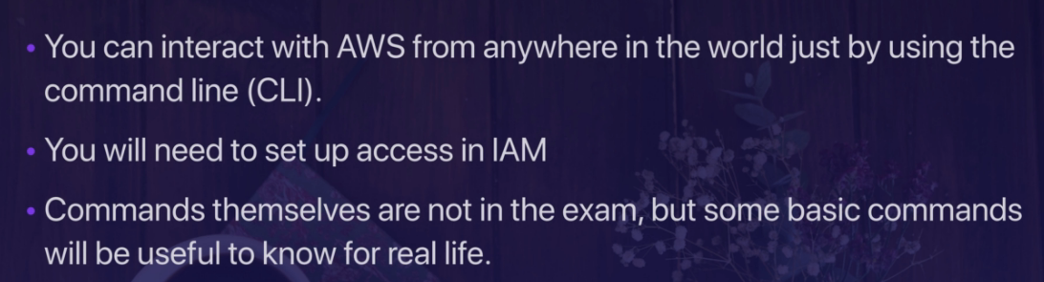

IAM Roles with EC2:
On the command line, go to your home directory, it has a hidden directory i.e. “.aws”. When you list the contents, there are 2 files “config” and “credentials”. You can view the content. This is a security threat as if a hacker is able to get into an EC2 instance, they can view these credentials. To handle this security threat, we can use roles,

Create a Role:
- To access Roles section; Go to Services -> Security, Identity & Compliance section -> IAM -> Roles
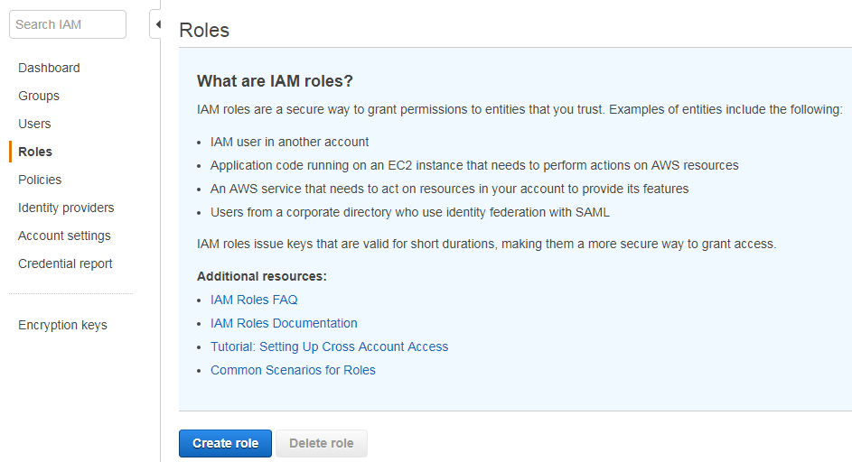

- Hit on “Create Role” button, then choose the service which will use this role as EC2,
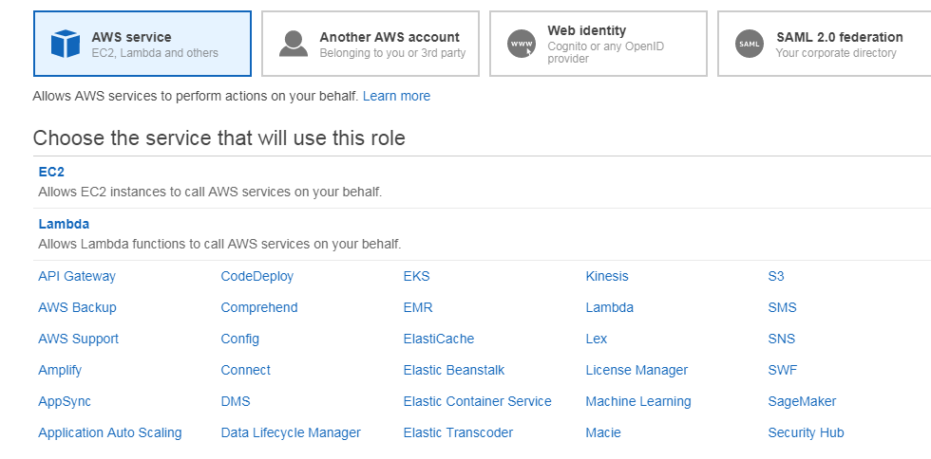

Choose EC2 -> Next: Permissions
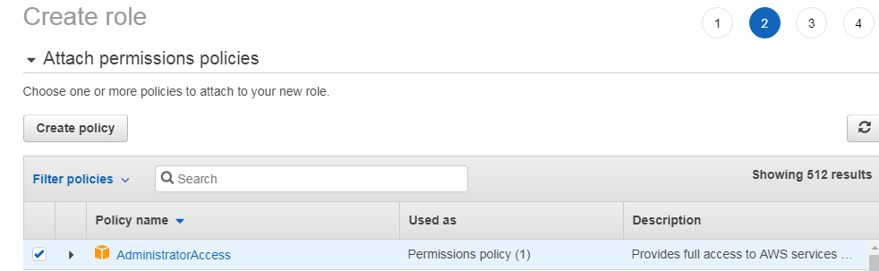

Add tags (skipped in this case)
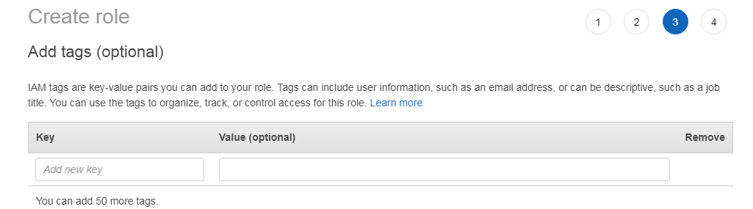

Go to review section and then “create role”
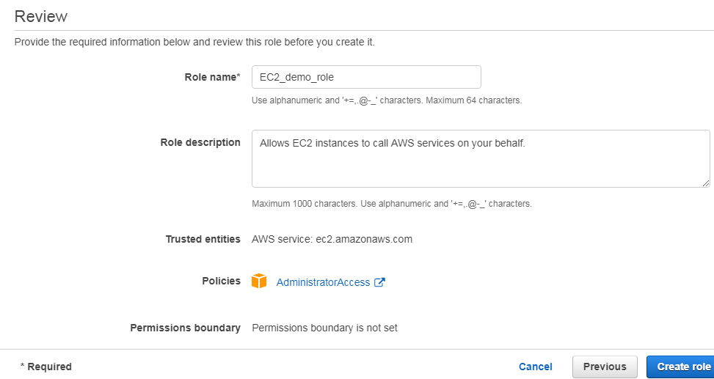

Access the role from CLI:
- Login to the Ec2 instance from Putty or chrome SSH
NOTE: we can delete the .aws folder in the home directory. When we do this, AWS is unable to locate the credentials and fails to execute AWS service commands. We can again create the creds by using “Aws configure” command, this will again create the .aws directory.

- Instead of doing that, we will attach a role to the EC2 instance as,
Go to the EC2 Instance running
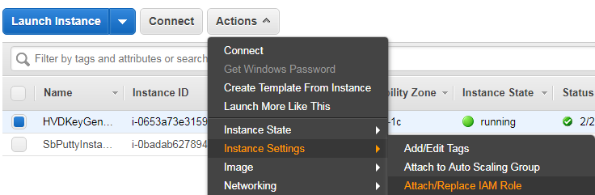

Then,
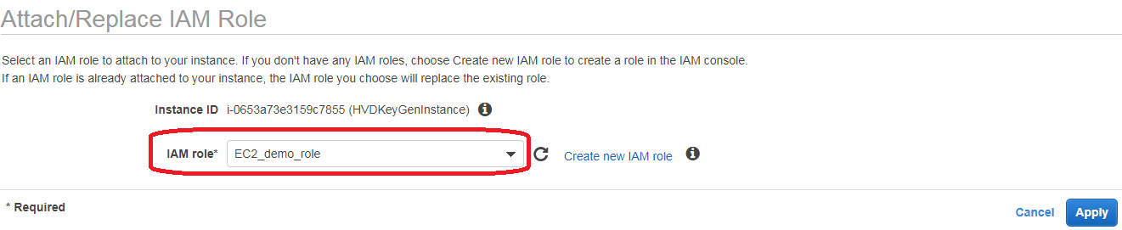

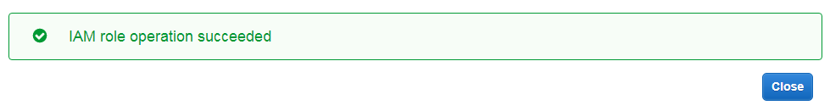
We can view the role in the description in EC2 Instance Description as,

If we click on the role, we can see the policy within the role (which in this case is admin access)
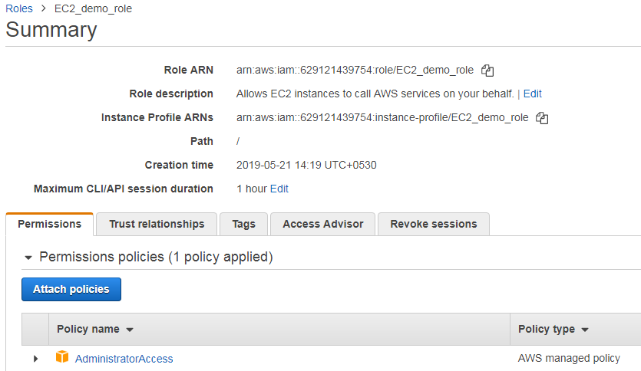

- Now, in our session, if we have removed the aws directory too, we can access the S3 buckets and other services without getting error “not able to locate configuration”

Adantages to roles over keys:
- When Using roles, hackers can hack into EC2 instances but not get the keys which can be used to hack all other EC2 instances running on the same keys.
- Roles are easier to manage, as in case we lose our keys, we need to update new keys in 1000 Ec2 instances where the keys were stored on. In case of role, user can just change the role and it takes into effect immediately.

Key takeaways,
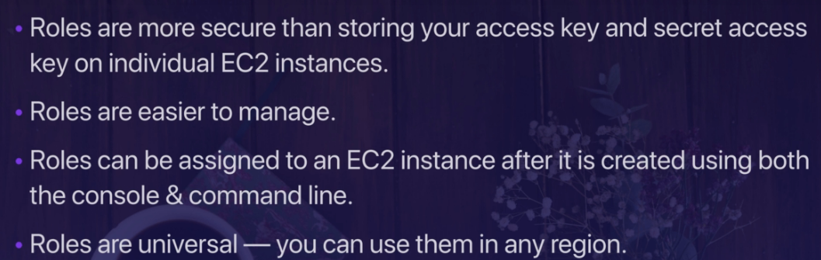

Boot Strap Scripting in AWS:
Is a way of automating AWS EC2 deployments i.e. running commands when EC2 boots.So we can run updates, install software, and anything that can be done via command line.
Steps for bootstrap scripting:
- Create a new EC2 instance. While creating, in STEP3 i.e. “configure instance details”, configure the following as,
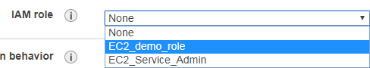

Then, go to “Advanced Details” section, here we will code the bootstrap script as,
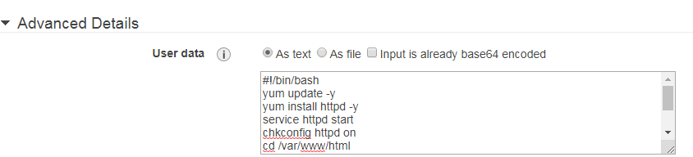

Here the statements mean,
#!/bin/bash

#install/update any upgrades and install apache to use this as a web server
yum update -y
yum install httpd –y

#start the webserver service. Restart in case EC2 goes down
service httpd start
chkconfig httpd on

#create a HTML page i.e. index.html
cd /var/www/html
echo "<html><h1>Hello ALL Welcome To Shubhro's Webpage</h1></html>" > index.html

#create a S3 bucket and backup index.xml to the bucket
aws s3 mb s3://INDEXHTMLBKUP
aws s3 cp index.html s3://INDEXHTMLBKUP

- Once the EC2 instance initiates, we can access the webpage using the ipV4 address as,
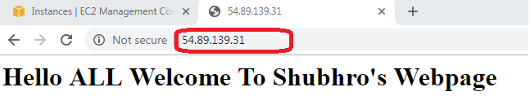
This will also create a S3 bucket and store index.html file on the bucket.

