Creating a Billing Alarm : for services that are not free tier, the billing amount may add up without our information. To add a check on the maximum billing amount we can afford, this AWS Service is used.
So billing alarm is used to store the maximum billing amount for a month.
TO set up a billing Alarm, use the following steps:
- Go to the account and hit “My Billing Dashboard”
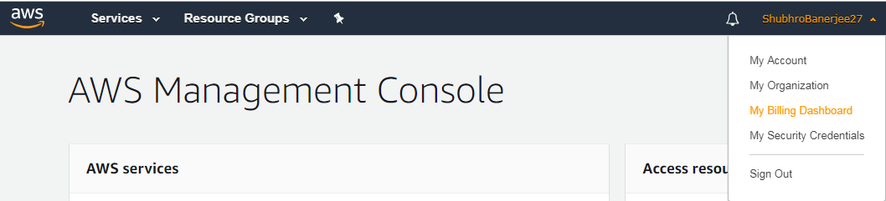

- Go to Preference -> Billing Preferences
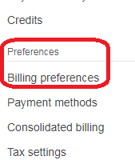

- Click on “Receive Billing Alerts” checkbox -> hit “Save Preferences”
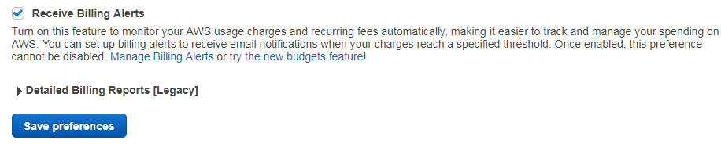

- Go To Services -> “Management & Governance” -> “Cloud Watch”
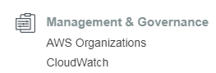

- Click on “Billing” option – “Create Alarm” as
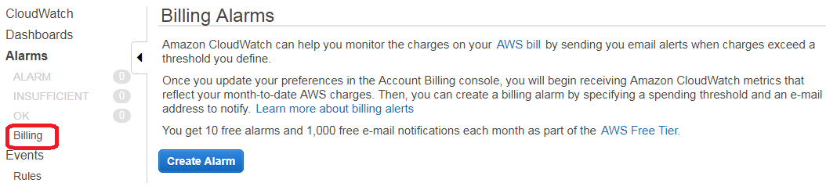

- Set up the threshold,
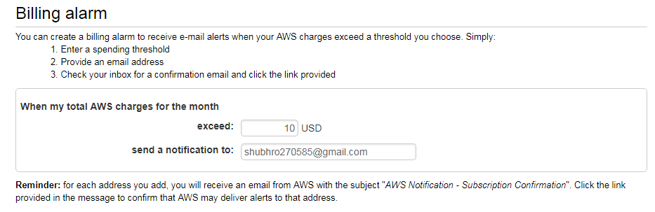

- Confirmation will be send on the email address mentioned which needs to be “confirmed” via the link provided. One done, click “View Alarm”
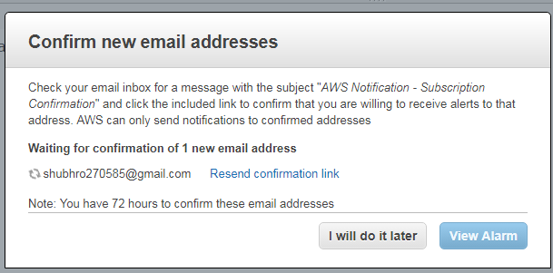

- The billing alarm is finally set as,
