Hi Shubhro,

As I can see from the above screenshots that versions and dependencies are incorrectly specified and also you have missed some packages in your SBT file.
If you are using Spark 1.x, it is mandatory to specify right Spark and Scala version in your file along with the dependency. As I can see that you have specified "provided" instead of Spark version which is not needed.

Please refer below code snippets for Spark 1.x and 2.x:

Please add below packages and make necessary changes in your program.
import org.apache.spark.streaming._
import org.apache.spark.streaming.kafka._

For Spark version1:
The simple.sbt file looks like:
name = Spark_Stream_App1
version = 1.5.2
scalaVersion = 2.10.4
libraryDependencies += "org.apache.spark" %% "spark-streaming-kafka-assembly" % "1.5.2"
For Spark version2:
The simple.sbt file looks like:
name = Spark_Stream_App1
version = 2.0.1
scalaVersion = 2.11.8
libraryDependencies += "org.apache.spark" %% "spark-streaming-kafka-0-8" % "2.0.1" % "provided"

Note: There is no dependency named spark-streaming-kafka-0-9. Only spark-streaming-kafka-0-8 and spark-streaming-kafka-0-10 jars are available for integration of Spark streaming and Kafka in Spark 2 version. Please refer below screenshot:

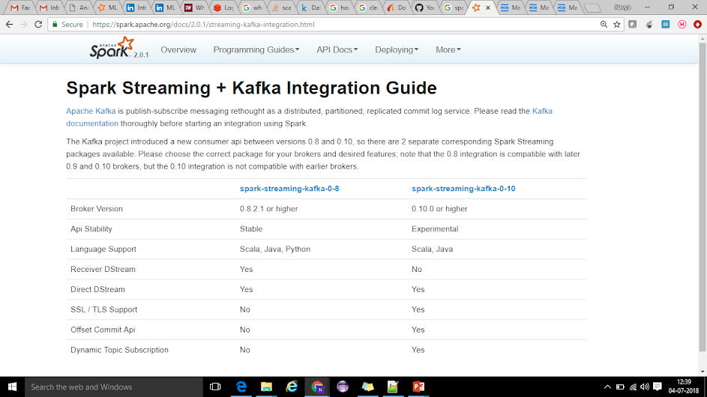
​
So, I request you to choose jars depending on the version of Kafka broker. You can download above mentioned jars from below links:

https://mvnrepository.com/artifact/org.apache.spark/spark-streaming-kafka-0-8

https://mvnrepository.com/artifact/org.apache.spark/spark-streaming-kafka-0-10

To add dependencies of above jars, you need to clearly mention Spark version as well in the SBT file as shown above. Also please refer to below screenshot in which you will find the dependency to be added for each jar which you want to include it in your project from the download location itself.





