S3 Security and Encryption:
By Default, all the newly created buckets are PRIVATE. To set up access control on buckts, there are 2 ways,
- Bucket Policies, which apply on buckets.
- Access Control Lists which apply to objects within buckets.
S3 buckets can be configured to create access logs which log all the requests made to S3 Buckets. These logs can be sent to a different bucket residing within the same account or a different AWS account.
Encryption can be applied to 2 different kinds of data,
- Encryption in transit. For instance, if we are using a HTTPS:// URL, then the traffic is encrypted when transiting between user and server. Encryption in transit is always achieved by SSL (or TLS)
- Encryption at Rest i.e. encrypting the data that is being stored. For instance, if a word document is stored in harddisk and the harddisk is stolen, so is the data.

In Amazon, all the keys are managed by either,
- “S3 MANAGED KEYS” also known as SSE-S3 i.e. Server Side Encryption S3.
- AWS also provides AWS Key Management Service where the user and Amazon both manage the keys together. This is called MANAGED KEYS – SSE-KMS
- Server Side Encryption with Customer Provided keys. This will where the user provides the Amazon his own keys which the user manage. This is also called – SSE-C.
The other option is client side encryption where we encrypt the data before storing it in Amazon S3.
To Set Up Encryption On S3:
- Go To S3 Console -> Enter the bucket -> select the file
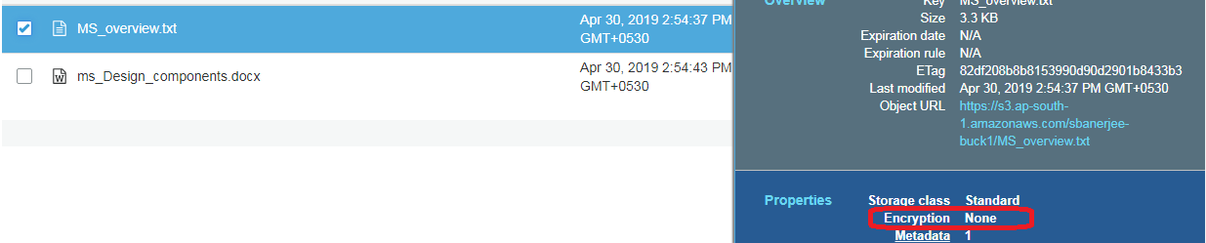

- Click on Encryption,
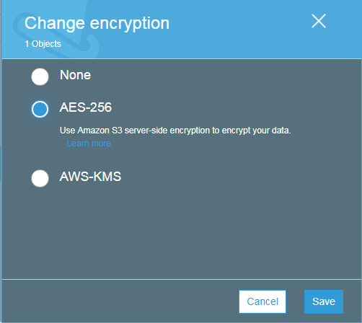

NOTE: AWS-KMS is out of scope for Solutions Architect. We will select AES-256 encryption on the file.

- Once Done, the file will show as encrypted,
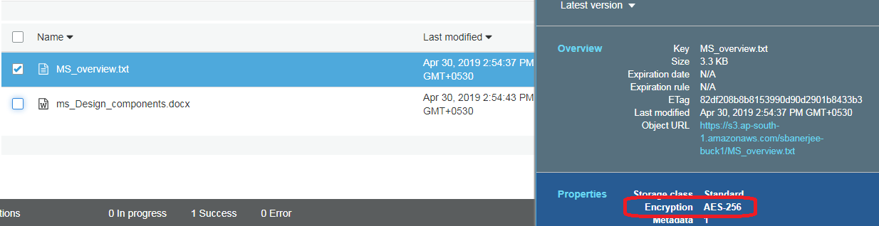

S3 Versioning:
- S3 stores all versions of an object that includes all the writes on the object and the versions are maintained even if the object is deleted.
- Once enabled, versioning cannot be disabled, however versioning can be suspended. So to disable versioning on a bucket, we have to delete the bucket and create a new one.
- Versioning on S3 is usually used as a backup tool.
- Versioning can be integrated with Lifecycle rules.
- Versioning also has MFA Delete capability which uses multi-factor authentication to provide an additional layer of security so that people do not accidently delete an object which is versioned.

Enable Versioning:
- Create a public bucket and upload a file (public).
- For the public file created, go to properties -> versioning
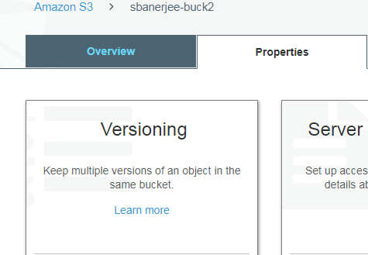
- Click on Versioning Option -> Enable versioning -> Save,
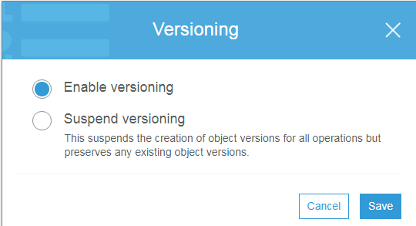
Now Versioning will be enabled.
- On the file Overview tab, a new versioning section starts appearing as,
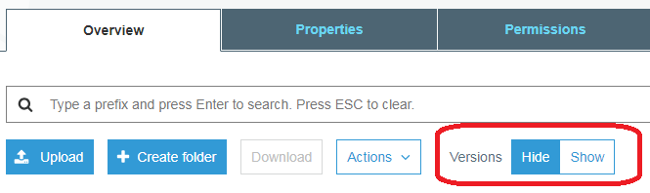
Activating “Show” option will show the versions of the file.
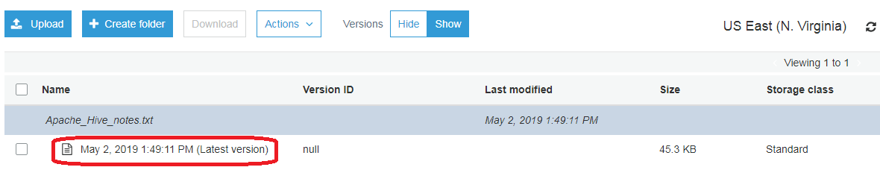
- Upload a new version of the same file,
2 things to NOTE when uploading a new version,
- The file permissions on the new version will be “Private”. So in order to update the file to public, the process has to be followed again. But the older versions will be still “Public”
- The size of the bucket is sum of all the versions of the file. So as per the example below, the size is “97.8 KB”. While architecting a solution, we have to consider this, if there are multiple updates to an object of considerable size, the bucket size will also increase. So either, we do not activate Versioning or employ a life cycle mechanism to delete the previous versions frequently.

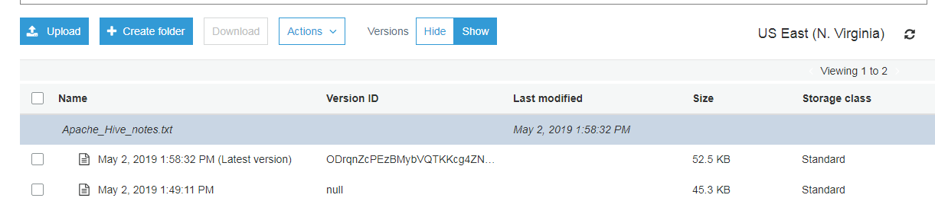

To remove a version of a file in S3,
- If we have deactivated “show versions” and try to delete,
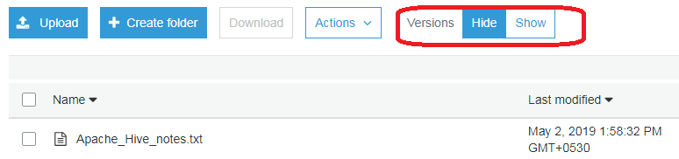

Try to “delete”,

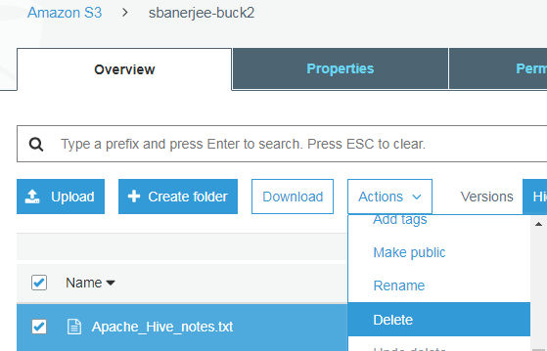

After performing “Delete”, we get the following screen,

But when we activate “show versioning”, there is a new version “Delete Marker” and the file has not been deleted. Delete Marker is a new (latest) version of the same file,
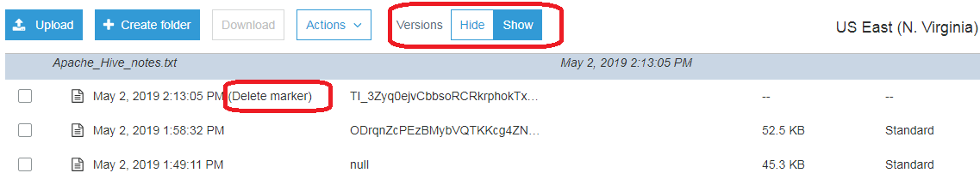

If we delete the “Delete Marker” version, the previous version becomes the latest one as,
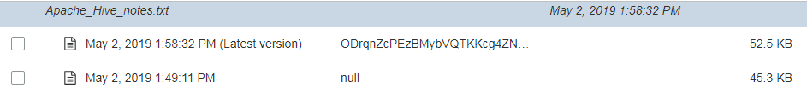

- With “Show Versions” on, we can delete files using the delete option as,
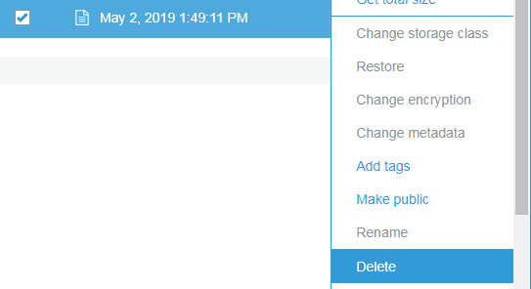

Once “Delete” is hit,
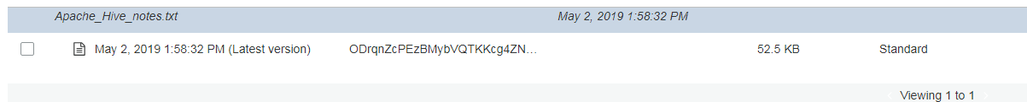

S3 Lifecycle management
We can use life cycle management to,
- Transition from one storage class to another storage class.
- Permanently delete a version (pervious or latest or both).
- Archive a file to Amazon glacier.
To activate lifecycle management rule,
- Go to S3 Storage -> bucket -> management
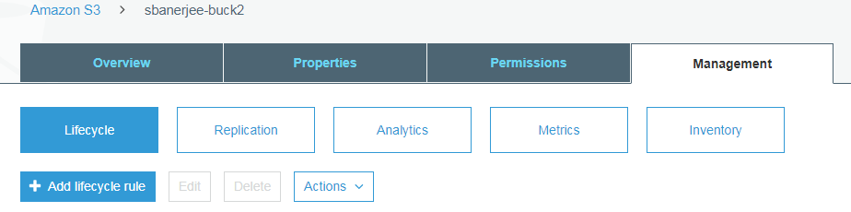

- Press “Add lifecycle rule”
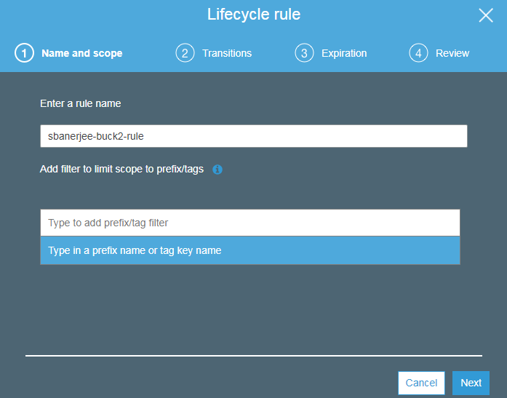

- Transition section, we can transition from one storage class to another,
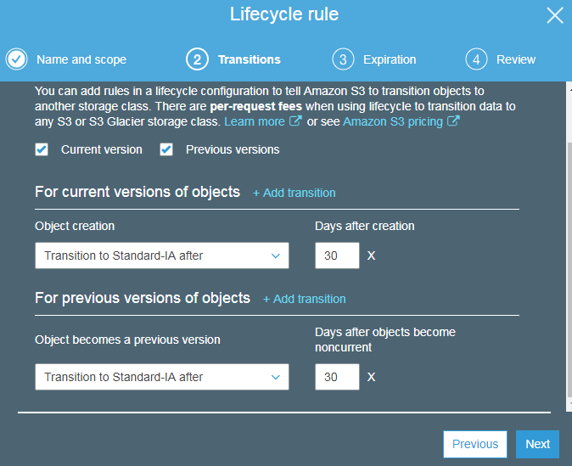

NOTE: We can also ignore this step and move to next section.
- Expiration section,
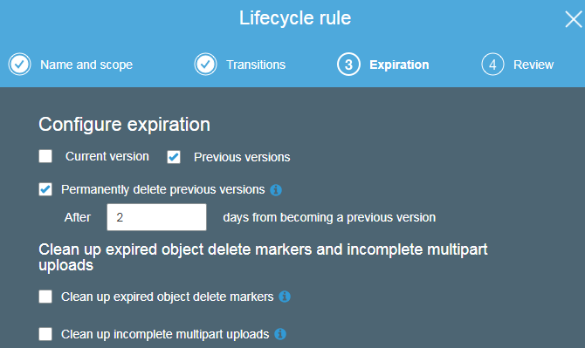

- Review Section,
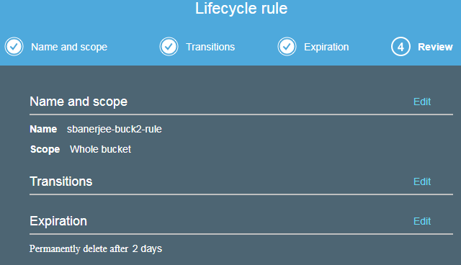

Click “Save” button.

- The lifecycle rule applies to the entire bucket as,

Refer to the following links for file transfer via Java:
https://docs.aws.amazon.com/AmazonS3/latest/dev/UploadingObjects.html
https://www.baeldung.com/aws-s3-java
https://github.com/aws-samples/aws-java-sample/blob/master/src/main/java/com/amazonaws/samples/S3Sample.java
https://docs.aws.amazon.com/AmazonS3/latest/dev/UploadObjSingleOpJava.html

