PICTORIAL REPRESENTATIONS:
- BAR GRAPH: used to represent categories i.e when you want to show a single variable value in terms of categories. Example, representing average income of domains as
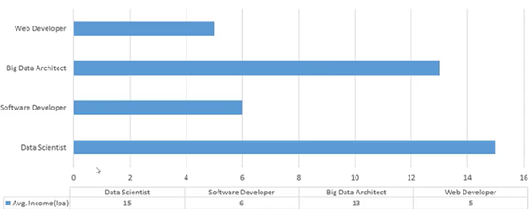

- HISTOGRAM: how is data distributed in the variable i.e. showing how salaries are distributed
X-axis is all values of salary and Y-axis is frequency of employees having the salary value.

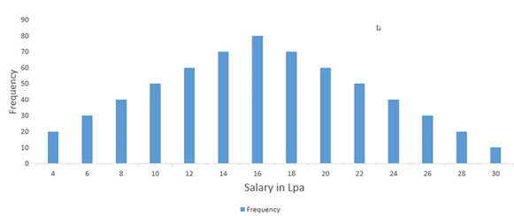

- BOX-PLOT: compares 4 different variables (/distributions). Box is plotted to plot outliers and IQR.
Here length of box gives IQR.
Smaller plot (2) tells that most of the data is not significantly different (less deviation)
Taller plot (3,1) tells that data is significantly different (more deviation)

So, if for example, the box plot represents salaries in 4 different departments of a company,
To reduce salary disparities, management will focus on 3rd plot, then 1st plot, then 4th plot and last 2nd plot
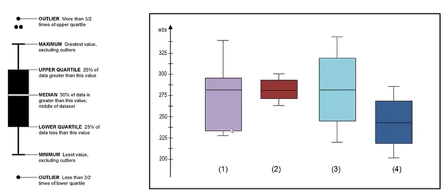

Note: the lines in the boxes represent Median. So for plot-1, it mentions skewed distribution i.e. more values in IQT are below median than above median.

- TIME-SERIES PLOT: Used for forecasting trends. i.e. when we see a continuous stream of data having time as the X-Axis.
Example, run-rate in a cricket match, share markets.

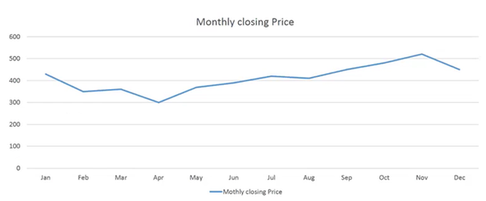

- HEAT-MAPS: Used to plot density of a variable i.e. within same data plot, if we need to highlight patches of data that is significant.
Example, airline passenger travel patterns for 10 years, dark colours mention high travel density, light colours have less travel density.
Sport analysis like bowler’s heat map on the pitch to measure bowler’s performance.

