To create an account, go to : go to https://aws.amazon.com
Exam question: what is the difference between Basic Plan, Developer Plan and Business Plan, when u create an AWS Account,
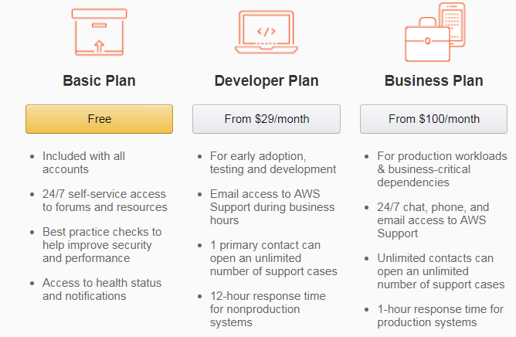
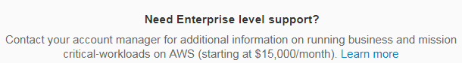

Identity access management (IAM):
allows to manage users and their level of access to AWS Console. In real life, it administers a company's aws account.

IMA offers,
1) Centralized control of your AWS account.
2) Shared access to your AWS account.
3) Granular Permissions i.e. grant access for one AWS service but revoke access for other service.
4) Identity Federation i.e you can use Active Directory, Facebook, Linkedin credentials etc to login to AWS account. ex, if you are gaming and in the game storing data to AWS console, AWS IAM can facilitate access to gaming AWS account via facebook.
5) Multifactor authentication i.e. IAM can also enable a code which needs to be entered along with AWS username and password to login to AWS.
6) Provide temporary access for users/devices and services. ex, using a mobile app to access AWS for storage.
7) Allows you to set up your own password rotation policy.
8) Integrates with many different AWS services.
9) Supports PCI DSS Compliance i.e. a framework which allows users to store their credit crd details securely.
IAM terminologies:
1) Users : End users such as people, employees of an organization etc.
2) groups: collection of users. Each user in group will inherit the permissions of the group.
3) Policies : Policies are permissions. Policies are made up of documents called Policy Documents (JSON format documents) and give permissions as to what a user/group/role is able to do.
4) Roles: you create roles and then assign them to AWS Resources.

