Facade Service: is an architecture used to introduce loose coupling and eliminate tight coupling between components.
(both screenshots are combined)
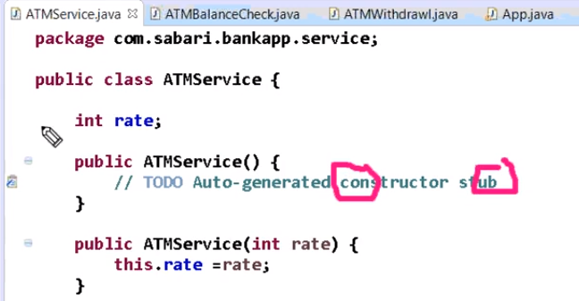
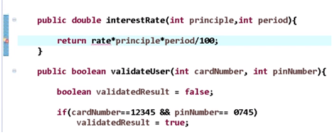
In ATMBalanceCheck and ATMWithdrawl, we add a new method which uses interestRate as follows,
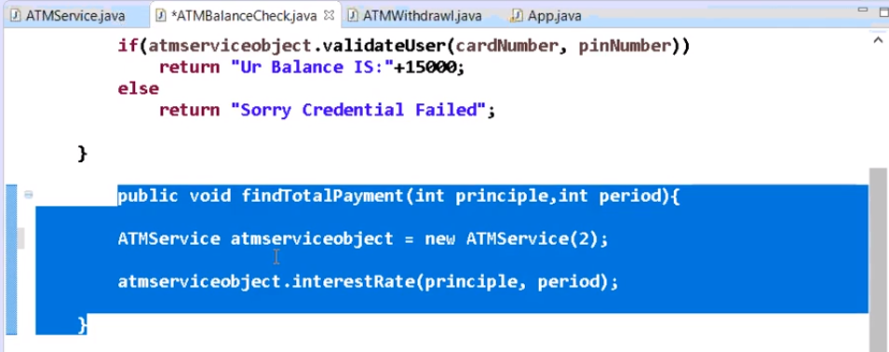
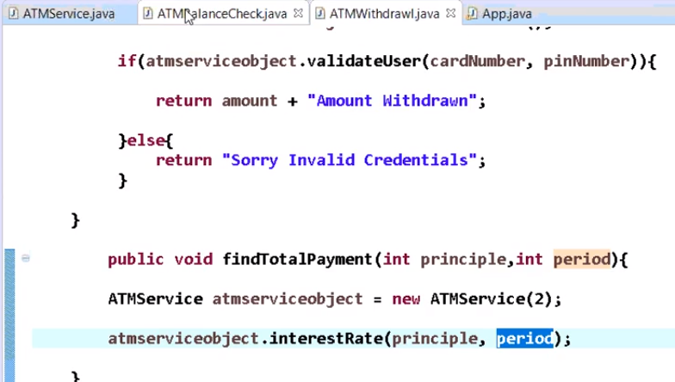
App.java:
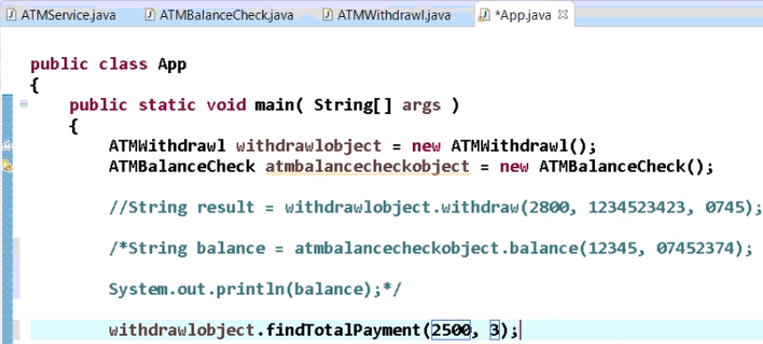
O/p from app.java:
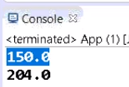
Now if client wants the rate on ATMService to be integer (other than double), the values passed in the other 2 modules will also have to be changed. This model is thus tightly coupled.
Spring allows us to implement loose coupling by not injecting ATMService instance in the 2 modules
by a service called External Entity which will have the configuration to inject ATmService instance into other 2 classes.
Here ATMService is a Bean Object (or POJO) which is a light weight entity that does not have life cycle of its own.
NOTE: Other 2 APIs are also beans.

External Entity is called Spring IOC (Inversion of control) Container. All framework will have this inbuilt container which has to created for a project.

