Custom VPC and Elastic Load Balancer:
First thing to check is that when we provision a load balancer, we need at least 2 public subnets. For instance,
- Create a load balancer,
Go to EC2 Dashboard -> Load Balancing Section -> Load Balancers
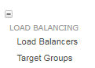
Go to “Create Load Balancer”
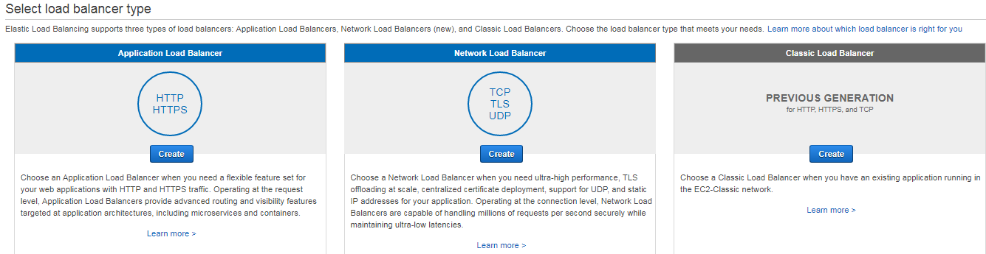

Chose “HTTP HTTPS” option and hit “Create”

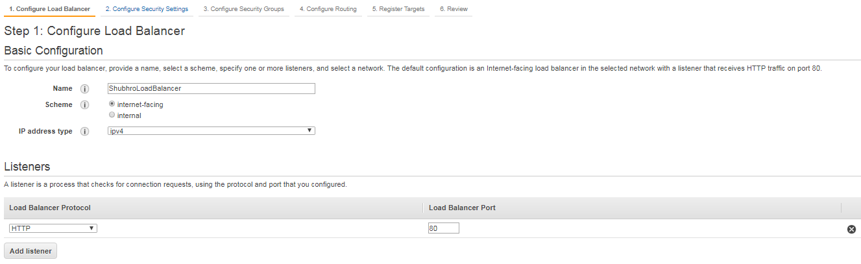

In the “Availability Zones” part, if we choose the private subnet, AWS does not allow it,
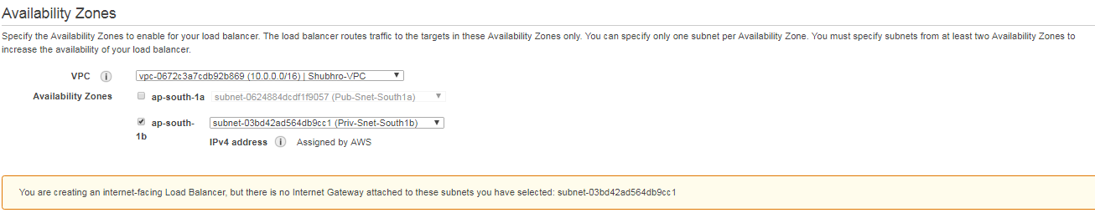
In the “Availability Zones” part, if we choose the public subnet, AWS gives error,
