Network Acccess Control List (NACL) VS Security Groups (SG):
A typical VPC now looks like,
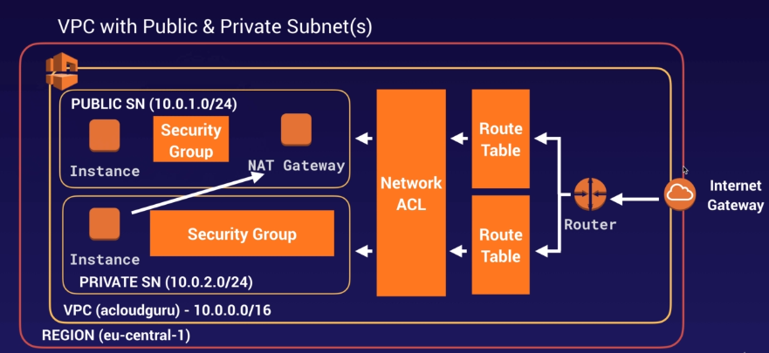

For NACL, go to VPC Dashboard -> Security -> Network ACLs
first is NACL for the VPC created and 2nd row is for DEFAULT VPC. In the Shubhro-VPC NACL, if we check the routes,
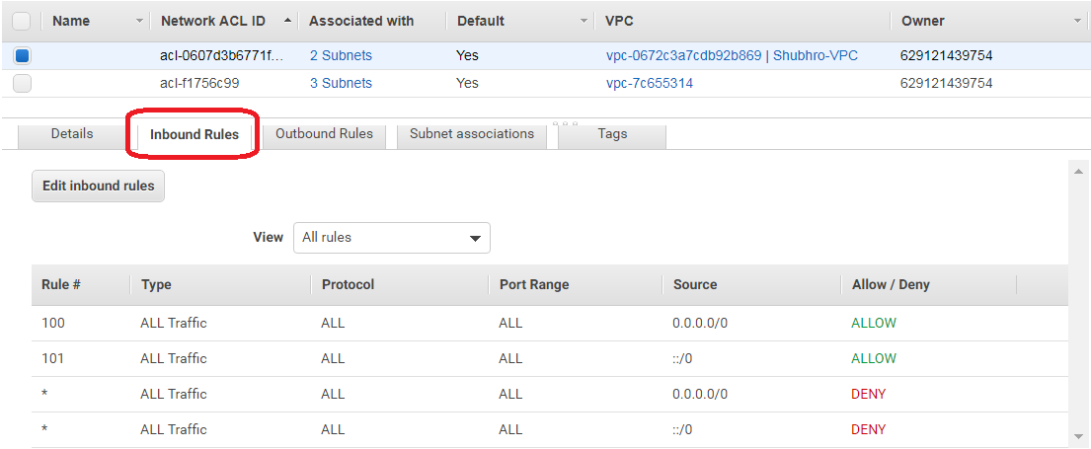
i.e. Rule 100 is for IPv4 and Rule 101 is for IPv6. AWS recomments rule increments of 100 i.e. if we add another rule for IPv4, we add rule number 200 and for IPv6 we add a rule number 201.
The above also applies for outbound rules,
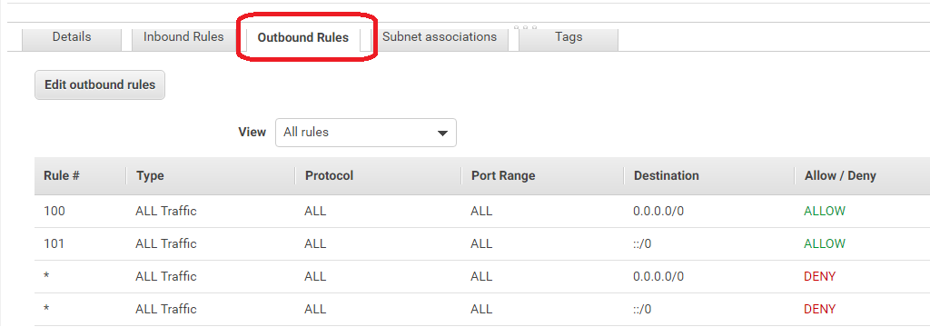
Creating a NACL:
1) VPC Dashboard -> Security -> Network ACLs -> Create network NACL
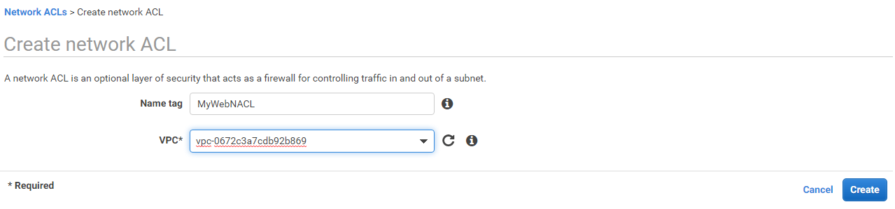
here VPC will be "Shubhro-VPC" i.e. the VPC created.
2) By default, the inbound rules and outbound rules will have all Rules Denied by default,
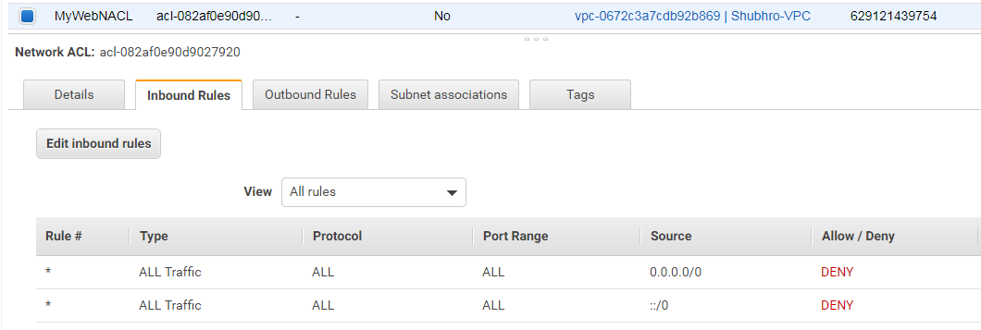
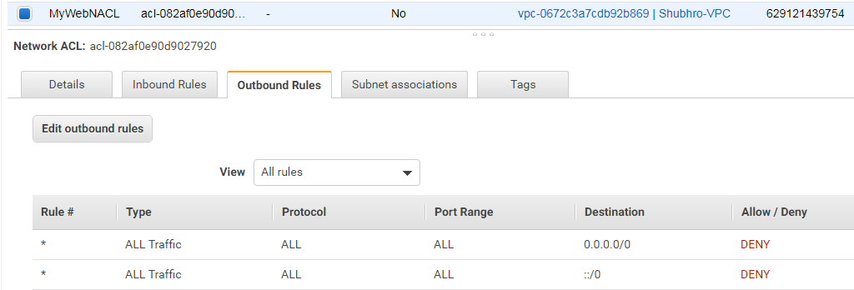
3) Test the new NACL created, go to Web EC2 Instance,
Type "service http status"
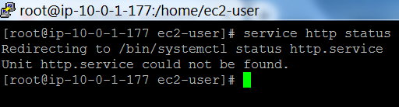
Implies this service is not yet installed. To install, hit command "yum install httpd -y"
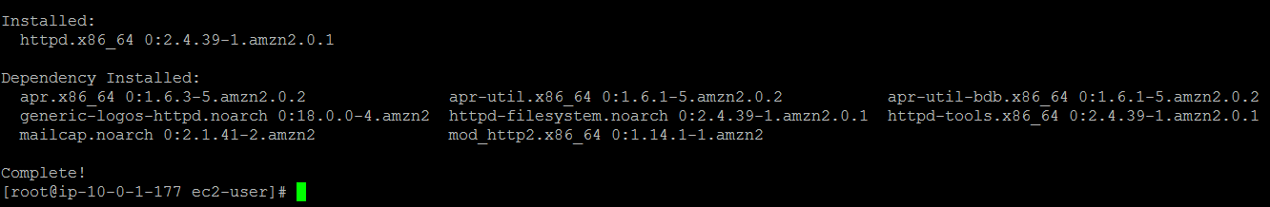
to check command "chkconfig httpd on",
then command "service httpd start" to start service
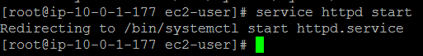
Create a html page as,
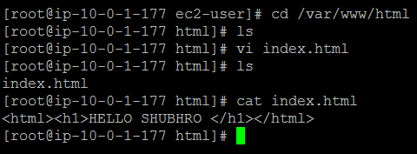
when I try to access the PublicIPV4 IP address on browser, it gives error,
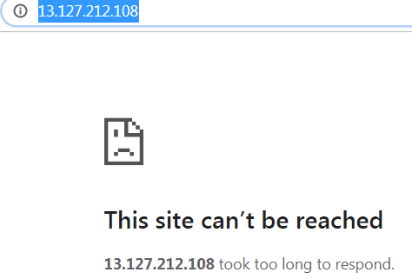
This is because the SG on this EC2 instance doesnt have HTTP configured.
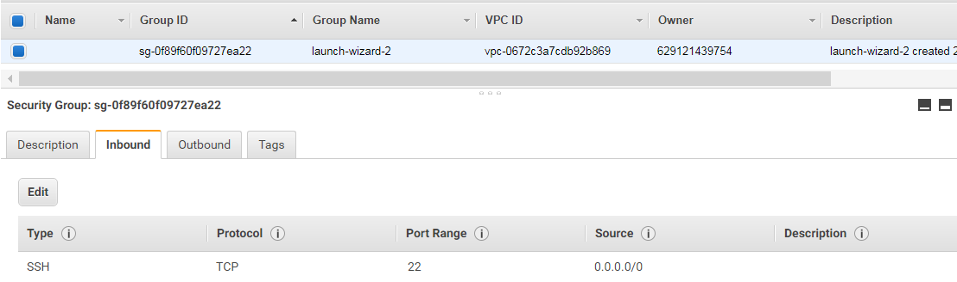
so when we configure http as,
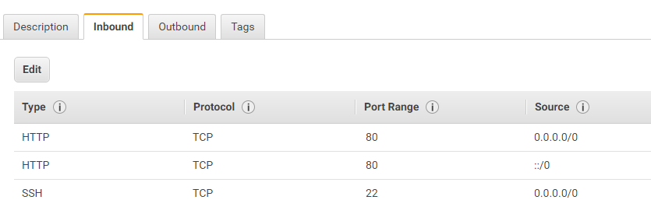

Now when we access the IP on browser,
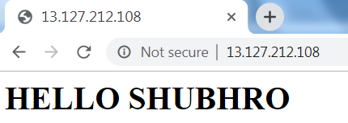
4) But the point to notice is that the new Network ACL created has all the inbound rules as “Denied”, still the EC2 web service is able to http.
The reason is that as of now both the subnets are attached to default Network ACL which has the “Inbound Rules” allowed.
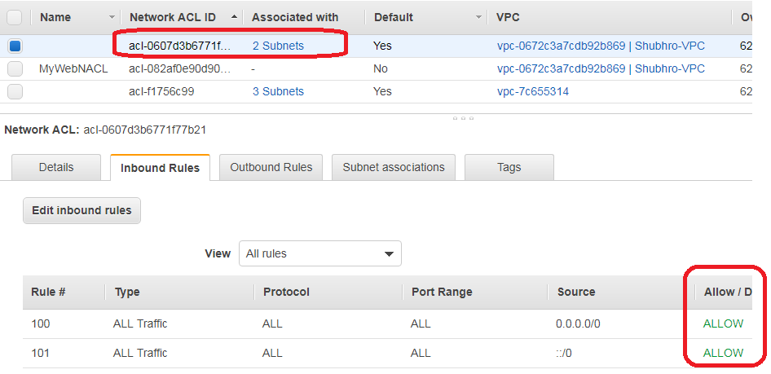
Now, let us attach our 2 subnets to the new Network ACL i.e. MyWebNACL. Here, associate the Public subnet with this MyWebNACL.
Click on “MyWebNACL” -> go to “Subnet Association” tab -> edit Subnet Association.
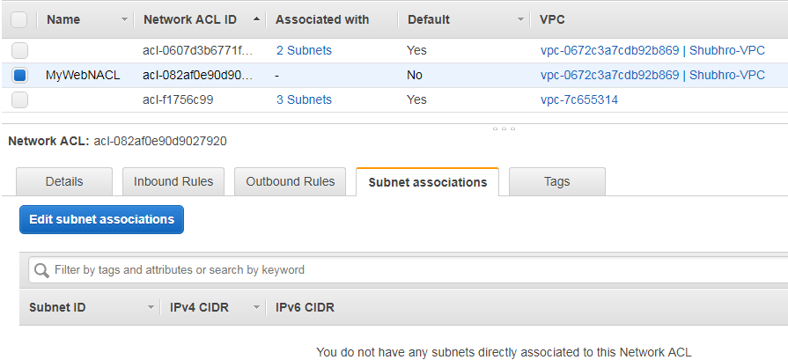
Then,
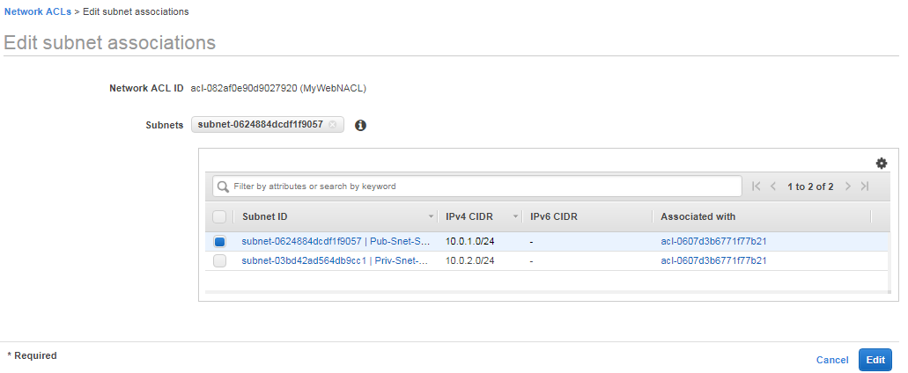
This will associate the public subnet to this Network ACL and remove it from the default network ACL, as,
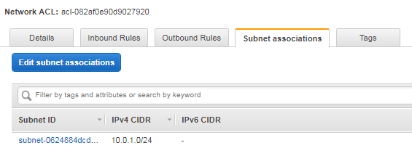
And ACLs view will look like,
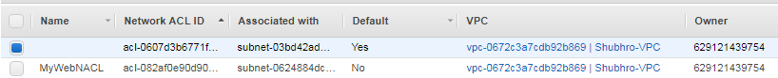
Now if we try to open the Public IP on the WebService EC2 Instance, it will timeout as this ACL does not allow http traffic to come thru.

To fix this, create some rules in “Inbound Rules” as, Go to Network ACL -> Inbound Rules -> Edit Inbound Rules -> Add Rule
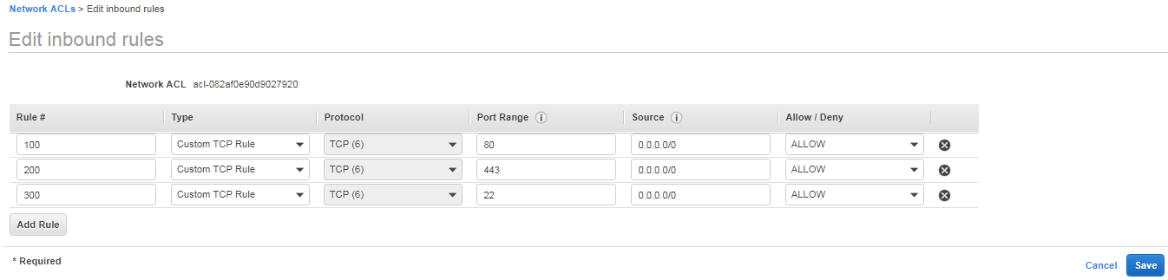
This will allow HTTP, HTTPS and SSH to whole world i.e. 0.0.0.0/0. We will also need to upgrade the Outbound rules as,
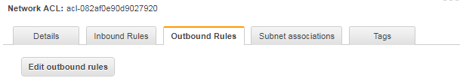
Then,
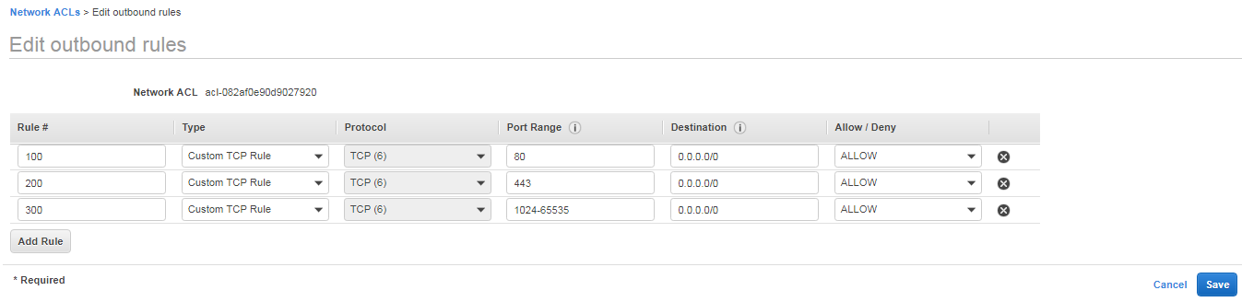
Here, 1024-65535 are called ephemeral ports i.e.
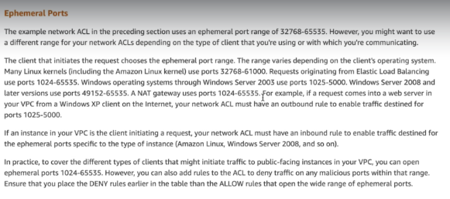
i.e. a NAT-gateway ises ports 1024-65535 (as mentioned in screenshot)
Outbound rules now look like,
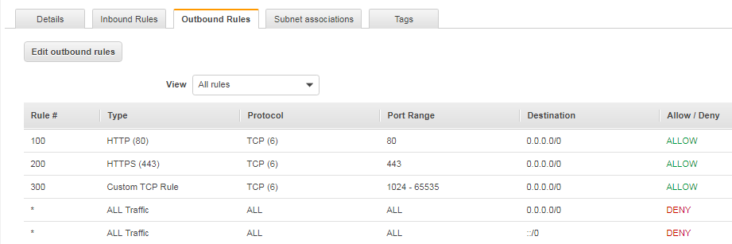

Once completed. Go to the website and hit refresh and the HTML should come up as,
5) How to deny a rule in Network ACL? The rules are executed in the order in which they have been entered i.e. for Inbound rules,
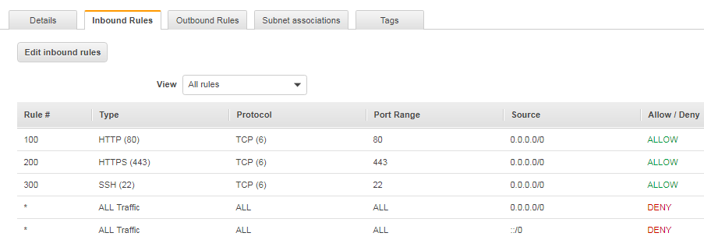
So rule 100 will be executed before 200 and 200 rule will be executed before 300. So ports 80, 443 and 22 will be opened to accept traffic, others will be closed.
To deny a rule, we can edit the rule and add one as,
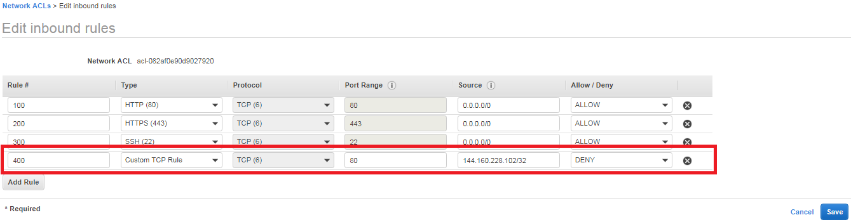
This will deny access to port 80 on my IP
To determine your IP Address,
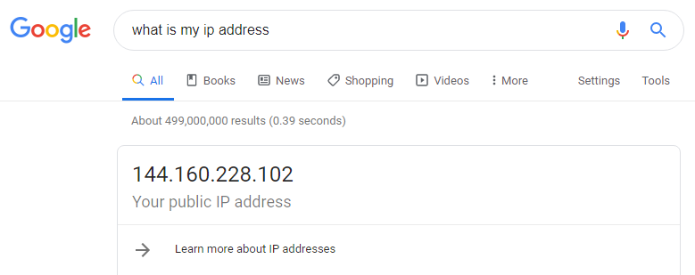
But when I try to open webpage it shows HTML as,
This is because rule 100 allows all IP addresses and then deny on my IP is rule 400, so rule 100 overrides rule 400.
NOTE : Network ACL rules are executed in chronological order.
To deny my IP, I shall have to add the deny before allow set of rules, as,
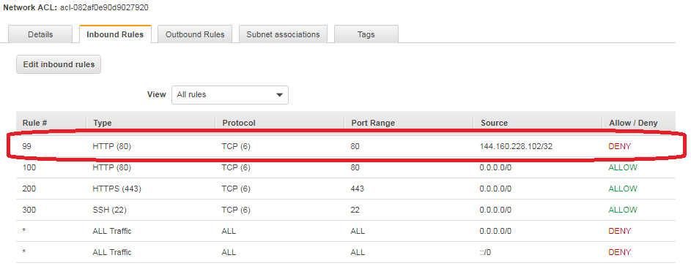

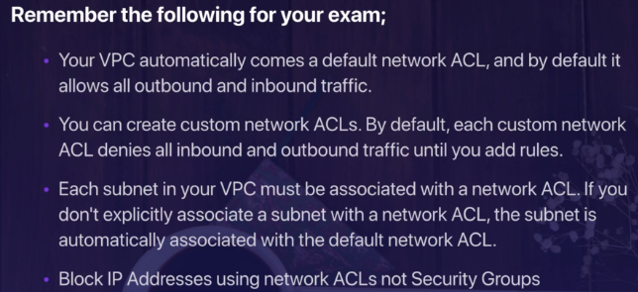
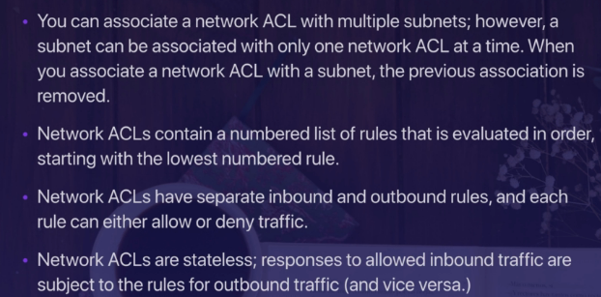
NOTE:
Network ACLS are always evaluated before Security Groups. So if an IP is denied by Network ACL, it will not even reach the Security Group evaluation.

