Understanding Hadoop and Map-reduce:
MapReduce uses list i.e. (key/value) pairs as its main data primitives. The keys and values are often integers or strings but can also be dummy values to be ignored or complex object types.
The complete data flow looks like,
- The application input will be a structured list ([key1,value1] pair). Example,
Example, list[<String filename, String file_content>]

- The list of (key/value) pairs are broken into individual pairs and are processed by mappers.
Mappers (or the map function) ignores the key values. Mapper will transform the [key1,Value1] pair into [key2,Value2] pairs.
Example,
<String filename, String file_content>
eg, <file1,"here is a text which has text">
<String word, count1 as Integer>.
eg, <"text",2>
Mapper
Input

Output

- The output of all the mappers are (conceptually) aggregated into one giant list of <k2, v2> pairs. All pairs sharing the same k2 are grouped together into a new (key/value) pair, <k2, list(v2)>.
The framework asks the reducer to process each one of these aggregated (key/value) pairs individually.
Example,
reducer will aggregate the <"text", list(1,1,1,1,1)> to <"text",5>
Reducer
aggregated pair the reducer will see is,
<"text", list(1,1,1,1,1)>
Mapper
map output for,
file1 may be a list with pair <"text", 1> three times
file2 may be a list with pair <"text", 1> two times

Take an example of a school principle and who has 1000 mathematics answer scripts of students from science, commerce and humanities department. If a teacher requires 10hrs to evaluate 100 answer scripts, so to evaluate 1000 scripts you need 10 teachers to complete the task in 10hrs.

Problem statement 1: Principal wants to find the top 3 students across all the departments.

Resource allocations:
1) Principal is Name Node
2) 10 teachers are data node.
3) Map-Reduce program will run on each teacher node.

How Map-Reduce will run?
1) Each Teacher will have both mapper and reducer functions
a) input to Mapper will be, [(department1,roll number),(department2,roll number),....,(department3, roll number)]
b) each mapper will disintegrate the input as
[(roll numberX,Answer script content),(roll numberY,Answer script content),(roll numberZ,Answer script content)..10 times]
c) mapper will produce output as,
[(roll numberX,Marks),(roll numberY,Marks),(roll numberZ,Marks)..10 times]
d) reducer will compare the marks and derive 1st 3 roll numbers on the data node (teacher)
2) This will happen across all 100 data nodes (i.e. teachers1 thru 10)

What Name node will do?
compare the results of each data node and form the top-3

Problem statement 2: Principal wants to find the top 3 students in each departments.

Resource allocations:
1) Principal is Name Node
2) 10 teachers are data node.
3) Map-Reduce program will run on each teacher node.

How Map-Reduce will run?
1) Each Teacher will have both mapper and reducer functions
a) input to Mapper will be, [(department1,roll number),(department2,roll number),....,(department3, roll number)]
b) each mapper will disintegrate the input as
[(roll numberX,Answer script content),(roll numberY,Answer script content),(roll numberZ,Answer script content)..10 times]
c) mapper will produce output as,
[
science,List[(roll numberX,Marks),(roll numberY,Marks)],
commerce,List[(roll numberZ,Marks),(roll numberA,Marks),(roll numberB,Marks)]
humanities,List[(roll numberC,Marks),(roll numberD,Marks),(roll numberE,Marks),(roll numberF,Marks),(roll numberG,Marks)]
]
d) reducer will compare the marks and derive 1st roll number from each department (having highest marks) on the data node (teacher)
2) This will happen across all 100 data nodes (i.e. teachers1 thru 10)

What Name node will do?
compare the results of each data node and form the top-3 for each department.

HDFS:
filesystem designed for storing very large files (terabytes and petabytes) with “write once and read many times” data access patterns running on clusters of commodity hardware.
HDFS is a virtual file system over the local file system. So, for accessing HDFS through command line go to /usr/local/Hadoop/bin folder and key in the commands.

HDFS is built over,
- Commodity hardware thus scalable.
- Batch processing mode only.
- Fault tolerant thus is reliable.
- Not suitable for storing small files.
- Modification of the file or multiple writes is not supported. It is meant for write once and read many times data access.

Hadoop stores large files by dividing them into blocks and spreading them across clusters of commodity machines. The default size of each of these blocks is 64MB (128MB in cloudera installations). Each block has a replication factor which decides how many times the blocks will be replicated.

What happens when we start the Hadoop-cluster?
When starting the Hadoop cluster, the namenode reads the namespace image file and restores it previous state. Then it starts modifying the metadata as per the contents of the edits log file. Once all the modifications are done, the edits log file is emptied. This entire process is done every time we start the Hadoop cluster.
Thus if the edit logs file is too large then the startup process of the Hadoop cluster would be longer. To speed this up secondary namenode periodically merges the edit log content with the namespace image file.

Hadoop 2 onwards, support for HDFS high availability (HA) has been added to avoid such situations. In this implementation, two namenodes are present one is in the active mode and the other in the standby or passive mode. In the vent of the failure of the active namenode, the standby namenode takes its place.

FS shell:
HDFS runs on File System (FS) shell. This shell can interact with Hadoop Distributed File System (HDFS) as well as other file systems that Hadoop supports (such as Local FS, HFTP FS, S3 FS, and others).
All FS shell commands take path URIs as arguments. The URI format is scheme://autority/path. For HDFS the scheme is hdfs, and for the Local FS the scheme is file.

In general Error information is sent to stderr and the output is sent to stdout.

HDFS command set:

Command | Purpose | Syntax
cat | For viewing the contents of a file | hadoop fs –cat myfile  ----  hdfs dfs -cat hdfs://nn1.example.com/file1 hdfs://nn2.example.com/file2  hdfs dfs -cat file:///file3 /user/hadoop/file4
chgrp | For changing the group of a file/directory (as a super user) | sudo -u hdfs hadoop fs -chgrp mygrp myfile.txt  -----  hdfs dfs -chgrp [-R] GROUP URI [URI …]
chown | Changing the owner of file/directory (as a super user) | sudo -u hdfs hadoop fs -chown myuser:mygroup myfile.txt
chmod | Changing the permissions of file/directory (as a super user) | sudo -u hdfs hadoop fs -chmod 600 myfile.txt
copyFromLocal | Similar to put command. Copies file from the local system to HDFS | Hadoop fs -copyFromLocal /home/Documents/purchases.txt /user/hduser  hdfs dfs -copyFromLocal <localsrc> URI
copyToLocal | Similar to get command. Copies file from the HDFS to local system | hadoop fs –copyToLocal /user/hduser/purchases.txt /home/Documents/data
cp | Copies files from source to destination within the HDFS | hadoop fs -cp /user/hduser/file1 /user/hduser/file2  hdfs dfs -cp /user/hadoop/file1 /user/hadoop/file2  hdfs dfs -cp /user/hadoop/file1 /user/hadoop/file2 /user/  hadoop/dir
get | Copies file/directory to the local system  Usage: hdfs dfs -get [-ignorecrc] [-crc] <src> <localdst>  Copy files to the local file system. Files that fail the CRC check may be copied with the-ignorecrc option. Files and CRCs may be copied using the -crc option. | hadoop fs -get /user/hduser/sample.txt /home/training/  hdfs dfs -get /user/hadoop/file localfile  hdfs dfs -get hdfs://nn.example.com/user/hadoop/file localfile
ls | Lists all the contents of a file | hadoop fs -ls /user/hduser/file1
Lsr | Recursive version of ls. | hdfs dfs -lsr <args>
mkdir | Making directories in HDFS | hadoop fs -mkdir /user/hduser/hadoop
mv | Moving the file from one directory to another in HDFS | hadoop fs -mv hadoop apache_hadoop
put | Copies file/directory from the local system to HDFS | hadoop fs -put home/Documents/sample.txt /user/hduser
rm | Removing a file from HDFS  Usage: hdfs dfs -rm [-skipTrash] URI [URI …]  If the -skipTrash option is specified,  the trash, if enabled, will be bypassed and the specified file(s) deleted immediately | hadoop fs -rm /user/hduser/retail/customers
Rmr | Recursive version of delete. The rmr command recursively deletes the directory and  any content under it. If the -skipTrash option is specified, the trash, if enabled, will  be bypassed and the specified file(s) deleted immediately  Usage: hdfs dfs -rmr [-skipTrash] URI [URI …] | hdfs dfs -rmr /user/hadoop/dir  hdfs dfs -rmr  hdfs://nn.example.com/user/hadoop/dir
Count | Count the number of directories, files and bytes under the paths that match the specified file pattern.  The output columns with -count are:  DIR_COUNT, FILE_COUNT, CONTENT_SIZE FILE_NAME  The output columns with -count -q are:  QUOTA, REMAINING_QUATA, SPACE_QUOTA, REMAINING_SPACE_QUOTA,  DIR_COUNT, FILE_COUNT, CONTENT_SIZE, FILE_NAME | hdfs dfs -count hdfs://nn1.example.com/file1 hdfs://nn2.example.com/file2  hdfs dfs -count -q hdfs://nn1.example.com/file1
Du | Displays sizes of files and directories contained in the given directory or the length of a file in case it is just a file.  Options:  • The -s option will result in an aggregate summary of file lengths being displayed, rather than the individual files.  • The -h option will format file sizes in a "human-readable" fashion (e.g 64.0m instead of  67108864) | hdfs dfs -du /user/hadoop/dir1 /user/hadoop/file1 hdfs://  nn.example.com/user/hadoop/dir1
Dus | Displays a summary of file lengths. This is an alternate form of hdfs dfs -du -s.
expunge | Used to empty the trash.  Note: The Hadoop trash feature helps prevent accidental deletion of files and directories. When you delete a file in HDFS, the file is not immediately expelled from HDFS. Deleted files are first moved to the /user/<username>/.Trash/Current directory, with their original filesystem path being preserved. | hdfs dfs –expunge
getmerge | Usage: hdfs dfs -getmerge <src> <localdst> [addnl]  Takes a source directory and a destination file as input and concatenates files in src into the destination local file. Optionally addnl can be set to enable adding a newline character at the end of each file.
setrep | Usage: hdfs dfs -setrep [-R] <path>  Changes the replication factor of a file. -R option is for recursively increasing the replication  factor of files within a directory. | hdfs dfs -setrep -w 3 -R /user/hadoop/dir1
Tail | Usage: hdfs dfs -tail [-f] URI  Displays last kilobyte of the file to stdout. -f option can be used as in Unix. | hdfs dfs -tail pathname
Test | Options:  -e check to see if the file exists. Return 0 if true.  -z check to see if the file is zero length. Return 0 if true.  -d check to see if the path is directory. Return 0 if true.  Usage: hdfs dfs -test -[ezd] URI | hdfs dfs -test -e filename
text | Takes a source file and outputs the file in text format. The allowed formats are zip and  TextRecordInputStream.  Usage: hdfs dfs -text <src>
touchz | Usage: hdfs dfs -touchz URI [URI …]  Create a file of zero length. | hadoop -touchz pathname

MapReduce:
MapReduce is a programming model for processing the data that is present in HDFS.

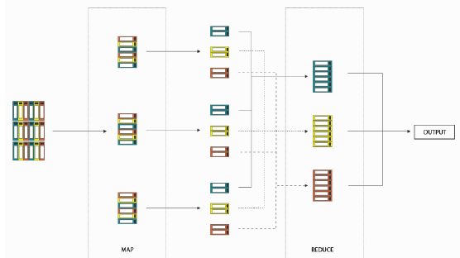

The output of the map task is the input to the reduce tasks. So all the map output from different nodes of the cluster come to the node that runs the reduce task. The output of the reduce task gets stored back to HDFS.
Choosing the number of reducers: if the intermediate data generated from mapper task is very large (say 100 GB), one reducer may not be efficient. In such cases the map task partitions the output and creates one partition for each of the reducer.

NOTE: A partition can have many keys. However, all the records for any given key are in the same partition.
Input Splits: the chunk of data on which a map task operates. Typically input split size is equal to the block size but Input splits don’t contain the data rather they are references to the data. These splits are processed in parallel, the execution time for the entire file will become lesser.
NOTE: Hadoop creates a map task for each input split and the map function written by the programmer is called for each record in the input split.

map and reduce phases:
- Merging phase
- Shuffling & Sorting phase
- Partitioning phase

Example,
Problem statement: in a deck of cards, count the number of club, diamond, heart, and spade.
Ignore the face cards (joker, king, queen).

Assumption: there are 4 data nodes, each node has 1 mapper and 4 reducers

Merging/Combine phase: Cards will be divided among mappers. Mapper will then start counting the cards as,
- It will ignore any face cards.
- It will create key/Value pairs as Suit/number on the card i.e.


All values for the same suite will be combined together as


Shuffling & Sorting phase:
Collect all the lists of values of the same suit together and arrange them in order.
Partitioning phase:
Instead of sending all the suits to the same reducer pile we can have 4 different reducer piles for each of the 4 suits. So before sending we need to partition the data in such a way that all value list for a particular suit go to a particular reducer pile.
So from the above list each suite is assigned to a reducer to add up on the list.

What happens when a task fails?
If a task fails while executing on a block of data, another instance of the task will be created for that block of data. If a task fails 4 times, then the task is killed and the entire job fails.

YARN (Yet Another Resource Negotiator)
YARN was introduced along with Hadoop 2 to improve the MapReduce implementation. This was done to improve on Hadoop-1 as,
- non MapReduce applications i.e. the applications that don’t follow the MapReduce programming model were not supported.
- map and reduce tasks run on slots and the slots for map tasks and reduce tasks were fixed. So if the no. of map task is more than the no. of map slots available they cannot use the free slots meant for reduce task.

YARN split the responsibilities of Job Tracker (i.e. resource allocation and job monitoring) into separate process in the resource manager daemon (i.e. it has 2 components: scheduler and application master).
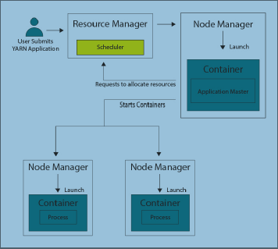

Definition of a container? A container is a fraction of the Node Manager capacity and it is used by the client for running a program. It represents a resource (memory + virtual core) on a single node at a given cluster. At run-time, the Resource Scheduler will decide how to use this capacity.

What is Resource manager? A resource manager (one per cluster) is the master. It knows where the slaves are located (Rack Awareness) and how many resources they have. One of the services it runs is Resource Scheduler which decides how to assign the resources.
What is Node manager? Node manager is the slave. Each Node Manager offers some resources to the cluster. Its resource capacity is the amount of memory and the number of vcores (A YARN cluster is composed of host machines i.e. commodity machines. Hosts provide memory and CPU resources. A vcore, or virtual core, is a usage share of a host CPU).
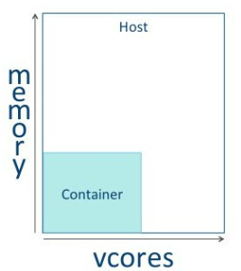
About NM, when it starts, it announces himself to the Resource Manager. Periodically, it sends a heartbeat to the Resource Manager

What is Application master process? Application Master is the main container requesting, launching and monitoring application specific resources. It has the responsibility of negotiating appropriate resource containers from the Resource Manager, tracking their status and monitoring progress.

Map Reduce on YARN:
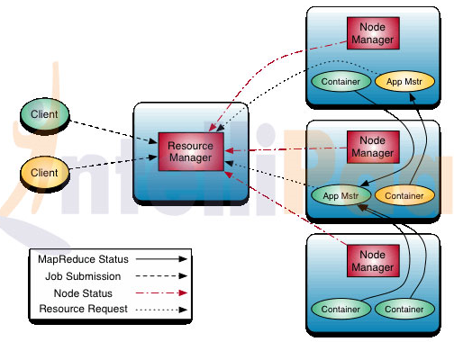

YARN resource manager – This manages the allocation of compute resources based on the cluster.
YARN node managers – It launches and monitors the compute containers on machines based on the cluster.
Map Reduce application master – It manages and arranges the tasks running the MapReduce job. The application master and the MapReduce application tasks run correspondingly in the containers which are scheduled by the resource manager and managed by the node managers.
Distributed file system (Normally HDFS) – It shares the job files created between the other entities.

What happens when the resource manager fails?
Resource manager is a single point of failure in YARN. If it fails, no jobs can run on the Hadoop cluster and no containers can be launched.
So it is preferred to have two resources manager instances must be present in two different machines in the active and standby configuration.

What happens when the application master for a particular application fails?
The application master sends periodic heart beats to the resource manager. In the event of a failure, the node manager will start a new instance of the application master in a new container. The new application master will use the job history to recover the state of the tasks that have been completed to avoid rerunning the tasks. This process is transparent to the user.

