Create a Custom VPC:
1) Go to Services -> Network and Content Delivery -> VPC. I have chosen Mumbai as my region.
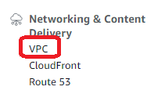
2) the launch page looks like,
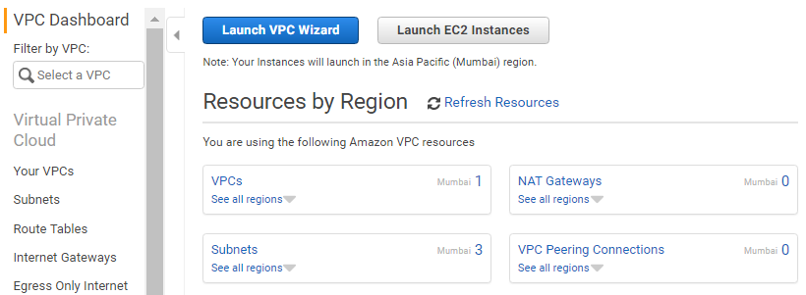
The launch VPC Wizard automatically creates a VPC. But as we are creating a custom VPC, we will skip this option.
3) Other things to notice are,
a) go to "Your VPC" section, there is one entry already and that is the default VPC
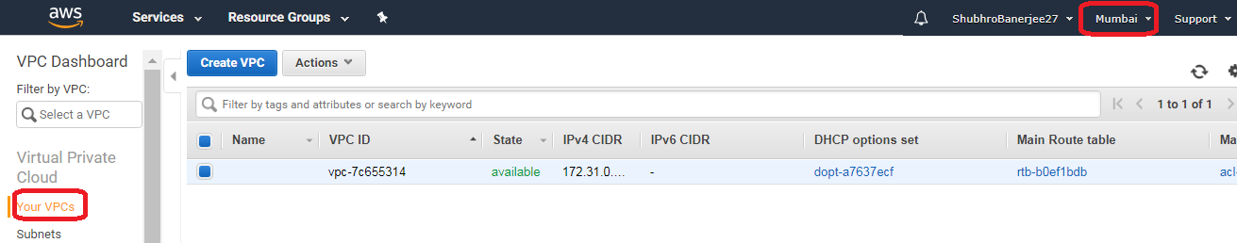
b) Go to "Subnets" section, there will be a subnet for each Availability Zone within "Mumbai" region,
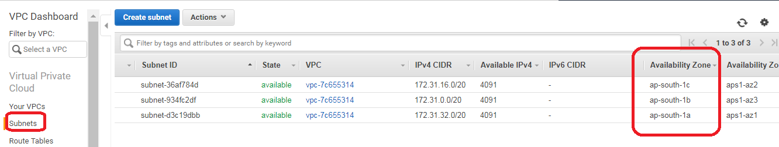
c) There is one default internet gateway
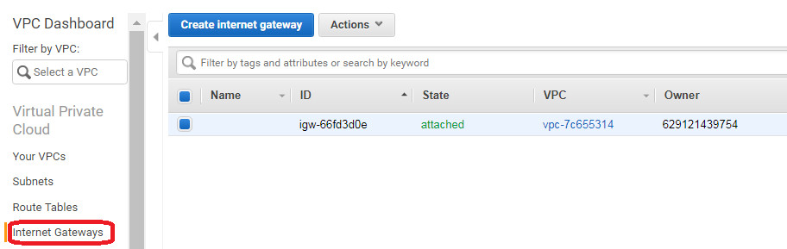
d) In Security Section -> we can check "Network ACLs" and "Security Groups"
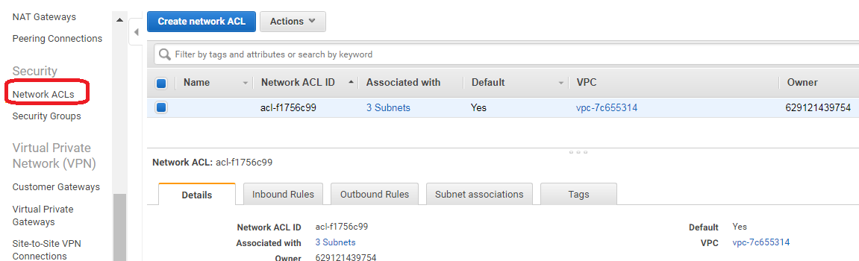
we will also have the security groups we have created as,
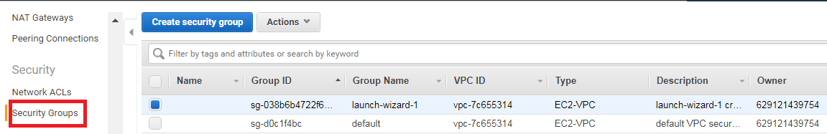
d) When we create a new VPC,
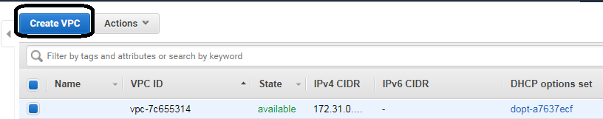
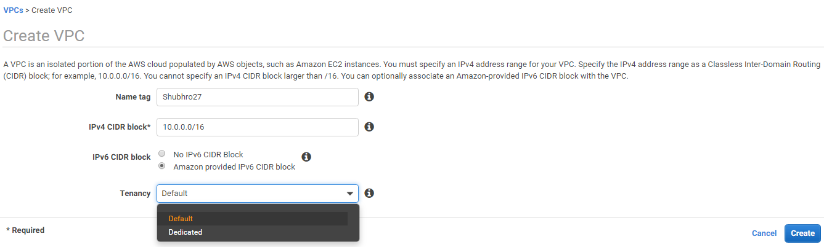
10.0.0.0/16 is the biggest address block possible.
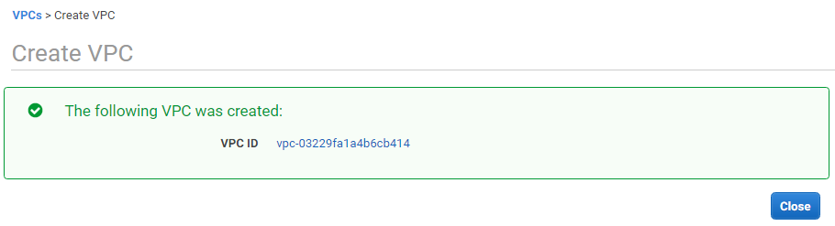
When we create a new VPC, NO NEW subnet, Internet Gateways are created BUT new Route Tables, Network ACLs, Security groups are created as,
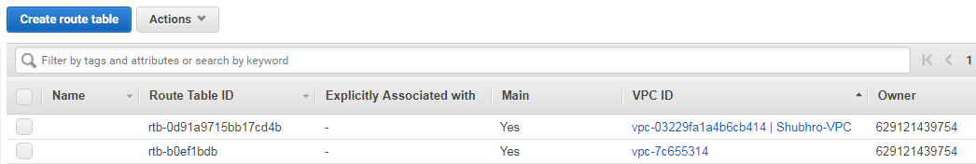
Security Groups,
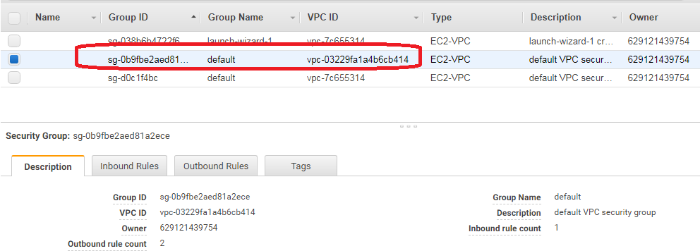
ACL,
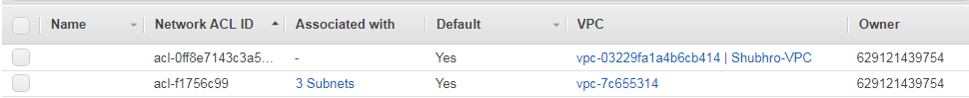

So far, the following structure has been created,
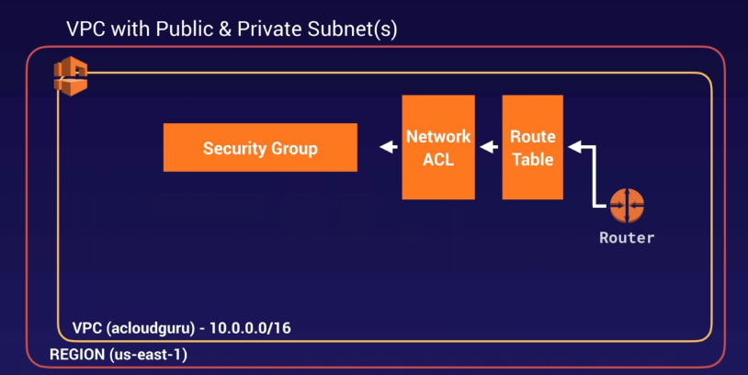
e) Now, we create a new Subnet for our VPC as, (go to Dashboard -> Subnets)
Currently, there will be the default Subnets available as,
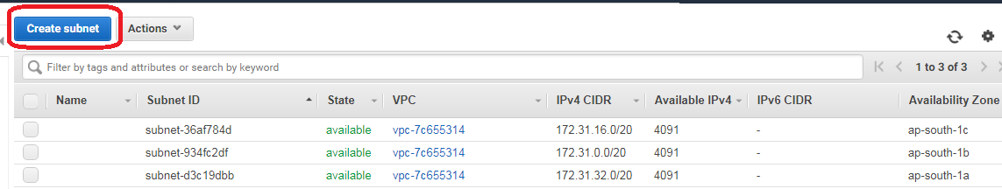
Now to create a new Subnet, go to "Create Subnet"
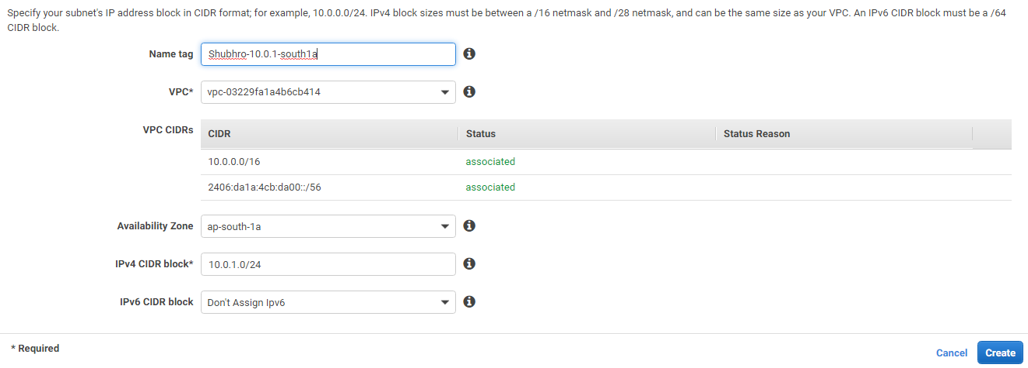
VPC is the one I have created i.e. Shubhro-VPC.
Amazon randomizes the Availability zone, so south-1a for one user may be different for another user.
Hit "create".
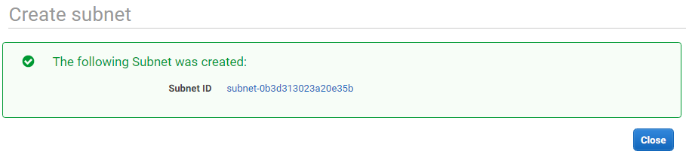
Create another Subnet in ap-south-1a Availability Zone.
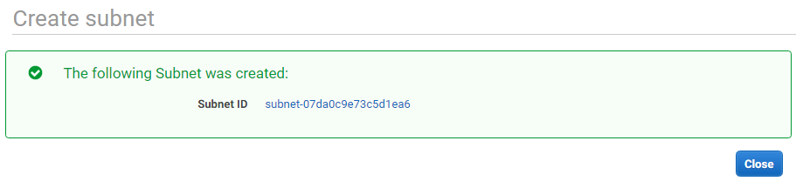
In the subnets console,
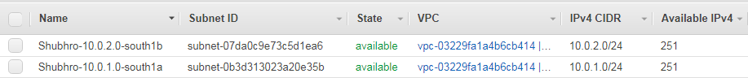
Remember,
1) there can be only one subnet in one availability zone. Subnets cannot span multiple availability zones.
2) The "Auto Assigned public IPv4 address" is turned off by default.
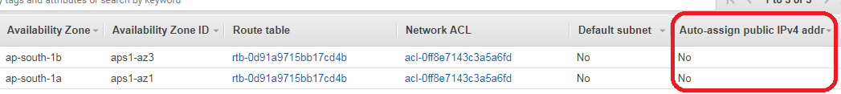
3) by default, the subnets only have 251 available IPv4. This is in contradiction with total IPv4 addresses that should be available. For instance, in cidr.xyz,
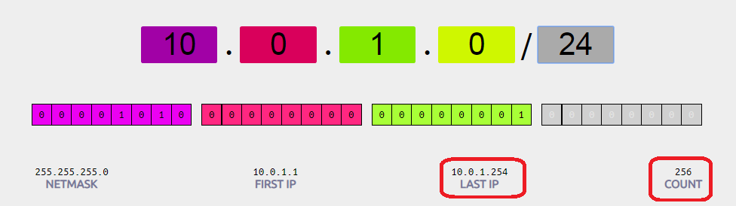

for the IPv4 range, we can see total available address is 256 out of which 254 addresses are usable.
This contradiction is because AWS reserves 5 IPs for its use by default.

4) To launch EC2 instances with Public IP address, we will have to turn on "Auto Assigned public IPv4 address". This can be done as, select the subnet -> go to actions as,
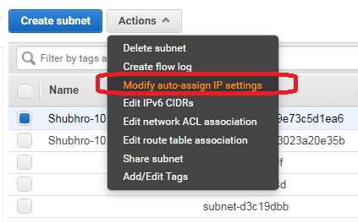
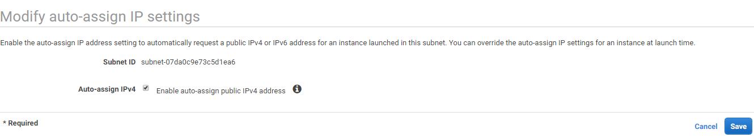

once done, for the subnet,
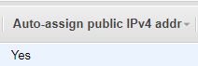

Once done with all the above steps, our custom VPC now looks like,
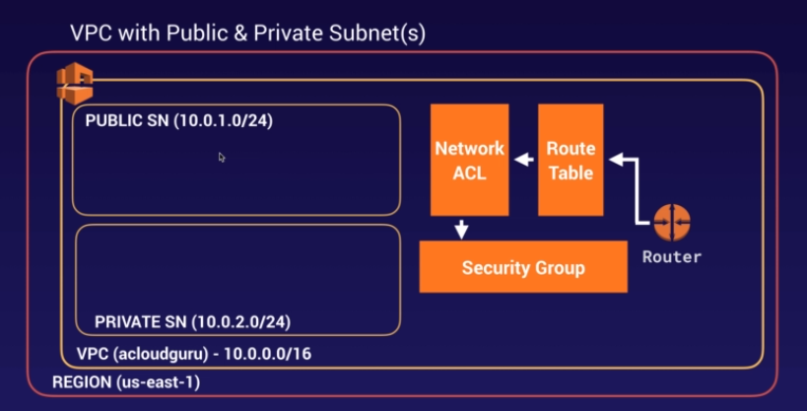

Next will be to add a network gateway to get into our VPC.

to add a internet gateway,
1) On the VPC dashboard, go to Internet Gateways,
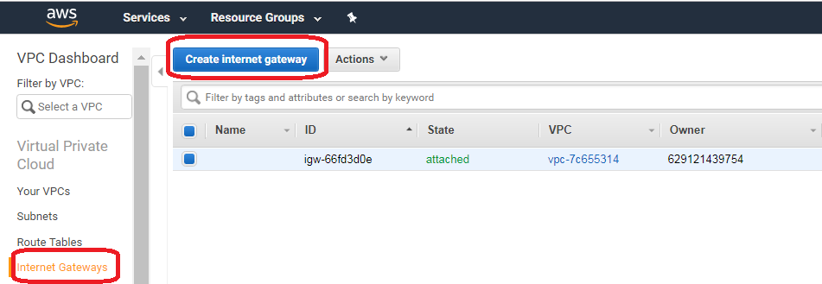

2) click "Create internet gateway"
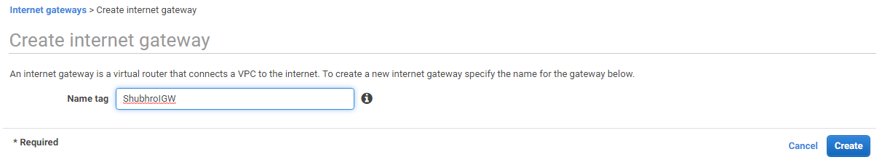

3) This will create a IG that is detached to any VPC, as,
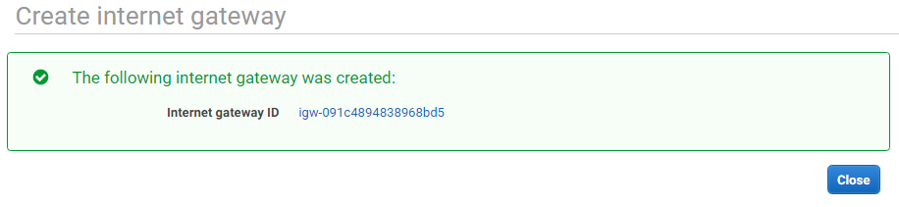

4) To attach it to a IG, we will go to Actions -> Attach to VPC,
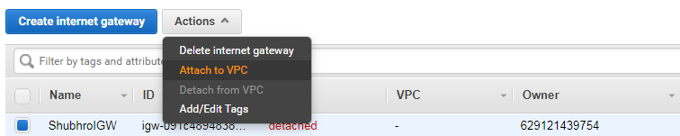

then,
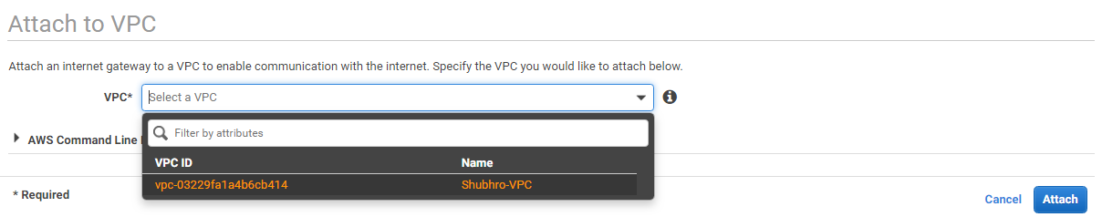

Once we attach the IG as,

NOTE: an IG can be attached to only one VPC. Once the VPC is attached, it is no longer available for other IGs.

Configure Route table (allows subnets to communicate to each other over IPv4/IPv6):
If a subnet is not associated with any RT, they are by default associated with main RT. This implies these subnets are by default PUBLIC which can be a security concern. A better approach is to have the main RT as Private and separate RT as PUBLIC.
1) go to VPC dashboard -> "Route Tables"
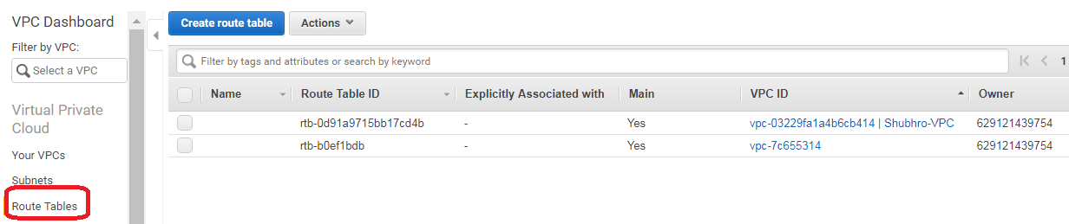

2) Click on create route table,
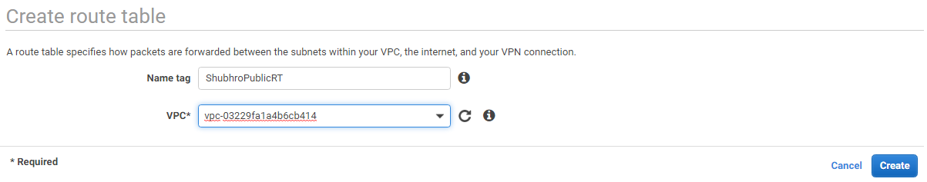

RT is now created as,
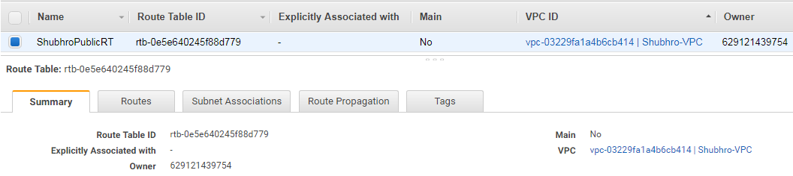

3) Note that now there is one Main RT and a separate RT as,
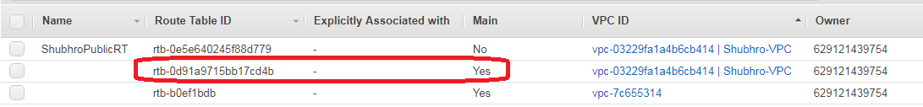

4) Create a route out, for the new RT created, hit "Edit Route"
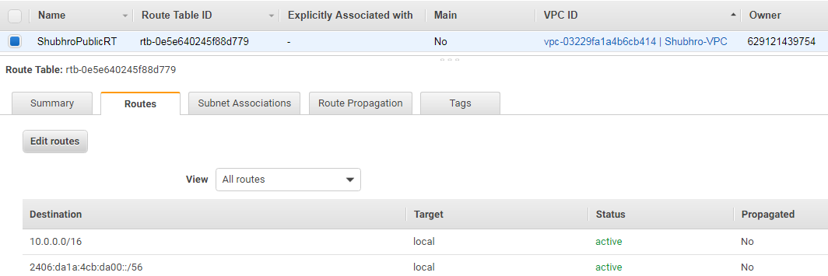

Now, click "Add Route"
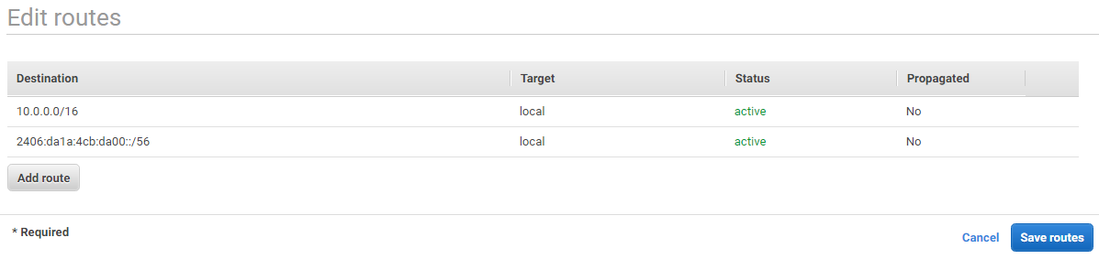
here add the IGs for IPv4 and IPv6 as,
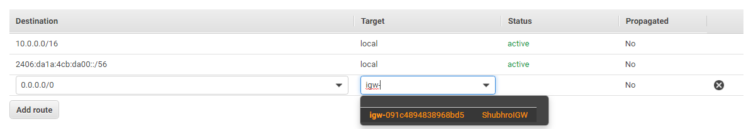
so,

now click "Save routes"
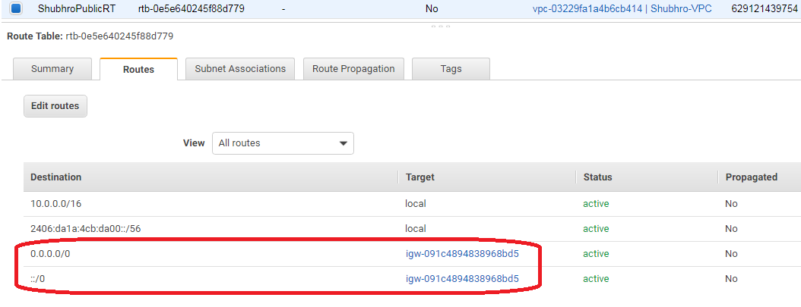

with this, any subnet associated with this RT will become public for all IPV4 and IPV6 connections.
So to associate a subnet with this RT,
1) we will go to "Subnet Associations" on the RT as,
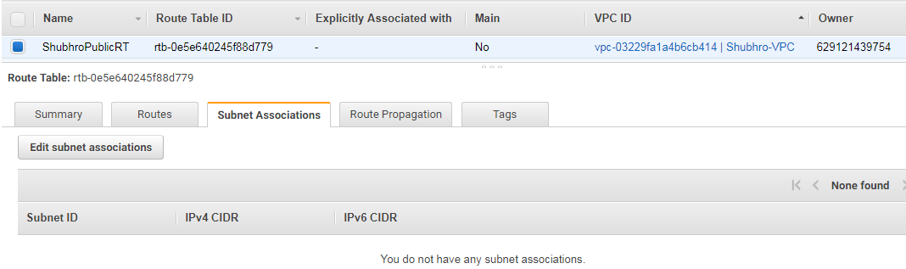

2) Click "edit subnet associations" to associate subnets,
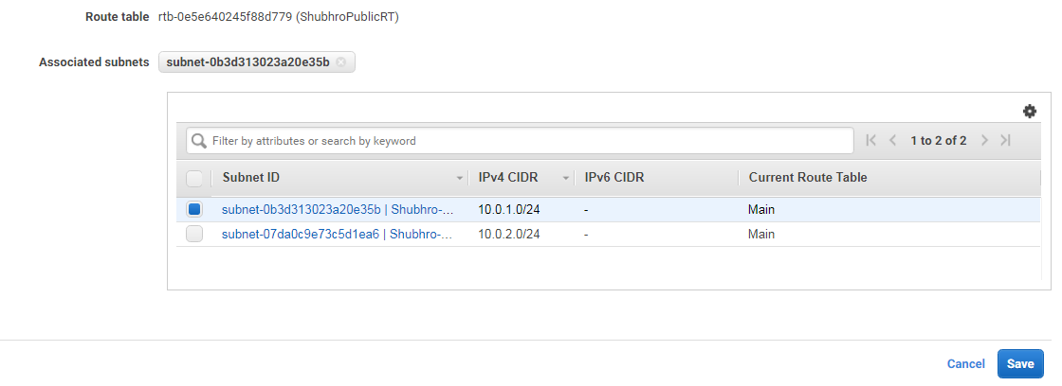

Now, we have one subnet associated with this public RT as,
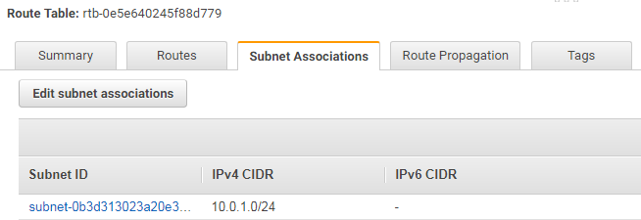

Once a Subnet is added to a public RT, it is removed from the main RT. So now RT will have only one subnet as,
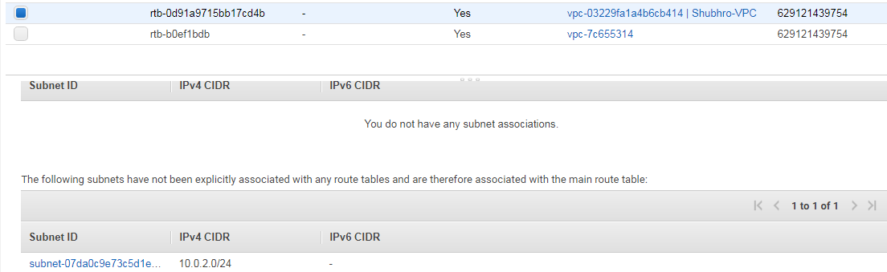

Create EC2 Instances (one in public subnet and one in private subnet)
1) To create an EC2 Instance on public subnet, all process remain same except,
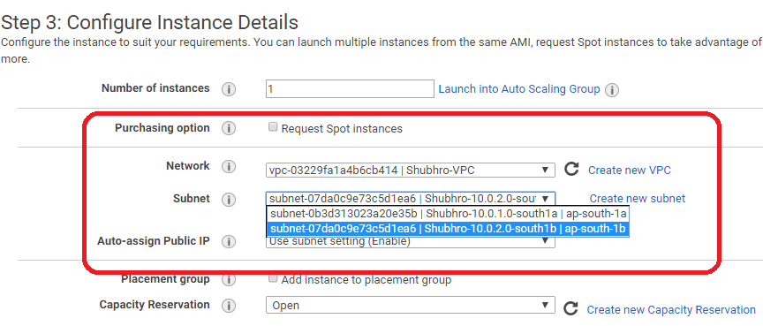
so this EC2 instance will automatically get a public IP address.

2) To create an EC2 Instance on public subnet, all process remain same except,
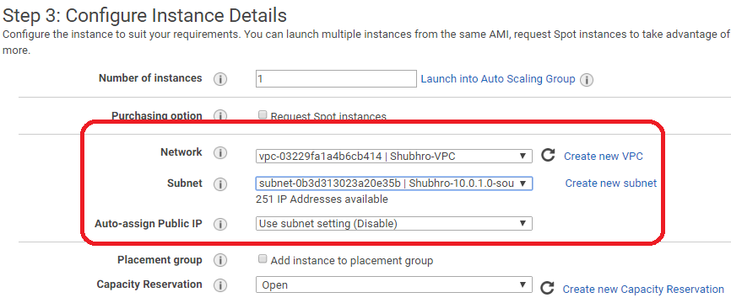
Also, keep only Default Security Group,

Subnet Auto Assign IP is disabled, so no public IP will be assigned to this EC2 Instance.

3) This process will create 2 EC2 Instances as,

this completes our custom VPC as,
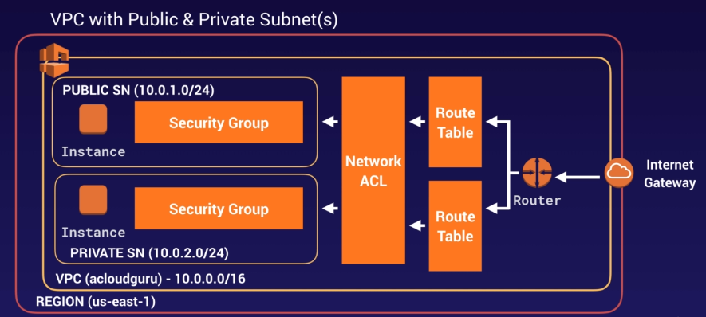

key takeaways,
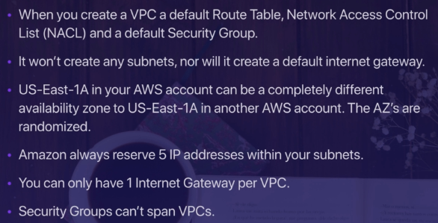

SSH to Public Subnet:
- Create a new Security Group as,
Include ICMP rule so that user should be able to ping the public server. In ICMP we can pass CIDR, IP or Security Group. We will pass CIDR as 10.0.1.0/24. This will help any Public security Group to communicate with this security group.

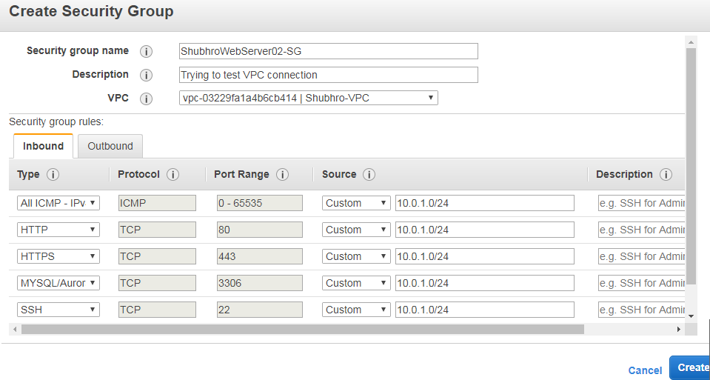
This will create a security group as,

- Go to the Private EC2 Instance and change the security group from “Default” to “ShubhroWebServer02-SG”
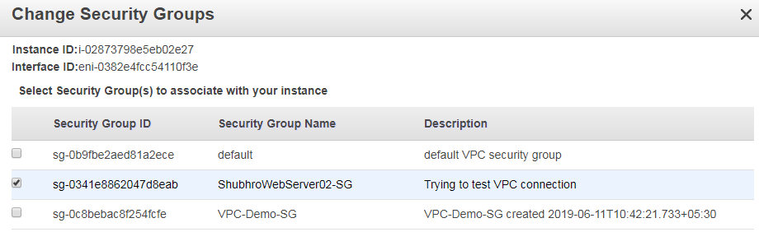
- To test if communication is now enabled between the Public and Private EC2 Instance we will,
- grab the Private IP Address of the WebServer02
- SSH to our public EC2 instance and
- try to ping to private SSH

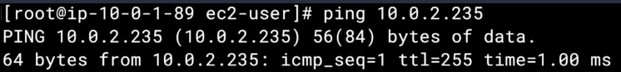

If we want to SSH to our Private Web Server, we will need the private key (this is however not done in production servers. To access Private Web Servers we use Bastion hosts). But as a demo,
On the public server follow the steps in screenshot:
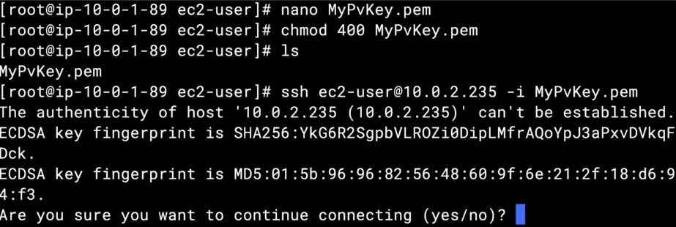

NOTE: if we want to update (yum update –y) or install new software on a private web server, it will fail as Private Server will not be connected to the internet. However, this can be done thru NAT Instances/gateways.

