NAT (Network Address Translation) Instances and Gateways:
This allows us to install software, update on a private subnet.
NAT Instances are EC2 Instances while NAT gateways are highly available and not just a single instance and span over multiple availability zones. Most of the times NAT gateways will be used,
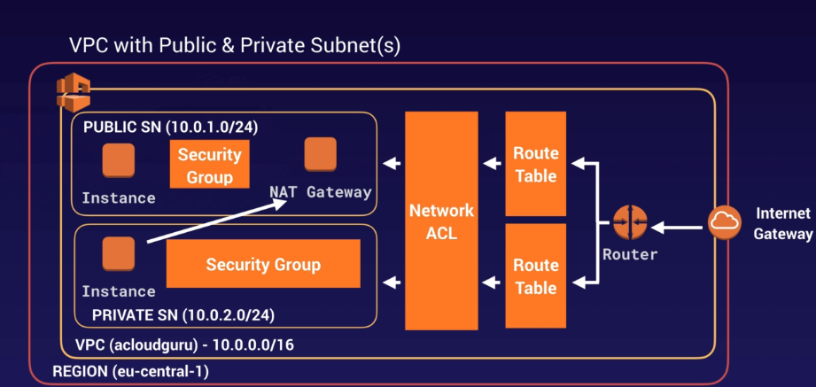

Creating a NAT Instance,
Create an EC2 Instance with the following changes,
In “Step 1: Choose an Amazon Machine Image (AMI)”, go to “Community AMIs” section,
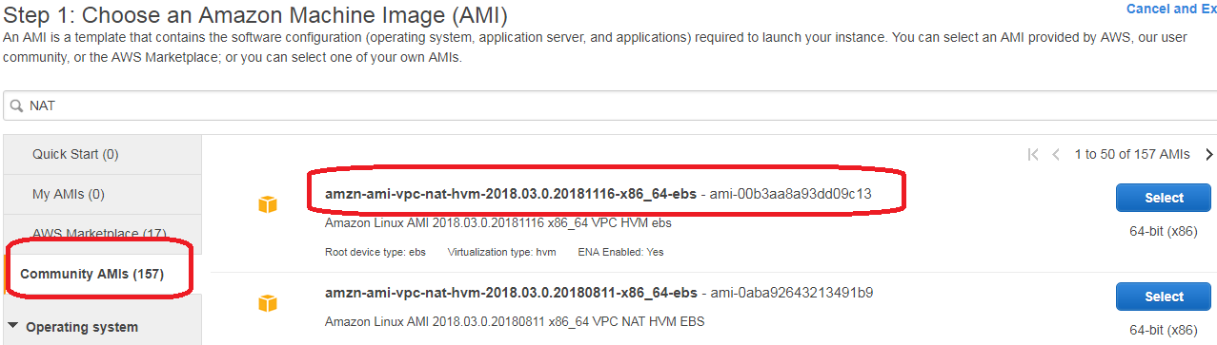
In Step-3, launch this EC2 Instance into a public subnet. This will help have a public IP for this EC2 Instance,

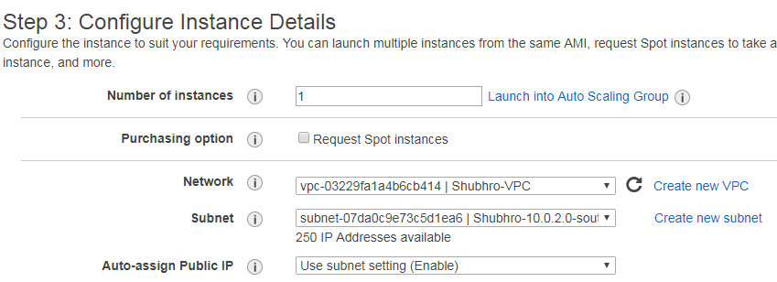

Configure SG,
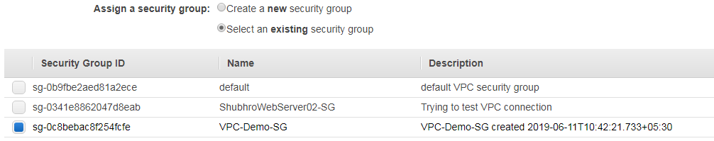
Finally when launching this EC2 Instance,
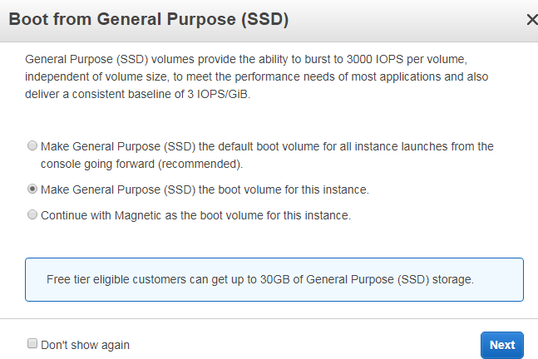

This Creates an EC2 Instance as,
Important Note:
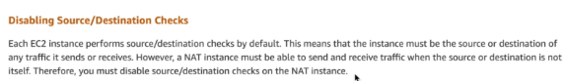
To disable,
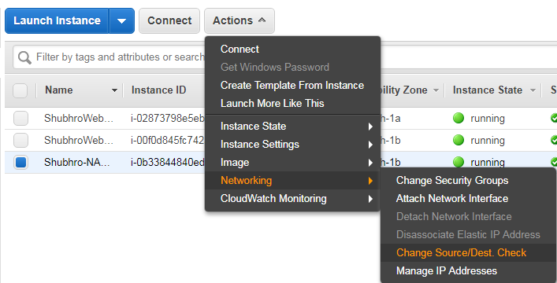
Then,
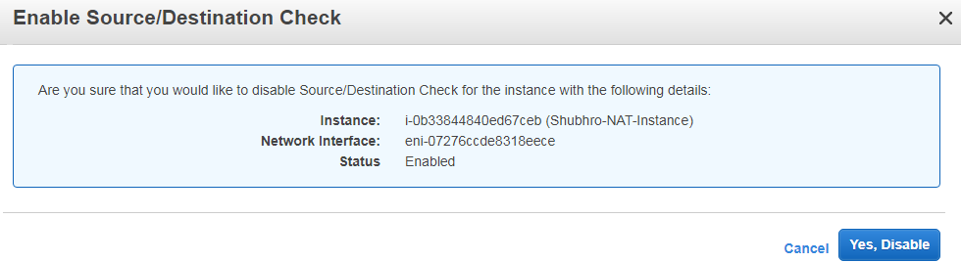

For our server to talk to NAT Instance, we need to create a route in Default Root Table. This is done as,
- Go to VPC Dashboard -> Route Tables -> go to Main Route Table -> Routes -> Edit Route -> add the IP’s for HTTP
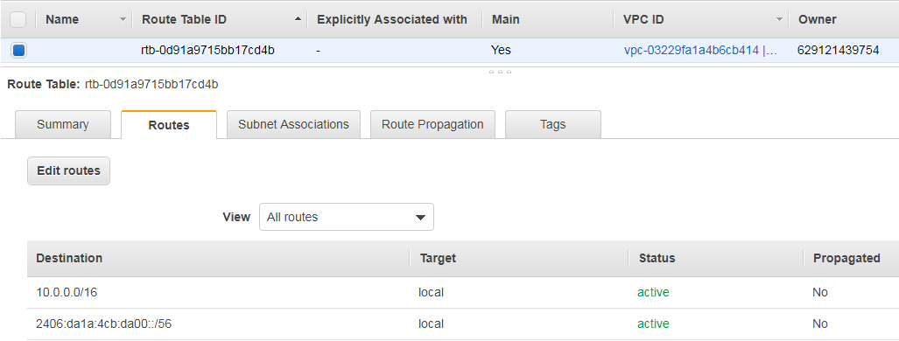

- Click add route and add the destination IP’s,
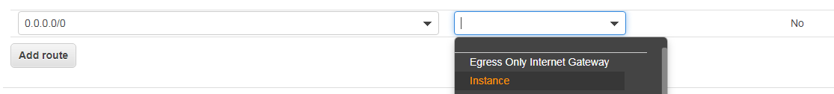

In “Target” we are going to use our EAT EC2 Instance,
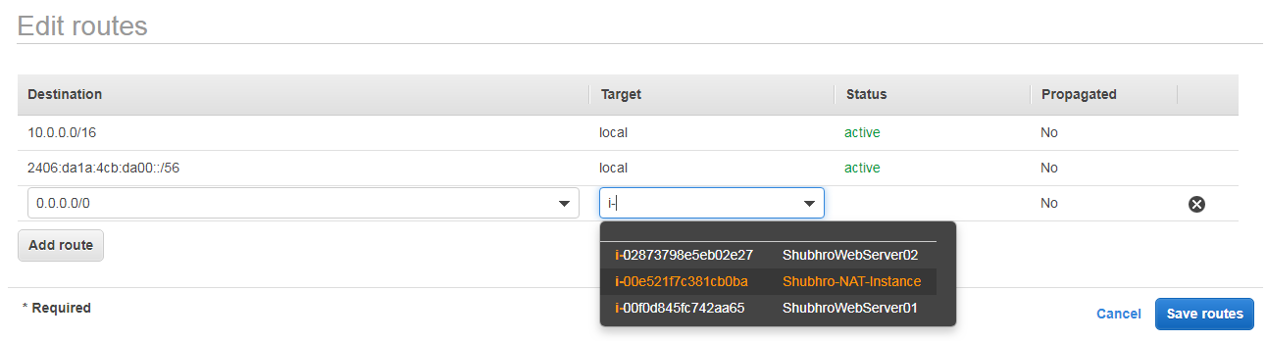
Once Saved,
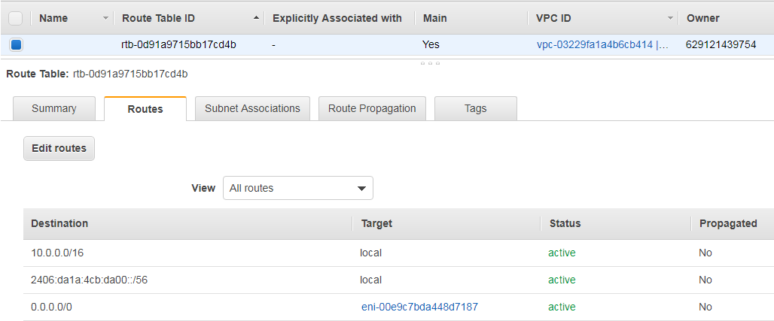

The problem with NAT Instances is that the entry to the Internet Gateway rely on a single instance, so if there are 1000 EC2 Instances and only 1 NAT instance, it becomes overwhelming and a single point of failure.
In such case, NAT Gateways are a better option.

