Basic Microservices Design :
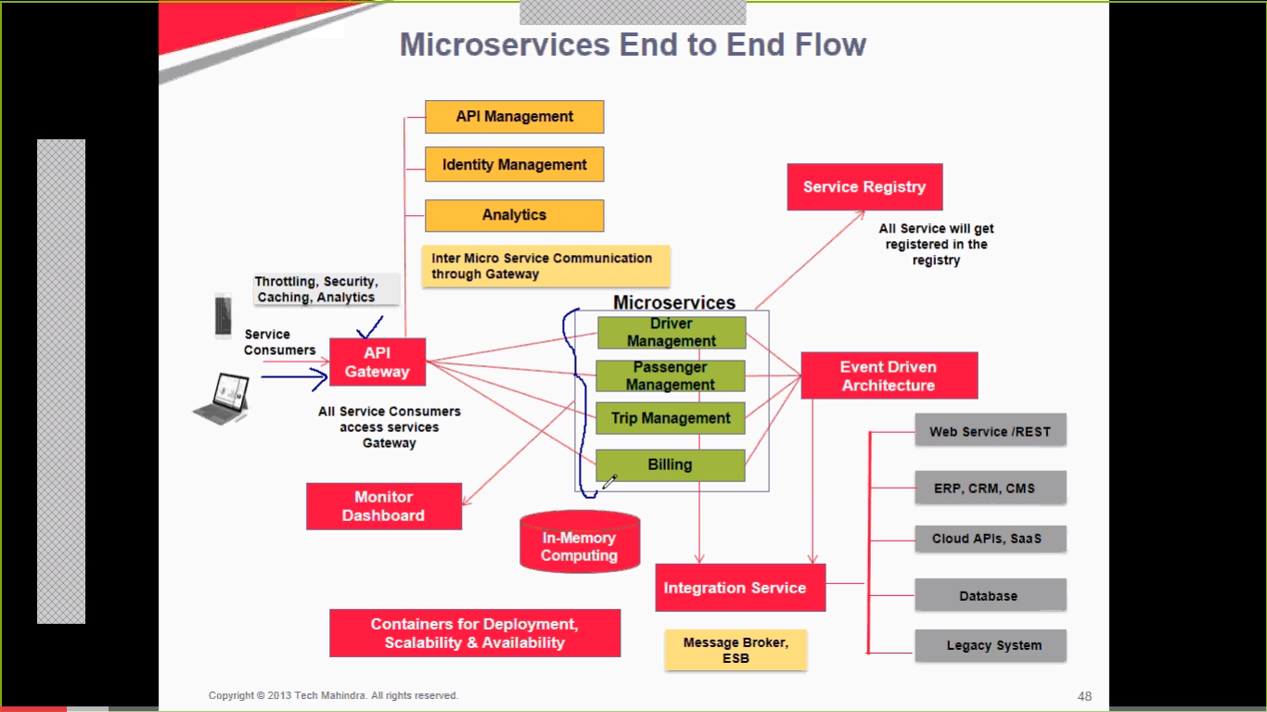
Here API Gateway is a single point of entry to the application where when client opens an application thru mobile or WEB, the API GAteway will
a) show the client the complete web page which is formed from different microservices representing each business functionality.
b) take requests from client and channel it to the proper MS. Every request is validated thru an authentication service before routing the request to a service.
c) also does load balancing and protocol translation (client sends requests using a protocol and allow ms to use different protocol suited for them).
API gateway should be highly available but in case of service failure, gateway should be able to mitigate/minimize the impact ( may be thru default responses etc).

Service invocation/call : in order for the services to communicate with each other, they can use,
a) Asyncronous messaging based mechanism : like kafka, rabbitMQ, ActivMQ.
b) Synchronous : like HTTP, Thrift.

Service Register : is a component where all the microservices are registered. It is a kind of DB where the service name, host port etc information about the services is listed i.e. the network locations of service instances. In order to update the Service Register,
1) Self registration : i.e. the code for microservices will have the logic to register itself to service registry Db i.e. service itself will register and unregister.
2) 3rd party registration : another component maintains the SR. example, zookeeper, Eureka, consul etc. These track the changes to the service instances by either polling or subscribing to events.
API Gateway ----> Service Discovery ---> information about microservices running in the system. So Service discovery mechanism connects the API gateway to the service registry.
API Gateway can cache the service registry information for faster processing of services. SD usually facilitates the location of the services the Application gateway is communicating with. Now, services have dynamically assigned locations (due to auto scaling and upgrades). so SD can be of 2 types:
a) Client Side Discovery : client queries the service registry and determines network locations of the available service instances.
b) Server side Discovery : i.e. API Gateway will do the service discovery. client makes request to a service via load balancer. LB queries the service registry and routes each request to available service instance.
Note: Server side discovery is preferred.

Inter service Communication:
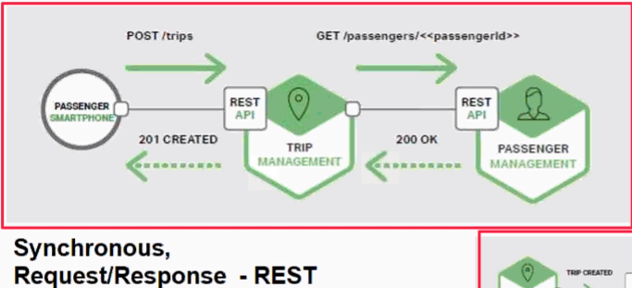
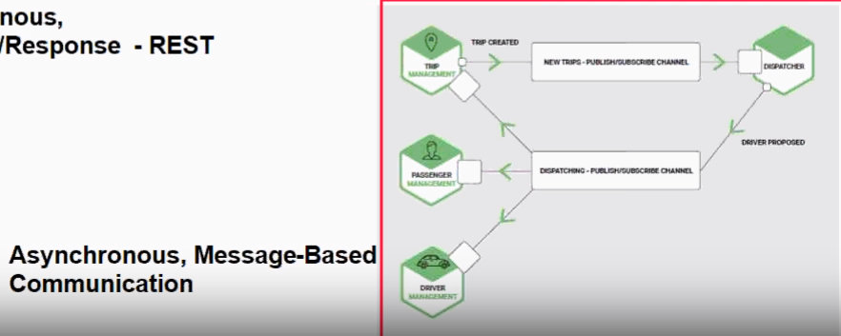

Service Monitoring : monitors the microservices that are running in the system. Service monitoring will keep a track of the number of services that are running and maintain the status in form of a dashboard called Monitoring Dashboard. Example of 3rd party tools are,
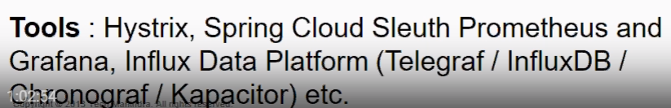

Logging of Microservices : logging of individual Ms is difficult due to Ms being distributed over Internet, so tracing E2E transactions by correlating logs from individual Ms is difficult. A logging solution for Ms is centralized logging where,
Collect all log messages and run analytics over the log messages.
eliminate dependency on local disk system.
correlate and track transactions e2e.
Aggregate log information from different sources.
examples of 3rd party tools,

Event Driven Architecture: is an architecture where the microservices interact with each other using a REST API or Message Queue.

In Memory Computing : In order to reduce frequent calls to the DB from each Services, the concept of caching is preferred to improve the performance of the system.
Containerization : all services are deployed as containers to different servers to implement availability and scalability.

Microservices Security:
