Data Factory – Copy Data Activity
Copy data from on premise to cloud or from one Azure cloud to another.
From On Premise to cloud :
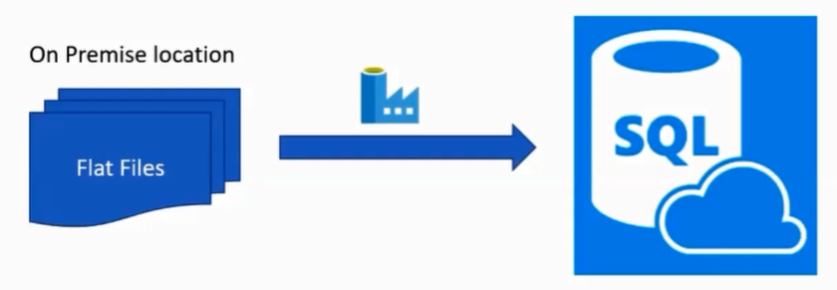
Steps:
- Create a Pipeline”CopyDataActivityPipeline”,
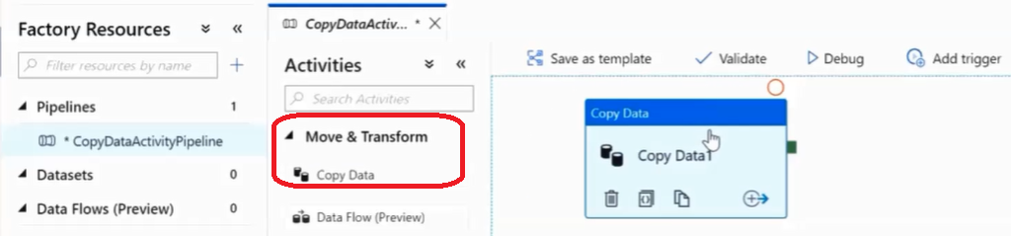

- Select Source as “file System“ -> “Select Format”
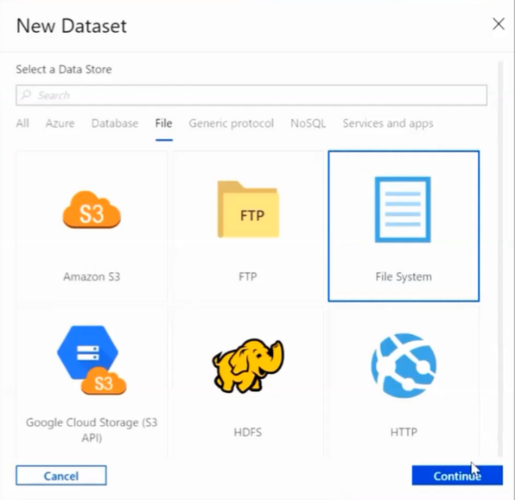

Then,
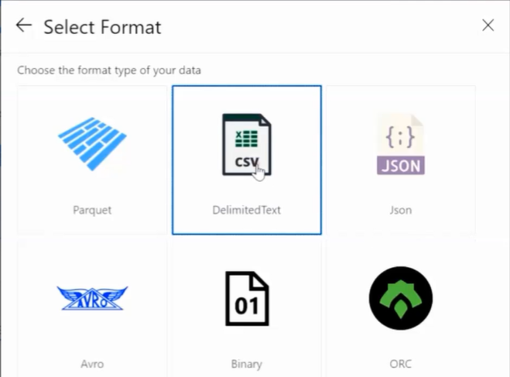

Now select/CREATE the linked Service,
This linked service should have an Integration Runtime pointing to my local machine (like SelfhostedIR used in below screenshot)

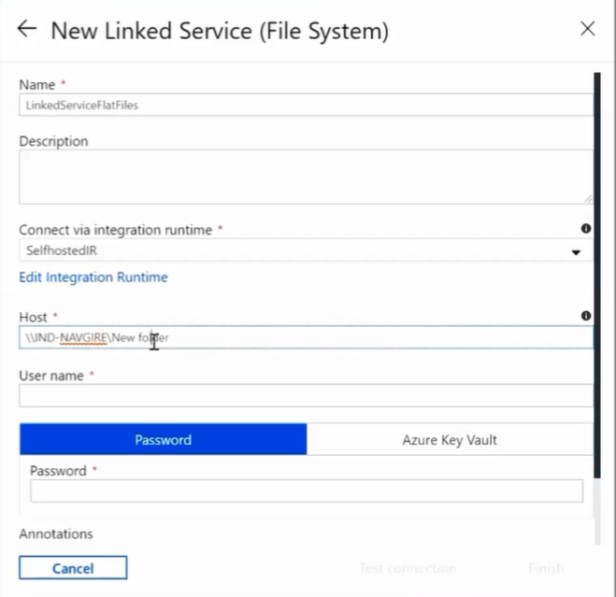
Give Username/Password
Location of file on local machine

Test connection and create this linked Service.

Next, give the name of the file,
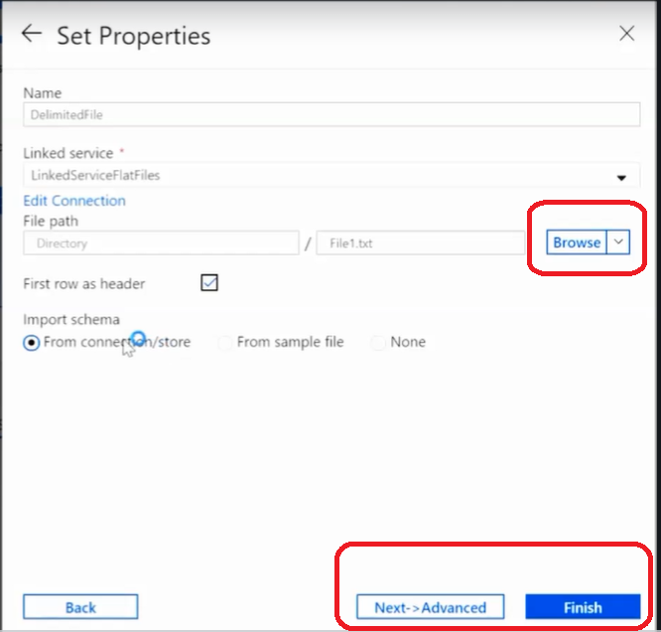

This will create a source.

- Create Destination,
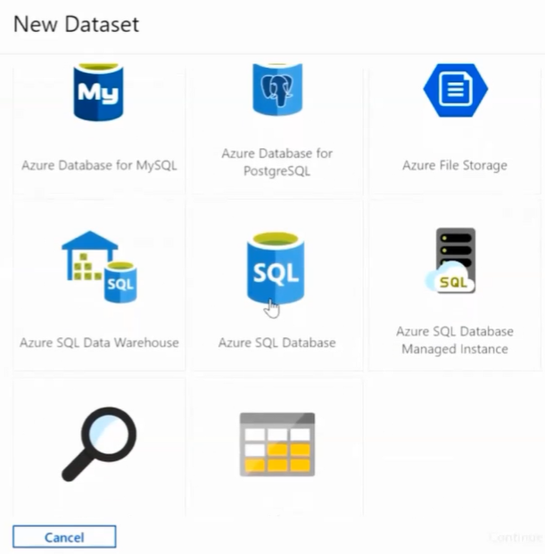

Create or use a linked service to Azure Data server.
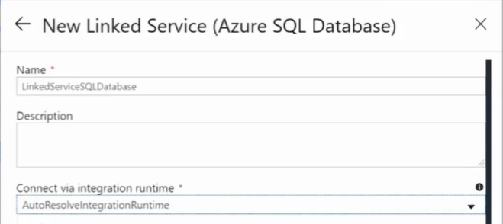
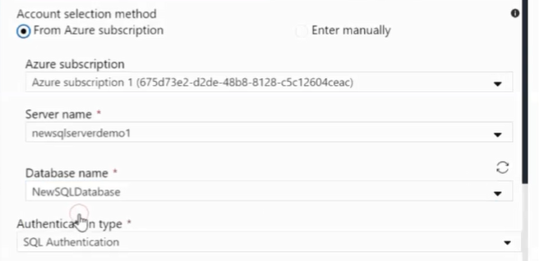

Provide the Usename and Password. Test Connection and finish.

TO select the destination DB,
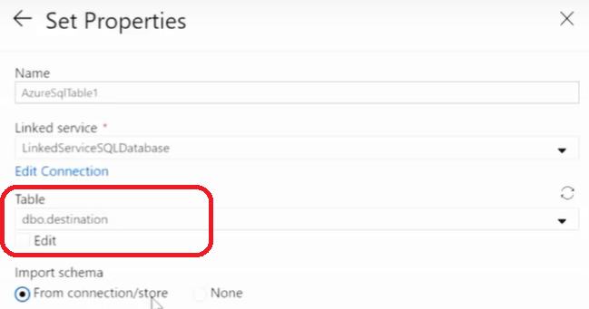

This will create the Source and Sink.
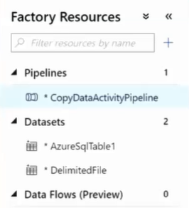

- Mapping will synch source to destination.
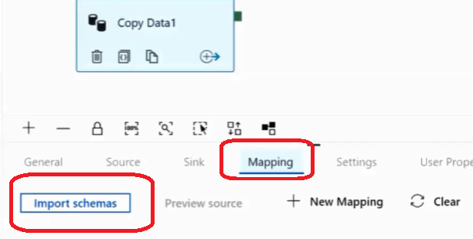
This will import schema from both Source and Destination and will try to map it.

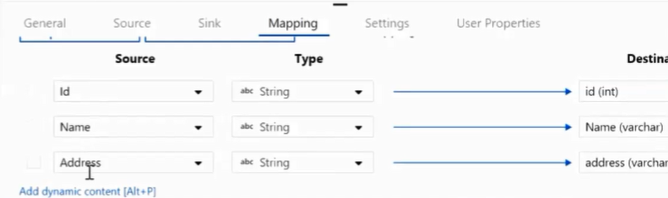

DEFAULT mapping can be changed.

- Publish the changes,
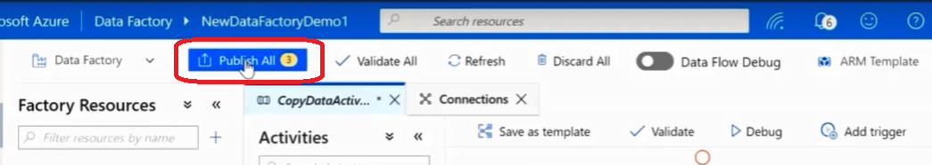

Click ”Publish All”.

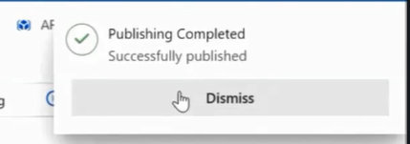

Pipeline has been published on Azure.

- Execute the pipeline i.e. add a trigger.
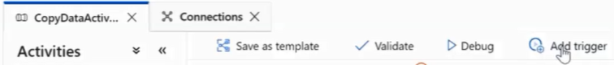

The status of progress can be seen from “monitor” section.

You can see the data in the DB server by querying the table.

From Azure to Azure :
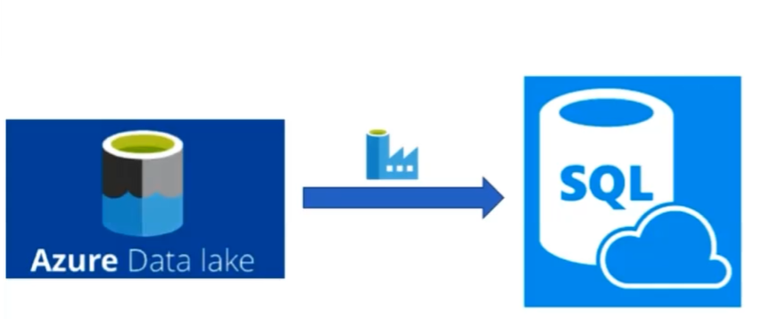

Steps to copy data from Azure Datalake to DataBase –
- We can clone an existing pipeline and change the new one to satisfy our criteria,
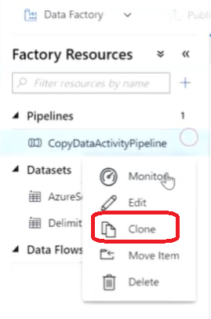
- Create a Source Dataset (source being in datalake)
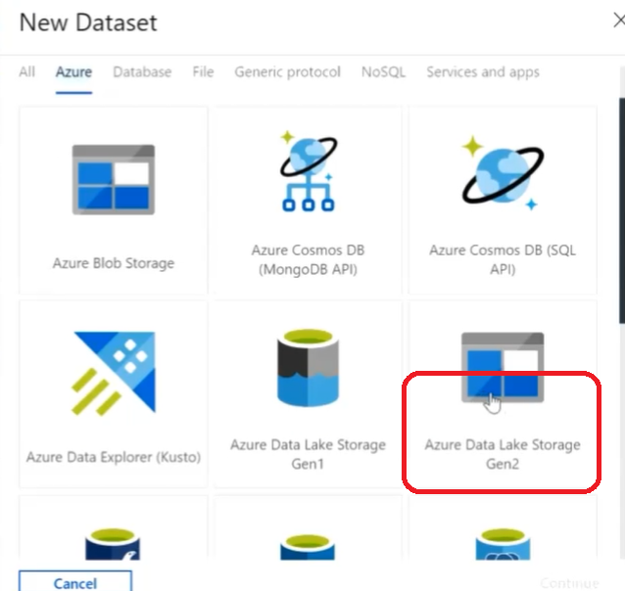

Next,
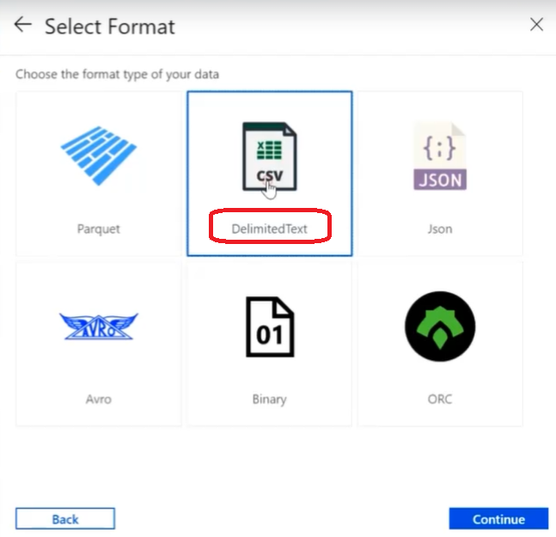
Create a New linked Service,
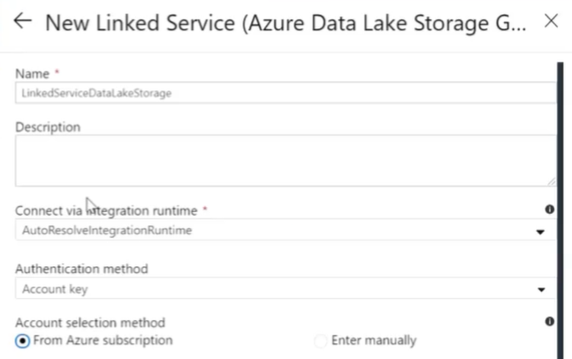
As src is in Azure
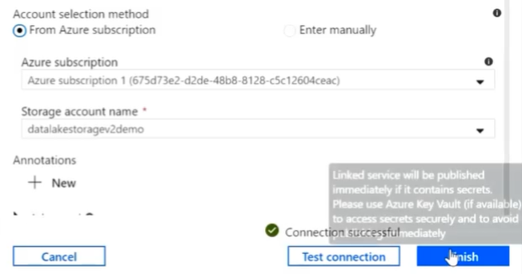
Existing Azure Subscription and DL

Click “Test Connection” and finish to create Source Dataset.

Browse the file which needs to be copied,
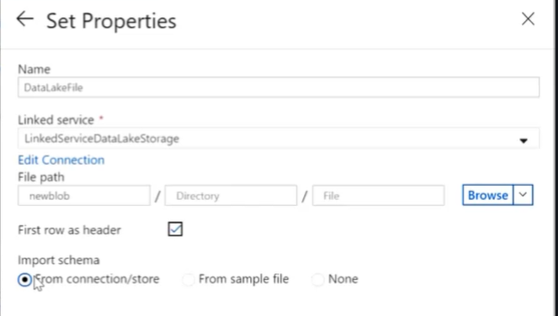

- Create Destination. Steps are same as in section-3 in “On Premise to cloud” setup steps.
- Mapping steps are also same.
- Click “Publish All”.
- TO run the pipeline, click “Add Trigger” -> “Trigger Now”

